Expert Sessions on Slike
v1 surfaces and journeys · 1:1 consultations · Draft, Sep 2026 · Abhimanyu
The objective. Organising the bookings guruji already gets is our convenience, not his — if his revenue stays flat he drifts back to WhatsApp. The bet is incremental demand: a booking link under his lives producing consultations that would never have existed. Everything below serves that.
Five surfaces. The WhatsApp booking door · his page, where a devotee signs in to see her own sessions · guruji’s calendar · the assistant console · the waiting room and the call. Two are real builds — the console and the room. The rest are thin.
1. Why his bookings go up
He already earns from consultations. The problem is the path: find a number, message, wait a day, agree a time over four messages, ask how to pay, send UPI, hope someone confirms. Intent decays in minutes; that path takes days.
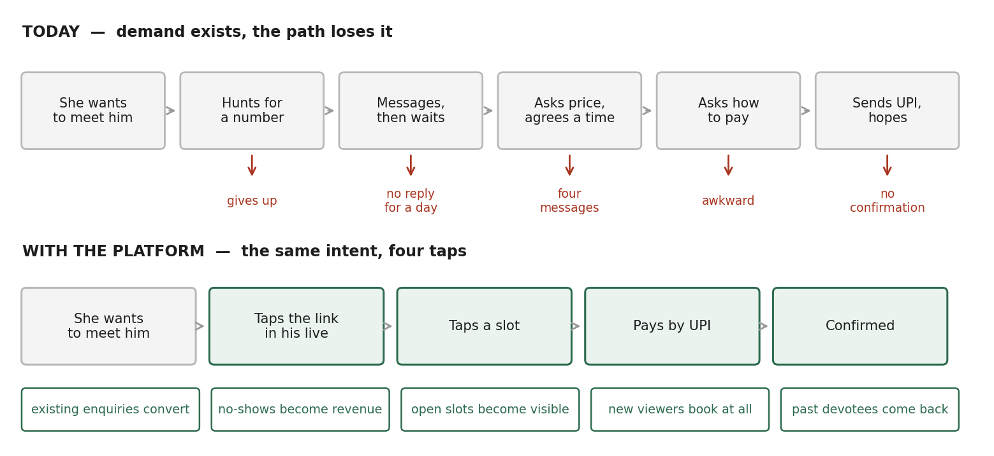
The same demand, two paths
FIVE LEAKS, PLUGGED
- Existing enquiries convert. Whoever messages the ashram this week can finish in four taps instead of falling out of a slow thread.
- No-shows become revenue. Unpaid bookings no-show heavily; every one is an hour that earned nothing and blocked someone else. Prepaid means the slot is used, or the dakshina stands.
- Open slots become visible. Nobody today knows Wednesday 11:00 is free. Showing the next three times fills gaps a notebook leaves.
- New viewers book at all. Two districts away, too hesitant to call, a son booking for his mother — these bookings do not exist today. This is the hypothesis.
- Past devotees come back. No record, no follow-up, no return. A thread and a history make repeat the cheapest booking he gets.
- And his team stops being the ceiling. Every booking today costs her minutes of back-and-forth; the limit becomes his calendar rather than her inbox.
Roughly, on his numbers. Say twelve consults a week at ₹500 — about ₹26,000 a month. Better conversion on enquiries he already gets, no-shows down from a quarter to under a tenth, four to six live-sourced bookings, a couple from repeat: twenty-four to twenty-eight a week. About double, on the same hours.
And the honest ceiling. Six slots a day, six days, is thirty-six a week — no software raises that. v1’s job is to fill his existing capacity and prove the funnel. Past that, the only ways up are price or group sessions, which is what v1 earns the right to build.

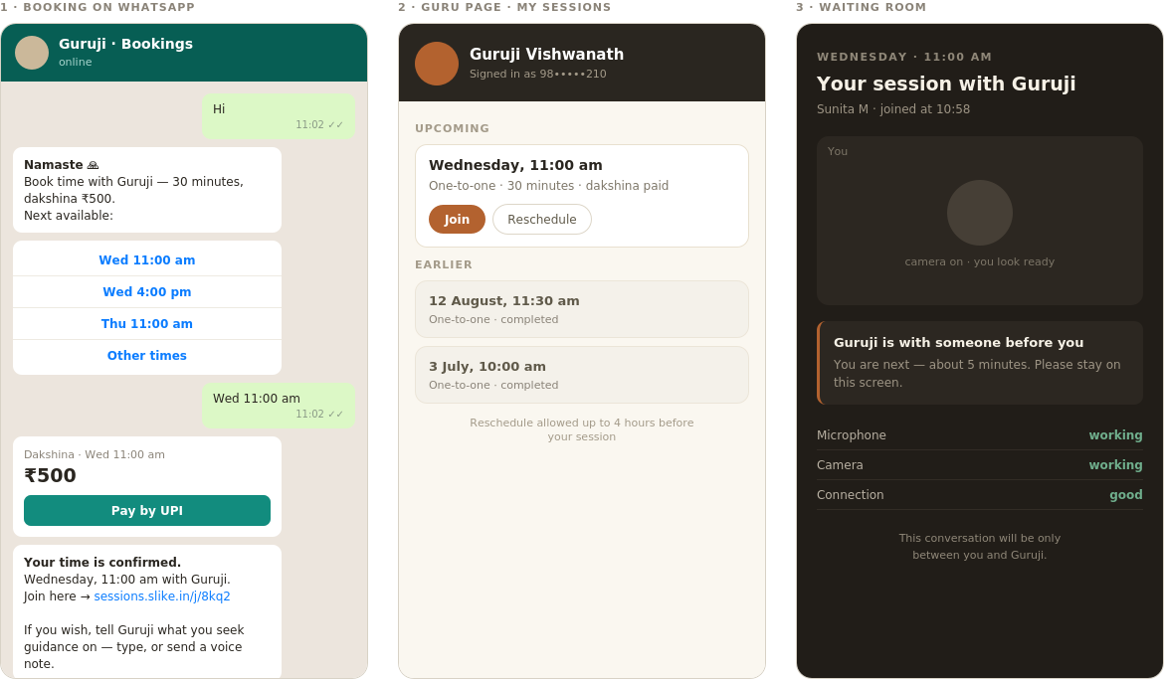
Three of the five surfaces — booking, my sessions, waiting room

2. The WhatsApp booking door
The only way to book. A QR at the ashram and on screen during lives; a tappable link under every video and in the pinned comment. No website, no app, no account.
THE DEVOTEE’S JOURNEY
- She watches the satsang and sees the link, or hears guruji mention it.
- She taps — WhatsApp opens on the ashram’s bookings number with “Hi” ready to send.
- The reply states the dakshina and offers the three nearest slots as buttons, plus “other times”.
- She taps a slot. “Other times” gives days first, then times — never a calendar grid.
- A payment message appears; she pays by UPI and the amount is confirmed in the same thread.
- Confirmation arrives with the room link, and an invitation — optional — to say what she seeks guidance on, by text or voice note.
- Reminders follow in the same thread: the night before, and ten minutes before.
IN V1  - Slot buttons from availability the team configures once — no human in the loop  - UPI payment in-thread; confirmation, reminders and room link as approved templates  - Optional voice note or text, captured after payment so nothing blocks the booking  - Waitlist capture when no slot suits — the team fills it in one tap | NOT IN V1  - No free-text understanding — anything she sends returns the same slot buttons  - No booking by voice note or phone call; voice carries the question, never the timing  - No discovery, no search, no expert directory  - No proxy identities — one optional line, “who is this session for”
3. His page — and her sessions
One page per guru: his photo, a few lines about him, the dakshina, and a button to book on WhatsApp. A devotee signs in with her phone number to see her own sessions.
THE DEVOTEE’S JOURNEY
- She opens the page from a bio link, a poster, or the confirmation message.
- She reads enough to trust the number she is about to pay — his photo, his lineage, the stated dakshina.
- She taps “My sessions”, enters her phone number, and confirms the OTP.
- She sees her upcoming session with two actions: join, or reschedule.
- Rescheduling shows the same slot buttons; allowed once, up to four hours before.
- Below it sits her history — the sessions she has already had.
IN V1  - A static page per guru, editable by the team  - Phone number and OTP sign-in — no passwords, ever  - Her own sessions: upcoming, join, reschedule once, and past sessions  - The same page carries the booking button when she arrives cold | NOT IN V1  - No profile to fill, no settings, no account to manage  - No cancellation and no self-serve refund — the team handles those  - No public reviews or ratings — they would cheapen the relationship  - No payment history downloads or receipts beyond the WhatsApp confirmation

4. Guruji’s calendar
A day, not a dashboard. He glances in the morning and taps join when it is time. He never sees a price, a payment, or a pending anything.
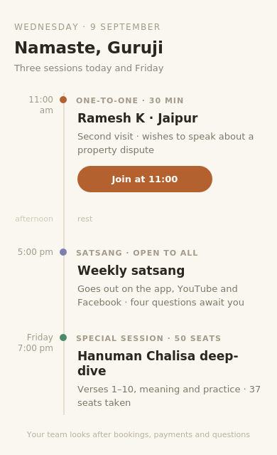 | HIS JOURNEY  - He opens the app once in the morning; the day is a timeline — times down the left, sessions beside them.  - Each session shows who is coming, and what they carry: second visit, and what she asked about last time.  - If she left a voice note, he plays it in the ten seconds before he speaks.  - At the hour he taps “join” and is in the room. Nothing loads, nothing asks permission twice.  - He ends the session; the next person’s name appears. Empty afternoons say “rest”.
IN V1  - Today and the days ahead as a read-only timeline  - The devotee card: name, city, visit count, her question or voice note  - One-tap join, one-tap end, then the next session  - Saved to his home screen as an icon — no install, no store | NOT IN V1  - No money on this screen — not earnings, not payment status  - No slot management, no pricing, no settings — the team owns all of it  - No notes, no prescriptions, no history beyond the one context line  - No notifications that can interrupt a session

5. The assistant console
This is the product we are judged on. The volunteer who runs the practice today lives here, and if she keeps a notebook alongside it we have failed.
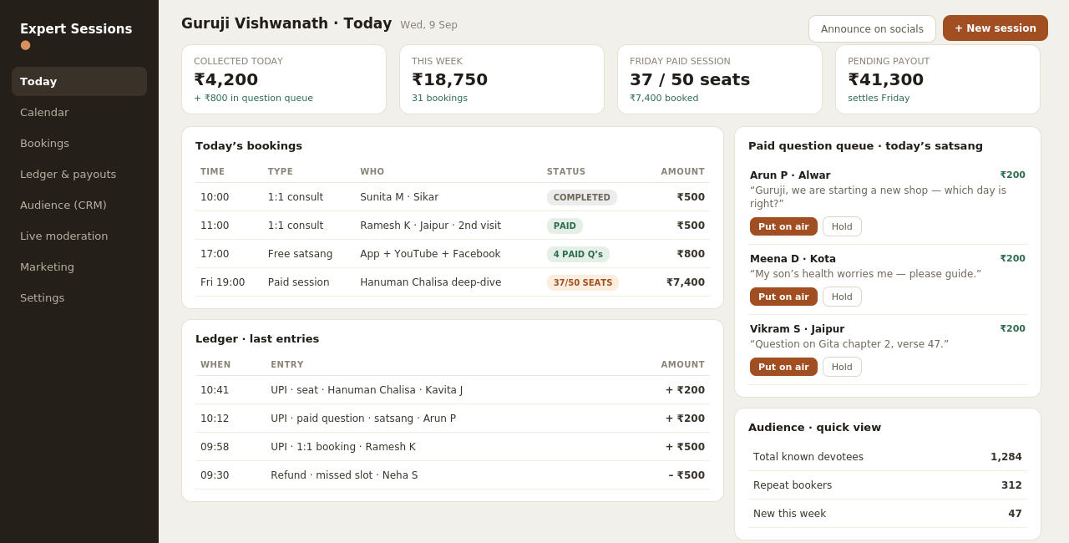
The console — desktop web
HER DAY
- Morning: she opens Today and sees who is coming, who has paid, and what each person asked.
- She opens next week’s slots from the availability she has already configured — a few taps, not a form.
- A devotee messages that she cannot make Wednesday; the assistant moves the slot and the devotee is notified automatically.
- Guruji says he is travelling Tuesday; she closes the day and the affected sessions move in one action.
- At session time she watches the waiting strip — who has joined, who is late — and pushes “Guruji will join in ten minutes” if needed.
- Someone does not turn up: she marks the no-show. Guruji could not take a session: she starts the refund.
- End of day she sees what came in and what is due to be settled, without adding anything up herself.
IN V1  - Availability setup, then slots, bookings and payment status in one view  - Reschedule — one booking, or a whole day at once — with automatic notification  - Refund when guruji cannot take a session; mark no-show  - Booking on behalf of someone who reached the ashram directly  - Live waiting strip, canned messages into the waiting room, click-to-call  - A running ledger of every rupee in, and what is pending settlement | NOT IN V1  - No full CRM — only the record a booking creates  - No campaigns, segments or marketing tools  - No analytics beyond the four pilot numbers  - No roles or permissions — the team shares one login in v1  - No sitting inside sessions, ever

6. The waiting room and the call
Guruji running late is normal, so the waiting room carries the trust rather than the punctuality. Once he joins, the room is two people.
THE DEVOTEE’S JOURNEY
- Ten minutes before, a nudge arrives on WhatsApp; she taps the link and the room opens in her browser.
- She sees her own session confirmed, herself on camera, and mic, camera and connection checked before she meets him.
- An honest status tells her where she stands — next, about five minutes — and updates. No countdown.
- One line promises what she needs to hear: this conversation will be only between her and guruji.
- He joins. They speak. If the network wobbles, video drops and audio holds.
- If he has not joined ten minutes past the hour, she is offered another slot or the dakshina back — without chasing anyone.
- Afterwards: a thank-you in the thread, and a link if she wishes to come again.
WHAT THE OTHER TWO SEE
- Guruji taps join from his calendar and lands directly in the room with her card beside the video.
- The team sees who is waiting and for how long, can message the room or call her — and is never inside the session.
IN V1  - A browser room on an established SDK, themed — no media stack of our own  - Waiting room: session confirmed, device check, honest status, privacy line  - Audio-first fallback on weak networks; one-tap rejoin after a drop  - The ten-minute escape hatch: reschedule or refund, self-serve  - Two people in the room. No admin, no observers | NOT IN V1  - No recording — it changes the privacy promise and needs guru consent  - No screen share, chat, files or whiteboard  - No group rooms — that arrives with paid sessions, later  - No native app; the room is a browser page  - No transcripts, summaries or session notes

7. What success looks like
Baseline first: eight weeks of his bookings, no-shows and enquiry volume, collected before we build. Without a “before” there is nothing to prove, and it is the one thing we cannot reconstruct later.
THE NUMBER THE PILOT LIVES ON
- Live-sourced bookings. By week eight, at least three a week arriving from the link under his lives — bookings that could not have happened before. A third of all bookings by day ninety.
HIS PRACTICE, GROWING
- Consultations per week up by half again on his baseline by day ninety — twelve to eighteen, if twelve is where he starts.
- No-shows under one in ten, from a starting point that is likely one in four.
- Seven in ten open slots filled in a normal week — the measure of whether the calendar is working, not just recording.
THE PRACTICE ACTUALLY RUNNING ON IT
- Every booking created in the system, and no parallel notebook. This is the adoption test, and the team will tell us honestly if we ask.
- Fewer than one booking in five needing the assistant to step in — the rest self-serve.
- Her time on booking admin down from hours a week to minutes.
THE DEVOTEE’S SIDE HOLDING UP
- Under three in ten dropping between tapping a slot and paying.
- One in five booking again within ninety days.
- No session lost to the room itself — the escape hatch used rarely, and never twice for the same person.
THE JUDGEMENT NO METRIC GIVES US
- He would not go back. Asked plainly at day ninety, guruji and his team say they would keep it.
- And the tell we are watching for: they ask for the next thing — paid questions on air, or a group session — without us raising it.
WHEN WE STOP
- If live-sourced bookings are under one a week by week eight, the funnel hypothesis is wrong. We say so, and either fix the link or stop — organising his existing bookings is not a business.
- If the team keeps the notebook past week eight, the console is wrong, and no amount of demand will save it.
What v1 earns the right to build: paid questions on air on the same rails, then ticketed sessions gated at the stream, then simulcast so the live originates with us — and after that, the next tenants as configuration rather than a new build.

