Expert Sessions on Slike
v1 build scope and milestones · 13 September 2026 · Abhimanyu
1. What we are building, and why
A booking and consultation system for one guru’s practice, built on Slike, run by his team, sold and onboarded by Speaking Tree. Devotees book paid 1:1 time with him in a few taps from his YouTube lives, his page or a QR; the session happens in a browser room; every rupee lands in a ledger his team can see.
The bet. Organising the bookings he already gets is our convenience, not his. The pilot exists to prove one thing: a booking link under his lives produces consultations that would never have existed. If that number moves, the practice grows and the platform earns its next increment. If it does not, we say so.
2. Scope — five surfaces, one system underneath
Surface | What ships in v1 | Deliberately not in v1
WhatsApp door  QR on the L-band and at the ashram; link under every live | Slot buttons from the team’s availability pattern · UPI in the thread · confirmation, reminders and join link as templates · optional voice note after payment · waitlist when no slot suits | Free-text understanding · booking by voice or phone call · discovery or directory
His page  the second door | Next three times on the page · tap → sheet (number, pay) → UPI → confirmed · “My sessions” behind number + OTP: join, reschedule once, history | Accounts or passwords · OTP before paying · cards or netbanking · self-serve refund · ratings
Guruji’s calendar  PWA on his phone | Read-only timeline of his day · who is coming and what they carry · voice note playback · one tap to join, one to end | Any money on screen · slot or price controls · notes · notifications during a session
Team console  desktop web | Today · week calendar grid (who, paid, live-sourced, gaps) · bookings and book-for-a-caller · waiting panel with one-tap messages and click-to-call · reschedule one or a whole day · refund, no-show · needs attention queue · money and settlement · settings | CRM beyond the booking record · campaigns · analytics beyond pilot numbers · roles and permissions · entering a session
Waiting room and call  browser room | Pre-entry check · waiting room with honest status and team messages · room on an established SDK, audio-first fallback, rejoin · ten-minute escape hatch · closing screen | Recording · chat, share, files · group rooms · native app · transcripts or notes
Underneath: one booking service and slot inventory, one payments-and-ledger service, WhatsApp via a business provider, the video SDK, and a tenant model from day one — the second guru is configuration, not a build.

3. Milestones
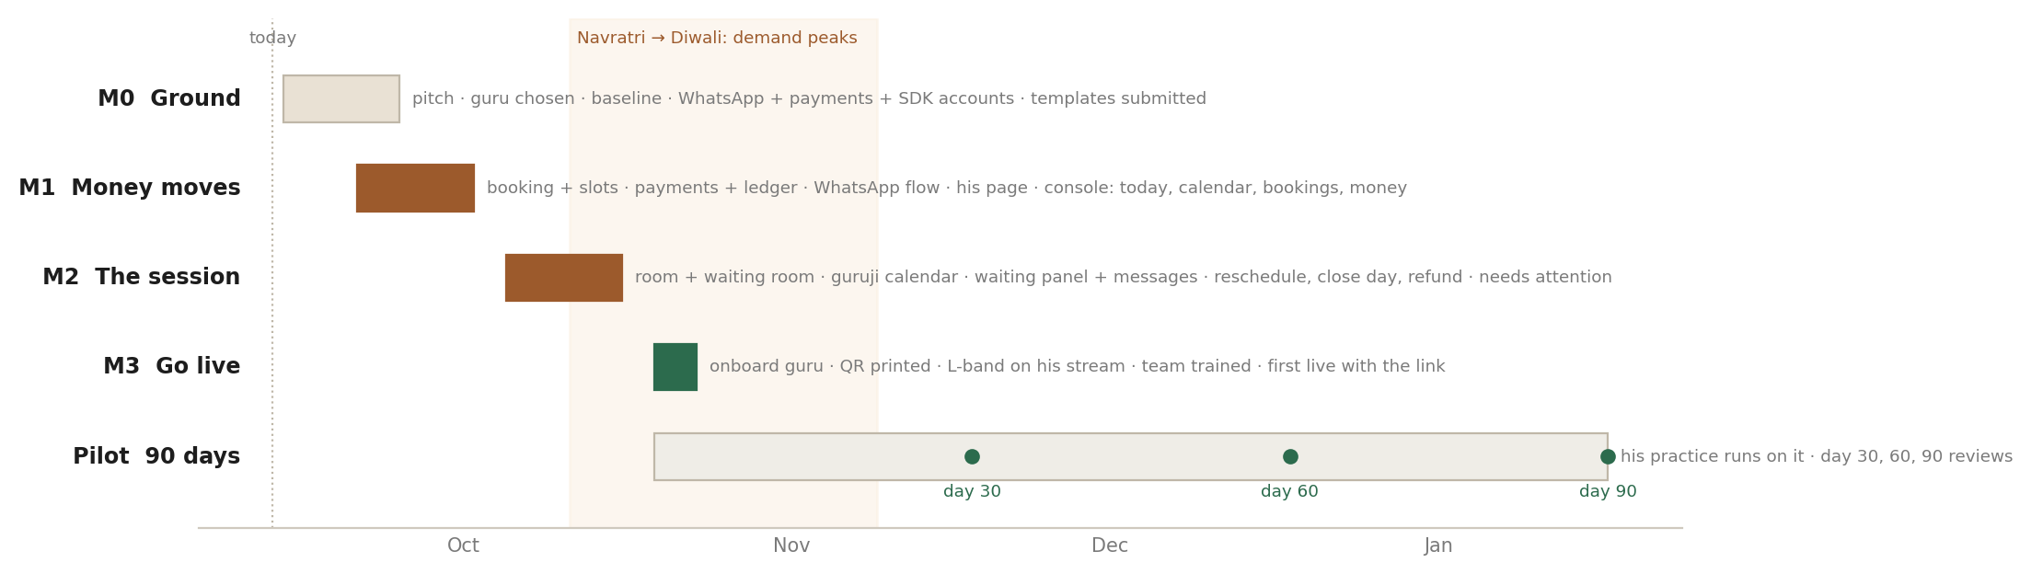
Six weeks to live, then ninety days of his practice running on it
Milestone | Dates | What is done | Exit — how we know
M0 Ground | 14 – 25 Sep  (overlaps M1) | Pitch to manager; working session with Speaking Tree; design-partner guru chosen; his last eight weeks of bookings collected as the baseline; WhatsApp business number, provider account and templates submitted; payment and video SDK accounts; dakshina, refund and no-show policy agreed with the guru | A named guru, a baseline number, and templates in review
M1 Money moves | 21 Sep – 2 Oct | Booking service and slot inventory from the availability pattern; payments and ledger; WhatsApp booking flow; his page with on-site booking; console: Today, calendar grid, Bookings, Money | A real ₹500 flows end to end through both doors into a test slot and shows in the console
M2 The session | 5 – 16 Oct | Room on the SDK with pre-entry check, waiting room, team messages, escape hatch, closing screen; guruji’s calendar PWA; console waiting panel, reschedule (one, or a day), refund, no-show, needs-attention queue; reminders | A full dry run with the guru’s team: book, wait, message, join, end, refund — on their own phones
M3 Go live | 19 – 23 Oct | Onboard the guru: page content, pattern, dakshina; QR printed for the ashram; L-band on his Slike stream; one-hour training for his team; first live with the link | The first booking that came from a live
Pilot | 19 Oct – 17 Jan | His practice runs on it. We shadow the team the first week, then step back. Reviews at day 30 (18 Nov), day 60 (18 Dec), day 90 (17 Jan) | The numbers in section 6
Timing note. M3 lands between Navratri and Diwali, when consultation demand is at its seasonal peak. That is deliberate: the pilot’s first weeks should not be its quietest.
4. Team and dependencies
- Video engineering (us): two backend, one frontend, design part-time, one PM. Anything less stretches M1 and M2 by a week each.
- Speaking Tree: picks and signs the guru, owns onboarding and the relationship, agrees the policies with him, packages the offer.
- The guru’s team: one named assistant who will run the console daily and give us the baseline; available for the M2 dry run and M3 training.
- External: WhatsApp Business API through a provider; the payment gateway TIL already uses; a video SDK (100ms or Agora); Slike for the L-band and any future streaming.
5. Risks, and what we do about them
Risk | Why it matters | Mitigation
WhatsApp template approval slips | Confirmations and reminders cannot send without approved templates | Submit in M0 week one; SMS fallback for confirmations; his page is a second door that does not depend on it
In-chat UPI not available through our provider | The WhatsApp door loses its last tap | Pay on his page instead — the flow already exists; WhatsApp still carries confirmation and the join link
Room quality on low-end Android over 4G | A bad call burns trust that is not ours to spend | Prebuilt SDK room; audio-first fallback; test on the team’s own phones in M2, not ours
The assistant keeps the notebook | Adoption is the pilot; a parallel notebook means we lost | Design with her from M1; shadow week one of the pilot; ask her plainly at day 30
Guru travel or irregular sittings | Empty weeks flatten every number | Close-a-day flow handles it; Speaking Tree sets expectations in the agreement
Single-guru dependence | One practice is an anecdote, not a pattern | Second guru onboarded by day 30 if M3 holds — configuration, not build
6. What success looks like — the short version
- Live-sourced bookings: at least three a week by week eight; a third of all bookings by day 90. This is the number the pilot lives on.
- His practice: consultations per week up by half on his baseline; no-shows under one in ten; seven in ten open slots filled.
- Adoption: every booking in the system, no notebook; fewer than one in five bookings needing the assistant.
- Devotees: under three in ten dropping between slot and payment; one in five back within 90 days.
- Stop rule: under one live-sourced booking a week by week eight means the funnel is wrong — fix the link or stop. A notebook past week eight means the console is wrong.
7. Decisions still open
Decision | Owner · by | Where we lean
Dakshina amount and wording | Speaking Tree + guru · M0 | His current price; “dakshina” if he prefers it over “fee”
Whose WhatsApp number is the door | Speaking Tree · M0 | A dedicated bookings number — cleaner to run and to hand to the next guru
No-show and refund policy | Speaking Tree + guru · M0 | One free reschedule; the dakshina stands on a no-show; refund only if he cannot sit
Recording sessions | Guru · after pilot | Off. It changes the privacy promise; revisit as a consented add-on
The consumer-facing name | Business · before M3 | His name is the brand on the page; ours stays in the footer

