# Marketing Analytics Group Assignment

Sticks Kebob Shop - Case

Prepared by-

1. Abhimanyu Pratap Singh (24XPGDM01)
2. Kumar Harshit (24XPGDM11)
3. Shefali Patra (24XPGDM28)
4. Sumeet Singh Ghai(24XPGDM31)
5. Viraj Pandya (24XPGDM32)

# Detailed Cluster Analysis of Sticks Kebob Shop Based on Survey Q16

## Introduction

This analysis is based on the HBR case 'Segmentation at Sticks Kebob Shop'. Using the responses from Survey Q16, clustering techniques were applied to identify distinct customer profiles. This report aims to interpret the clusters and provide insights into customer behaviors to inform strategic business decisions.

## Methodology

The survey responses to Q16, which include behavioral and attitudinal statements, were analyzed using clustering techniques. Principal Component Analysis (PCA) was utilized for dimensionality reduction and visualization in a 3D scatter plot. Clusters were evaluated based on average scores of four key attributes from Q16.

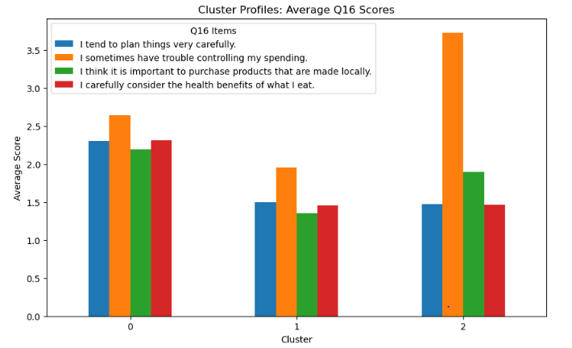

## Cluster Profiles and Insights

### Cluster 0: Balanced Planners

• Average score of 2.30 for planning indicates moderate planning behavior.  
• Higher spending challenges with a score of 2.64.  
• Moderate support for purchasing locally (2.19) and health-conscious eating (2.31).  
  
Insights:  
- These customers show balanced behavior with some tendencies to spend impulsively.  
- They are moderately health-conscious and value local products.  
- Marketing strategies could focus on highlighting health benefits and local sourcing while addressing value propositions to control spending.

### Cluster 1: Frugal Minimalists

• Low planning tendency (1.50).  
• Relatively low issues with spending control (1.96).  
• Least interest in local products (1.36) and health (1.46).  
  
Insights:  
- These are price-sensitive customers who prefer simplicity.  
- Promotions and discounts could appeal to them.  
- Product offerings should emphasize affordability over premium or health-centric options.

### Cluster 2: Impulsive Spenders

• Lowest planning behavior (1.47).  
• Highest spending issues (3.73), indicating strong impulsivity.  
• Moderate interest in local products (1.89) and health (1.47).  
  
Insights:  
- These customers make quick purchase decisions and may respond well to limited-time offers and impulse-buy promotions.  
- Emphasizing convenience and instant gratification could drive sales.  
- Cross-selling strategies and meal combos could be attractive to this group.

### Visual Analysis

The 3D PCA scatter plot illustrates the clear separation of the three clusters, demonstrating distinct customer segments. The bar chart of average Q16 scores further highlights the contrasting behaviors across clusters, especially regarding spending control and planning tendencies.

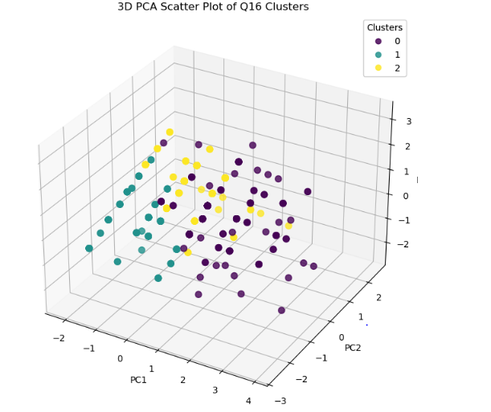

### Business Implications

- Tailor marketing strategies to each cluster's needs.  
- Create promotional offers that align with each cluster's behavior.  
- Optimize menu and service designs to target impulsive buyers and health-conscious consumers.  
- Consider pricing strategies and loyalty programs to enhance retention of price-sensitive customers.

### Conclusion

Understanding these clusters enables Sticks Kebob Shop to better segment its customer base, optimize its marketing strategies, and offer personalized experiences to increase customer satisfaction and profitability.

### ****Better Customer Segmentation****

Cluster analysis divides the customer base into **homogeneous groups** based on shared attitudes and behaviors. For Sticks Kebob Shop, the clusters are:

|  |  |  |  |  |  |  |  |  |  |
| --- | --- | --- | --- | --- | --- | --- | --- | --- | --- |
| |  |  | | --- | --- | | **Cluster** | **Key Traits** | | **Cluster 0** | Careful planners, value local products, moderately health-conscious, struggle with spending control. | | **Cluster 1** | Least engaged: low on planning, local purchases, and health focus. | | **Cluster 2** | Impulsive spenders, low on planning, moderate value on local products, not very health-conscious. | |  |
| **Impact:** |  |

* Sticks can now **tailor products, services, and promotions** to each group.
* Instead of generic marketing, they can develop **targeted campaigns** that resonate with each segment's unique mindset.

### ****Optimized Marketing Strategies****

With these insights, Sticks Kebob Shop can craft **specific marketing messages** for each cluster:

|  |  |  |  |  |  |  |  |  |  |
| --- | --- | --- | --- | --- | --- | --- | --- | --- | --- |
| |  |  | | --- | --- | | **Cluster** | **Marketing Approach** | | **Cluster 0** | Emphasize **local sourcing**, **meal planning options**, and **budget-friendly combos** to appeal to their planning nature and desire for local products. | | **Cluster 1** | Focus on **awareness-building**. These customers need to be educated about the shop’s unique value. Try **introductory discounts** or **simple meal bundles**. | | **Cluster 2** | Highlight **impulse-purchase triggers** like **limited-time offers**, **flash sales**, and **quick, indulgent meals**. | |  |

**Impact:**

* Marketing resources are used more effectively.
* Messaging is **more persuasive** because it aligns with customer mindsets.
* Increased conversion rates and customer engagement.