ANIMATRONS - ANIMATION CLUB

Head: Dara Shanmukha sai

Mail ID: [gupta.2@iitj.ac.in](mailto:gupta.2@iitj.ac.in)

Facebook: https://www.facebook.com/shannu.gupta.7

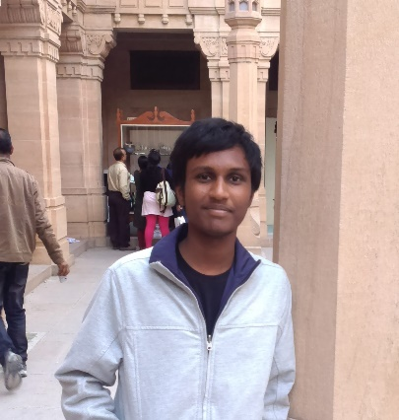

Assistant Heads:

1)Vanam Bhanu Sai Simha

Mail ID: [simha.1@iitj.ac.in](mailto:simha.1@iitj.ac.in)

Facebook: https://www.facebook.com/saisimha.vanam

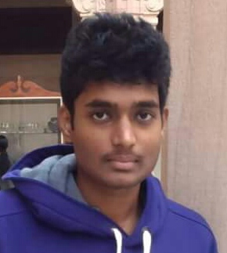

2) Sai Mukesh Bandi

Mail ID: [mukesh.1@iitj.ac.in](mailto:mukesh.1@iitj.ac.in)

Facebook : <https://www.facebook.com/mukesh.mahi007>



Club Content

1. Introduction and Vision

Animatrons provides a platform to those who wish to explore the world of animation.

Here people are encouraged to use their imagination and creativity to express their ideas and thoughts through the medium of animation.

This club is both for beginners and also for those who have previous experience in animation.

“Animation is not the art of drawings that move but the art of movements that are drawn.”

-Norman McLaren

1. Club Activities

Designing and development of 2D cartoons and 3D models.

Making of short animated films (stop motion,2D and 3D).

We deal with various softwares some of which are : 3ds max,Maya, Adobe Flash, After Effects.

C)Achievements

https://www.youtube.com/watch?v=bTTenKUEm9A

https://www.youtube.com/watch?v=CiVYDqKJ6Ok

d)FB links: https://www.facebook.com/Animatrons