***Ateliers***

1. Mohit Mehta (Head)

<https://www.facebook.com/mohit.mehta.391420>

Email: [mehta.1@iitj.ac.in](mailto:mehta.1@iitj.ac.in)

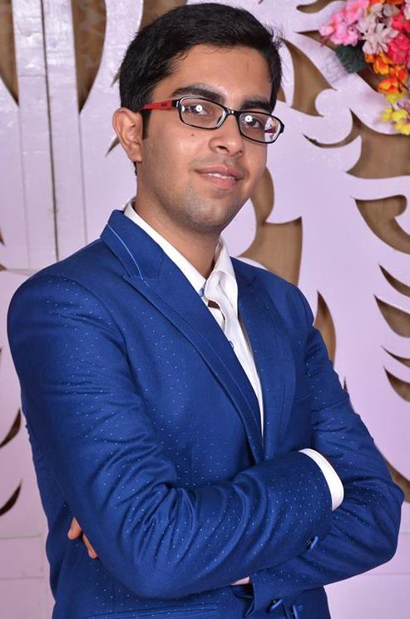

1. Yasharth Sahu (Head)

<https://www.facebook.com/profile.php?id=100005286139106&fref=ts>

Email: [sahu.1@iitj.ac.in](mailto:sahu.1@iitj.ac.in)

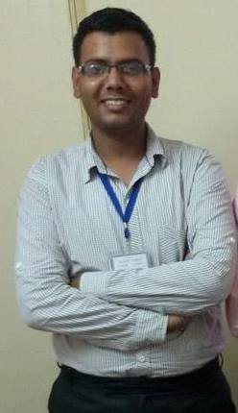

1. Rohit Paliwal (Assistant Head)

<https://www.facebook.com/back.stabber.775?fref=ts>

Email: [paliwal.1@iitj.ac.in](mailto:paliwal.1@iitj.ac.in)

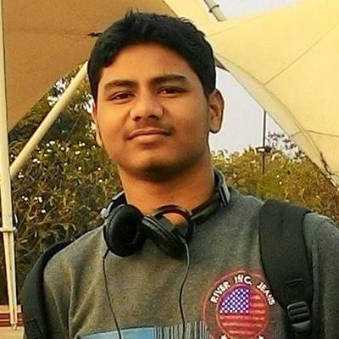

1. Ankita Muzalda (Assistant Head)

<https://www.facebook.com/ankita.muzalda?fref=ts>

Email: [muzalda.1@iitj.ac.in](mailto:muzalda.1@iitj.ac.in)

1. Ritu Singh (Assistant Head)

<https://www.facebook.com/profile.php?id=100004646655808&fref=ts>

Email:singh.2@iitj.ac.in

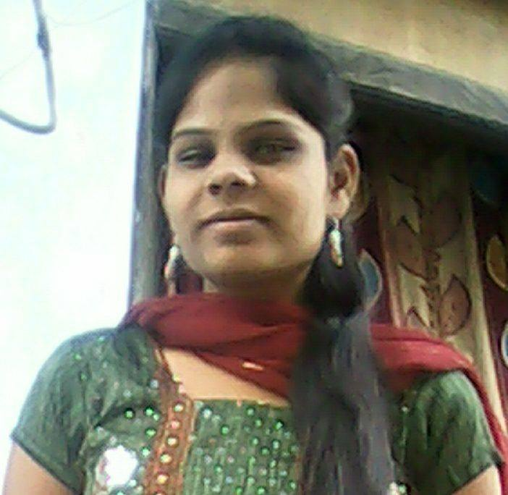

**Introduction and vision:**

Ateliers, the finearts club of IIT Jodhpur aims to provide a platform to the interested students who want to learn, develop and improve their Fine Arts skills under the guidance of senior club members. It is not just a club consisting of the most creative people in the institute, it is a family where you learn, teach and enjoy the art of making life colorful. In any fest be it Ignus, Spandan or Varchas, this club has a major contribution making it look beautiful, artistic and eyecatching.

**Activities:**

1. Sketching Workshops
2. Graffiti
3. Origami and Kirigami
4. Organising and participating in college level competitions.

**Achievements:**

* Won 3rd prize in chaos 2015 in IIM Ahmedabad.
* Participated in IITB Mood Indigo 2013
* Organised Kalakriti, finearts festival of IIT Jodhpur

https://www.facebook.com/finearts.IITJ?fref=ts