**FILM MAKING and VIDEO EDITING CLUB** (**FRAME-X**)

**Heads**

KUMAR VENKATESHWAR

Mail ID : venkateshwar.1@iitj.ac.in

Contact Number : 09472203900

Facebook Link : https://www.facebook.com/Kr.Venkateshwar?fref=ts&ref=br_tf

Twitter Link : https://twitter.com/Kr_Venkateshwar

LinkedIn: https://in.linkedin.com/pub/kumar-venkateshwar/b7/a93/941

Photo : 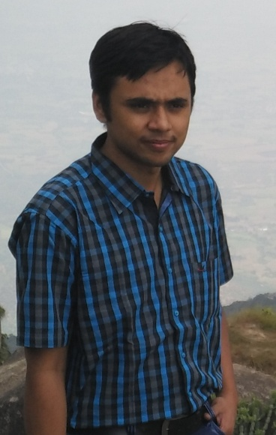

MANOJ MALVIYA

Mail ID : malviya.1@iitj.ac.in

Contact Number : 09602724745

Facebook Link : https://www.facebook.com/mmalviyar?fref=ts&ref=br_tf

Twitter Link :

LinkedIn : https://in.linkedin.com/pub/manoj-malviya/a4/a/447

|  |  |
| --- | --- |
|  |  |

Photo : 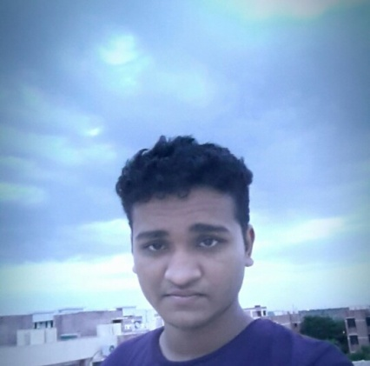

The club works on making short movies on topics which require serious attention and we use DSLRs, Handy cams and GoPros for this. For the fun part we consistently make spoofs, trip videos and short funny videos which include a nice and learning experience on sophisticated softwares like Adobe After Effects, Sony Vegas and Windows Movie Maker. We, consistently and actively, take part in inter college fest ,by presenting our work, to check our performance with outside world. Moreover the club also holds the responsibility of doing all the video graphic media coverage, making aftermovies in various activities and fests of the institute.

Facebook Link : https://www.facebook.com/iitjvideoeditingclub?fref=ts&ref=br_tf

YouTube Channel : https://www.youtube.com/channel/UCTuhG_-ttE0H8abeuqRxpLQ