**ShutterBugs**

1. Vivek Yadav (Club Head)

<https://www.facebook.com/profile.php?id=100003219024081&fref=ts>

Email:vivek.1@iitj.ac.in

1. Annuay Jayarakash (Club Head)

<https://www.facebook.com/profile.php?id=100008343016740&fref=ts>

Email:annuay.1@iitj.ac.in

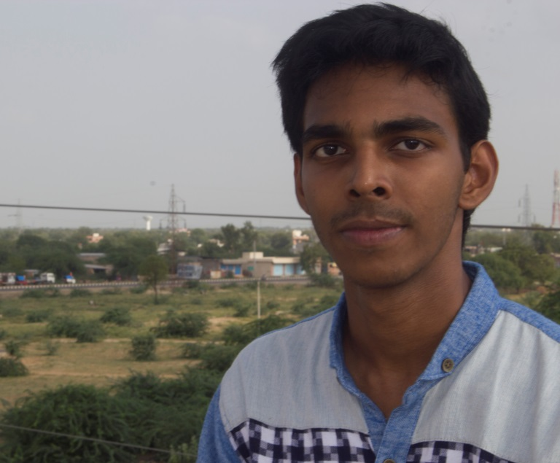

1. Mohit Mehta (Assistant Head)

<https://www.facebook.com/mohit.mehta.391420>

Email: [mehta.1@iitj.ac.in](mailto:mehta.1@iitj.ac.in)

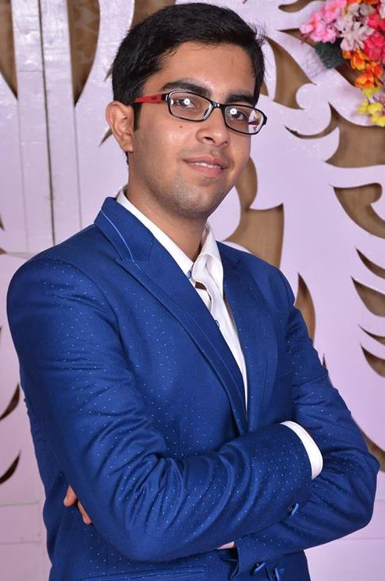

1. Pruthvi Boghara (Assistant Head)

<https://www.facebook.com/Pruthvee.Boghara?fref=ts>

Email: [rameshbhai.1@iitj.ac.in](mailto:rameshbhai.1@iitj.ac.in)

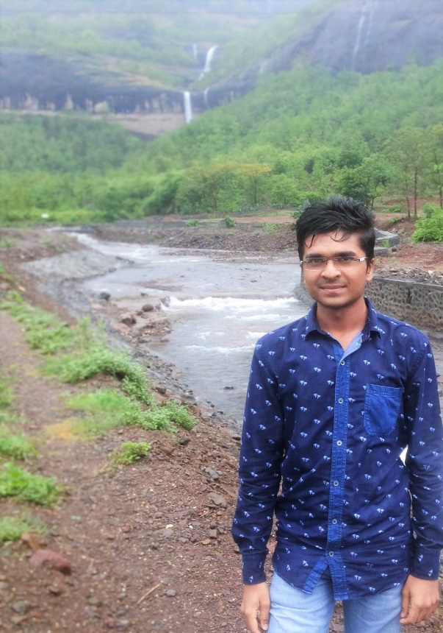

**Introduction and Vision:**

The Photography club envisages a vision comprising an outburst of every possible activity and in whatever domain one wants to do. Proposals are abundant, ambitions are high. Pioneering photography, event coverage, time-lapse photography etc. tops the list of our activities and plans. The club provides the students tremendous opportunities to live up this beautiful hobby or to pursue interest in it.

**Activities:**

1. Freshanza Backdrop Making
2. Photography Workshops
3. Photo Walks
4. Creating a photo journal of IIT Jodhpur
5. Photography Exhibitions
6. Conduct and participate in photography competitions.

**Achievements:**

**https://www.facebook.com/PhotographyClubIitJodhpur/timeline**