Declaration

We declare that this written submission represents my/our ideas in my/our own words and where others' ideas or words have been included, I/We have adequately cited and referenced the original sources. We also declare that I/We have adhered to all principles of academic honesty and integrity and have not misrepresented or fabricated or falsified any idea/data/fact/source in my/our submission. I/We understand that any violation of the above will be cause for disciplinary action by the Institute and can also evoke penal action from the sources which have thus not been properly cited or from whom proper permission has not been taken when needed.

Pranav Rane | -52 | ----------------------------------------
Prem Patil | -44 | -----------------------------------------
Vipul Padwal -39 -----------------------------------------
Vrushali Thombre -63 -----------------------------------------

( Signature’s )

Date:

Acknowledgement

We have great pleasure in presenting the report on Mini-Project of selected topic. We take the opportunity to express our sincere thanks towards our guide Dr.Ankush Pawar sir Department of CSE(AIML), ViMEET Khalapur for providing a technical guidelines and suggesstions regarding line of work. We would like to express my gratitude towards her constant encouragement, support and guidance through the development of project. We thankful for our guide Prof. Sneha Nimbare sir, for his encouragement during progress meeting and providing guidelines to write this report and encouraging throughout the course and for guidelines. We also thankful for our entire staff of ViMEET for their invaluable help rendered during the course of this work. We wish to express our deep gratitude towards all the staff of ViMEET for their encouragement.

INDEX
Chapter No. | Table of Content | Page No.
 | ABSTRACT | iv
 | LIST of FIGURES | v
 | LIST of TABLES | vi
1 | INTRODUCTION | 1-6
1.1 | Introduction and Motivation | 1-2
1.2 | Existing System | 2
1.3 | Problem Statement | 3
1.4 | Objective | 3
1.5 | Scope | 4
1.6 | Proposed System | 4-6
2 | LITERATURE REVIEW | 7-12
2.1 | Secondary Research | 7-8
2.2 | Primary Research | 8-9
2.3 | Brief | 9-10
2.4 | Comparative Analysis of Existing System | 10-11
2.5 | Research Gap Analysis | 12
3 | REQUIREMENT ANALYSIS | 13-18
3.1 | Product Analysis Market Research for Business Potential | 13-14
3.2 | Ideation | 14-15
3.3 | Functional Requirements of System | 15-16
3.4 | Non-Functional Requirements of System | 16-17
3.5 | Software Requirement | 17-18
4 | DESIGN AND PLANNING | 19-21
4.1 | Sketches | 19
4.2 | Flowchart | 20
4.3 | System Architecture | 21
5 | Conclusion & Future Scope | 22
6 | Appendices | 23
7 | References | 24-25

Abstract
Career counselling and guidance serve as essential pillars in shaping the academic and professional trajectories of students by helping them identify their interests, abilities, personality traits, and long-term career goals. In today’s fast-evolving world, where career opportunities are expanding beyond traditional boundaries, students often face difficulties in making the right career choices due to limited awareness, lack of mentorship, and insufficient access to structured counselling systems. Many schools and colleges still rely on outdated or one-size-fits-all approaches, which fail to cater to the unique aspirations, skills, and potential of each student. This lack of a comprehensive and data-driven guidance framework frequently leads to confusion, misinformed decisions, and eventual career dissatisfaction.
By leveraging modern technologies such as artificial intelligence, data analytics, and recommendation systems, Edu Navigator creates a personalized roadmap for every student, helping them align their education with their desired career path. The system further empowers teachers and parents by offering analytical dashboards and progress insights, enabling them to guide students effectively. Through the review of existing counselling frameworks, identification of key gaps, and establishment of clear objectives, this project aims to bridge the disconnect between education and employability.
Ultimately, Edu Navigator aspires to build a culture of informed decision-making, self-awareness, and proactive career planning among students. By reducing career misalignment, enhancing motivation, and preparing learners for the challenges of a dynamic global job market, the project envisions a future where every student can discover, plan, and pursue a career path that aligns with their passion, skills, and potential

SR.NO. | FIGURE | PG.NO.
1 | Sketches | 19
2 | Flowchart | 20
3 | System Architecture | 20-21

List of figures
List of Tables

SR.NO. | FIGURE | PG.NO.
1 | Comparative | 11

Chapter 1

INTRODUCTION

Introduction and Motivation

1.1.1 Introduction
The transition from school to higher education or the job market is one of the most crucial phases in a student’s life. Yet, many students make career choices based on peer influence, societal pressure, or limited information, often resulting in dissatisfaction and underachievement. With rapid changes in global employment trends and the emergence of new career paths, traditional education alone is insufficient to guide students effectively. Career counselling, therefore, is not just a support service but a necessity in modern education. Effective counselling programs can help students identify their interests, evaluate their abilities, explore opportunities, and make well-informed choices. This study emphasizes the need for structured career counselling programs in schools that integrate both traditional methods and modern digital tools to empower students in making strategic career decisions.
1.1.2 Motivation
The development of Edu Navigator is fundamentally driven by a need to solve the crisis of career confusion and misalignment prevalent among modern students. In a rapidly evolving job market, students are often overwhelmed by choice and pressured to make life-altering decisions based on insufficient information or external expectations, leading to stress, career dissatisfaction, and wasted academic effort. Our motivation is to move beyond generic counseling by leveraging AI and data-driven insights to provide personalized, accurate career roadmaps. By integrating an intelligent AI Career Recommendation engine with direct access to Mentorship Sessions and multi-role dashboards, Edu Navigator empowers not just the student, but the entire support ecosystem—parents and teachers—with clarity and actionable feedback. The ultimate goal is to bridge the critical gap between a student's innate potential and their long-term career fulfillment, ensuring they pursue paths where they are most likely to find success, purpose, and professional resilience.

1.2 Existing System
Several career counselling and guidance platforms currently exist to assist students, parents, and educators in identifying suitable career paths based on interests, aptitude, and academic performance. Some notable examples include:
- CareerGuide
CareerGuide is an online platform that offers personalized career counselling services through psychometric tests and one-on-one sessions with certified counsellors. It provides students with insights into their strengths, interests, and personality traits to help them make informed academic and career choices. However, the system primarily focuses on paid consultations, which may not be accessible to all students.
- Mindler
Mindler uses AI-based assessment tools to evaluate students’ skills, aptitude, and personality. It generates detailed career reports and suggests career paths that align with a student’s strengths and interests. While effective, its heavy reliance on subscription-based models limits widespread adoption in schools, especially in rural or underfunded institutions.
- Univariety
Univariety partners with schools to provide structured career counselling programs, student portfolios, and guidance sessions. It connects students with universities and professionals for mentorship. However, its platform mainly caters to premium schools, leaving a gap for affordable and accessible solutions for all students.
- BridgeU
BridgeU helps students with higher education planning by matching them with universities based on their preferences, academic records, and goals. The platform focuses more on international college admissions rather than holistic career discovery for all academic levels.

1.3 Problem Statement
In today’s rapidly changing world, students are faced with an overwhelming number of career options. However, many of them make career decisions based on limited exposure, peer pressure, parental expectations, or societal stereotypes rather than their own skills, interests, and aspirations. In most schools, structured and effective career counselling programs are either absent, underdeveloped, or limited to one-time workshops and general guidance. This lack of systematic career counselling leads to: Uninformed choices – Students selecting courses or career paths without understanding long-term implications. Skill–career mismatch – Students pursuing fields that do not align with their strengths, resulting in underperformance or dissatisfaction. Reduced confidence – Uncertainty about the future contributes to stress, anxiety, and lack of motivation. Narrow awareness – Overemphasis on traditional careers (doctor, engineer, lawyer) limits exploration of emerging opportunities. Given these challenges, there is a pressing need to develop and implement effective career counselling and guidance programs in schools. Such programs must go beyond conventional counselling, integrating psychological assessments, career awareness, mentorship, industry exposure, and the use of modern digital tools. A well-structured system would empower students to make informed choices, align their aspirations with market opportunities, and prepare them for personal and professional success.

1.4 Objectives
The main objectives of the Edu Navigator project are as follows:
- To develop an intelligent, student-centered career counselling system that assists students in identifying their interests, strengths, and aptitudes through structured assessments and AI-based analysis.
- To integrate psychometric and aptitude testing modules that generate personalized career recommendations aligned with students’ skills, academic performance, and preferences.
- To design an interactive web-based platform that enables students, teachers, and parents to collaboratively explore suitable career paths and track progress in real time.
- To implement AI and data analytics techniques for mapping skills to career domains and predicting emerging job opportunities based on industry trends.
- To provide mentorship and guidance support by connecting students with experts, alumni, and professionals in their fields of interest.
- To reduce career confusion and misalignment by promoting informed decision-making and helping students set achievable career goals early in their academic journey.
- To bridge the gap between education and employability by encouraging personalized learning paths that align with students’ future aspirations.

1.5 Scope
The Precision Agriculture using Machine Learning project aims to transform traditional farming practices by providing farmers with intelligent, data-driven decision-making tools. The scope of the project includes the following key aspects:
- Integration of Multiple Career Guidance Modules
  - The system integrates three core modules: Aptitude & Psychometric Assessment, AI-Based Career Recommendation, and Mentorship Support.
  - These modules work together to provide comprehensive guidance for students, helping them identify suitable academic and career paths.
- Data-Driven Decision Support
  - The project focuses on analyzing students’ academic records, skills, interests, and personality traits to generate actionable career insights.
  - It allows students to make informed decisions about courses, higher education, and skill development.
- Enhanced Career Clarity and Readiness
  - By providing personalized career suggestions and connecting students with mentors, the system aims to reduce confusion and improve confidence in career choices.
  - Students can plan their education and skill development more effectively, improving long-term employability.
- Accessibility and Usability
  - The platform is designed to be user-friendly for students, teachers, and parents with minimal technical knowledge.
  - The system can be deployed as a web or mobile application to ensure wide accessibility.
- Future Expansion
  - The system can be extended to include features such as AI-driven internship recommendations, college/course selection guidance, or integration with job portals.
  - Modules can be updated with new datasets and AI models to improve accuracy and adapt to changing industry trends.

1.6 Proposed System

User Registration and Profile Management:

Students create secure accounts and complete detailed profiles including academic records, interests, hobbies, and future goals.

Teachers and parents can create linked accounts to monitor student progress, provide feedback, and support decision-making.

Authentication mechanisms ensure data privacy and account security.

Assessment Module:

Conduct psychometric tests, aptitude tests, personality assessments, and interest inventories.

Adaptive tests adjust question difficulty based on student responses to accurately evaluate abilities and preferences.

Assessment results are stored in a structured format for AI-based analysis.

AI Analysis and Career Recommendation Engine:

Machine learning algorithms process assessment results, academic data, and student interests to suggest personalized career paths.

Recommendations include potential academic courses, suitable higher education streams, skill development plans, and emerging job opportunities.

The AI engine continuously learns from feedback to improve accuracy and relevance of recommendations.

Mentorship and Counselling Module:

Connect students with career mentors, teachers, and professional counsellors for guidance.

Support scheduling of one-on-one virtual or in-person counselling

Enable interactive Q&A sessions, goal setting, and progress review.

Interactive Dashboard and User Interface:

Provide students with an easy-to-use dashboard to view assessments, AI recommendations, and career progress.

Teachers and parents can access analytics dashboards to track performance, career alignment, and skill gaps.

Include gamified elements and progress trackers to motivate students to complete assessments and explore career options.

Database Management System:

Maintain a structured database of career options, academic courses, skill requirements, mentorship profiles, and industry trends.

Enable easy updating of career information as new opportunities and courses emerge.

Store anonymized data for research and system improvement purposes.

Feedback and Progress Tracking:

Collect feedback from students and mentors to evaluate the usefulness of recommendations and counselling sessions.

Monitor improvements in decision-making confidence, clarity of career goals, and skill development over time.

Generate reports for students, parents, and educators to help guide next steps.

Accessibility and Deployment:

Web and mobile application deployment ensures accessibility on multiple devices and platforms.

Low-bandwidth optimization allows access in regions with limited internet connectivity.

Incorporate multilingual support and accessibility features for inclusive education.

Integration with External Platforms:

Integrate with educational portals, job portals, internship databases, and scholarship platforms for real-world guidance.

Enable notifications and alerts for deadlines, application opportunities, and mentorship sessions.

Security and Privacy:

Implement encryption and secure authentication to protect student data.

Ensure compliance with data protection regulations and ethical use of AI-driven recommendations.

Future Enhancements:

Include voice-assisted guidance and AI chatbots for instant career advice.

Add predictive analytics for internship suitability, skill gap analysis, and future job trends.

Expand to incorporate virtual career fairs, industry expert webinars, and skill-based challenges.

Chapter 2

LITERATURE REVIEW
2.1 Secondary Research
Secondary research involves collecting and analyzing existing studies, platforms, and data related to career counselling, guidance systems, and AI-based recommendation tools. It provides a foundation for understanding current trends, challenges, and technologies, helping to design a more effective solution for student career guidance.
- Trends in Career Counselling Systems
  - Career counselling has evolved from traditional in-person sessions to online and AI-driven platforms.
  - Studies indicate that personalized, data-driven guidance improves students’ decision-making confidence and reduces career misalignment.
  - AI and machine learning techniques, including recommendation engines, predictive analytics, and psychometric assessment analysis, are increasingly applied to enhance career suggestions.
- Career Assessment and Recommendation Platforms
  - Several platforms use aptitude tests, psychometric evaluations, and interest inventories to recommend potential career paths.
  - Techniques like decision trees, clustering, and neural networks are used to match student profiles with suitable academic courses and careers.
  - These systems help students identify areas of strength and align them with emerging job opportunities, improving long-term employability.
- Mentorship and Guidance Systems
  - Some research highlights the importance of mentorship and counselling in complementing AI-based recommendations.
  - Platforms that connect students with career mentors, teachers, or industry professionals improve guidance quality and engagement.
  - Studies show that combining AI insights with human mentorship increases trust and adoption of career guidance systems.
- Interactive Dashboards and Analytics
  - Modern career platforms provide dashboards to visualize assessment results, skill gaps, and career progress.
  - Data analytics allow teachers, parents, and students to track performance and adjust learning paths or career plans.
  - Visualization tools enhance decision-making and encourage student participation in the guidance process.

2.2 Primary Research
Primary research was conducted to identify the challenges faced by farmers in crop selection, fertilizer usage, and disease management. A Google Form survey was circulated among local farmers to collect quantitative data on their current farming practices, crop choices, fertilizer application, and disease management methods. In addition, question-and-answer sessions and interviews were conducted with farmers and agricultural experts to gather qualitative insights.

Key findings revealed that farmers predominantly rely on traditional knowledge rather than scientific methods, resulting in suboptimal fertilizer use, delayed disease detection, and unpredictable yields. Farmers expressed a need for a simple, integrated system that can provide clear recommendations for crop selection, fertilizer management, and early disease detection. These insights directly informed the design of the proposed machine learning-based precision agriculture system.

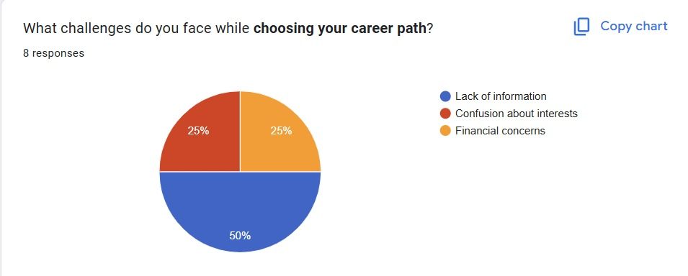
The research also highlighted the farmers’ interest in adopting technology-driven solutions if they are easy to use, accessible, and available in local languages. Many farmers expressed that they would benefit from a system that not only provides recommendations but also explains the reasoning behind them in simple terms. Additionally, respondents emphasized the importance of mobile compatibility, offline functionality, and visual aids, such as images or charts, to help understand crop health, fertilizer needs, and disease patterns. These preferences were considered while designing the interface and functionality of the machine learning-based system to ensure it meets real-world usability requirements.

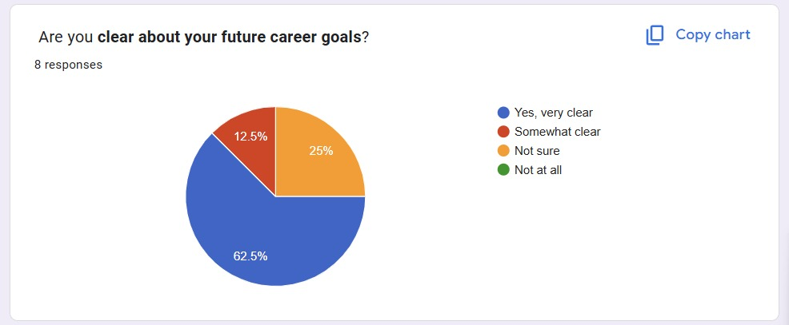
fig 2.1 : Primary Research analysis Pi chart

fig 2.2 : Primary Research Analysis Pi Chart
2.3 Brief
Recent literature on career counselling and student guidance systems highlights a growing transition from traditional counselling methods toward AI-driven, data-centric, and personalized platforms. Earlier systems primarily relied on manual assessments and general aptitude tests, which often failed to account for individual differences in skills, interests, and learning styles. With advancements in machine learning, psychometrics, and data analytics, modern career guidance tools now provide more precise and dynamic recommendations.
Studies show that AI-based recommendation models and psychometric profiling techniques significantly enhance the accuracy of career suggestions by analyzing a combination of personality traits, academic performance, and real-time labour market trends. Interactive dashboards and intelligent chatbots are increasingly being used to improve student engagement and provide round-the-clock counselling support. Despite these developments, major challenges remain — including limited access in rural schools, lack of culturally adaptive models, insufficient expert validation, and poor integration with existing educational systems.
To address these gaps, the Edu Navigator project emphasizes the need for a unified, accessible, and AI-powered career guidance system that integrates assessment tools, mentorship, and analytics into a single platform. By streamlining the process of aptitude evaluation, career mapping, and mentor interaction, the system aims to enhance student decision-making, improve communication between counsellors and learners, and reduce uncertainty in career choices. The expected outcome is a significant improvement in career awareness, goal clarity, and student confidence, thereby contributing to a more informed and future-ready academic community.

2.4 Comparative analysis of Existing System

The existing career guidance solutions can be broadly categorized into traditional counselling, online portals, psychometric platforms, AI-based recommendation systems, and hybrid mentorship models. Each type serves a specific purpose: traditional counselling provides personal guidance, online portals offer easy access to career information, psychometric tests evaluate student strengths, and AI-driven systems generate personalized recommendations. Hybrid models combine AI insights with expert mentorship to improve reliability and engagement.

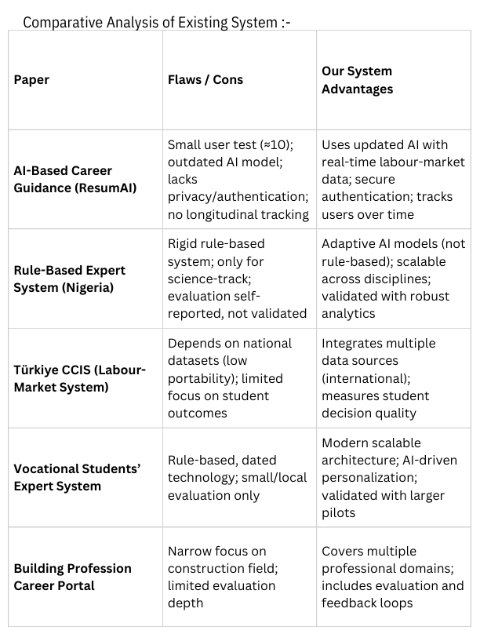

2.5 Research Gap Analysis
1. Career Assessment Systems
- Gaps: Many platforms provide generic aptitude and psychometric tests without considering local education systems, student backgrounds, or cultural context. They also often lack explainability, leaving students unsure why certain careers are recommended.
- Opportunities: Develop adaptive, region-specific assessment models and incorporate explainable AI to help students understand the reasoning behind recommendations.
2. Career Recommendation Platforms
- Gaps: Existing AI-based platforms often rely on limited datasets, leading to biased or incomplete suggestions. There is also insufficient integration with mentorship support or real-world industry trends.
- Opportunities: Integrate large, diverse datasets, incorporate real-time labour market data, and combine AI recommendations with expert mentorship for more reliable guidance.
3. Mentorship and Counselling Systems
- Gaps: Many mentorship programs are not scalable and lack structured tracking of student progress. Accessibility for students in remote areas is also limited.
- Opportunities: Use online and mobile platforms to scale mentorship, track student progress, and provide personalized guidance to a wider audience.

Chapter 3

REQUIREMENT ANALYSIS

3.1Product Analysis Market Research For Business Potential
Value for Students:
- Improve decision-making confidence and reduce career confusion.
- Align academic and skill development with career goals.
- Access personalized guidance and mentorship anytime, anywhere.
- Visualize potential career paths and actionable steps for success.
Target Users:
- High School Students: Seeking guidance for higher secondary education and career options.
- College Students: Planning further education, internships, or early career paths.
- Teachers and Counsellors: Helping students make informed academic and career choices.
- Parents: Monitoring student progress and supporting career decision-making.
Market Trends:
- AI-driven educational and career guidance systems are becoming popular globally.
- Psychometric and aptitude testing platforms are increasingly used to personalize guidance.
- Mobile and web applications are preferred for accessibility and engagement.

Competitor Analysis:
- Existing solutions often focus on assessments, recommendations, or mentorship individually, not all three together.
- Many platforms are generic and do not provide region-specific or personalized guidance.
- There is a gap for an integrated, AI-driven platform that combines assessments, recommendations, and mentorship in one system.
Challenges:
- Students’ limited awareness of career options.
- Accessibility in remote areas or regions with low internet connectivity.
- Ensuring AI recommendations are reliable, explainable, and unbiased.
- Engaging both students and mentors to actively use the platform.
Business Potential:
- Can generate revenue through freemium apps, subscription models, or partnerships with schools and educational institutions.
- High impact: better career alignment, improved student satisfaction, and skill development.
- Scalable to multiple regions and education boards, with potential for future expansion into internships, scholarships, and job recommendations.
Recommendations:
- Design a mobile-friendly and web-accessible platform for wide reach.
- Provide personalized, explainable career recommendations.
- Include interactive dashboards and visual tools to track progress and explore career paths.
- Offer a freemium model for easy adoption by schools and students.
- Continuously update AI models with new career data, industry trends, and student feedback.

3.2 Ideation
An integrated AI-driven platform that helps students make informed career decisions and plan their academic and professional paths effectively. The platform will have three main features:
- Career Assessment Module:
  - Evaluates students’ aptitude, personality traits, interests, and skills using structured psychometric tests, aptitude tests, and interest inventories.
  - Provides a clear profile of student strengths, weaknesses, and preferred learning styles.
- AI-Based Career Recommendation System:
  - Suggests personalized career paths, suitable academic courses, and skill development plans based on assessment results and labour market trends.
  - Aligns student interests with emerging career opportunities and industry requirements.
- Mentorship and Counselling Module:
  - Connects students with mentors, teachers, and professional counsellors for guidance, goal-setting, and progress tracking.
  - Provides interactive counselling sessions, Q&A, and personalized advice to reinforce AI recommendations.
Innovation / Uniqueness:
- Combines assessment, AI-driven recommendations, and mentorship in a single, integrated platform.
- Makes career guidance accessible and affordable for students across schools and colleges.
- Provides data-driven, personalized guidance without requiring prior knowledge of career pathways.
- Can be extended in the future to include internship opportunities, scholarship recommendations, voice-based guidance, and industry trend updates.
Goal:
Enable students to make informed, confident, and practical career decisions, align their skills with suitable academic and professional paths, and reduce uncertainty about their future by providing a comprehensive, user-friendly, AI-powered guidance system.

Functional Requirement Of System
The Edu Navigator system will provide the following functionalities to help students make informed career decisions and plan their academic and professional paths:
- Career Assessment Module
  - Conduct aptitude tests, personality evaluations, and interest inventories.
  - Analyze student strengths, weaknesses, and preferred learning styles.
  - Generate a comprehensive student profile for career guidance.
- AI-Based Career Recommendation System
  - Suggest personalized career paths, suitable academic courses, and skill development plans.
  - Align recommendations with student interests, skills, and emerging industry trends.
  - Provide information on career growth, required qualifications, and potential job opportunities.
- Mentorship and Counselling Module
  - Connect students with mentors, teachers, and professional career counsellors.
  - Allow interactive counselling sessions, goal setting, and progress tracking.
  - Offer actionable advice to supplement AI-driven recommendations.
- User Management
  - Enable secure user registration and login for students, parents, and mentors.
  - Store student profiles and assessment results securely to provide personalized guidance.
- Data Storage and Analytics
  - Maintain a database of career paths, courses, skill requirements, and industry trends.
  - Use historical and real-time data to improve AI recommendation accuracy.
  - Generate reports and insights for students, teachers, and parents.
- Mobile-Friendly and User-Centric Interface
  - Provide an intuitive and easy-to-use interface suitable for students with varying technical skills.
  - Support multiple languages to ensure accessibility for students from diverse regions.
  - Include visual dashboards, charts, and progress trackers for better understanding and engagement.

3.4 Non Functional Requirement Of The System
Non-functional requirements define how the Edu Navigator system should perform, rather than what it does. These include:
- Performance
  - The system should provide career assessment results and AI-based recommendations within a few seconds.
  - Should handle multiple students, parents, and mentors simultaneously without performance degradation.
- Usability
  - User-friendly interface suitable for students with minimal technical knowledge.
  - Clear instructions, visual aids, and interactive dashboards for better understanding of assessments and recommendations.
  - Mobile-friendly and responsive design to support use on smartphones, tablets, and PCs.
- Reliability
  - System should operate 24/7 with minimal downtime.
  - Ensure AI recommendations are consistent and based on validated datasets and psychometric assessments.
- Scalability
  - System should handle a growing number of users and increasing student data over time.
  - Should allow addition of new career paths, courses, skills, and mentorship programs easily.
- Security
  - Secure user data with proper authentication and authorization mechanisms.
  - Protect sensitive information, such as assessment results and personal profiles, from unauthorized access.
- Maintainability
  - System should be easy to update and maintain.
  - AI models and assessment algorithms should be easy to retrain or improve with new data.
- Portability
  - Should work on multiple devices (PC, tablet, smartphone) and across different operating systems.
  - Can be deployed on cloud servers for wider access or locally for offline usage if needed.
- Accuracy
  - Career recommendations should be accurate, relevant, and aligned with students’ interests, skills, and academic background.
  - Assessment and guidance results should correctly identify student strengths, weaknesses, and suitable career options with high confidence.

3.5 Software Requirement
The software requirements specify the tools, frameworks, and platforms needed to develop and run the Edu Navigator system effectively.
Programming Languages
- JavaScript (Node.js) – for backend development and server-side logic.
- HTML / CSS / EJS – for frontend development and dynamic page rendering.
Frameworks & Libraries
- Express.js – for building the web server and handling routes.
- EJS (Embedded JavaScript Templates) – for dynamic frontend rendering.
- Mongoose – for object data modeling (ODM) to interact with MongoDB.
- Node.js Packages (like bcrypt, dotenv, body-parser, etc.) – for authentication, environment configuration, and data handling.
Database
- MongoDB – for storing student profiles, assessment results, career paths, mentorship data, and system logs.
Development Tools
- VS Code – for coding and development of both frontend and backend.
- Git – for version control and collaborative development.
Operating System
- Windows, Linux, or macOS – compatible with development and deployment.
Web Browser
- Chrome, Firefox, or any modern browser – to access the web-based Edu Navigator platform.
Optional / Future Requirements
- Cloud Platforms (AWS, Google Cloud, Azure) – for scalable deployment and hosting.
- REST API / JSON – for connecting potential mobile apps or third-party services.
- Additional Node.js Libraries – for features like notifications, file uploads, or analytics dashboards.

Chapter 4

DESIGN AND BUSINESS MODELING

Sketches
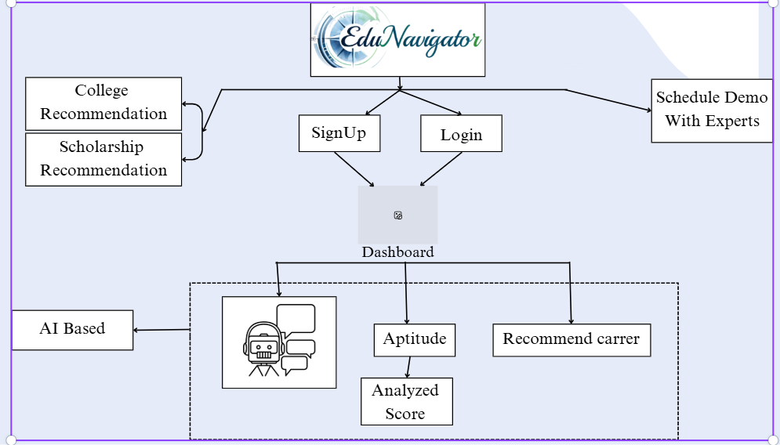
Fig 4.1 : System Overview

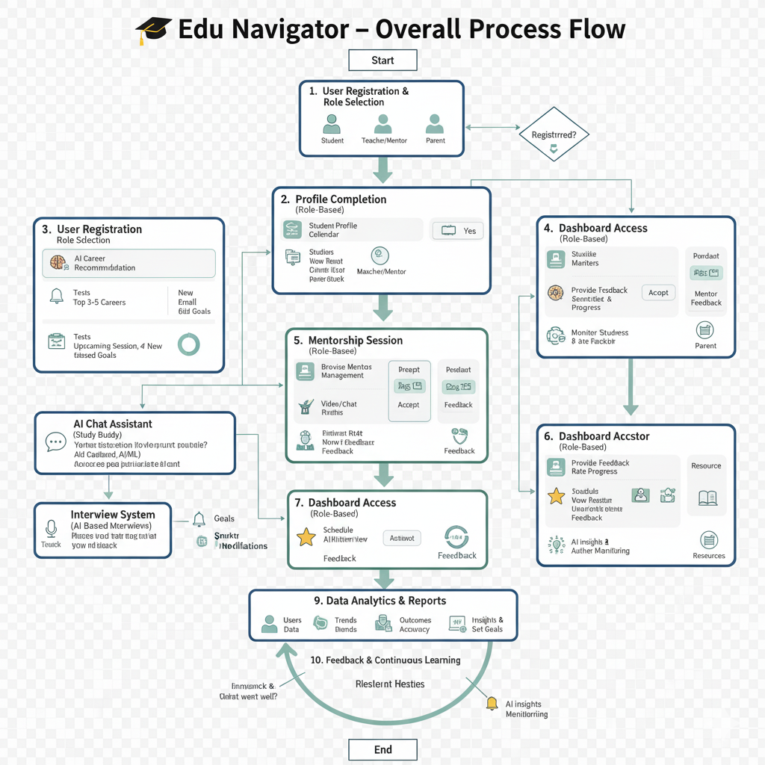
Flowchart
Fig 4.2 : Data Flow Diagram
Edu Navigator helps students discover the right career path through AI-based recommendations. After registering and completing their profile, students receive personalized career guidance, connect with mentors, attend mentorship or mock interview sessions, and get feedback. Parents and teachers can track progress through dedicated dashboards, ensuring continuous learning and improvement.

4.3 System Architecture

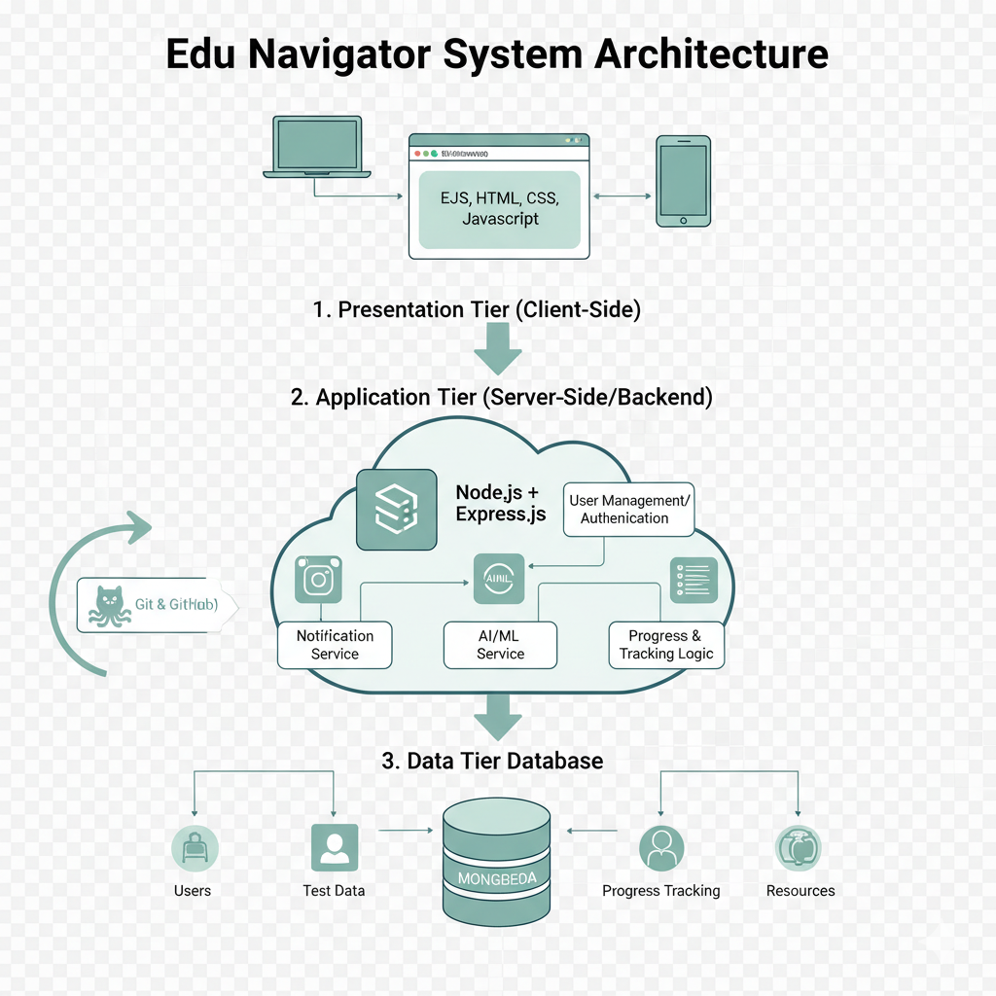

Fig 4.3:System Architecture Diagram

The system architecture of Edu Navigator follows a three-tier model with a frontend, backend, and database. The frontend (EJS, HTML, CSS, JS) provides interactive dashboards for users. The backend (Node.js, Express) handles logic, AI recommendations, and session management. The database (MongoDB) stores user data, career results, and mentorship records securely.

Chapter 5

CONCLUSION & FUTURE SCOPE
Developing effective career counselling and guidance programs is a cornerstone in empowering students to navigate the increasingly complex and competitive world of education and employment. In today’s fast-changing global environment—where new career fields emerge rapidly and traditional jobs evolve with technology—students require proper direction, motivation, and awareness to make decisions that align with their talents, interests, and future aspirations. By integrating psychological assessments, aptitude tests, career talks, mentorship programs, and practical workshops, institutions can help students gain a deep understanding of themselves and the world of work. These programs not only inform students about different career options but also cultivate critical life skills such as decision-making, goal setting, resilience, and adaptability, which are essential in the modern era.
The future scope of developing effective career counselling and guidance programs is vast, promising, and deeply transformative in shaping the educational and professional landscape for upcoming generations. As industries evolve with the integration of Artificial Intelligence (AI), Machine Learning (ML), data science, automation, and globalization, the nature of work and required skill sets are undergoing a dramatic shift. The focus will be on equipping students with lifelong learning skills and preparing them for careers that may not even exist today.
One of the most significant future developments will be the integration of artificial intelligence and data analytics in career guidance systems. AI-powered career counselling tools will analyze a student’s interests, behavior patterns, academic performance, and personality traits to provide precise and tailored career suggestions.

APPENDICES

The appendices of the *Edu Navigator* project provide a vital extension to the entire framework of developing effective career counselling and guidance programs. They include practical examples, structured tools, and implementation strategies that transform theoretical understanding into actionable solutions for enhancing students’ career choices. The appendices act as a bridge between knowledge and practice, helping educational institutions implement a systematic, engaging, and student-centered approach to career development. The sample career counselling session plan included in this section demonstrates how counsellors can organize interactive sessions aimed at helping students discover their strengths, interests, and personality traits through self-assessment activities, aptitude tests, and guided discussions. These sessions are designed to build self-awareness, confidence, and decision-making skills, enabling students to explore different career opportunities aligned with their individual potential.

The appendices also highlight the integration of modern technological platforms such as CareerGuide, Mindler, National Career Service (NCS), LinkedIn Learning, and Coursera. These tools support digital career counselling by offering psychometric testing, AI-based recommendations, and online learning opportunities that help students acquire new-age skills. It helps improve future sessions by identifying strengths, weaknesses, and areas that need more focus, thereby ensuring continuous quality enhancement of the program.

REFERENCES
- National Career Service (NCS), Ministry of Labour and Employment, Government of India. (2023). Career Guidance and Counselling Services. https://www.ncs.gov.in
- Mindler. (2023). AI-Based Career Assessment and Guidance Platform. https://www.mindler.com
- CareerGuide.com. (2023). Psychometric Tests and Career Counselling Services. https://www.careerguide.com
- LinkedIn Learning. (2023). Online Courses for Skill Development and Career Growth. https://www.linkedin.com/learning
- Coursera. (2023). Online Learning Platform for Professional and Academic Development. https://www.coursera.org
- National Career Development Association (NCDA). (2022). Career Development and Guidance Practices. https://www.ncda.org
- UNESCO. (2021). Career Guidance for Lifelong Learning. https://www.unesco.org
- Singh, P., & Sharma, R. (2020). “Importance of Career Counselling in Higher Education.” Journal of Educational Research and Development, 12(3), 45–53.
- Gupta, A., & Verma, S. (2021). “Integrating Technology in Career Guidance Programs.” International Journal of Career Development, 15(2), 18–27.
- Edu Navigator Project Team. (2023). Edu Navigator: A Framework for Student Career Counselling and Guidance. Internal Project Documentation.
- Ministry of Education, Government of India. (2022). Guidelines for Career Guidance in Schools and Colleges. https://www.education.gov.in
- IBM Research India. (2021). AI Tools for Career Planning and Skill Development. https://research.ibm.com
- NASSCOM. (2020). Role of Technology in Career Counselling in India. https://nasscom.in
- World Bank. (2021). Skills Development and Career Guidance: Global Perspectives. https://www.worldbank.org
- Meena, M. L., et al. (2019). “Impact of Structured Career Guidance Programs on Student Outcomes.” Indian Journal of Educational Studies, 76(4), 210–218.

