

CS401: Computational Finance

Lab 1

Name​: Abhin Kakkad

Id​: 201501419

Name: ​Manthan Mehta

Id​: 201501420

Q1. Binomial Pricing Model

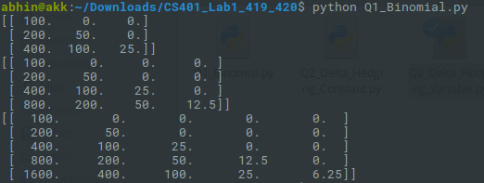

Q2(a). Delta-Hedging with constant Rate of Interest





Q2(b). Delta-Hedging with variable Rate of Interest





Q3. Asian Option

