

CS401: Computational Finance

Lab 3

Name​: Abhin Kakkad

Id​: 201501419

Name: ​Manthan Mehta

Id​: 201501420

**Q1. Regular Brownian Motion**

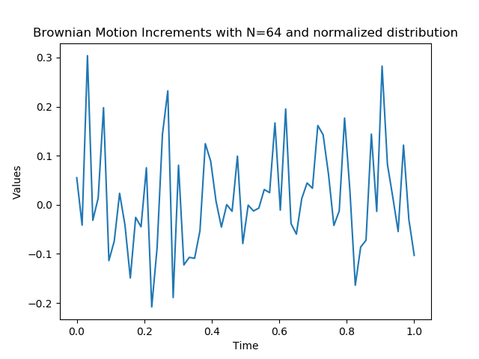

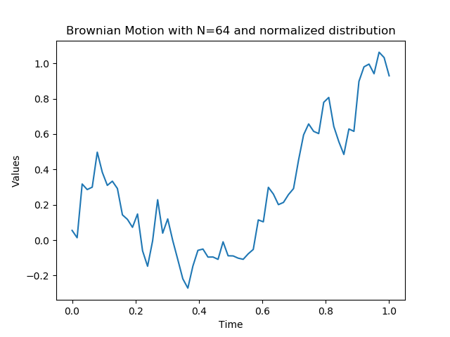

**Q2. Geometric Brownian Motion**

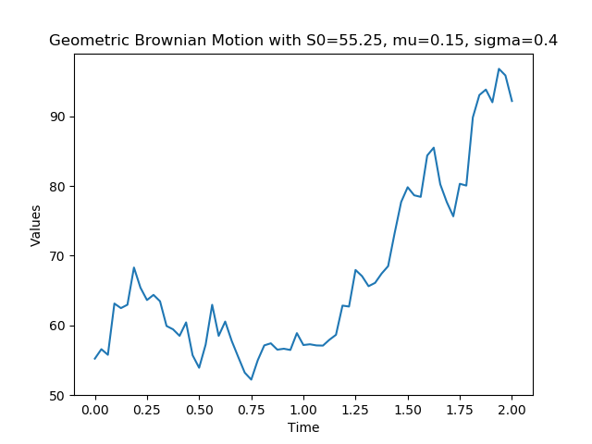

**Q3. Amazon Stock Price Modeling**

