

CS401: Computational Finance

Lab 2

Name​: Abhin Kakkad

Id​: 201501419

Name: ​Manthan Mehta

Id​: 201501420

**Q1. Probability of Eventual Return**

1-D : 1.0

2-D : 0.71 - 0.75

3-D : 0.2 - 0.3

**Q2. Estimate P (M(100) ≥ 25) where M(n) = max{S(i) : 1 ≤ i ≤ n}. Simulate around 1000 random walks and calculate the probabilities.**

Ans. 0.016

**Q3. Random Walk**

Empirical density of α2n(2k) for 2n = 100 time steps

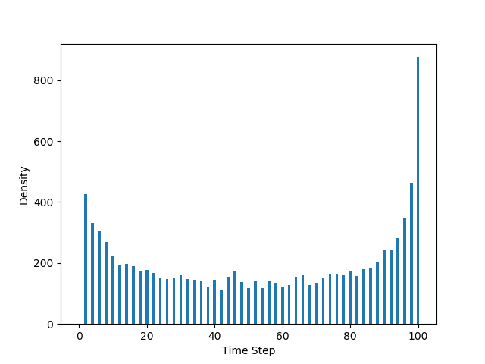

**Q4. Derivative Pricing**

European call option price at time t = 0 : 0.144281882549

**Q5. Stock Pricing using Geometric Brownian Motion**

