**ALY 6050: Enterprise Analytics**

***Project: A Transshipment Problem & A Risk Minimizing Problem***

**Submitted to: Prof. Roy, Wada**

**Submitted by: Abhinav Jain**

**Date: 07/03/2022**

**INTRODUCTION**

In this report, we are going to analyze the shipping and transportation of Rockhill company for the south-Atlantic division, which is negotiating a new shipping agreement with the Chimotoxic, for a chemical usage in the industry by a manufacturer. Many other factors and services which will be provided by Chimotoxic like collecting and delivering garbage for the six factories so that the chemical will not leak while doing the transportation Some localities in the areas where the factories are located can have laws against hazardous materials from being transported within their municipal boundaries. As a result, more than only shipments need to be handled. They may need to travel via convoluted paths if they are being moved slowly and with care.

The risk management plan, on the other side, involves the discovery, evaluation, adoption, or investment decisions. Total risk is entwined in the field of investment. There are various ways to calculate risk, but one of the most used is standard deviation, which is a statistical measure of the distribution around a central tendency.

In part 1 Allen’s cost estimate for shipping the barrel of waste which includes 6 plants for each 3 waste disposal sites. Given in the problem that plants Denver, Morganton, Morrisville, Pine Ville

Cars can drop off their load at a facility or a landfill, where each one will gather them up to take them to where they need to go. Additionally, Rockhill would not be liable for any handling expenses because Chimotoxic has promised to cover any managed fees at the installation and disposal sites.

***Part – I Rockhill Shipping & Transport Company***

***Analysis and Interpretation***

Allen, the manager, seeks to determine the optimal transit path for making a profit and finishing the task as soon as is practical. Rockhill Shipping and Carry Organization, Allen's company, is seeking for a means to transport pollutants from six chemical factories to three cleanup locations. Because toxins may hurt both humans and the environment if they leak, Allen needs to convey them safely. Additionally, some communities around the industries may impose traffic restrictions on harmful chemicals via debt securities. As a result, objects must not only be handled carefully and moved at a slow pace, but they may also need to travel in circles at times.

Table 1: Waste Proposal Site

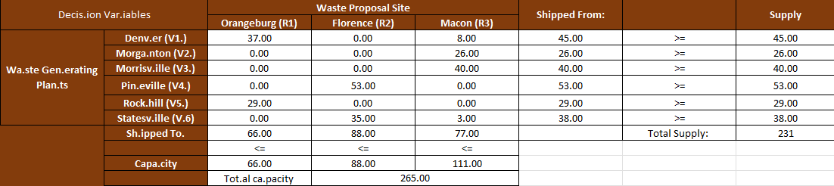

The manager is considering shipping directly from each of the 6 companies to one of the three garbage disposal sites, as well as using all six factories and the sewerage disposal facilities as transitory consignment ports. The 3 sanitary landfills at Orangeburg, Florence, and Macon can hold 67, 89, and 108 containers, respectively, each week

Cars can drop off their load at a facility or a landfill, where each one will gather them up to take them to where they need to go. Additionally, Rockhill would not be liable for any handling expenses because Chimtoxic has promised to cover any managed fees at the installation and disposal sites.

Table 2: Solver solution

Our aim is to put Rockhill's expenses down so that we can pull together a proposal for an arrangement for Chemotaxis' trash. We need to determine if it is more cost-effective to purchase products directly from a plant and dispose of them in the trash or whether it is preferable to lose and then find them at waste disposal and herbal remedy locations before deciding which alternative is practical.

Depending on the demand and supply situation, goods are either delivered from nearby warehouses to strategic locations or transported by ships from these locations to demand points. The dimension of the package affects transportation costs in the opposite direction. Another Algorithm problem is the trans-shipment one. For resolving issues, it takes into account the possibility that all providers may equally accept and distribute shipments, and that the impacts would be the same for both routes (LLP).

The least expensive method of travel is $7, as well as the most expensive is $20, as readers may have seen. This will be crucial for the paerification because we want to keep our overall expenditures as low as possible. The cost of traveltravelingone location is shown in the graph above.

***PART II Investment Allocations***

In this problem, we are going to do a risk assessment of the securities which include bonds, high-tech stocks, and put and call options with gold price analysis also. In this solution, we are expected a higher return with lower risk or minimum risk.

Table 3: Co-variance matrix

***Table 5: Asset***

|  |  |  |
| --- | --- | --- |
| **Asset/Securities** | **DV's** | **Amount.in.USD** |
| **Bond.s** | 0.235 | 2353.321 |
| **High.tech.stocks** | 0.137 | 1374.117 |
| **Foreign.stocks** | 0.168 | 1684.341 |
| **Call.options** | 0.116 | 1158.818 |
| **Put.options** | 0.205 | 2052.541 |
| **Gold.P** | 0.138 | 1376.862 |
| **Sum** | 1.000 | 10000.000 |

In the above graph, we can see that the return is higher than the risk of the securities. The asset classes listed below are the ones an investor chose for his portfolio. Using historical data, the predicted return for each investment industry has been calculated:

The figure on the following page shows how risk changes as returns increase. Quadratic programming may be used to solve the representation, which appears to be algebraic. The danger grows as the return on investment rises (return on Investment).

***Conclusion:***

It has given a great understanding of the product and analyses the risk of the assets which provides a better way to invest in the stock market and evaluate the risk and return. We found that the securities in this challenge for risk, including bonds, high-tech stocks, put and call options, and gold price analysis. We anticipate a larger return with less risk or no risk in this approach. Before investing in the stock market industry, it is necessary to do a risk assessment to get better returns from the investment. Because toxins may hurt both humans and the environment if they leak, Allen needs to convey them safely. Additionally, some communities around the industries may impose traffic restrictions on harmful chemicals via debt securities. As a result, objects must not only be handled carefully and moved at a slow pace, but they may also need to travel in circles at times.