


Christ

Academy

Hullahalli,

Begur

Koppa

Road,

Sakkalwara

Post,

Bangalore

–

83

PROJECT

REPORT

COMPUTER SCIENCE

Submitted for the

ISC

XI Practical

Examination

2023
-
24

By

ABHINAV SARKAR

XI

ISC

Roll

No.

18



Laboratory

Certificate

Certified

that

this

is

a

Bonaf
i
de

record

of

work

done

as

Project

in

the

Department of

COMPUTER SCIENCE
by

Abhinav sarkar

in

Christ

Academy,

Bangalore.

Roll

No : 18

Date

:

Teacher
-
in
-
charge

Head

of

Dept

Examiner

Acknowledgement
I would like to express my heartfelt thanks to the principal of Christ Academy Junior College, Reverend Fr. Lebin, for giving me an opportunity to showcase my views on this topic as a marked project. I would also like to extend my gratitude for all his support.
Sincere thanks to my Computer Science teacher, Mrs. Subhashini for her constant guidance with all requisite information regarding the topic and moral support throughout the completion of this project. With the help of her valuable suggestions, guidance and encouragement, I was able to compile all the information I had collected from across every possible source into the form of this project.
On an overwhelmed note, I once again thank each and every one who guided me throughout the completion of this project.

Synopsis
The project is a fully functional Tetris game developed in Java using Swing framework. It faithfully recreates the classic puzzle game where players manipulate falling geometric shapes called Tetriminos to form complete horizontal lines.
The game features all seven standard Tetrimino types (I, J, L, O, S, T, and Z), each represented by distinct colours. Players can move pieces left and right, rotate them clockwise or counterclockwise, and use soft drop or hard drop features for strategic placement. When a horizontal line is completely filled with blocks, it clears automatically and the player earns points based on the number of lines cleared simultaneously.
A sophisticated scoring system awards points for line clears with multipliers based on the current level. The game implements soft drop (1 point per cell) and hard drop (2 points per cell) bonuses. The difficulty progressively increases as players advance through levels, with the falling speed accelerating every 10 lines cleared.
The user interface displays real-time score, current level, total lines cleared, and a preview of the next piece. A ghost piece feature shows where the current piece will land, helping players plan their moves strategically. The game includes subtle visual enhancements like gridlines, shaded blocks with highlights, and smooth rendering.
The project is coded in IntelliJ IDE and designed to run in BlueJ without any external dependencies. It uses Java Swing (JFrame and JPanel) for the graphical interface and javax.swing.Timer for implementing a steady 60 FPS game loop.

Table of Contents
1. | Introduction | 6
2. | System Overview | 7
3. | System Design | 9
4. | Explanation of Data Flow | 11
5. | Screenshots | 13
6. | Testing | 14
7. | Bibliography | 15

1. Introduction
Java is widely used in game development due to its platform independence, robust libraries, and object-oriented nature. The language's Swing and AWT packages provide excellent tools for creating graphical user interfaces, making it ideal for developing classic games like Tetris.
Tetris, created by Alexey Pajitnov in 1984, is one of the most recognizable and played video games in history. Its simple yet addictive gameplay has made it a perfect project for understanding game development fundamentals, including game loops, collision detection, and real-time user input handling.
Java was chosen for this implementation due to its ease of use and extensive documentation. The object-oriented approach allows for clean code organization where each Tetrimino shape is an object with its own properties and behaviours. The game logic is separated from the graphical rendering, following good software design principles.
By using Java's Timer class, the game implements a constant game loop that controls the falling speed of pieces. The Graphics2D class is used for rendering the game board, Tetriminos, and UI elements. JFrame and JPanel from Swing provide the window framework and drawing canvas respectively.

2. System Overview

2.1 System Requirements
Operating System | Requirements
Windows | Windows 7 or later, 2 GB RAM, 2 GB of hard disk space, and a screen resolution of 1024x768 or higher.
Mac | macOS 10.8.3 or later, 2 GB RAM, 2 GB of hard disk space, and a screen resolution of 1024x768 or higher.
Linux | GTK 2.8 or later, 2 GB RAM, 2 GB of hard disk space, and a screen resolution of 1024x768 or higher.

2.2 Software Requirements
- Java Development Kit (JDK) 8 or higher
- Eclipse IDE or BlueJ
- Java Runtime Environment (JRE) 8 or higher
- No external libraries required

2.3 Game Specifications
- Board Size: 10 columns × 20 rows
- Cell Size: 30 pixels
- Game Speed: 60 FPS (frames per second)
- Initial Fall Delay: 700ms (decreases with level)
- Minimum Fall Delay: 80ms (speed cap)

2.4 Keywords Used in the Project
Column 1 | Column 2 | Column 3
package | boolean | import
public | private | protected
static | void | final
class | extends | implements
new | this | super
int | long | double
true | false | null
if | else | switch
case | break | return
for | while | do
try | catch | throw
interface | enum | abstract

3. System Design

3.1 Class Structure
The project consists of 7 main classes:
- Main.java - Entry point, initializes JFrame
- TetrisPanel.java - Game loop, rendering, and coordination
- Board.java - Manages 10×20 game board and line clearing
- Tetromino.java - Defines 7 piece types and rotation logic
- PieceFactory.java - Generates random pieces using bag system
- Scoreboard.java - Tracks score, level, and lines
- InputHandler.java - Processes keyboard input

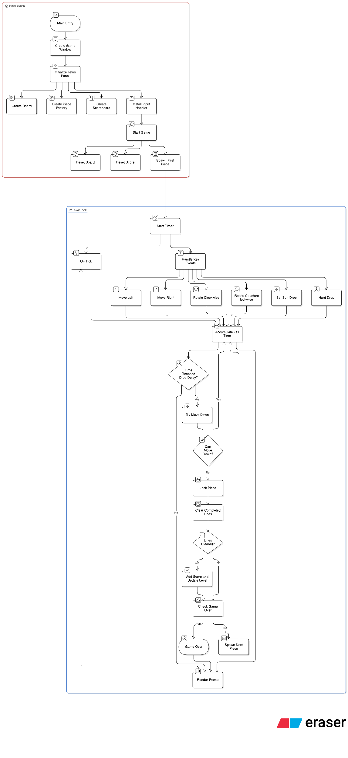
3.2 Data Flow Diagram

4. Explanation of Data Flow

1. Game Initialization
The Main class creates a JFrame window with the title "Tetris". The TetrisPanel constructor initializes all game components: a 10×20 Board represented as a 2D integer array, a PieceFactory using the bag randomization system, and a Scoreboard starting at level 1 with zero score.

2. Input Setup
The InputHandler installs keyboard bindings using InputMap and ActionMap. Arrow keys control movement, Up/X rotate clockwise, Z rotates counterclockwise, Space triggers hard drop, Down enables soft drop, and R restarts the game.

3. Game Start
The startGame() method resets the board to all empty cells (-1 values), resets the piece factory's bag, clears the scoreboard, and spawns the first Tetromino at the top centre of the board (x=3, y=-2 to allow spawn above visible area).

4. Game Loop (60 FPS)
A javax.swing.Timer fires every 16 milliseconds (60 times per second). The onTick() method calculates elapsed time in milliseconds using System.nanoTime() for precision. This time accumulates in the fallAccumulatorMs variable.

5. Automatic Falling
When the accumulated time exceeds the current fall delay (determined by score.getFallDelayMs()), the game attempts to move the current piece down by calling tryMove(0, 1). If soft dropping is active, the delay is reduced to 50ms. The fall delay starts at 700ms and decreases by 50ms per level, with a minimum of 80ms.

6. Movement and Rotation
User input calls methods like moveLeft(), moveRight(), rotateCW(), or rotateCCW(). Each method uses tryMove() or tryRotate() which check with board.canPlace() before applying changes. The canPlace() method verifies that all four blocks of the Tetromino fit within board boundaries and don't overlap existing pieces.

7. Rotation with Wall Kicks
When rotating, if the initial rotation position collides, the game attempts simple wall kicks: shifting left by 1 or 2, right by 1 or 2, or up by 1. If all kicks fail, the rotation is reverted to maintain a smooth playing experience.

8. Piece Locking
When a piece can no longer move down, board.lockPiece() is called. This writes the piece's type ordinal (0-6 for I, J, L, O, S, T, Z) into the board's 2D array at the positions occupied by the piece's four blocks.

9. Line Clearing
The board.getCompletedLines() method scans all 20 rows to find completely filled lines. The removeLines() method shifts all rows above each cleared line down by one row. Multiple lines can be cleared simultaneously for higher scores.

10. Scoring System
The Scoreboard awards points based on line clears: Single (1 line) = 100 points, Double (2 lines) = 300 points, Triple (3 lines) = 500 points, Tetris (4 lines) = 800 points. All line scores are multiplied by the current level. Soft drop adds 1 point per cell, hard drop adds 2 points per cell.

11. Level Progression
The level increases by 1 for every 10 total lines cleared (level = 1 + totalLines / 10). Each level reduces the fall delay by 50ms, making pieces fall faster and increasing difficulty.

12. Hard Drop
Pressing Space computes the drop distance using computeDropDistance(), which checks how many rows down the piece can fall. The piece instantly moves to that position, awards hard drop points (2 × distance), and immediately locks.

13. Game Over Detection
After locking a piece, isLockedAboveTop() checks if any blocks are above row 0 (the visible top). If true, the game is over. Additionally, if spawnNext() creates a piece that immediately collides (board is full), gameOver is set to true.

14. Rendering (paintComponent)
Every frame, paintComponent() draws the dark background, subtle gridlines, all locked blocks from the board array using their stored colours, the ghost piece (translucent preview of landing position), the current falling piece, and the side panel showing score, level, lines, and next piece preview.

15. Next Piece Preview
The PieceFactory uses a 7-bag randomization system. All seven piece types are shuffled and dispensed in random order, then a new bag is shuffled. This ensures fair distribution. The peekNextTypes(1) method shows the next piece without removing it from the queue.

5. Screenshots

5.1 Main Game Screen
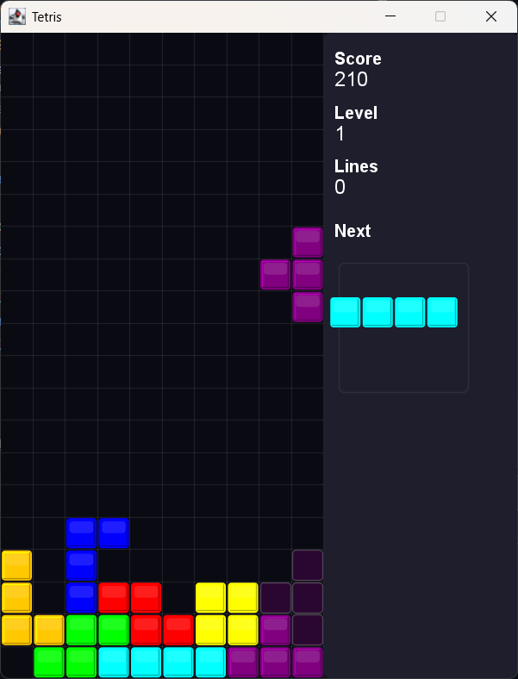

5.2 Game Over Screen
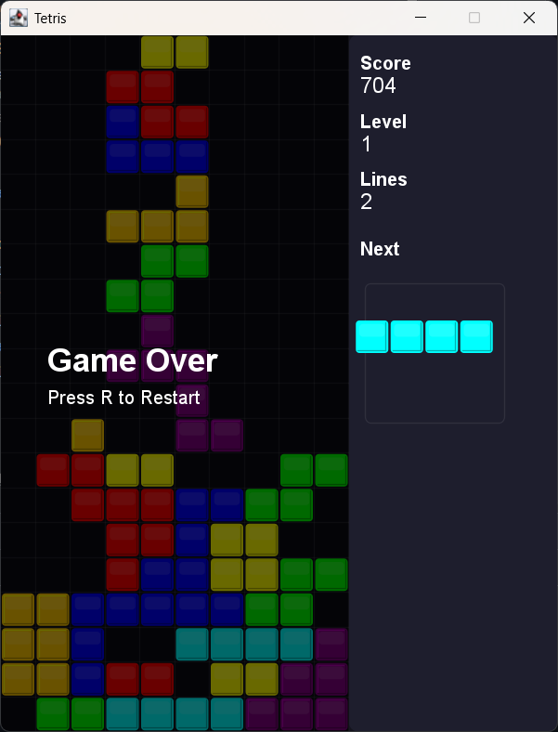

6. Testing

6.1 Types of Errors
- Logical Errors: Due to errors in the logic used.
- Syntax Errors: Due to wrong syntax in Java code, caught during compilation.
- Semantic Errors: Due to improper usage of syntax.
- Compile-Time Errors: Errors that occur during compilation.
- Run-Time Errors: Errors that occur during execution.

6.2 Testing of the Project
Unit testing is a method of testing individual software units, e.g., by testing public methods from a given class. Most unit tests use predefined inputs to execute the functions of the system under test and observe the outputs and behaviour to determine if the test passes or fails.
Additionally, testing methods can help identify and mitigate security vulnerabilities, which is critical for protecting sensitive data and maintaining the integrity of the application. In this project, each class was tested individually to ensure proper functionality before integration. The game was also tested extensively through actual gameplay to verify all features worked correctly together.

7. Bibliography
- Youtube.com - for tutorials and guides
- Anthropic. Claude 4.5 Sonnet (AI Language Model) - for explanation, research and content drafting
- App.eraser.io – for flowchart in data flow diagram
- Github.com – for publishing repository
view the source code=> https://github.com/abhinaaaavvv/Tetris
- Play.tetris.com – for game reference

