ABHINAB CHOUDHURY
Registration no. 2341003051
SECTION: 23413A1, BRANCH: CSIT

DESCRIPTION FILE

Classes:
- Member (Member.java): Represents a member of the club with attributes like ID, name, handicap, gender, team, member type, coach, phone number, and join date. It includes:
  - A constructor to initialize all member details.
  - A display() method to print the member's information.
  - Getter methods to retrieve individual member details.
    - public int getMemberID()
    - public String getLastName()
    - public String getFirstName()
    - public int getHandiCap()
    - public char getGender()
    - public String getTeam()
    - public String getMemberType()
    - public int getCoach()
    - public long getPhone()
    - public Date getJoinDate()

- Date (Date.java): Represents the join date of a member with day, month, and year. It includes:
  - A constructor to set date details.
  - Getter methods to retrieve individual member details this functions will be required while making queries to retrieveing specific data.
    - public int getDay()
    - public int getYear()
    - public String getMonth()
  - A toString() method to convert the date object to a readable string format (you can modify this for your desired format).

- Golf - Club (GolfClub.java): Performs specific queries as asked in Quesion. It includes:
  - Insert Member Data (InsertData):
This static method populates a Member array with pre-defined member details. Each member object is created with its specific attributes, including join date.
  - Display Records (main):
    - The main method creates a Member array of size 20.
    - It calls the InsertData method to populate the array with sample member data.
    - The program then performs three searches and displays matching members:
      - Members who joined before 07-Apr-2009 (checks year and month for April specifically).
      - Senior members with a handicap score less than 12 (filters based on member type and handicap).
      - Female senior members on TeamB (combines gender, member type, and team checks).

Output :
- Display the records of all members with join date before 07-Apr-09 :
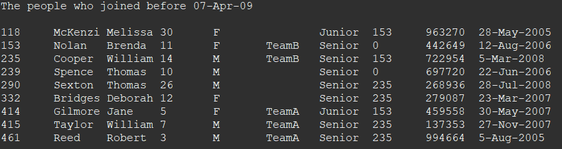
- Display the records of all the senior members whose handicap score is less than 12 :

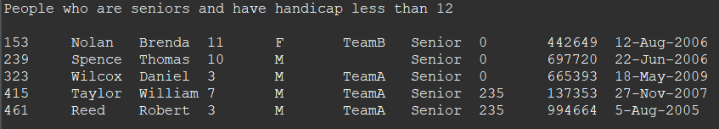

- Display the records of all the female senior members who are part of TeamB :

