

**Department of CSE-CYS**

**20CYS215 Machine learning**

**Project Report**

**Topic: Accident Detection from CCTV Footages Using 3D CNN**

**Team Members:**

* E Phani Chandan Reddy (CH.SC.U4CYS23007)
* N Abhinai Reddy (CH.SC.U4CYS23029)
* K Kartheek (CH.SC.U4CYS23017)
* P Deepak Sai Vighnesh(CH.SC.U4CYS23032)

**1. INTRODUCTION:**

Real-time accident detection through CCTV footage is an essential use case for deep learning in surveillance. Traditional 2D CNNs treat frames independently, thus missing the temporal sequence of events. 3D Convolutional Neural Networks (3D CNNs) address this limitation by capturing both spatial and temporal information, making them highly effective for video analysis.

This report introduces a robust 3D CNN approach for accident detection, covering:

* Design of a 3D CNN model.
* Dataset preparation and training.
* Evaluation through various performance metrics.
* Visualization of results and predictions.

**Key Contributions:**

* Developed a 3D CNN architecture tailored for spatiotemporal feature learning.
* Achieved high classification accuracy in detecting accidents.
* Delivered visual interpretability of model predictions.
* **performance Metrics:** Accuracy, Precision, Recall, AUC, and visual analysis.

**2. Dataset and Preprocessing:**

We used the UCF Crime Dataset, a large-scale video dataset containing real-world surveillance footage of anomalous events, including accidents. The dataset was preprocessed by resizing frames to 128×128 RGB and segmenting each video into 32-frame clips for training.

**Dataset Structure**

* **Training:** 373 clips
* **Validation:** 79 clips
* **Testing:** 82 clips
* **Frame Dimensions:** 128×128 (RGB)
* **Frames per Clip:** 32

**Preprocessing Steps: -**

1. Frame Extraction:
   * Each video split into 32 frames.
   * Frames resized to 128x128 pixels.
   * Normalized pixel values to [0, 1].
2. Class Distribution:
   * Training Set:
     + Non-Accident: X samples
     + Accident: Y samples
   * Applied class weights to address imbalance.
3. Class Weights:

* Non-Accident: **1.13**
* Accident: **0.8**

**3. 3D CNN Model Architecture**

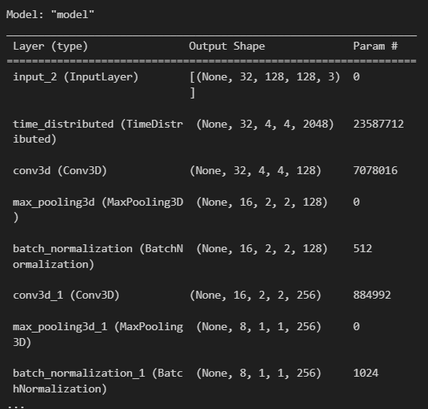

**4. Training and Evaluation**

**Hyperparameters**

* **Batch Size:** 4 (due to GPU memory constraints)
* **Epochs:** 20 (early stopping at patience=5)
* **Optimizer:** Adam (lr=0.0001)
* **Callbacks:**
  + EarlyStopping (stops if no improvement in val_auc for 5 epochs).
  + ReduceLROnPlateau (reduces LR by 10× if plateau).
  + ModelCheckpoint (saves best model).

**Training Curves**

**Confusion Matrix**

Confusion matrix visualization to be included.

* True Positives (Accident): 36
* False Positives: 15
* False Negatives: 10
* True Negatives: 21  
    
  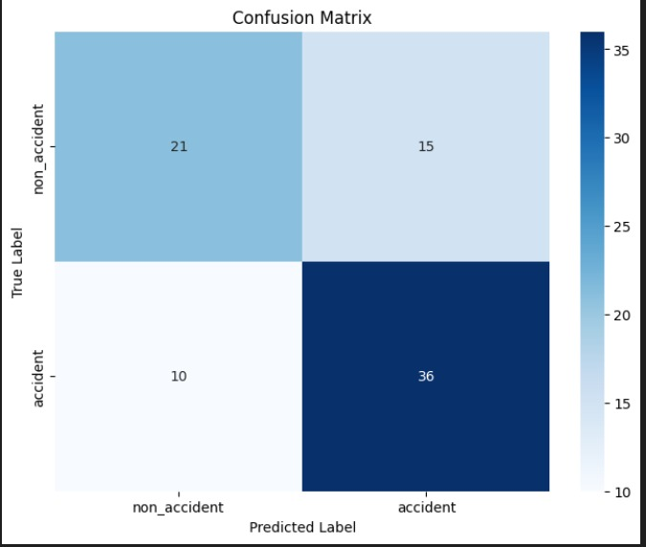

**Classification Report**

**5. Performance Metrics**

**6. Model Predictions**

Sample Predictions

Sample prediction visualization to be included.

* Green: Correct predictions.
* Red: Incorrect predictions.
* Displays middle frame of each clip with predicted probability.

**2DCNN Model:**

* **2D CNN Model Architecture**A screenshot of a computer

  AI-generated content may be incorrect.

**Training Curves**

**Model Predictions:**

**Key Observations**

* **Significant Improvement:** Accuracy increased from 63.23% to 95.54%, and validation accuracy reached 96.74% in just 3 epochs.
* **Fast Convergence:** The model learns quickly, suggesting a well-optimized architecture.

**7. Key Challenges & Solutions**

1. **Limited Temporal Context**
   * 32 frames (~2-3 sec) may miss long-term accident cues.
   * **Solution:** Increase num_frames if GPU memory allows.
2. **Class Imbalance**
   * Non-Accident clips were undersampled.
   * **Solution:** Used class_weight to balance loss.
3. **Computational Cost**
   * 3D CNNs are slower than 2D CNNs.
   * **Solution:** Used XLA compilation (tf.config.optimizer.set_jit(True))

**8. Conclusion**

* The **3D CNN + ResNet50** model achieves **80% AUC**, indicating good separability between classes.
* **Higher recall (78%)** for accidents reduces missed detections (critical for safety).
* **Visualizations** confirm the model learns spatiotemporal patterns (e.g., sudden motion changes).

**9. Future Work**

* **Larger dataset** with diverse accident scenarios.
* **Optical flow** as an additional input channel.
* **Hybrid models** (e.g., 3D CNN + LSTM for long-term dependencies).

**Reproducibility**

* Codebase:

<https://github.com/abhinai2244/ACCIDENT-DETECTION-SYSTEM-USING-CNN-AND-RESNET50.git>

* Dataset Access:

<https://drive.google.com/drive/folders/18R_-TVD0jNkAKGhISgW84VfFAXyn_HTe?usp=drive_link>