**locate Command**

locate only files within the database.

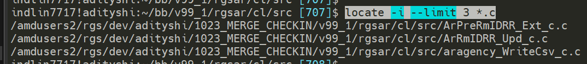

Database information for searching files.

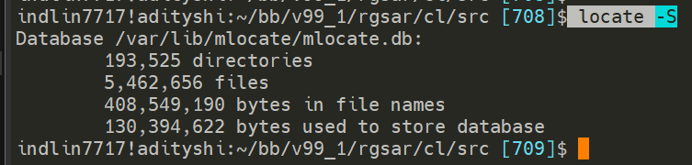

Checks if file still exist in DB and symbolic link exist.



find Command

Lists every single file/directory in current directory and recursively in all the directories inside it.

lists everything on the file system from root: **find /**

**list everything within a directory:-**

Use: find if already in directory

Use: find <path> if not in directory



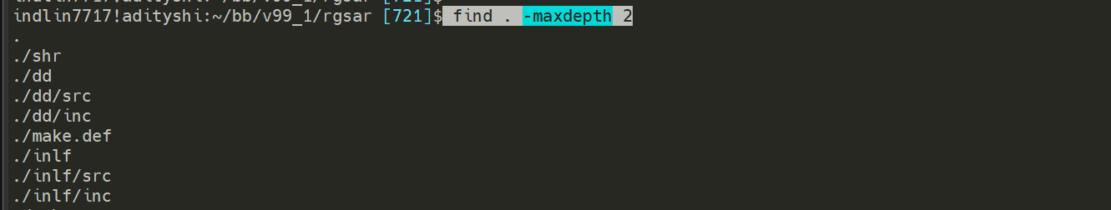

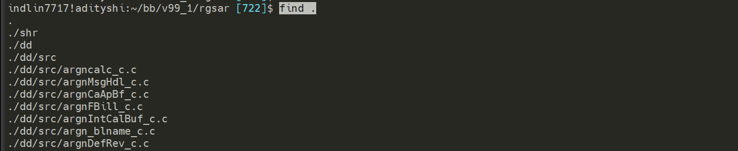

File type: f = file , d = directory

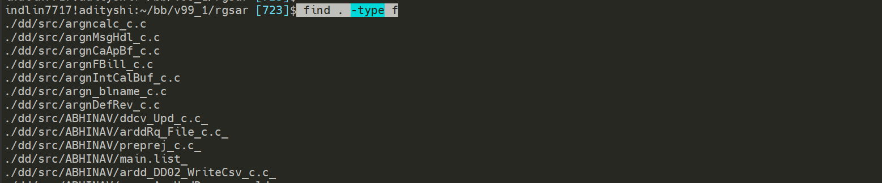

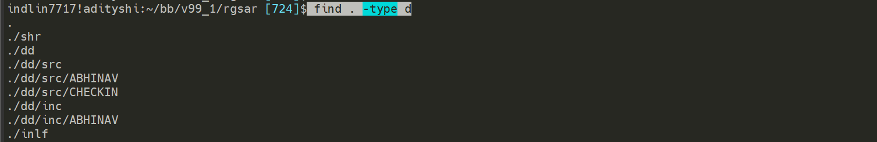

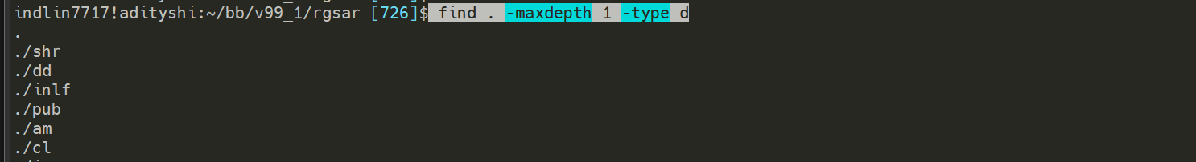



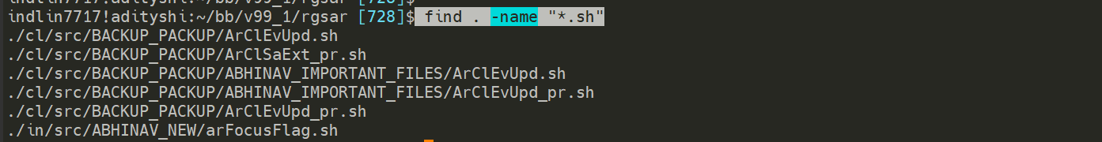



Case Insensitive: -iname

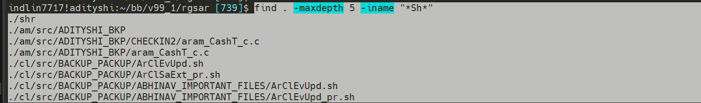

Get files whose size > 1000 kilobytes

Use + for greater than and – for less than

Use sudo if getting permission denied for certain directories

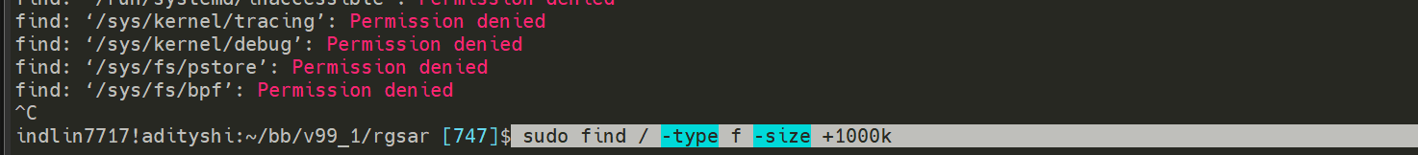





File size > 100kb and < 5mb



File size < 100kb or File size > 5mb



**find . -maxdepth 10 -type f -size +100k -size -5M -exec cp {} /amdusers2/rgs/dev/adityshi/bb/v99_1/rgsar/ir/FIND_ABHINAV \;**

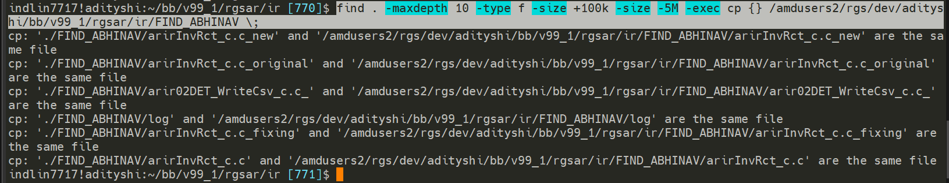

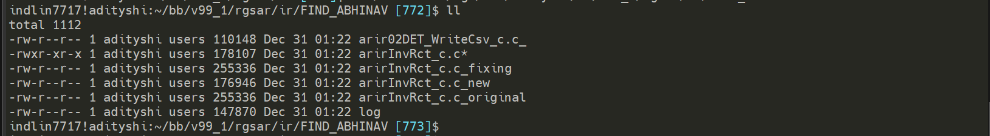

Use: **-ok** to prompt y/n every time it tries to copy stuff.

