INTERNSHIP CLOSURE

Engineering Work Dossier
From Python foundations to production-oriented ShopFlow delivery

Intern: Venkata Abhinandan Kancharla
Programme: Knowledge Factory Internship Program 2026 · Batch 7
Organisation: Coastal Seven Technologies Private Limited
Reporting window: 15 September 2026 – 16 October 2026
Primary project: ShopFlow — Full-Stack E-Commerce Application
Document purpose: Technical lead review, engineering handover and internship closure

Scope note: This dossier is based on the rows belonging to Venkata Abhinandan Kancharla in the supplied Daily Assessment Tracker. Other interns' entries are excluded. The tracker records substantive daily work from 17 September onward, with a completed-status row dated 16 September and the final capstone row dated 16 October.

Executive Summary
During the Knowledge Factory internship, the work progressed from Python programming and backend fundamentals into a progressively integrated ShopFlow e-commerce system. The engineering scope covered FastAPI, validation and persistence, authentication and authorization, asynchronous jobs, Redis and Celery, a React/Vite frontend, state management, TypeScript and automated tests, real-time updates, PostgreSQL search, AI/RAG capabilities, Docker, GitHub Actions and managed cloud deployment.
The final application uses a separate React/Vite frontend and FastAPI backend deployed on Render, with PostgreSQL hosted on Neon. The repository's Docker/Compose and CI/CD workflow provides a repeatable validation path independent of the managed production runtime. The final delivery included Locust load testing, production Gunicorn/Uvicorn configuration, database-pool investigation, a merged DevOps pull request with three successful post-merge jobs, and a completed peer demonstration and code review.
Delivery dimension | Outcome
Backend engineering | REST APIs, schema validation, SQLAlchemy/PostgreSQL, migrations, authentication, RBAC and error handling.
Frontend engineering | React/Vite, reusable components, responsive UI, protected routes, product discovery, cart/checkout/admin workflows.
Integration and runtime | Frontend/API integration, environment-based endpoints, WebSockets, Celery/Redis background tasks and advanced search.
AI capabilities | Streaming chat, RAG/product assistance, semantic search, generated product descriptions, provider fallback, caching and controlled agent/tool patterns.
DevOps and delivery | Docker multi-stage builds, Compose, GitHub Actions validation, GHCR publishing, branch protection and Render deployment.
Quality and performance | Vitest/Playwright/TypeScript validation in the recorded frontend work, health checks, Locust load testing and database pool investigation.

1. Engineering Narrative — From Foundations to Delivery

1.1 Python, API design and data fundamentals
The initial phase established core Python proficiency through control flow, reusable functions, data structures, file handling, exceptions and object-oriented design. Practical work included a Contact Book and a Bank Account implementation. SQL/PostgreSQL and psycopg2 were then used in an object-oriented CLI Task Manager with Task/TaskManager abstractions, CRUD operations, relational queries, JSON export, logging, runtime validation and unit tests. Git branching and repository workflow were introduced as part of the implementation process.

1.2 FastAPI, validation, persistence and security
The backend phase developed REST APIs using FastAPI and Pydantic, including request/response modelling, path and query parameters, and HTTP methods. SQLAlchemy 2.0 and PostgreSQL integration introduced ORM entities, relationships, async engine/session patterns and Alembic migrations. Authentication work covered password hashing, JWT access/refresh tokens, OAuth2PasswordBearer, dependency-based current-user handling, role-based access control, protected product operations, CORS and environment-based configuration. A dedicated Task Management API extended the work to project/task CRUD, status workflows, filtering, pagination, migrations, error handling, API documentation and testing.

1.3 Async processing, caching and backend integrations
The backend evolved to include asynchronous I/O, Redis cache-aside patterns, TTL and invalidation, rate limiting, Celery task execution, retries and task-state retrieval, Celery Beat scheduling and Flower monitoring. File-upload work covered validation and image processing. WebSocket work introduced connection management and real-time notifications. The testing and code-quality scope included pytest, pytest-asyncio, TestClient, coverage objectives, formatting, linting, typing and pre-commit practices.

1.4 E-commerce backend and frontend
The ShopFlow application then consolidated backend capabilities into commerce workflows: authentication, product management, cart and order operations, Redis/Celery integrations and real-time updates. The frontend moved from React fundamentals and routing into Tailwind CSS, Shadcn/ui, forms and validation, product listing/detail views, category/subcategory filtering, search and sorting, registration/login, protected customer/admin views and integration with FastAPI.
The tracker records a catalogue of 120 products across six major categories and 17 subcategories during frontend integration. Subsequent work introduced Zustand for client state, TanStack/React Query for server-state caching, pagination and infinite-scroll patterns, typed API contracts, TypeScript, Vitest, Playwright and checkout validation using React Hook Form and Zod. The recorded Day 16 validation notes state that TypeScript checking passed, 21/21 Vitest tests passed, the production build passed, and 3/3 Playwright E2E tests passed, with a repeated E2E run passing 6/6.

1.5 Full-stack integration, real-time flows and search
The integration phase aligned frontend and backend authentication contracts, CORS, API endpoint configuration and WebSocket event formats. A reusable TypeScript WebSocket hook supported connection states and reconnection behaviour for live order status and notifications. Background-task workflows were connected from the UI to Celery/Redis with task lifecycle states and progress/result handling. Advanced database search included PostgreSQL full-text search and typo-tolerant search patterns. The tracker also records invoice generation, bulk product processing and troubleshooting of a search-route regression caused by a changed function signature.

1.6 AI, RAG and agentic product features
The AI phase integrated free-tier/provider API patterns using Groq, Gemini and Mistral, an AI service layer, streaming responses and retrieval-augmented generation. The application scope included catalogue-grounded assistance, semantic product search, AI-generated descriptions, response caching, per-user rate limiting, provider fallback, usage visibility, background-task integration and WebSocket-based order updates. The Day 22 implementation notes reference dedicated routes for AI queries, streaming, semantic search, description generation and usage tracking. Later work added response validation, rejection of incomplete outputs, controlled tool execution and safeguards against caching invalid generations.

2. ShopFlow Architecture and Runtime
Layer | Implementation | Engineering role
Web client | React + Vite; Tailwind CSS; Shadcn/ui; TypeScript in later frontend work | Product discovery, account workflows, cart/checkout, order history, admin UI and AI assistant.
API | FastAPI; Pydantic; SQLAlchemy 2.0 | REST endpoints, authentication, business rules, database access and AI integrations.
Persistence | PostgreSQL; Neon managed hosting; Alembic migrations | Relational data and schema evolution.
Client/server state | Zustand; TanStack/React Query | Cart/client state, server-state caching, pagination and query lifecycle.
Background processing | Celery; Redis broker/result backend; Celery Beat | Asynchronous jobs, task progress/results and scheduled processing.
Real-time communication | FastAPI WebSockets; reusable frontend hook | Order updates, notifications and connection lifecycle handling.
AI layer | Groq/Gemini/Mistral provider patterns; streaming and RAG | Catalogue assistance, semantic retrieval, generated descriptions, fallback and response validation.
Production hosting | Frontend and backend as separate Render services; Neon PostgreSQL | Managed public deployment and hosted database connectivity.
Container validation | Dockerfiles; Docker Compose | Repeatable service packaging and integration checks.
Automation | GitHub Actions; GHCR publishing workflow | Validation, integration checks and container image publishing.

Public deployment links
- Frontend — Render: https://zeta-0pew.onrender.com
- Backend — Render: https://zetaa.onrender.com
- Backend Swagger UI: https://zetaa.onrender.com/docs
- GitHub repository: https://github.com/abhinandanCS05/Coastal7_Learning_Internship
- Merged DevOps pull request #1: https://github.com/abhinandanCS05/Coastal7_Learning_Internship/pull/1
- GitHub Actions run: https://github.com/abhinandanCS05/Coastal7_Learning_Internship/actions/runs/38534460711

3. Engineering Quality, Performance and Reliability

3.1 Automated validation and code quality
The tracker records TypeScript checking, Vitest tests, production builds and Playwright end-to-end runs in the frontend phase. Backend validation included API/manual checks, schema and endpoint testing, health-route checks and integration work. The final DevOps workflow validates backend/frontend code, exercises Docker Compose integration and builds/publishes container images when the workflow trigger permits it.

3.2 Load testing and database pool behaviour
Locust was used to exercise concurrent API traffic. The Day 19 record includes an earlier baseline of approximately 871 requests over two minutes at 50 users with zero failures, mean latency around 4.48 seconds, median around 4.8 seconds, maximum around 9.38 seconds and throughput around 7.45 requests/second. A later run was recorded at up to 60 concurrent users for approximately eight minutes with zero request errors reported. These are workload-specific observations, not a guarantee for all traffic patterns.
A SQLAlchemy QueuePool timeout was investigated during concurrent testing. The recorded non-SQLite settings included pool_size=5, max_overflow=5, pool_timeout=30 seconds and pool_recycle=300 seconds. The request-scoped database dependency used a finally block to close sessions. The investigation considered concurrency, query duration, engine settings and connection-holding paths rather than assuming a missing close call.

3.3 Runtime and production configuration
The deployed FastAPI backend uses a Gunicorn command with Uvicorn workers. Docker configuration was hardened with a multi-stage backend build and a multi-stage Node/Vite frontend build served through an Nginx runtime image. Compose brings together the API, PostgreSQL, Redis, Celery worker, Celery Beat and frontend, with dependencies, health checks, networking and named volumes. Environment configuration requires explicit database-password and JWT-secret values, and frontend API/WebSocket URLs are configurable.

3.4 Day 24 cloud and monitoring decision
The Day 24 learning plan covered EC2/SSH/security groups, Nginx/Certbot, Vercel, structured logging/Sentry, health checks, Prometheus, UptimeRobot, IAM, S3, load balancing, Auto Scaling and CloudWatch. The running application retained Render for the React/Vite frontend and FastAPI backend and Neon for PostgreSQL. Render-managed HTTPS and deployment/runtime logs were used for the current hosted services. AWS account payment verification prevented the planned EC2 provisioning path, so AWS-specific services were studied and documented rather than represented as deployed resources. The Vercel/Next.js item was adapted because the actual frontend is React/Vite and was already deployed.

3.5 Observed issue-resolution approach
- Frontend/backend contract mismatches were resolved by inspecting the actual FastAPI and WebSocket contracts and aligning client routes, authentication keys and event formats.
- Pagination response changes were handled by updating the API response shape and auditing frontend consumers rather than relying on the previous array-only contract.
- A product-search HTTP 500 was traced to a changed service-function signature; the route call was updated to pass the database session.
- AI provider variability was handled with fallback logic, output validation and rejection of incomplete results before caching or returning them.
- CI job behaviour was interpreted against workflow triggers; the GHCR publish job's pull-request skip was distinguished from a failed job, and the post-merge workflow passed.

4. Git, CI/CD and Delivery Governance
The daily tracker links the early implementation branches and feature branches to the Coastal7_Learning_Internship repository. The DevOps hardening change was committed as 12de3dc, submitted through PR #1 and merged into day22-ai-application. The subsequent remote branch tip recorded in the terminal was dffea545cb071ca61eea407e2ab745f1433c1be4. The post-merge GitHub Actions run showed three successful jobs: backend/frontend validation, Docker Compose integration and GHCR image publishing.
Delivery evidence | Reference
Repository | https://github.com/abhinandanCS05/Coastal7_Learning_Internship
PR #1 | https://github.com/abhinandanCS05/Coastal7_Learning_Internship/pull/1
Actions run | https://github.com/abhinandanCS05/Coastal7_Learning_Internship/actions/runs/38534460711
DevOps commit | 12de3dc — feat(devops): harden containers and environment configuration
Merged branch | day22-ai-application
Remote merge commit | dffea545cb071ca61eea407e2ab745f1433c1be4

5. Engineering Judgement and Technical Ownership
- Extended the existing ShopFlow application incrementally instead of repeatedly creating disconnected mini-projects, preserving integration continuity across backend, frontend, AI and DevOps phases.
- Used automated tests and end-to-end checks to validate frontend changes, and traced API/runtime errors to the relevant route, schema, service or client contract.
- Applied environment-based configuration for public API/WebSocket endpoints and sensitive credentials, separating deployment configuration from source code.
- Selected managed Render and Neon services for the existing lightweight application's public deployment rather than duplicating an already functioning deployment while AWS account verification was blocked.
- Kept container-based integration validation and CI/CD as reproducible engineering controls even though production hosting uses managed services.
- Considered operational concerns—database pool exhaustion, AI latency, fallback behaviour, response validation, runtime logs and health endpoints—alongside feature implementation.

6. Key Technical Learnings
Area | Learning consolidated
Backend architecture | REST API design, Pydantic validation, SQLAlchemy sessions, migrations, auth dependencies, RBAC and API error handling.
Database engineering | PostgreSQL modelling and search, indexes, async connectivity, connection pooling, session lifecycle and managed database integration.
Distributed work | Redis caching, Celery workers/Beat, task status and progress, background jobs, WebSockets and asynchronous user workflows.
Frontend architecture | React composition, routing, form validation, accessible UI, client/server state separation, typed contracts and end-to-end testing.
AI engineering | Provider abstraction, streaming, RAG, semantic retrieval, output validation, fallbacks, caching, rate limits and bounded tool execution.
Reliability and performance | Locust concurrency testing, latency/error interpretation, pool-exhaustion investigation, health endpoints and runtime log analysis.
DevOps and delivery | Multi-stage Docker builds, Compose dependencies/health checks, GitHub Actions, branch protection, secret configuration and GHCR publishing.
Cloud trade-offs | Managed application hosting versus self-managed EC2, platform-managed HTTPS/logs versus self-managed Nginx/Certbot and AWS observability services.

7. Final Glimpse — Day-by-Day Key Outcomes
This final table is a compact index of the tracker. The main dossier above is organised by engineering workstream rather than day-by-day narration, as requested. Only rows matching Venkata Abhinandan Kancharla were used.
Stage | Date | Key outcome | Tracker status
Day 1 | 17 Sep | Python fundamentals and FastAPI; Student REST API, HTTP methods, Pydantic validation. | Completed
Day 2 | 18 Sep | Control flow, functions, collections, JSON/CSV and exception handling; Contact Book application. | Completed
Day 3 | 19 Sep | Python OOP: classes, inheritance, polymorphism, abstraction and Bank Account implementation. | Completed
Day 4 | 21 Sep | PostgreSQL/psycopg2 and OOP CLI Task Manager with CRUD, JSON export, logging and tests. | Completed
Day 5 | 22 Sep | FastAPI, Pydantic V2, SQLAlchemy 2.0 async, PostgreSQL, Alembic and user/product CRUD. | Completed
Day 6 | 23 Sep | Password hashing, JWT access/refresh tokens, OAuth2 flow, RBAC, protected APIs and CORS. | Completed
Day 7 | 24 Sep | Task Management REST API with projects/tasks, status workflow, filtering, pagination and migrations. | Completed
Day 8 | 25 Sep | Async programming, Redis cache/rate limiting, Celery, retries, task results, Beat and Flower. | Completed
Day 9 | 26 Sep | File uploads, image validation/resizing, WebSockets, real-time notifications and testing/code quality. | Completed
Day 10 | 28 Sep | Production-oriented e-commerce backend: authentication, products, cart/order workflows and integrations. | Completed
Day 11 | 29 Sep | React fundamentals, hooks, component design and routing integration. | Completed
Day 12 | 30 Sep | Tailwind/Shadcn UI, forms, validation, dynamic forms, image preview and accessibility improvements. | Completed
Day 13 | 01 Oct | ShopFlow React/Vite frontend integrated with FastAPI; product discovery, auth and admin workflows. | Completed
Day 14 | 03 Oct | Zustand and React Query, pagination/infinite scrolling, custom hooks and server-state caching. | Completed
Day 15 | 05 Oct | TypeScript contracts, typed hooks/components, Vitest and Playwright testing. | Completed
Day 16 | 06 Oct | Cart/checkout, order history, admin workflows; TypeScript, 21/21 Vitest, build and Playwright validations recorded. | Completed
Day 17 | 07 Oct | Frontend/API environment configuration, WebSocket integration, order updates and reconnection handling. | Completed
Day 18 | 08 Oct | Celery tasks from UI, task progress, PDF invoice generation, bulk processing and PostgreSQL search. | Completed
Day 19 | 09 Oct | Full-stack integration, performance polish, Lighthouse score recorded as 100 and Locust/pool investigation. | Completed
Day 20 | 10 Oct | AI providers, streaming chat, RAG pipeline, AI service layer, fallback validation and AI status endpoint. | Completed
Day 21 | 12 Oct | AI product descriptions, content moderation, semantic search, caching, rate limiting and controlled agent/tool execution. | Completed
Day 22 | 13 Oct | AI-enhanced ShopFlow routes, streaming, semantic search, generated descriptions, usage visibility and Render deployment. | Completed
Day 23 | 14 Oct | Docker multi-stage builds, Compose, environment/secret hardening, GitHub Actions, GHCR and protected PR merge. | Completed
Day 24 | 15 Oct | Managed Render/Neon deployment approach, HTTPS, health/log review and AWS deployment/monitoring fundamentals. | Completed — alternative approach
Capstone | 16 Oct | Locust load tests, connection-pool investigation, Gunicorn/Uvicorn, Docker/CI/CD, documentation, demo and review. | Completed
Tracker scope note: the workbook also contains a 16 September completed-status row without an assigned topic, and a 2 October row marked Not Started. These are not represented as completed technical milestones in the key-outcome table. The substantive workstream summaries and dated glimpse above preserve the tracker’s recorded statuses.

8. Closing Statement
The internship work moved from programming fundamentals to an integrated full-stack application with production-oriented engineering practices. ShopFlow brought together backend APIs, database persistence, authentication, asynchronous processing, a React/Vite interface, real-time workflows, AI-assisted product experiences, automated validation, containerization and managed deployment. The final handover captures the implementation approach, operational decisions, test evidence and repository trail so a technical reviewer can understand not only what was built, but how the system was integrated, validated and delivered.
— End of Internship Closure Dossier —

10. Project Structure, System Design and Workflow Diagrams
This section provides a visual, Word-native handover reference for ShopFlow. Diagrams are embedded as images rather than Mermaid source, so they remain visible when the document is opened, exported to PDF or reviewed in common office software. The structure below is a logical overview based on the project tracker and known repository layout; bracketed functional areas are descriptive groupings, not asserted literal paths.

10.1 Repository Structure
Coastal7_Learning_Internship/
├── .github/
│ └── workflows/
│ └── day23-ci.yml
├── backend/
│ ├── Dockerfile
│ ├── requirements.txt
│ └── app/
│ ├── main.py
│ ├── config.py
│ ├── API routes and endpoints
│ ├── database models, schemas and session handling
│ ├── authentication and authorization
│ ├── services and business logic
│ ├── Redis and Celery integrations
│ ├── WebSocket handlers
│ └── AI and RAG integrations
├── frontend/
│ ├── Dockerfile
│ ├── package.json
│ ├── vite.config.ts
│ └── src/
│ ├── components/
│ ├── pages/
│ ├── hooks/
│ ├── services/
│ ├── store/
│ ├── types/
│ └── application entry points
├── docs/
├── compose.yaml
├── .env.example
├── .gitignore
├── RUN_BACKEND.ps1
├── RUN_FRONTEND.ps1
├── README.md
└── LICENSE
The backend owns API contracts, validation, business logic and persistence integration. The frontend owns presentation, routing, client/server state and user interaction. Docker Compose describes the integration stack, while GitHub Actions automates validation and image publishing.

Main component responsibilities
Component | Responsibility
frontend/ | React/Vite user interface, product discovery, authentication screens, cart and checkout flows, order views, administrative UI and AI interactions.
backend/ | FastAPI endpoints, request validation, business logic, authentication, database access, background-task integration and AI functionality.
Database layer | PostgreSQL persistence, SQLAlchemy connection/session management and schema migration workflows.
Redis and Celery | Caching and asynchronous background jobs, task status, retries and scheduled processing.
WebSocket layer | Real-time notifications and order-status updates between the backend and connected clients.
AI service layer | Provider integration, streaming responses, retrieval-augmented generation, semantic search and generated product content.
compose.yaml | Local and CI integration environment for the application services and their dependencies.
.github/workflows/ | Automated validation, integration checks and container-image publishing.
.env.example | Documents required environment configuration without storing production secrets.

10.2 High-Level System Architecture
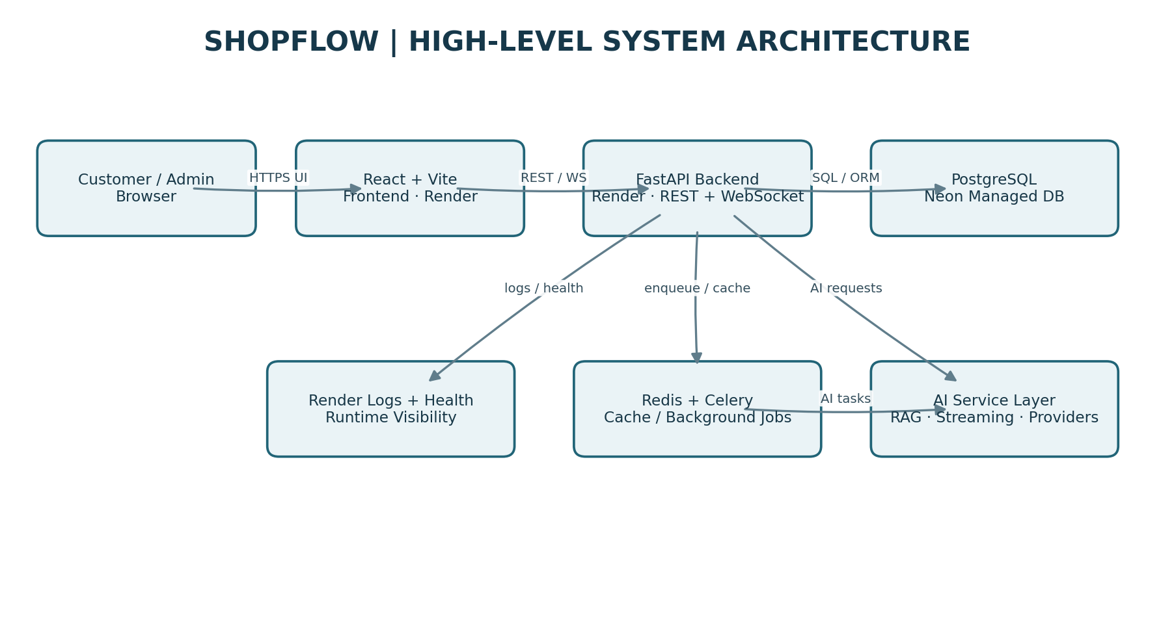
Request path: Browser → Render HTTPS → React/Vite frontend → FastAPI backend → Neon PostgreSQL. The API also integrates with Redis/Celery for asynchronous work and the AI service layer for retrieval, streaming and generated content. Render deployment/runtime logs and the backend health endpoint provide operational visibility.
Architecture explanation
- Presentation layer: React/Vite renders the user interface and manages navigation, forms, product browsing, cart interactions and AI-assisted experiences.
- API layer: FastAPI exposes application endpoints, validates requests, enforces access rules and delegates operations to application services.
- Persistence layer: PostgreSQL stores relational application data. Neon provides the managed database hosting.
- Asynchronous layer: Redis and Celery support background processing, caching and task execution.
- Real-time layer: WebSocket connections deliver live updates, including order-status and notification events.
- AI layer: Provider integrations support streaming, RAG-based assistance, semantic search and generated product content.
- Operations layer: Render provides the hosted application runtime and deployment logs, while GitHub Actions validates code and container integration.

10.3 Application Request Workflow
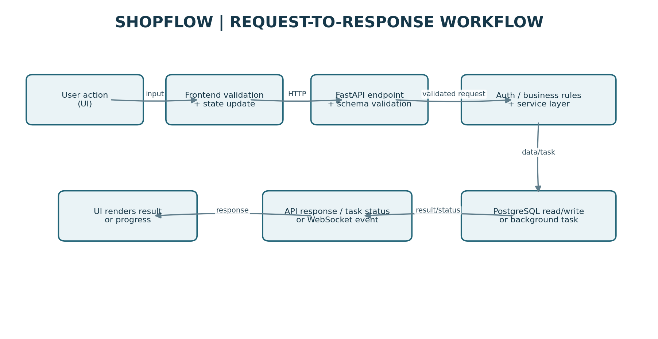
A user action is handled by the frontend, which validates local input and calls the appropriate API. FastAPI validates the request, applies authentication/authorization and business rules, then accesses PostgreSQL or schedules background work. The frontend renders the result, task status or supported real-time event.

10.4 AI and RAG Workflow
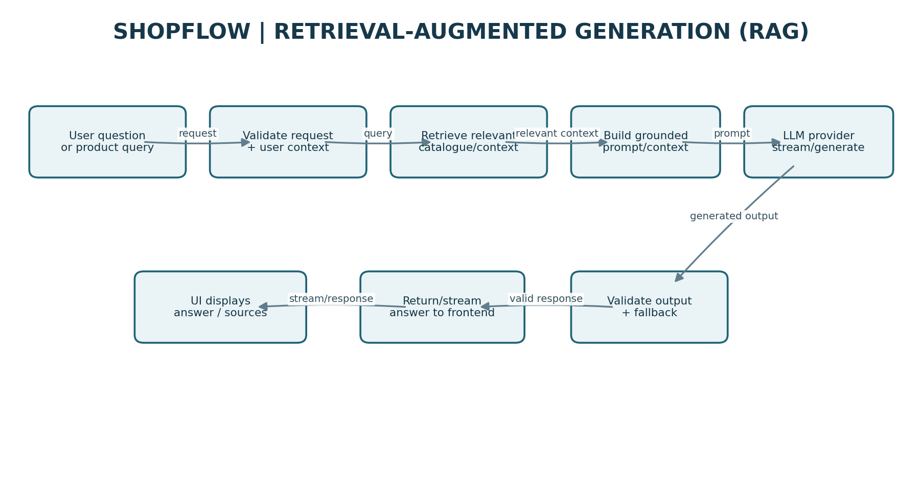
The AI flow validates the question and relevant user context, retrieves relevant product/catalogue context, assembles a grounded prompt, and calls the configured provider. The returned output is validated before it is returned or streamed to the frontend. Provider fallback and invalid-output handling help prevent incomplete generations from being treated as valid answers. This is the query-time RAG flow; ingestion/indexing internals are described only to the extent supported by the project records.

10.5 Background Task Workflow
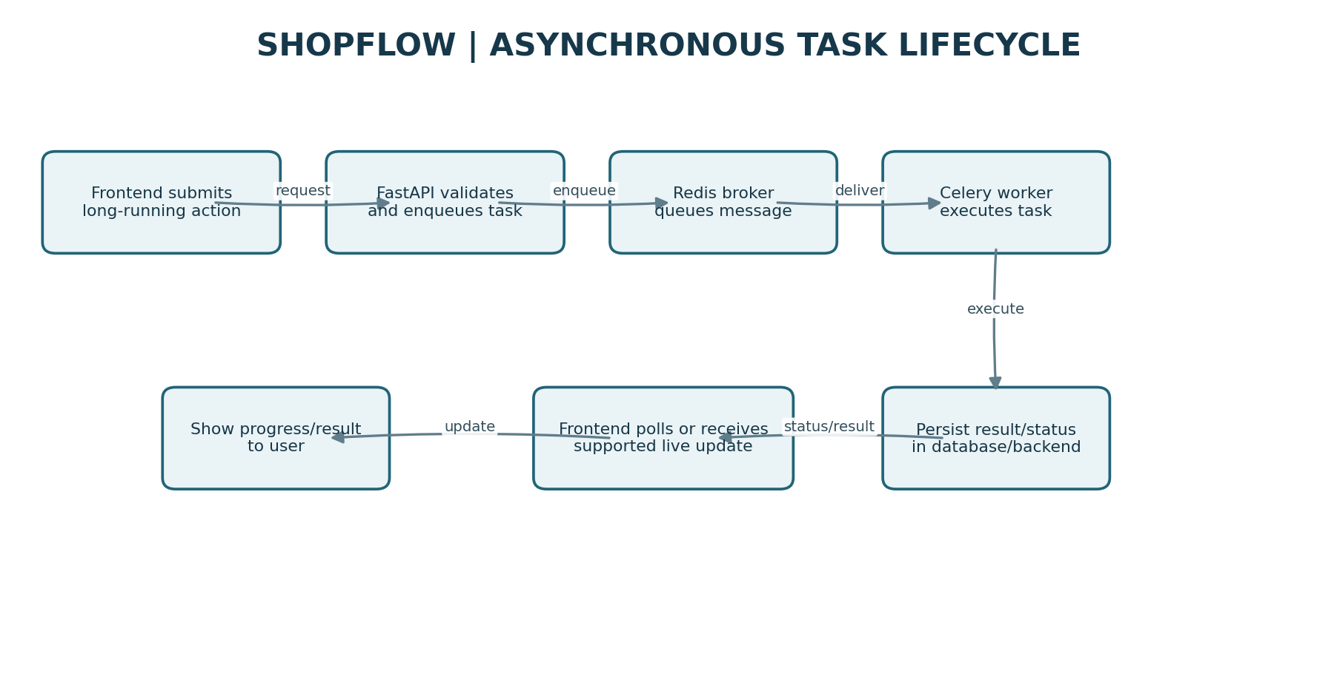
Long-running work can be queued through FastAPI to Redis/Celery. A worker executes the task and persists its result/status, after which the frontend can retrieve status or receive a supported update. This pattern separates user request acknowledgement from work that may take longer to complete.

10.6 CI/CD and Delivery Workflow
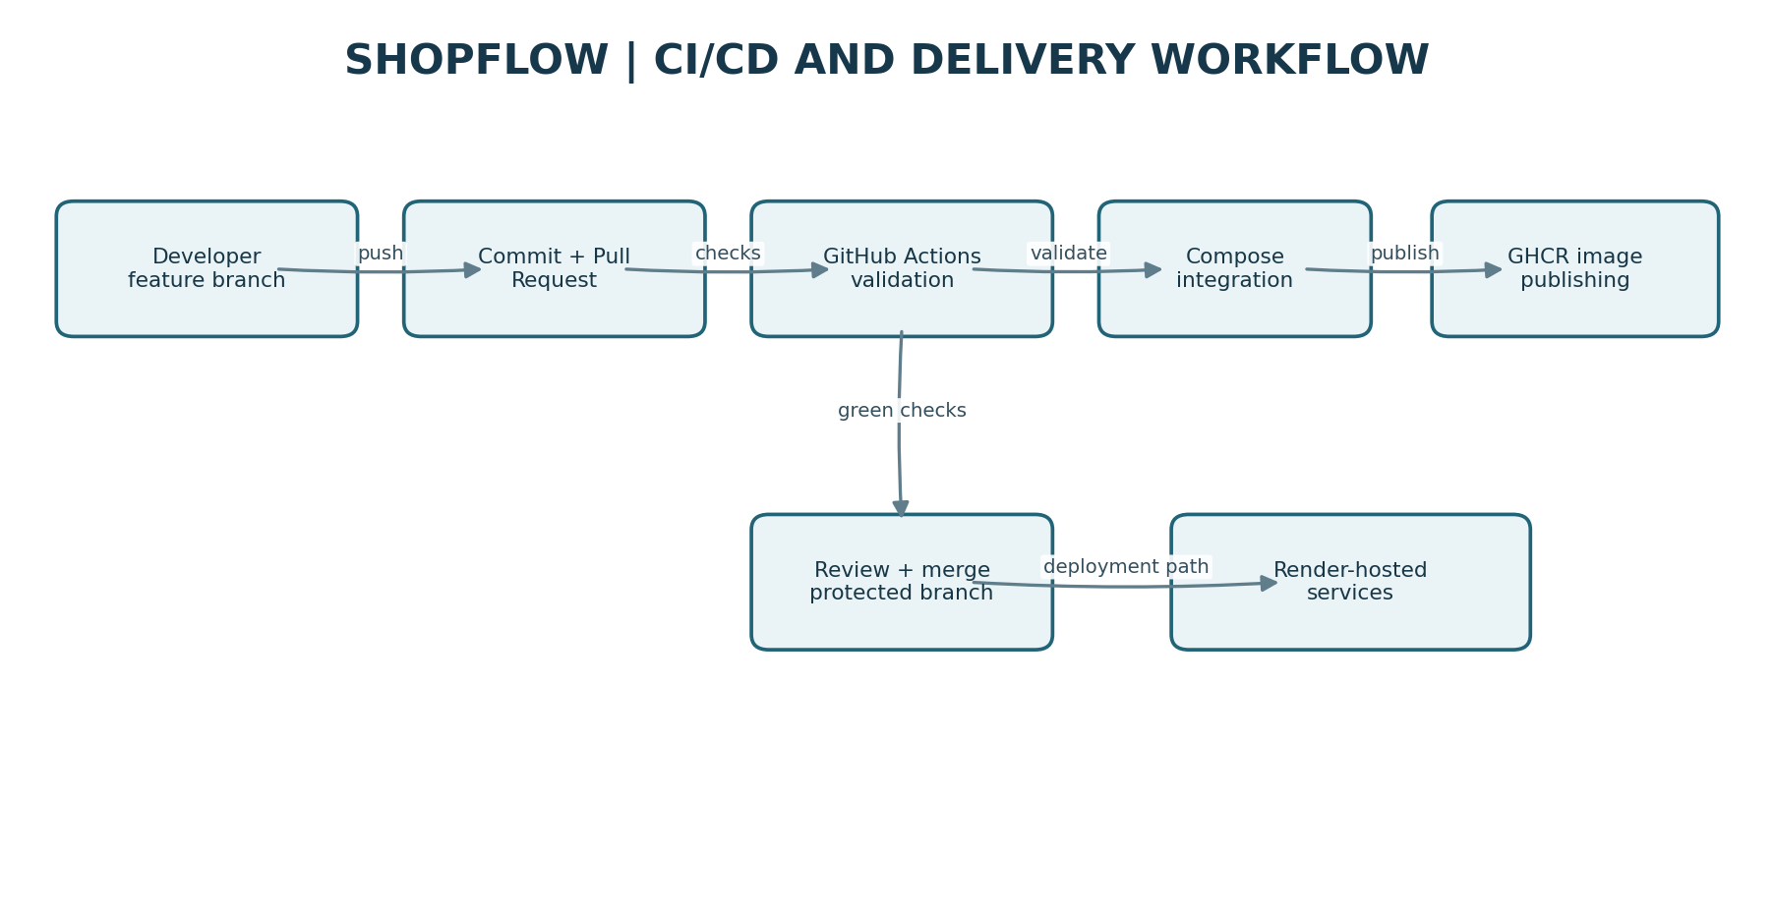
The developer pushes changes and opens a pull request. GitHub Actions runs the configured validation and Compose integration checks, and the workflow includes GHCR image publishing. The Day 23 change was merged through PR #1 and the post-merge workflow showed three successful jobs. Render hosts the public frontend/backend services; GHCR publishing is a separate container artifact workflow.

10.7 Deployment Topology and Design Decisions
Layer | Deployment / technology | Reasoning
Frontend | React/Vite on Render | Existing frontend retained; independent build and runtime configuration.
Backend | FastAPI on Render; Gunicorn/Uvicorn workers | Production ASGI serving and independently managed API service.
Database | PostgreSQL on Neon | Managed relational database; secrets remain in environment configuration.
Background jobs | Redis/Celery in the application integration architecture | Decouple longer-running work and support task lifecycle handling.
CI/CD | GitHub Actions + Docker Compose + GHCR | Automated validation, integration checks and container-image publishing.
HTTPS / logs | Render-managed HTTPS and deployment/runtime logs | Managed TLS and operational visibility without a separate EC2/Nginx/Certbot stack.
Platform boundary: the application is deployed on Render with Neon PostgreSQL. AWS EC2, IAM, S3, CloudWatch, ELB and Auto Scaling were covered as Day 24 learning topics; they are not represented as live resources in this deployment. Render-managed HTTPS is not the same implementation as a manually configured Nginx/Certbot stack.

10.8 Public Links and Delivery Evidence
- Live frontend: https://zeta-0pew.onrender.com
- Live backend: https://zetaa.onrender.com
- FastAPI Swagger UI: https://zetaa.onrender.com/docs
- GitHub repository: https://github.com/abhinandanCS05/Coastal7_Learning_Internship
- Merged pull request #1: https://github.com/abhinandanCS05/Coastal7_Learning_Internship/pull/1
- GitHub Actions evidence: https://github.com/abhinandanCS05/Coastal7_Learning_Internship/actions/runs/38534460711

10.9 System Design Decisions
Design decision | Technical rationale
Separate frontend and backend | Independent application builds and deployment configuration; clear client/API boundary.
FastAPI for the backend | Typed request validation, API routing, dependency injection and asynchronous endpoint support.
PostgreSQL on Neon | Managed relational persistence without maintaining a separate database server for this deployment.
Redis and Celery | Decouple longer-running work from synchronous request handling and support caching/task execution.
WebSockets | Support real-time updates without requiring constant full-page refreshes.
AI service abstraction | Isolate provider integration and support validation, streaming and fallback handling.
Docker and Compose | Reproducible container packaging and integration validation.
GitHub Actions | Automate checks and container workflow steps to reduce dependence on manual validation.
Render-managed deployment | Reuse the existing hosted services, HTTPS and operational logs without duplicating the application on AWS.
Environment-based secrets | Keep credentials and deployment-specific endpoints outside committed source code.

10.10 End-to-End Design Summary

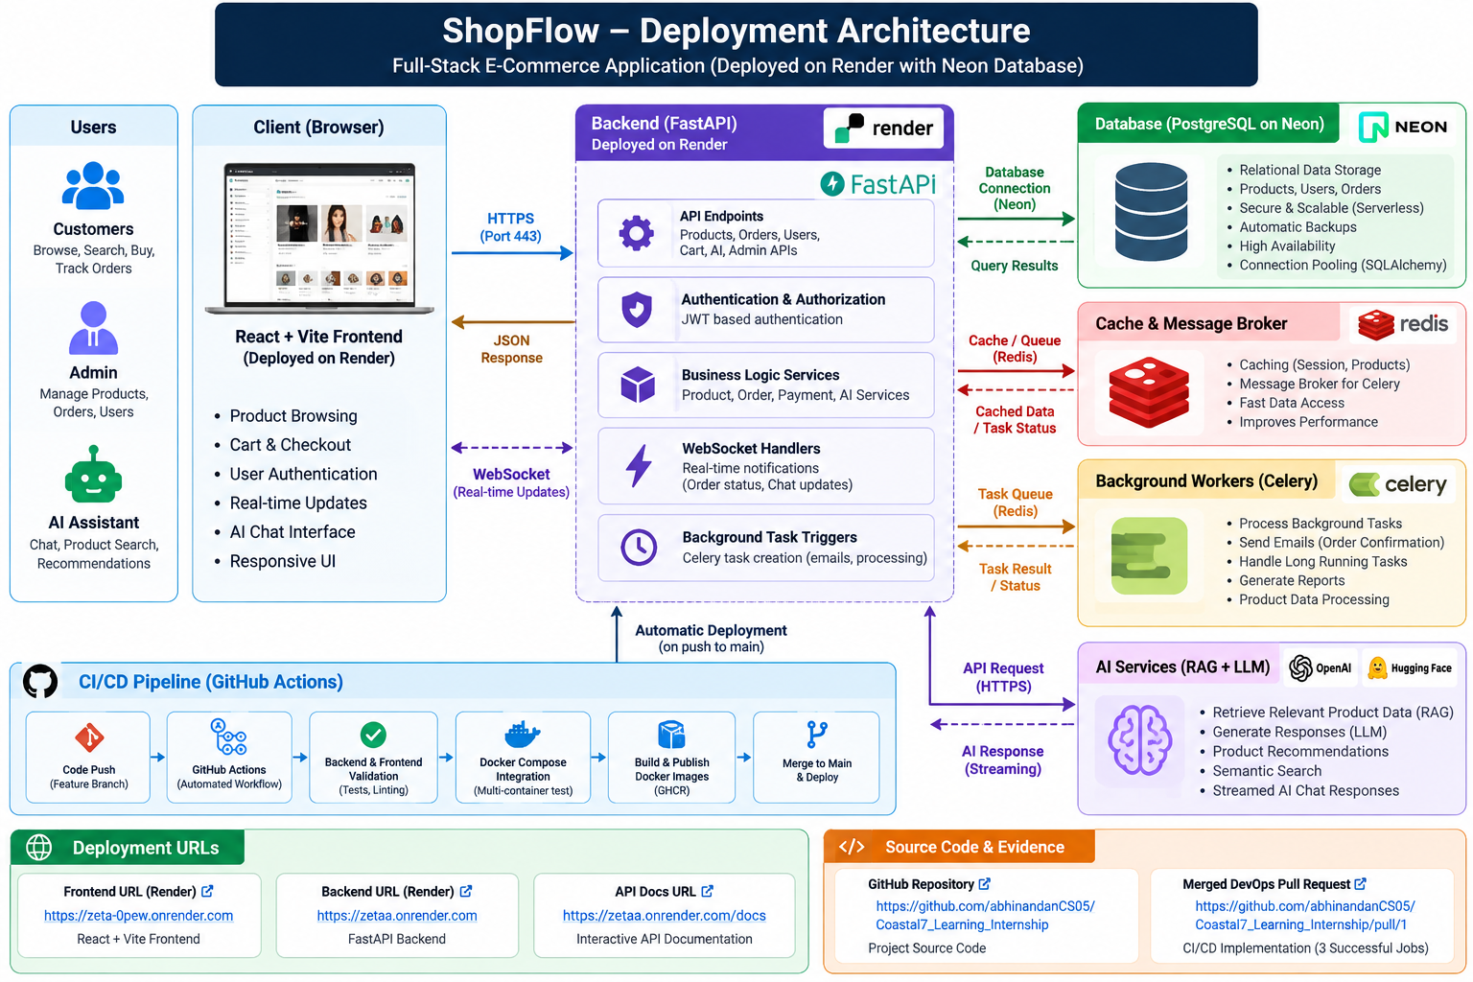

The production deployment and CI environment have different responsibilities. Render hosts the publicly accessible application, whereas Docker Compose provides a repeatable integration environment and GitHub Actions performs automated checks and container-image publishing.
ShopFlow follows a layered, service-oriented application design. The React/Vite frontend handles user interactions, FastAPI coordinates requests and business logic, PostgreSQL provides persistent storage, Redis/Celery supports background execution, WebSockets support real-time communication, and the AI service layer enables context-aware application features.
The production application is hosted using Render and Neon, while Docker Compose and GitHub Actions provide repeatable integration and delivery validation. This architecture brings together full-stack development, asynchronous processing, AI integration, database management, automated testing and deployment operations in a single e-commerce application.

— End of Internship Closure Dossier —

