Assignment Case Study – Complete Session Work Pack
ReconAI | 18 Days × 4 Hours (72 h) | Every Session Includes Hourly Break-up + Workflow + Steps + Why
Source-locked to: AI_Banking_SourceLocked_18_Day_72_Hour_TOC_and_Project_Mapping.xlsx

1. How This Pack Maps to the Source-Locked TOC
This work pack follows the Session Work Pack pattern (workflow diagram, steps with reasons, detailed execution, input → work → output, exit criteria and carry-forward for every session) and applies it to the 18-day banking curriculum. The TOC, day structure, hourly blocks, source IDs and topic wording are taken unchanged from the mapping workbook; nothing in the curriculum has been re-sequenced or re-worded.
Each day is one session of 4 hours. Inside each session, every step is pinned to the hourly block (and therefore the exact source IDs) in which it is taught, so the workflow diagram, the hourly break-up and the step table all line up.
Case | ReconAI
Use | Assignment Case Study – Guided Implementation
Workbook mapping IDs | SOL-R01 … SOL-R18
Delivery mode | Learner-led assignment. Launched in Hour 4 of each day ("ReconAI assignment launch and evidence") after the BankAssist demonstration; learners apply the same topics independently. This pack is the guided implementation / solution reference.
Programme | 18 days × 4 hours = 72 hours; 114 source lines (S002 absent in the supplied workbook)
Companion cases | BankAssist 360 (guided) | ReconAI (assignment) | ChargebackIQ (capstone)
Human decision boundary | The deterministic matcher decides match status. ReconAI may investigate exceptions, link SOP evidence and draft non-authoritative narratives. Dispositions, adjustments, write-offs and ledger postings are made only by reconciliation analysts/reviewers, and every transition is audited.
Access & honesty notes | Gemini Enterprise / ADK steps run only where access is approved; otherwise use mocks and record the design. Code status per day is copied from the workbook ("Reference app codebase + planned day-specific lab (not yet standalone)" for Days 1–15; named daywise demo files for Days 16–18) and is not claimed as a finished implementation.

2. Case Background
ReconAI supports a bank’s reconciliation team. It compares the internal ledger with card/payment settlement files, raises exceptions (missing items, amount mismatches, duplicates, timing differences), links each exception to the governing reconciliation SOP, and drafts non-authoritative exception narratives for analyst review.
The deterministic matcher is always the authority for match status. AI is added only around it: to explain, retrieve evidence and route work to reviewers — never to post adjustments or close exceptions.
Training data and templates (names as listed in the workbook File Index; all synthetic):
File | Use in this case
data/ledger.csv | Internal ledger records
data/settlement.csv | Settlement file records
data/duplicate_settlement.csv | Fixture with duplicate settlement rows
data/bad_amount.csv | Fixture with invalid amounts
data/policies.json / data/golden.json | SOP excerpts and gold set for retrieval and sign-off evaluation

3. Session Coverage
Day | Exact modules | Source IDs | Concept | Lab | Primary output | Map ID
1 | Python for AI | S001, S003, S004, S005 | 1.25h | 2.75h | ReconAI schema manifest and control-total report | SOL-R01
2 | Gen AI & Challenges | S006, S007, S008, S009, S010 | 1.25h | 2.75h | Two reviewed exception examples | SOL-R02
3 | Gen AI & Challenges | Prompt Engineering | S011, S012, S013, S014, S015, S016 | 1.25h | 2.75h | Recon prompt library v1 and test matrix | SOL-R03
4 | Prompt Engineering | LLM/LRM/LMM | S017, S018, S019, S020, S021, S022 | 1.25h | 2.75h | Recon JSON contract and prompt regression cases | SOL-R04
5 | LLM/LRM/LMM | Agentic Workflows – LangChain Essentials | S023, S024, S025, S026, S027 | 1.25h | 2.75h | Recon vector-data plan | SOL-R05
6 | Agentic Workflows – LangChain Essentials | Retrieval-Augmented Generation (RAG) | S028, S029, S030, S031, S032, S033 | 1.25h | 2.75h | Chain implementation brief | SOL-R06
7 | Retrieval-Augmented Generation (RAG) | S034, S035, S036, S037, S038, S039 | 1.25h | 2.75h | Recon evidence-backed retrieval examples | SOL-R07
8 | Retrieval-Augmented Generation (RAG) | S040, S041, S042, S043, S044, S045 | 1.25h | 2.75h | Recon retrieval evaluation pack | SOL-R08
9 | Demystifying Agentic AI | S046, S047, S048, S049, S050, S051 | 1.25h | 2.75h | Agent role and action policy | SOL-R09
10 | Demystifying Agentic AI | Context, Harness & Loop Engineering | S052, S053, S054, S055, S056, S057, S058 | 1.25h | 2.75h | Controlled exception investigation trace | SOL-R10
11 | Context, Harness & Loop Engineering | S059, S060, S061, S062, S063, S064, S065, S066 | 1.25h | 2.75h | Reviewer state transitions and evidence log | SOL-R11
12 | LangGraph/CrewAI/AutoGen – Advanced AI Agents | S067, S068, S069, S070, S071 | 1.25h | 2.75h | Recon graph and sample execution trace | SOL-R12
13 | LangGraph/CrewAI/AutoGen – Advanced AI Agents | Architecting Agentic Systems – MCP & A2A Protocols | Applied Data Processing — Batch Fundamentals & Streaming Fundamentals | S072, S073, S074, S075, S076, S077, S078 | 1.25h | 2.75h | Boundary diagram and message examples | SOL-R13
14 | Architecting Agentic Systems – MCP & A2A Protocols | Gemini Enterprise Agent Development | Cloud Batch & Event-Streaming Architecture — Pub/Sub, Dataflow/Apache Beam & BigQuery | S079, S080, S081, S082, S083, S084, S085, S086 | 1.25h | 2.75h | Recon agent design and approval checklist | SOL-R14
15 | Gemini Enterprise Agent Development | LLM Fine-Tuning & Evaluation | Batch Validation & Publisher Batching — Event Time, Windows, Watermarks & Late Data | S087, S088, S089, S090, S091, S092, S093 | 1.25h | 2.75h | Recon evaluation notes and tuning recommendation | SOL-R15
16 | Deployment, Evaluation & Observability | Streaming Observability & Delivery Semantics — Correlation, Acknowledgement & Durable Processing | S094, S095, S096, S097, S098, S099, S100 | 0.75h | 3.25h | Recon integration trace and contract tests | SOL-R16
17 | Deployment, Evaluation & Observability | AI Validation/ Testing | Batch Backfill/Replay & Stream Recovery — Idempotency, Duplicate Handling & Failure Recovery | S101, S102, S103, S104, S105, S106, S107, S108, S109 | 0.75h | 3.25h | Recon regression evidence and rollback plan | SOL-R17
18 | AI Validation/ Testing | Gemini Enterprise Deployment | Batch/Stream Production Readiness — Cutover, Rollback, Governance & Release Validation | S110, S111, S112, S113, S114, S115 | 0.75h | 3.25h | Final assignment report and reviewer sign-off | SOL-R18

4. Session-by-Session Detailed Work

Day 1: Python/Data – define reconciliation input contract
Session duration | 4h = 1.25h concept + 2.75h lab (4 × 1-hour blocks)
Exact modules | Python for AI
Source IDs (primary) | S001, S003, S004, S005
Repeated source IDs (application) | —
Input | Ledger.csv, settlement.csv, join keys and tolerances
Guided implementation (workbook) | Validate source schemas; calculate counts, totals and missing field exceptions.
Primary output | ReconAI schema manifest and control-total report
Human decision / governance | The deterministic matcher decides match status. ReconAI may investigate exceptions, link SOP evidence and draft non-authoritative narratives. Dispositions, adjustments, write-offs and ledger postings are made only by reconciliation analysts/reviewers, and every transition is audited.
Mapping ID / section locator | SOL-R01 | Day 01 / SOL-R01
Slide deck | Day01_SourceLocked_5W1H_Architecture.pptx
Code mapping / status | Reference app codebase + planned day-specific lab (not yet standalone)
Architecture / workflow (workbook) | Data → Python validation → Banking API → Audit log

A. Exact TOC Topics for This Session (unchanged)
Source ID | Exact topic + subtopic
S001 | Python for AI | Python Basics & Syntax
S003 | Variables, Operators, Conditional Statements, Loops
S004 | Data Structures: Lists, Tuples, Sets, Dictionaries
S005 | *Functions, FAST API, File Handling & Error Handling*

B. Hourly Session Break-up (from the workbook Hourly Plan)
Hour | Intention | Source IDs | Exact source words | Revisit IDs | ReconAI activity | Steps
Hour 1  (00:00–01:00) | Theory and 5W1H | S001 | Python for AI | Python Basics & Syntax | — | ReconAI: define reconciliation input contract | 1
Hour 2  (01:00–02:00) | Instructor demonstration | S003 | Variables, Operators, Conditional Statements, Loops | — | ReconAI: define reconciliation input contract | 2, 3
Hour 3  (02:00–03:00) | Guided BankAssist implementation | S004 | Data Structures: Lists, Tuples, Sets, Dictionaries | — | ReconAI: define reconciliation input contract | 4
Hour 4  (03:00–04:00) | ReconAI assignment launch and evidence | S005 | *Functions, FAST API, File Handling & Error Handling* | — | Validate source schemas; calculate counts, totals and missing field exceptions. | 5

C. Workflow Diagram for This Session
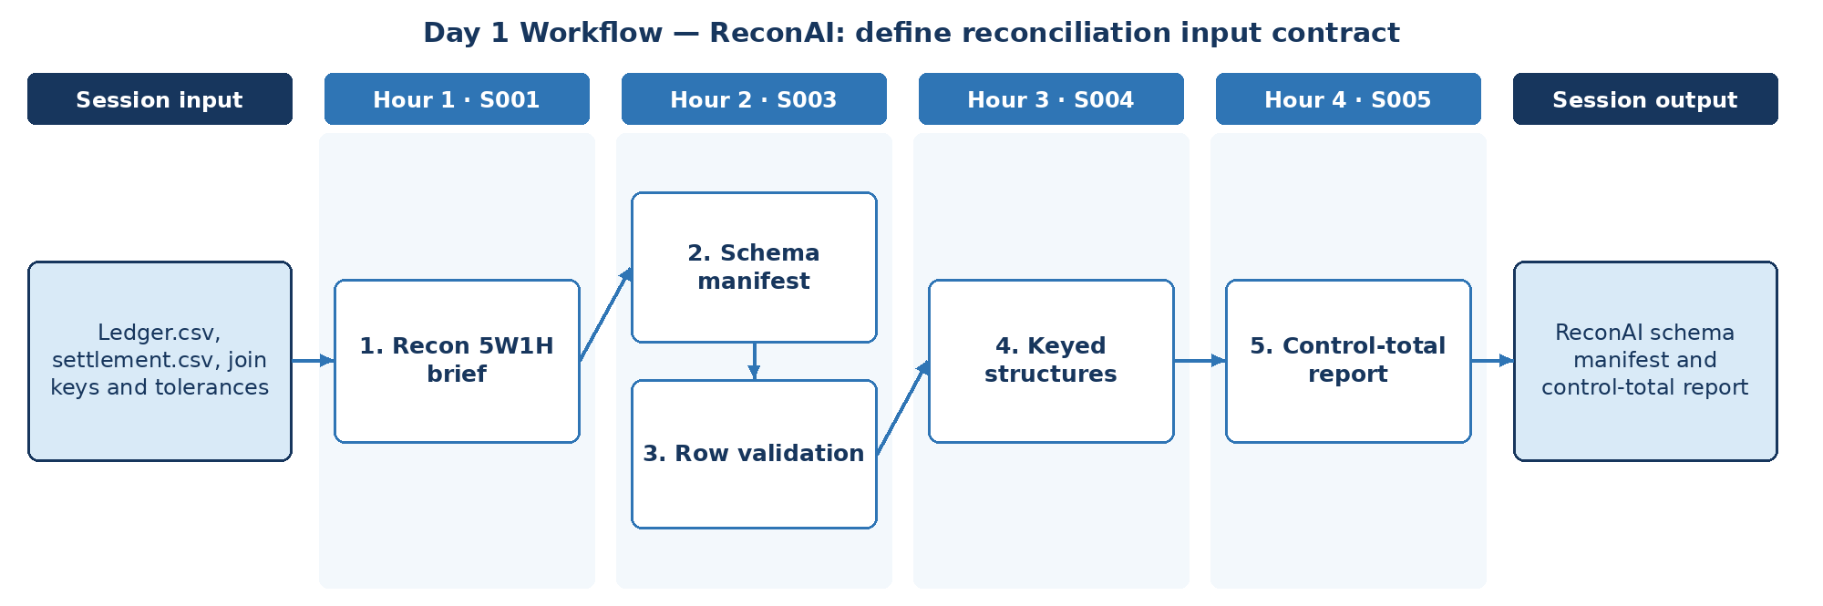

D. Steps to Perform the Work – and Why
Step | Hour · IDs | What to perform | Why this step is required | Expected output
1 | H1 · S001 | Write the ReconAI brief with 5W1H: who reconciles, which sources (ledger vs settlement), when it runs, why exceptions matter, how results are approved; set up the Python project. | Reconciliation is a control; scope and authority must be fixed first. | Recon 5W1H brief + project skeleton
2 | H2 · S003 | Define the input contract: fields, types, join keys (txn_ref, value_date, currency) and amount tolerance. | A written contract lets every later check be automated. | Schema manifest
3 | H2 · S003 | Validate each row using variables, operators, conditionals and loops, including bad_amount.csv. | Invalid rows must be exceptions, not silent mismatches. | Row validation results
4 | H3 · S004 | Index ledger and settlement rows in dictionaries by join key and detect duplicates with sets using duplicate_settlement.csv. | Correct structures make matching and duplicate detection reliable. | Keyed indexes + duplicate list
5 | H4 · S005 | Wrap logic in functions with file and error handling; compute counts, totals and missing-field exceptions. | Control totals prove completeness before matching begins. | Control-total report

E. Detailed Execution Instructions
Step 1 – Write the ReconAI brief with 5W1H: who reconciles, which sources (ledger vs settlement), when it runs, why exceptions matter, how results are approved; set up the Python project.
Hour / source IDs: Hour 1 · S001
How to perform: Name ledger.csv and settlement.csv as sources; state that the matcher, not AI, decides match status; create the src/ layout.
Why: Reconciliation is a control; scope and authority must be fixed first.
Output to retain: Recon 5W1H brief + project skeleton
Step 2 – Define the input contract: fields, types, join keys (txn_ref, value_date, currency) and amount tolerance.
Hour / source IDs: Hour 2 · S003
How to perform: List each field with type and required flag; state tolerance (e.g., 0.01) and date window; store as schema_manifest.json.
Why: A written contract lets every later check be automated.
Output to retain: Schema manifest
Step 3 – Validate each row using variables, operators, conditionals and loops, including bad_amount.csv.
Hour / source IDs: Hour 2 · S003
How to perform: Check required fields, numeric amount, currency code, date format; record failures with row and rule.
Why: Invalid rows must be exceptions, not silent mismatches.
Output to retain: Row validation results
Step 4 – Index ledger and settlement rows in dictionaries by join key and detect duplicates with sets using duplicate_settlement.csv.
Hour / source IDs: Hour 3 · S004
How to perform: dict[(txn_ref, currency)] → row; a seen-set flags duplicates; list keys missing on either side.
Why: Correct structures make matching and duplicate detection reliable.
Output to retain: Keyed indexes + duplicate list
Step 5 – Wrap logic in functions with file and error handling; compute counts, totals and missing-field exceptions.
Hour / source IDs: Hour 4 · S005
How to perform: Per source: row count, amount total by currency, invalid count; difference ledger vs settlement; save control_total_report.json.
Why: Control totals prove completeness before matching begins.
Output to retain: Control-total report

F. Session Input → Work → Output
Input | Work performed | Output
Ledger.csv, settlement.csv, join keys and tolerances | Recon 5W1H brief → Schema manifest → Row validation → Keyed structures → Control-total report | ReconAI schema manifest and control-total report

G. Validation / Exit Criteria
- The required output exists: ReconAI schema manifest and control-total report.
- Control totals reconcile to raw file totals before and after validation.
- Duplicates and bad amounts appear as named exceptions.
- Every step traces to its hourly block and source IDs (S001, S003, S004, S005); no TOC topic is skipped or re-worded.
- The workflow diagram matches the work actually performed.
- The human decision boundary is preserved wherever the session touches a consequential decision.
- Open gaps or assumptions (including tool or platform access) are recorded rather than silently filled.

H. Carry-Forward
ReconAI schema manifest and control-total report becomes an explicit input for Day 2 — ReconAI: exception explanation prototype (Day 2 input: Two mismatched reconciliation samples).

Day 2: GenAI – exception explanation prototype
Session duration | 4h = 1.25h concept + 2.75h lab (4 × 1-hour blocks)
Exact modules | Gen AI & Challenges
Source IDs (primary) | S006, S007, S008, S009, S010
Repeated source IDs (application) | S001, S003, S004, S005
Input | Two mismatched reconciliation samples
Guided implementation (workbook) | Draft non-authoritative exception narratives and document evidence gaps.
Primary output | Two reviewed exception examples
Human decision / governance | The deterministic matcher decides match status. ReconAI may investigate exceptions, link SOP evidence and draft non-authoritative narratives. Dispositions, adjustments, write-offs and ledger postings are made only by reconciliation analysts/reviewers, and every transition is audited.
Mapping ID / section locator | SOL-R02 | Day 02 / SOL-R02
Slide deck | Day02_SourceLocked_5W1H_Architecture.pptx
Code mapping / status | Reference app codebase + planned day-specific lab (not yet standalone)
Architecture / workflow (workbook) | Banking record → AI task boundary → Draft explanation → Reviewer

A. Exact TOC Topics for This Session (unchanged)
Source ID | Exact topic + subtopic
S006 | Gen AI & Challenges | AI vs ML vs GenAI
S007 | Core Principles of GenAI
S008 | Types of GenAI Models
S009 | How Generative Models Create Data; Key Challenges: Bias, Hallucination, Stochasticity
S010 | Business and Technical Challenges in Deployment

B. Hourly Session Break-up (from the workbook Hourly Plan)
Hour | Intention | Source IDs | Exact source words | Revisit IDs | ReconAI activity | Steps
Hour 1  (00:00–01:00) | Theory and 5W1H | S006 | Gen AI & Challenges | AI vs ML vs GenAI | — | ReconAI: exception explanation prototype | 1
Hour 2  (01:00–02:00) | Instructor demonstration | S007 | Core Principles of GenAI | — | ReconAI: exception explanation prototype | 2
Hour 3  (02:00–03:00) | Guided BankAssist implementation | S008 | Types of GenAI Models | — | ReconAI: exception explanation prototype | 3, 4
Hour 4  (03:00–04:00) | ReconAI assignment launch and evidence | S009, S010 | How Generative Models Create Data; Key Challenges: Bias, Hallucination, Stochasticity  Business and Technical Challenges in Deployment | — | Draft non-authoritative exception narratives and document evidence gaps. | 5

C. Workflow Diagram for This Session
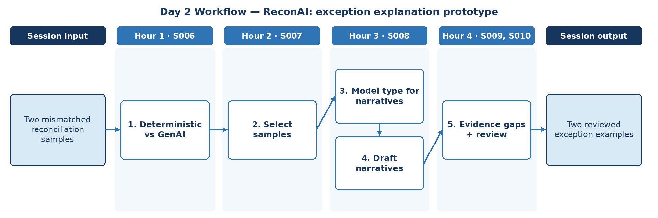

D. Steps to Perform the Work – and Why
Step | Hour · IDs | What to perform | Why this step is required | Expected output
1 | H1 · S006 | Separate reconciliation tasks into deterministic (matching, totals) and GenAI (exception narratives). | Match status is a financial control and must stay deterministic. | Responsibility split
2 | H2 · S007 | Select two mismatched samples (amount difference; missing in settlement) and assemble their evidence. | Narratives must be tested on real exception shapes. | Sample exception packs
3 | H3 · S008 | Choose a GenAI model type suitable for short factual narratives. | Model choice affects cost and factual discipline. | Model choice note
4 | H3 · S008 | Draft non-authoritative exception narratives from the evidence packs. | Analysts save time only if drafts are clearly labelled and grounded. | Two draft narratives
5 | H4 · S009, S010 | Document hallucination/stochasticity risks and evidence gaps; get reviewer comments. | Unsupported statements must be caught before reuse. | Two reviewed exception examples

E. Detailed Execution Instructions
Step 1 – Separate reconciliation tasks into deterministic (matching, totals) and GenAI (exception narratives).
Hour / source IDs: Hour 1 · S006
How to perform: Build a table of reconciliation tasks (load, validate, match, total, explain, disposition) with technique (code / GenAI / human) and a one-line rationale; confirm matching stays in code.
Why: Match status is a financial control and must stay deterministic.
Output to retain: Responsibility split
Step 2 – Select two mismatched samples (amount difference; missing in settlement) and assemble their evidence.
Hour / source IDs: Hour 2 · S007
How to perform: For each: both records (masked), difference, matcher reason code.
Why: Narratives must be tested on real exception shapes.
Output to retain: Sample exception packs
Step 3 – Choose a GenAI model type suitable for short factual narratives.
Hour / source IDs: Hour 3 · S008
How to perform: Run the two evidence packs through two candidate model types with the same prompt; compare factual accuracy, length and cost; record the choice and a fallback.
Why: Model choice affects cost and factual discipline.
Output to retain: Model choice note
Step 4 – Draft non-authoritative exception narratives from the evidence packs.
Hour / source IDs: Hour 3 · S008
How to perform: Prefix 'DRAFT – for analyst review'; reference only fields in the pack.
Why: Analysts save time only if drafts are clearly labelled and grounded.
Output to retain: Two draft narratives
Step 5 – Document hallucination/stochasticity risks and evidence gaps; get reviewer comments.
Hour / source IDs: Hour 4 · S009, S010
How to perform: Mark each sentence supported/unsupported; list missing evidence; record reviewer outcome.
Why: Unsupported statements must be caught before reuse.
Output to retain: Two reviewed exception examples

F. Session Input → Work → Output
Input | Work performed | Output
Two mismatched reconciliation samples | Deterministic vs GenAI → Select samples → Model type for narratives → Draft narratives → Evidence gaps + review | Two reviewed exception examples

G. Validation / Exit Criteria
- The required output exists: Two reviewed exception examples.
- Both narratives are labelled non-authoritative.
- Every unsupported statement is flagged.
- Every step traces to its hourly block and source IDs (S006, S007, S008, S009, S010); no TOC topic is skipped or re-worded.
- The workflow diagram matches the work actually performed.
- The human decision boundary is preserved wherever the session touches a consequential decision.
- Open gaps or assumptions (including tool or platform access) are recorded rather than silently filled.

H. Carry-Forward
Two reviewed exception examples becomes an explicit input for Day 3 — ReconAI: structured reconciliation prompt (Day 3 input: Known mismatches and exception taxonomy).

Day 3: GenAI + Prompts – structured reconciliation prompt
Session duration | 4h = 1.25h concept + 2.75h lab (4 × 1-hour blocks)
Exact modules | Gen AI & Challenges | Prompt Engineering
Source IDs (primary) | S011, S012, S013, S014, S015, S016
Repeated source IDs (application) | S006, S007, S008, S009, S010
Input | Known mismatches and exception taxonomy
Guided implementation (workbook) | Create exception prompt with examples; prohibit unsupported root causes.
Primary output | Recon prompt library v1 and test matrix
Human decision / governance | The deterministic matcher decides match status. ReconAI may investigate exceptions, link SOP evidence and draft non-authoritative narratives. Dispositions, adjustments, write-offs and ledger postings are made only by reconciliation analysts/reviewers, and every transition is audited.
Mapping ID / section locator | SOL-R03 | Day 03 / SOL-R03
Slide deck | Day03_SourceLocked_5W1H_Architecture.pptx
Code mapping / status | Reference app codebase + planned day-specific lab (not yet standalone)
Architecture / workflow (workbook) | Masked records → Prompt contract → Model → Rule validation

A. Exact TOC Topics for This Session (unchanged)
Source ID | Exact topic + subtopic
S011 | Guardrail Solutions: Bias Mitigation (balanced datasets, fairness metrics, post-processing)
S012 | Security Approaches (prompt injection defense, data anonymization, differential privacy)
S013 | Guardrail Techniques (RLHF, Constitutional AI, red-teaming, moderation APIs)
S014 | Prompt Engineering | Prompt Anatomy & Context Types
S015 | Zero-shot, One-shot, Few-shot Prompting
S016 | Chain-of-Thought Prompting

B. Hourly Session Break-up (from the workbook Hourly Plan)
Hour | Intention | Source IDs | Exact source words | Revisit IDs | ReconAI activity | Steps
Hour 1  (00:00–01:00) | Theory and 5W1H | S011 | Guardrail Solutions: Bias Mitigation (balanced datasets, fairness metrics, post-processing) | — | ReconAI: structured reconciliation prompt | 1
Hour 2  (01:00–02:00) | Instructor demonstration | S012, S013 | Security Approaches (prompt injection defense, data anonymization, differential privacy)  Guardrail Techniques (RLHF, Constitutional AI, red-teaming, moderation APIs) | — | ReconAI: structured reconciliation prompt | 2
Hour 3  (02:00–03:00) | Guided BankAssist implementation | S014 | Prompt Engineering | Prompt Anatomy & Context Types | — | ReconAI: structured reconciliation prompt | 3
Hour 4  (03:00–04:00) | ReconAI assignment launch and evidence | S015, S016 | Zero-shot, One-shot, Few-shot Prompting  Chain-of-Thought Prompting | — | Create exception prompt with examples; prohibit unsupported root causes. | 4, 5

C. Workflow Diagram for This Session
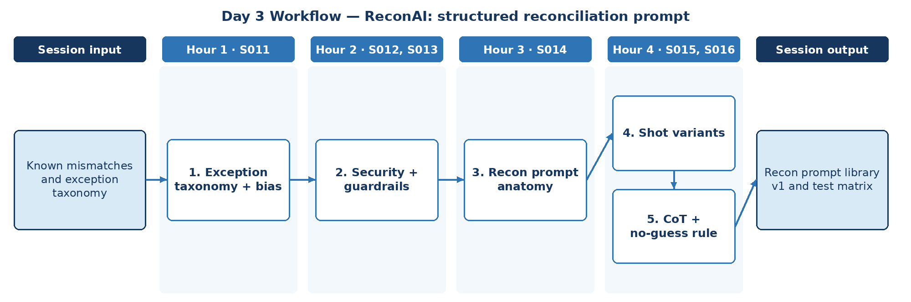

D. Steps to Perform the Work – and Why
Step | Hour · IDs | What to perform | Why this step is required | Expected output
1 | H1 · S011 | Define the exception taxonomy and check narratives for biased language about counterparties. | A fixed taxonomy anchors prompts, tests and reporting; neutral wording avoids implying counterparty fault. | Exception taxonomy
2 | H2 · S012, S013 | Mask account references and defend against injection in free-text narrative fields; choose guardrail techniques. | Settlement memo fields are untrusted text that could carry instructions or sensitive references. | Recon security controls
3 | H3 · S014 | Write the exception prompt with role, task, context, constraints and output format. | Named prompt parts make the recon prompt reviewable, versionable and testable. | Recon prompt v1
4 | H4 · S015, S016 | Create zero-, one- and few-shot variants with example exceptions. | Examples teach the expected exception format and tone better than instructions alone. | Prompt variants
5 | H4 · S015, S016 | Add a chain-of-thought variant and a rule returning 'root cause undetermined' without evidence; build the test matrix. | An unsupported root cause in a reconciliation record is a control failure, not a style issue. | Recon prompt library v1 + test matrix

E. Detailed Execution Instructions
Step 1 – Define the exception taxonomy and check narratives for biased language about counterparties.
Hour / source IDs: Hour 1 · S011
How to perform: missing_in_settlement, missing_in_ledger, amount_mismatch, duplicate, timing; neutral wording rule.
Why: A fixed taxonomy anchors prompts, tests and reporting; neutral wording avoids implying counterparty fault.
Output to retain: Exception taxonomy
Step 2 – Mask account references and defend against injection in free-text narrative fields; choose guardrail techniques.
Hour / source IDs: Hour 2 · S012, S013
How to perform: Masking rule; delimiters; injection tests; moderation check.
Why: Settlement memo fields are untrusted text that could carry instructions or sensitive references.
Output to retain: Recon security controls
Step 3 – Write the exception prompt with role, task, context, constraints and output format.
Hour / source IDs: Hour 3 · S014
How to perform: Include taxonomy; forbid stating root causes not in evidence.
Why: Named prompt parts make the recon prompt reviewable, versionable and testable.
Output to retain: Recon prompt v1
Step 4 – Create zero-, one- and few-shot variants with example exceptions.
Hour / source IDs: Hour 4 · S015, S016
How to perform: Write zero-shot, one-shot and few-shot variants; the few-shot variant carries one masked example per taxonomy type; keep examples in a versioned file.
Why: Examples teach the expected exception format and tone better than instructions alone.
Output to retain: Prompt variants
Step 5 – Add a chain-of-thought variant and a rule returning 'root cause undetermined' without evidence; build the test matrix.
Hour / source IDs: Hour 4 · S015, S016
How to perform: Matrix: case × variant × pass/fail on accuracy and no-guess rule.
Why: An unsupported root cause in a reconciliation record is a control failure, not a style issue.
Output to retain: Recon prompt library v1 + test matrix

F. Session Input → Work → Output
Input | Work performed | Output
Known mismatches and exception taxonomy | Exception taxonomy + bias → Security + guardrails → Recon prompt anatomy → Shot variants → CoT + no-guess rule | Recon prompt library v1 and test matrix

G. Validation / Exit Criteria
- The required output exists: Recon prompt library v1 and test matrix.
- No test output states a root cause absent from evidence.
- The test matrix covers every taxonomy type.
- Every step traces to its hourly block and source IDs (S011, S012, S013, S014, S015, S016); no TOC topic is skipped or re-worded.
- The workflow diagram matches the work actually performed.
- The human decision boundary is preserved wherever the session touches a consequential decision.
- Open gaps or assumptions (including tool or platform access) are recorded rather than silently filled.

H. Carry-Forward
Recon prompt library v1 and test matrix becomes an explicit input for Day 4 — ReconAI: schema-constrained remediation summaries (Day 4 input: Mismatch examples, policy metadata and expected JSON schema).

Day 4: Prompts + Models – schema-constrained remediation summaries
Session duration | 4h = 1.25h concept + 2.75h lab (4 × 1-hour blocks)
Exact modules | Prompt Engineering | LLM/LRM/LMM
Source IDs (primary) | S017, S018, S019, S020, S021, S022
Repeated source IDs (application) | S014, S015, S016
Input | Mismatch examples, policy metadata and expected JSON schema
Guided implementation (workbook) | Add function-call prompt examples, failure handling, adversarial testing.
Primary output | Recon JSON contract and prompt regression cases
Human decision / governance | The deterministic matcher decides match status. ReconAI may investigate exceptions, link SOP evidence and draft non-authoritative narratives. Dispositions, adjustments, write-offs and ledger postings are made only by reconciliation analysts/reviewers, and every transition is audited.
Mapping ID / section locator | SOL-R04 | Day 04 / SOL-R04
Slide deck | Day04_SourceLocked_5W1H_Architecture.pptx
Code mapping / status | Reference app codebase + planned day-specific lab (not yet standalone)
Architecture / workflow (workbook) | Prompt → Structured model I/O → JSON schema → Escalation

A. Exact TOC Topics for This Session (unchanged)
Source ID | Exact topic + subtopic
S017 | Prompt Interventions & Prompt Tuning
S018 | Adversarial Prompting & Prompt Security
S019 | Prompts for Agents & ReAct-style Prompting
S020 | *Structured Output Prompting (JSON mode, schemas, function-call prompts)*
S021 | LLM/LRM/LMM | LLMs vs LRMs vs LMMs
S022 | Transformers Architecture, Scaling Laws

B. Hourly Session Break-up (from the workbook Hourly Plan)
Hour | Intention | Source IDs | Exact source words | Revisit IDs | ReconAI activity | Steps
Hour 1  (00:00–01:00) | Theory and 5W1H | S017 | Prompt Interventions & Prompt Tuning | — | ReconAI: schema-constrained remediation summaries | 1
Hour 2  (01:00–02:00) | Instructor demonstration | S018, S019 | Adversarial Prompting & Prompt Security  Prompts for Agents & ReAct-style Prompting | — | ReconAI: schema-constrained remediation summaries | 2
Hour 3  (02:00–03:00) | Guided BankAssist implementation | S020 | *Structured Output Prompting (JSON mode, schemas, function-call prompts)* | — | ReconAI: schema-constrained remediation summaries | 3, 4
Hour 4  (03:00–04:00) | ReconAI assignment launch and evidence | S021, S022 | LLM/LRM/LMM | LLMs vs LRMs vs LMMs  Transformers Architecture, Scaling Laws | — | Add function-call prompt examples, failure handling, adversarial testing. | 5

C. Workflow Diagram for This Session
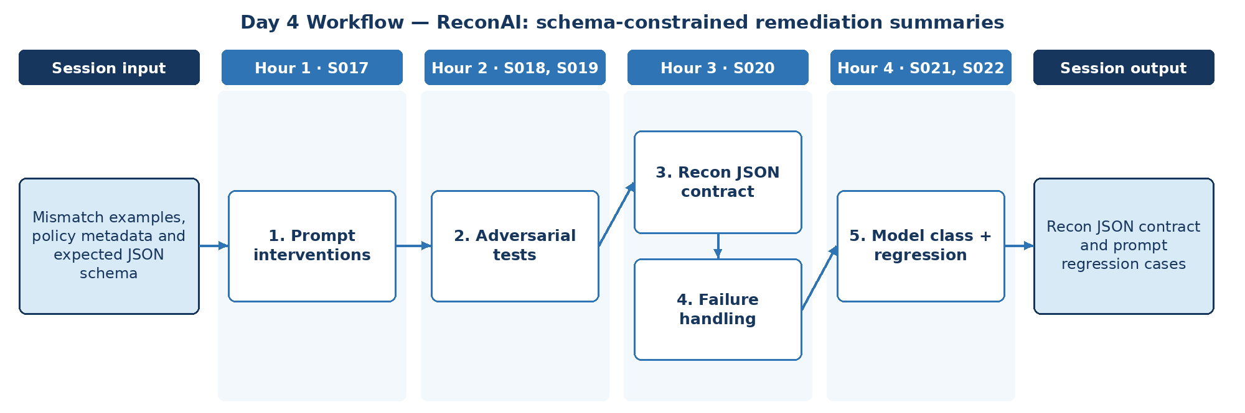

D. Steps to Perform the Work – and Why
Step | Hour · IDs | What to perform | Why this step is required | Expected output
1 | H1 · S017 | Apply versioned prompt interventions to the Day 3 library. | Versioned single changes show which intervention actually improved accuracy. | Prompt change log
2 | H2 · S018, S019 | Run adversarial prompts and ReAct-style prompt drafts for exception lookup. | Weaknesses must be found before the model is connected to matcher and SOP tools. | Adversarial findings
3 | H3 · S020 | Define the remediation JSON schema with function-call prompt examples. | Downstream queues need structured, validated output. | Recon JSON contract
4 | H3 · S020 | Add validation, retry and reject handling for invalid output. | Invalid output must never enter the exception queue. | Failure-handling rules
5 | H4 · S021, S022 | Compare LLM/LRM options for the contract and record prompt regression cases. | A frozen regression set locks accepted behaviour so later changes can be controlled. | Prompt regression cases

E. Detailed Execution Instructions
Step 1 – Apply versioned prompt interventions to the Day 3 library.
Hour / source IDs: Hour 1 · S017
How to perform: Change one prompt element per version (instruction, example, constraint); re-run the Day 3 test matrix; log version, change and score delta in the change log.
Why: Versioned single changes show which intervention actually improved accuracy.
Output to retain: Prompt change log
Step 2 – Run adversarial prompts and ReAct-style prompt drafts for exception lookup.
Hour / source IDs: Hour 2 · S018, S019
How to perform: Insert injection text into settlement memo fields and ask the model to 'mark as matched'; draft a ReAct-style lookup prompt with read-only actions; record pass/fail and mitigation.
Why: Weaknesses must be found before the model is connected to matcher and SOP tools.
Output to retain: Adversarial findings
Step 3 – Define the remediation JSON schema with function-call prompt examples.
Hour / source IDs: Hour 3 · S020
How to perform: Fields: exception_id, type, evidence_refs, proposed_next_step, root_cause (enum incl. 'undetermined'), requires_reviewer=true.
Why: Downstream queues need structured, validated output.
Output to retain: Recon JSON contract
Step 4 – Add validation, retry and reject handling for invalid output.
Hour / source IDs: Hour 3 · S020
How to perform: Validate every output with pydantic/jsonschema; retry once with the validation error appended; if it fails again, route the exception to the manual queue and log the reason.
Why: Invalid output must never enter the exception queue.
Output to retain: Failure-handling rules
Step 5 – Compare LLM/LRM options for the contract and record prompt regression cases.
Hour / source IDs: Hour 4 · S021, S022
How to perform: Run the contract on two model classes where available; compare schema-valid rate, latency and cost per exception; freeze the passing cases as the regression set.
Why: A frozen regression set locks accepted behaviour so later changes can be controlled.
Output to retain: Prompt regression cases

F. Session Input → Work → Output
Input | Work performed | Output
Mismatch examples, policy metadata and expected JSON schema | Prompt interventions → Adversarial tests → Recon JSON contract → Failure handling → Model class + regression | Recon JSON contract and prompt regression cases

G. Validation / Exit Criteria
- The required output exists: Recon JSON contract and prompt regression cases.
- All accepted outputs validate against the JSON contract.
- requires_reviewer is always true.
- Every step traces to its hourly block and source IDs (S017, S018, S019, S020, S021, S022); no TOC topic is skipped or re-worded.
- The workflow diagram matches the work actually performed.
- The human decision boundary is preserved wherever the session touches a consequential decision.
- Open gaps or assumptions (including tool or platform access) are recorded rather than silently filled.

H. Carry-Forward
Recon JSON contract and prompt regression cases becomes an explicit input for Day 5 — ReconAI: SOP representation (Day 5 input: Reconciliation SOP excerpts).

Day 5: Models + LangChain – SOP representation
Session duration | 4h = 1.25h concept + 2.75h lab (4 × 1-hour blocks)
Exact modules | LLM/LRM/LMM | Agentic Workflows – LangChain Essentials
Source IDs (primary) | S023, S024, S025, S026, S027
Repeated source IDs (application) | S021, S022
Input | Reconciliation SOP excerpts
Guided implementation (workbook) | Prepare text chunks and embeddings candidate list; compare sampling choices.
Primary output | Recon vector-data plan
Human decision / governance | The deterministic matcher decides match status. ReconAI may investigate exceptions, link SOP evidence and draft non-authoritative narratives. Dispositions, adjustments, write-offs and ledger postings are made only by reconciliation analysts/reviewers, and every transition is audited.
Mapping ID / section locator | SOL-R05 | Day 05 / SOL-R05
Slide deck | Day05_SourceLocked_5W1H_Architecture.pptx
Code mapping / status | Reference app codebase + planned day-specific lab (not yet standalone)
Architecture / workflow (workbook) | Banking SOP → Tokenizer/Embeddings → LLM config

A. Exact TOC Topics for This Session (unchanged)
Source ID | Exact topic + subtopic
S023 | Tokenization & Embedding Techniques (Byte Pair Encoding)
S024 | Reasoning Tokens & Inference Strategies
S025 | Max New Tokens, Sampling, Temperature, Top_K, Top_P
S026 | LMMs: DALL-E, Imagen, Diffusion Models
S027 | Agentic Workflows – LangChain Essentials | Introduction to LangChain Architecture

B. Hourly Session Break-up (from the workbook Hourly Plan)
Hour | Intention | Source IDs | Exact source words | Revisit IDs | ReconAI activity | Steps
Hour 1  (00:00–01:00) | Theory and 5W1H | S023 | Tokenization & Embedding Techniques (Byte Pair Encoding) | — | ReconAI: SOP representation | 1
Hour 2  (01:00–02:00) | Instructor demonstration | S024 | Reasoning Tokens & Inference Strategies | — | ReconAI: SOP representation | 2
Hour 3  (02:00–03:00) | Guided BankAssist implementation | S025 | Max New Tokens, Sampling, Temperature, Top_K, Top_P | — | ReconAI: SOP representation | 3
Hour 4  (03:00–04:00) | ReconAI assignment launch and evidence | S026, S027 | LMMs: DALL-E, Imagen, Diffusion Models  Agentic Workflows – LangChain Essentials | Introduction to LangChain Architecture | — | Prepare text chunks and embeddings candidate list; compare sampling choices. | 4, 5

C. Workflow Diagram for This Session
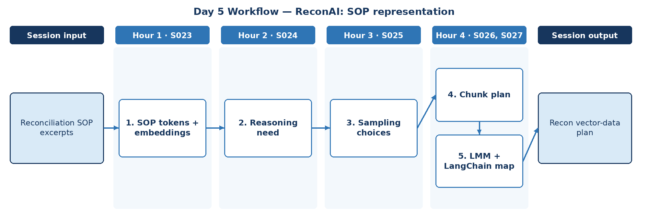

D. Steps to Perform the Work – and Why
Step | Hour · IDs | What to perform | Why this step is required | Expected output
1 | H1 · S023 | Tokenise reconciliation SOP excerpts and list embedding model candidates. | Token counts set chunk size and cost; the embedding choice decides retrieval quality on Day 7. | Token counts + embedding candidates
2 | H2 · S024 | Decide where reasoning tokens are justified for exception explanation. | Reasoning tokens add cost and latency, so they should be used only where accuracy improves. | Reasoning decision
3 | H3 · S025 | Compare sampling choices (temperature, top_k, top_p, max tokens) for narratives. | Reconciliation narratives must be stable; variable wording undermines review and audit. | Sampling decision
4 | H4 · S026, S027 | Prepare text-chunk plan for SOPs with metadata (exception_type, section). | Metadata by exception type makes exception-to-SOP lookup possible and filterable. | Chunk plan
5 | H4 · S026, S027 | Record that image-generation LMMs are out of scope and map ReconAI to LangChain components. | Recording what is out of scope keeps the design honest and the component map complete. | Recon vector-data plan

E. Detailed Execution Instructions
Step 1 – Tokenise reconciliation SOP excerpts and list embedding model candidates.
Hour / source IDs: Hour 1 · S023
How to perform: Count tokens per SOP section; list 2–3 embedding options.
Why: Token counts set chunk size and cost; the embedding choice decides retrieval quality on Day 7.
Output to retain: Token counts + embedding candidates
Step 2 – Decide where reasoning tokens are justified for exception explanation.
Hour / source IDs: Hour 2 · S024
How to perform: Run three complex exceptions with and without reasoning; record tokens, latency and correctness; allow reasoning only for multi-leg or timing exceptions.
Why: Reasoning tokens add cost and latency, so they should be used only where accuracy improves.
Output to retain: Reasoning decision
Step 3 – Compare sampling choices (temperature, top_k, top_p, max tokens) for narratives.
Hour / source IDs: Hour 3 · S025
How to perform: Test temperature 0 / 0.3 / 0.7 with fixed max tokens; measure variation across 5 runs; select the lowest setting that keeps narratives readable.
Why: Reconciliation narratives must be stable; variable wording undermines review and audit.
Output to retain: Sampling decision
Step 4 – Prepare text-chunk plan for SOPs with metadata (exception_type, section).
Hour / source IDs: Hour 4 · S026, S027
How to perform: Choose chunk size and overlap from the token counts; attach metadata (sop_id, section, exception_type, version); check that no SOP rule is split across chunks.
Why: Metadata by exception type makes exception-to-SOP lookup possible and filterable.
Output to retain: Chunk plan
Step 5 – Record that image-generation LMMs are out of scope and map ReconAI to LangChain components.
Hour / source IDs: Hour 4 · S026, S027
How to perform: State that image-generation LMMs are not used; map loader, splitter, embeddings, vector store, retriever, prompt and parser to LangChain components; combine into the vector-data plan.
Why: Recording what is out of scope keeps the design honest and the component map complete.
Output to retain: Recon vector-data plan

F. Session Input → Work → Output
Input | Work performed | Output
Reconciliation SOP excerpts | SOP tokens + embeddings → Reasoning need → Sampling choices → Chunk plan → LMM + LangChain map | Recon vector-data plan

G. Validation / Exit Criteria
- The required output exists: Recon vector-data plan.
- The vector-data plan names chunking, metadata and embedding choice.
- Sampling settings are justified by evidence.
- Every step traces to its hourly block and source IDs (S023, S024, S025, S026, S027); no TOC topic is skipped or re-worded.
- The workflow diagram matches the work actually performed.
- The human decision boundary is preserved wherever the session touches a consequential decision.
- Open gaps or assumptions (including tool or platform access) are recorded rather than silently filled.

H. Carry-Forward
Recon vector-data plan becomes an explicit input for Day 6 — ReconAI: reconciliation chain (Day 6 input: Validated ledger/settlement rows and SOPs).

Day 6: LangChain + RAG – reconciliation chain
Session duration | 4h = 1.25h concept + 2.75h lab (4 × 1-hour blocks)
Exact modules | Agentic Workflows – LangChain Essentials | Retrieval-Augmented Generation (RAG)
Source IDs (primary) | S028, S029, S030, S031, S032, S033
Repeated source IDs (application) | S027
Input | Validated ledger/settlement rows and SOPs
Guided implementation (workbook) | Design sequential ingest → match → explain chain; outline retrieval integration.
Primary output | Chain implementation brief
Human decision / governance | The deterministic matcher decides match status. ReconAI may investigate exceptions, link SOP evidence and draft non-authoritative narratives. Dispositions, adjustments, write-offs and ledger postings are made only by reconciliation analysts/reviewers, and every transition is audited.
Mapping ID / section locator | SOL-R06 | Day 06 / SOL-R06
Slide deck | Day06_SourceLocked_5W1H_Architecture.pptx
Code mapping / status | Reference app codebase + planned day-specific lab (not yet standalone)
Architecture / workflow (workbook) | Request → LangChain chain → Mock tools → RAG retriever

A. Exact TOC Topics for This Session (unchanged)
Source ID | Exact topic + subtopic
S028 | Model I/O & Integration
S029 | Chains, Prompt Templates, Sequential Flows
S030 | Memory & Context Handling
S031 | Tool/Agent Integration
S032 | Hands-on Workflow Creation
S033 | Retrieval-Augmented Generation (RAG) | Introduction to RAG & Its Importance

B. Hourly Session Break-up (from the workbook Hourly Plan)
Hour | Intention | Source IDs | Exact source words | Revisit IDs | ReconAI activity | Steps
Hour 1  (00:00–01:00) | Theory and 5W1H | S028 | Model I/O & Integration | — | ReconAI: reconciliation chain | 1
Hour 2  (01:00–02:00) | Instructor demonstration | S029, S030 | Chains, Prompt Templates, Sequential Flows  Memory & Context Handling | — | ReconAI: reconciliation chain | 2
Hour 3  (02:00–03:00) | Guided BankAssist implementation | S031 | Tool/Agent Integration | — | ReconAI: reconciliation chain | 3
Hour 4  (03:00–04:00) | ReconAI assignment launch and evidence | S032, S033 | Hands-on Workflow Creation  Retrieval-Augmented Generation (RAG) | Introduction to RAG & Its Importance | — | Design sequential ingest → match → explain chain; outline retrieval integration. | 4, 5

C. Workflow Diagram for This Session
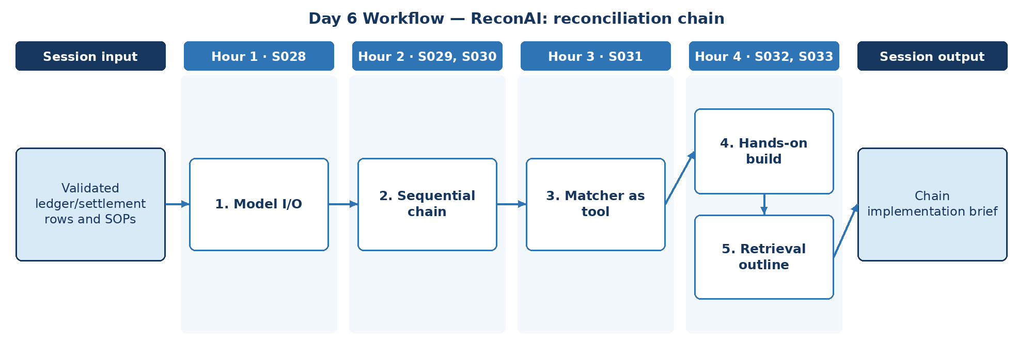

D. Steps to Perform the Work – and Why
Step | Hour · IDs | What to perform | Why this step is required | Expected output
1 | H1 · S028 | Define model I/O for the explain step using the Day 4 contract. | A typed explain step keeps chain output compatible with the Day 4 contract. | Explain-step I/O
2 | H2 · S029, S030 | Design the sequential chain ingest → match → explain, with memory scoped to one exception batch. | Separates deterministic and generative stages. | Chain design
3 | H3 · S031 | Expose the deterministic matcher result as a tool the chain calls. | The model consumes match results; it never computes them. | Matcher tool
4 | H4 · S032, S033 | Build and run the chain on validated ledger/settlement rows. | Running on the real Day 1 exceptions proves the chain works beyond hand-picked samples. | Chain run log
5 | H4 · S032, S033 | Outline how SOP retrieval integrates into the explain step. | Defining the retrieval insertion point now keeps Day 7 work focused and testable. | Chain implementation brief

E. Detailed Execution Instructions
Step 1 – Define model I/O for the explain step using the Day 4 contract.
Hour / source IDs: Hour 1 · S028
How to perform: Bind the Day 4 recon JSON contract to a prompt template and output parser; unit-test with two known exceptions.
Why: A typed explain step keeps chain output compatible with the Day 4 contract.
Output to retain: Explain-step I/O
Step 2 – Design the sequential chain ingest → match → explain, with memory scoped to one exception batch.
Hour / source IDs: Hour 2 · S029, S030
How to perform: Ingest and match are code; explain is the model; batch-scoped memory.
Why: Separates deterministic and generative stages.
Output to retain: Chain design
Step 3 – Expose the deterministic matcher result as a tool the chain calls.
Hour / source IDs: Hour 3 · S031
How to perform: Wrap the matcher as a typed tool returning reason code, both amounts, difference and dates; the chain may read it but never override it.
Why: The model consumes match results; it never computes them.
Output to retain: Matcher tool
Step 4 – Build and run the chain on validated ledger/settlement rows.
Hour / source IDs: Hour 4 · S032, S033
How to perform: Run every exception from the Day 1 control-total run through the chain; log ingest, match and explain outputs separately; count schema failures.
Why: Running on the real Day 1 exceptions proves the chain works beyond hand-picked samples.
Output to retain: Chain run log
Step 5 – Outline how SOP retrieval integrates into the explain step.
Hour / source IDs: Hour 4 · S032, S033
How to perform: Mark the exact point in the explain step where SOP retrieval is called; define what is cited (sop_id, section) and how it appears in the narrative.
Why: Defining the retrieval insertion point now keeps Day 7 work focused and testable.
Output to retain: Chain implementation brief

F. Session Input → Work → Output
Input | Work performed | Output
Validated ledger/settlement rows and SOPs | Model I/O → Sequential chain → Matcher as tool → Hands-on build → Retrieval outline | Chain implementation brief

G. Validation / Exit Criteria
- The required output exists: Chain implementation brief.
- The matcher, not the model, sets match status.
- The chain brief shows where retrieval plugs in.
- Every step traces to its hourly block and source IDs (S028, S029, S030, S031, S032, S033); no TOC topic is skipped or re-worded.
- The workflow diagram matches the work actually performed.
- The human decision boundary is preserved wherever the session touches a consequential decision.
- Open gaps or assumptions (including tool or platform access) are recorded rather than silently filled.

H. Carry-Forward
Chain implementation brief becomes an explicit input for Day 7 — ReconAI: SOP retrieval assignment (Day 7 input: Recon exception catalog and SOPs).

Day 7: RAG indexing – SOP retrieval assignment
Session duration | 4h = 1.25h concept + 2.75h lab (4 × 1-hour blocks)
Exact modules | Retrieval-Augmented Generation (RAG)
Source IDs (primary) | S034, S035, S036, S037, S038, S039
Repeated source IDs (application) | S033
Input | Recon exception catalog and SOPs
Guided implementation (workbook) | Implement chunking, index build and exception-to-policy lookup.
Primary output | Recon evidence-backed retrieval examples
Human decision / governance | The deterministic matcher decides match status. ReconAI may investigate exceptions, link SOP evidence and draft non-authoritative narratives. Dispositions, adjustments, write-offs and ledger postings are made only by reconciliation analysts/reviewers, and every transition is audited.
Mapping ID / section locator | SOL-R07 | Day 07 / SOL-R07
Slide deck | Day07_SourceLocked_5W1H_Architecture.pptx
Code mapping / status | Reference app codebase + planned day-specific lab (not yet standalone)
Architecture / workflow (workbook) | Documents → Chunking → Vector store → Retrieval → Citations

A. Exact TOC Topics for This Session (unchanged)
Source ID | Exact topic + subtopic
S034 | Vector Databases for RAG (FAISS, Chroma)
S035 | Chunking Strategies in RAG Applications
S036 | Semantic Search vs. Exact Matching
S037 | RAG for Domain-Specific Applications
S038 | Optimizing RAG for Large-Scale AI Models
S039 | Real-Time Information Retrieval Using RAG

B. Hourly Session Break-up (from the workbook Hourly Plan)
Hour | Intention | Source IDs | Exact source words | Revisit IDs | ReconAI activity | Steps
Hour 1  (00:00–01:00) | Theory and 5W1H | S034 | Vector Databases for RAG (FAISS, Chroma) | — | ReconAI: SOP retrieval assignment | 1
Hour 2  (01:00–02:00) | Instructor demonstration | S035, S036 | Chunking Strategies in RAG Applications  Semantic Search vs. Exact Matching | — | ReconAI: SOP retrieval assignment | 2
Hour 3  (02:00–03:00) | Guided BankAssist implementation | S037 | RAG for Domain-Specific Applications | — | ReconAI: SOP retrieval assignment | 3
Hour 4  (03:00–04:00) | ReconAI assignment launch and evidence | S038, S039 | Optimizing RAG for Large-Scale AI Models  Real-Time Information Retrieval Using RAG | — | Implement chunking, index build and exception-to-policy lookup. | 4

C. Workflow Diagram for This Session
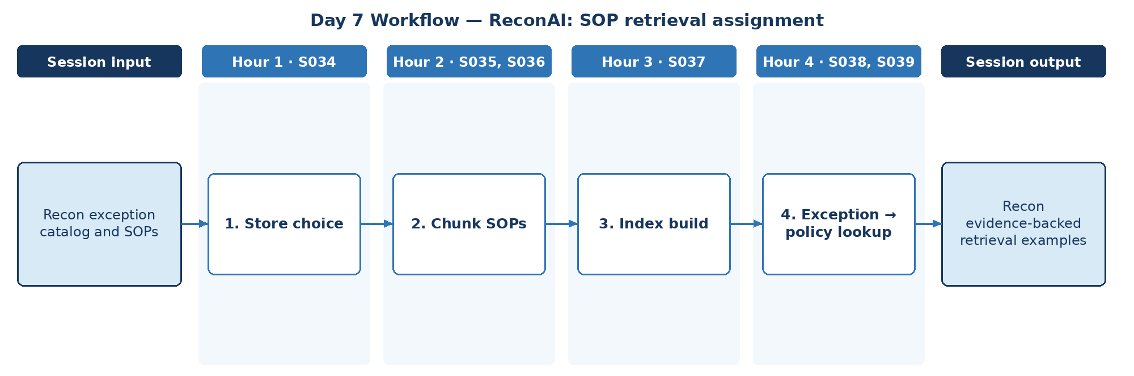

D. Steps to Perform the Work – and Why
Step | Hour · IDs | What to perform | Why this step is required | Expected output
1 | H1 · S034 | Select FAISS or Chroma for SOP retrieval. | Store features affect filtering by exception type. | Store decision
2 | H2 · S035, S036 | Chunk SOPs and the exception catalogue; compare semantic and exact match on SOP codes. | Codes need exact match; descriptions need semantic. | Chunks + match comparison
3 | H3 · S037 | Build the domain-specific index with metadata. | Metadata enables filtered, cited look-ups that reviewers can verify. | Recon SOP index
4 | H4 · S038, S039 | Implement exception-to-policy lookup and note scale and freshness handling. | Every exception should link to the governing SOP. | Recon evidence-backed retrieval examples

E. Detailed Execution Instructions
Step 1 – Select FAISS or Chroma for SOP retrieval.
Hour / source IDs: Hour 1 · S034
How to perform: Compare FAISS and Chroma on metadata filtering by exception_type, persistence and local setup; record the choice and reason in the decision log.
Why: Store features affect filtering by exception type.
Output to retain: Store decision
Step 2 – Chunk SOPs and the exception catalogue; compare semantic and exact match on SOP codes.
Hour / source IDs: Hour 2 · S035, S036
How to perform: Chunk SOPs and the exception catalogue using the Day 5 plan; run 10 queries by semantic search and by exact SOP code; record hits and set a routing rule (code → exact, text → semantic).
Why: Codes need exact match; descriptions need semantic.
Output to retain: Chunks + match comparison
Step 3 – Build the domain-specific index with metadata.
Hour / source IDs: Hour 3 · S037
How to perform: Embed chunks and index them with sop_id, section, exception_type and version; test metadata filtering by exception_type on 5 queries.
Why: Metadata enables filtered, cited look-ups that reviewers can verify.
Output to retain: Recon SOP index
Step 4 – Implement exception-to-policy lookup and note scale and freshness handling.
Hour / source IDs: Hour 4 · S038, S039
How to perform: For each exception type, retrieve top SOP chunk with citation; note re-index on SOP update.
Why: Every exception should link to the governing SOP.
Output to retain: Recon evidence-backed retrieval examples

F. Session Input → Work → Output
Input | Work performed | Output
Recon exception catalog and SOPs | Store choice → Chunk SOPs → Index build → Exception → policy lookup | Recon evidence-backed retrieval examples

G. Validation / Exit Criteria
- The required output exists: Recon evidence-backed retrieval examples.
- Each exception type returns a cited SOP section.
- Exact-code queries return the exact SOP.
- Every step traces to its hourly block and source IDs (S034, S035, S036, S037, S038, S039); no TOC topic is skipped or re-worded.
- The workflow diagram matches the work actually performed.
- The human decision boundary is preserved wherever the session touches a consequential decision.
- Open gaps or assumptions (including tool or platform access) are recorded rather than silently filled.

H. Carry-Forward
Recon evidence-backed retrieval examples becomes an explicit input for Day 8 — ReconAI: improve retrieval relevance (Day 8 input: Day7 exception-to-SOP results and expected links).

Day 8: RAG advanced – improve retrieval relevance
Session duration | 4h = 1.25h concept + 2.75h lab (4 × 1-hour blocks)
Exact modules | Retrieval-Augmented Generation (RAG)
Source IDs (primary) | S040, S041, S042, S043, S044, S045
Repeated source IDs (application) | S034, S035, S036, S037, S038, S039
Input | Day7 exception-to-SOP results and expected links
Guided implementation (workbook) | Test alternate queries, failure cases and rubric; report precision/recall.
Primary output | Recon retrieval evaluation pack
Human decision / governance | The deterministic matcher decides match status. ReconAI may investigate exceptions, link SOP evidence and draft non-authoritative narratives. Dispositions, adjustments, write-offs and ledger postings are made only by reconciliation analysts/reviewers, and every transition is audited.
Mapping ID / section locator | SOL-R08 | Day 08 / SOL-R08
Slide deck | Day08_SourceLocked_5W1H_Architecture.pptx
Code mapping / status | Reference app codebase + planned day-specific lab (not yet standalone)
Architecture / workflow (workbook) | Hybrid retrieval → Evidence selection → Faithfulness test

A. Exact TOC Topics for This Session (unchanged)
Source ID | Exact topic + subtopic
S040 | Challenges in RAG Implementation
S041 | Hybrid Search & Multi-Query RAG Systems
S042 | Multi-modal RAG
S043 | Agentic RAG: using an agent to determine how to retrieve the most relevant information before answering
S044 | *RAG Evaluation (faithfulness, retrieval precision/recall)*
S045 | Guidelines and Best Practices

B. Hourly Session Break-up (from the workbook Hourly Plan)
Hour | Intention | Source IDs | Exact source words | Revisit IDs | ReconAI activity | Steps
Hour 1  (00:00–01:00) | Theory and 5W1H | S040 | Challenges in RAG Implementation | — | ReconAI: improve retrieval relevance | 1
Hour 2  (01:00–02:00) | Instructor demonstration | S041, S042 | Hybrid Search & Multi-Query RAG Systems  Multi-modal RAG | — | ReconAI: improve retrieval relevance | 2
Hour 3  (02:00–03:00) | Guided BankAssist implementation | S043 | Agentic RAG: using an agent to determine how to retrieve the most relevant information before answering | — | ReconAI: improve retrieval relevance | 3
Hour 4  (03:00–04:00) | ReconAI assignment launch and evidence | S044, S045 | *RAG Evaluation (faithfulness, retrieval precision/recall)*  Guidelines and Best Practices | — | Test alternate queries, failure cases and rubric; report precision/recall. | 4

C. Workflow Diagram for This Session
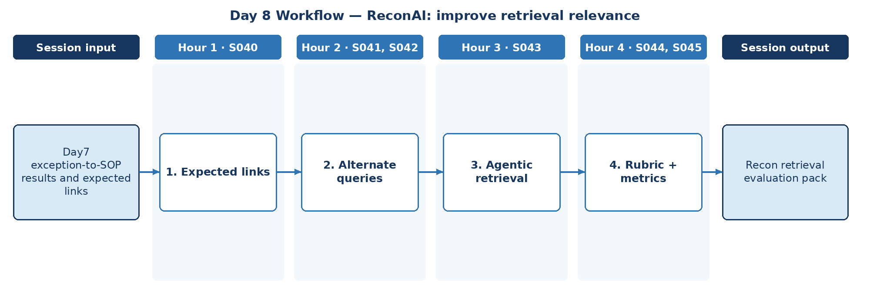

D. Steps to Perform the Work – and Why
Step | Hour · IDs | What to perform | Why this step is required | Expected output
1 | H1 · S040 | Create the expected exception-to-SOP links and a failure taxonomy. | Precision and recall can only be measured against agreed ground-truth links. | Expected-link set
2 | H2 · S041, S042 | Test hybrid and multi-query alternatives; note multimodal needs. | Analysts phrase exceptions differently; alternate queries improve recall. | Alternate-query results
3 | H3 · S043 | Test whether an agent choosing the source improves relevance. | Some exceptions are best explained by the exception catalogue, others by the SOP. | Agentic retrieval result
4 | H4 · S044, S045 | Apply rubric; report precision, recall and faithfulness; record best practices. | A rubric and metrics turn 'looks better' into measurable improvement. | Recon retrieval evaluation pack

E. Detailed Execution Instructions
Step 1 – Create the expected exception-to-SOP links and a failure taxonomy.
Hour / source IDs: Hour 1 · S040
How to perform: For every test exception record the one expected SOP section; classify Day 7 misses (wrong SOP, missing SOP, partial rule, stale version).
Why: Precision and recall can only be measured against agreed ground-truth links.
Output to retain: Expected-link set
Step 2 – Test hybrid and multi-query alternatives; note multimodal needs.
Hour / source IDs: Hour 2 · S041, S042
How to perform: Add keyword + vector hybrid search and 3 query rewrites per exception; compare hit rate against the Day 7 baseline on the same expected-link set; note any evidence needing multimodal handling.
Why: Analysts phrase exceptions differently; alternate queries improve recall.
Output to retain: Alternate-query results
Step 3 – Test whether an agent choosing the source improves relevance.
Hour / source IDs: Hour 3 · S043
How to perform: Let an agent choose between the exception catalogue and the SOP index before retrieving; log every routing decision and compare relevance with the non-agentic retriever.
Why: Some exceptions are best explained by the exception catalogue, others by the SOP.
Output to retain: Agentic retrieval result
Step 4 – Apply rubric; report precision, recall and faithfulness; record best practices.
Hour / source IDs: Hour 4 · S044, S045
How to perform: Score each variant with the rubric; report precision@3, recall and faithfulness in one table; list remaining failure cases and the best-practice rules adopted.
Why: A rubric and metrics turn 'looks better' into measurable improvement.
Output to retain: Recon retrieval evaluation pack

F. Session Input → Work → Output
Input | Work performed | Output
Day7 exception-to-SOP results and expected links | Expected links → Alternate queries → Agentic retrieval → Rubric + metrics | Recon retrieval evaluation pack

G. Validation / Exit Criteria
- The required output exists: Recon retrieval evaluation pack.
- Precision and recall are reported for each variant.
- Failure cases are listed, not hidden.
- Every step traces to its hourly block and source IDs (S040, S041, S042, S043, S044, S045); no TOC topic is skipped or re-worded.
- The workflow diagram matches the work actually performed.
- The human decision boundary is preserved wherever the session touches a consequential decision.
- Open gaps or assumptions (including tool or platform access) are recorded rather than silently filled.

H. Carry-Forward
Recon retrieval evaluation pack becomes an explicit input for Day 9 — ReconAI: exception analyst role (Day 9 input: Reconciliation rules and mismatch samples).

Day 9: Agent foundations – exception analyst role
Session duration | 4h = 1.25h concept + 2.75h lab (4 × 1-hour blocks)
Exact modules | Demystifying Agentic AI
Source IDs (primary) | S046, S047, S048, S049, S050, S051
Repeated source IDs (application) | S044, S045
Input | Reconciliation rules and mismatch samples
Guided implementation (workbook) | Specify autonomous versus deterministic responsibilities.
Primary output | Agent role and action policy
Human decision / governance | The deterministic matcher decides match status. ReconAI may investigate exceptions, link SOP evidence and draft non-authoritative narratives. Dispositions, adjustments, write-offs and ledger postings are made only by reconciliation analysts/reviewers, and every transition is audited.
Mapping ID / section locator | SOL-R09 | Day 09 / SOL-R09
Slide deck | Day09_SourceLocked_5W1H_Architecture.pptx
Code mapping / status | Reference app codebase + planned day-specific lab (not yet standalone)
Architecture / workflow (workbook) | Case intake → Suitability decision → Read-only agent

A. Exact TOC Topics for This Session (unchanged)
Source ID | Exact topic + subtopic
S046 | Demystifying Agentic AI | Understanding Agentic vs. Non-Agentic AI Systems
S047 | Overview of Autonomous Agents
S048 | Agents vs. Models
S049 | What is an LLM Agent — Role of LLMs in Autonomous Systems
S050 | When (and When Not) to Use Agents
S051 | Questions to Ask Before Considering an AI Agent

B. Hourly Session Break-up (from the workbook Hourly Plan)
Hour | Intention | Source IDs | Exact source words | Revisit IDs | ReconAI activity | Steps
Hour 1  (00:00–01:00) | Theory and 5W1H | S046 | Demystifying Agentic AI | Understanding Agentic vs. Non-Agentic AI Systems | — | ReconAI: exception analyst role | 1
Hour 2  (01:00–02:00) | Instructor demonstration | S047, S048 | Overview of Autonomous Agents  Agents vs. Models | — | ReconAI: exception analyst role | 2
Hour 3  (02:00–03:00) | Guided BankAssist implementation | S049 | What is an LLM Agent — Role of LLMs in Autonomous Systems | — | ReconAI: exception analyst role | 3
Hour 4  (03:00–04:00) | ReconAI assignment launch and evidence | S050, S051 | When (and When Not) to Use Agents  Questions to Ask Before Considering an AI Agent | — | Specify autonomous versus deterministic responsibilities. | 4

C. Workflow Diagram for This Session
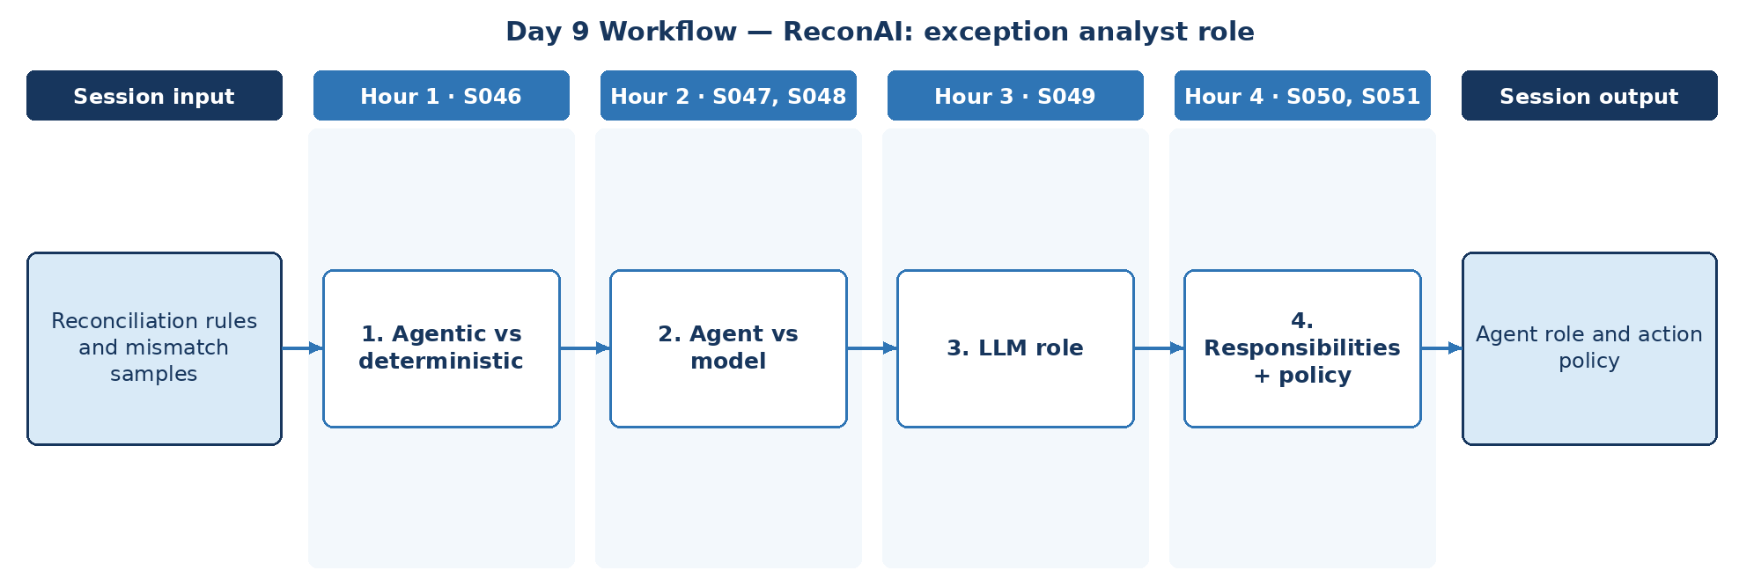

D. Steps to Perform the Work – and Why
Step | Hour · IDs | What to perform | Why this step is required | Expected output
1 | H1 · S046 | Compare agentic and non-agentic designs for exception handling. | Reconciliation is a financial control; autonomy is acceptable only where it cannot change outcomes. | Design comparison
2 | H2 · S047, S048 | Identify agent components versus model for the exception analyst. | Knowing which component is the model and which is the agent defines what each test targets. | Component list
3 | H3 · S049 | Define the LLM role in the analyst agent. | Keeps match status and dispositions with deterministic code and human reviewers. | LLM role
4 | H4 · S050, S051 | Specify autonomous vs deterministic responsibilities and the action policy using the pre-agent checklist. | An explicit action policy prevents the agent from changing ledger or exception state. | Agent role and action policy

E. Detailed Execution Instructions
Step 1 – Compare agentic and non-agentic designs for exception handling.
Hour / source IDs: Hour 1 · S046
How to perform: Draw exception handling as a fixed workflow and as an agent loop; mark every decision point and tool call; note which decisions carry financial-control risk.
Why: Reconciliation is a financial control; autonomy is acceptable only where it cannot change outcomes.
Output to retain: Design comparison
Step 2 – Identify agent components versus model for the exception analyst.
Hour / source IDs: Hour 2 · S047, S048
How to perform: Label the loop, tools, memory and model on the exception-analyst flow; state which component each test will target.
Why: Knowing which component is the model and which is the agent defines what each test targets.
Output to retain: Component list
Step 3 – Define the LLM role in the analyst agent.
Hour / source IDs: Hour 3 · S049
How to perform: State that the LLM gathers evidence and drafts narratives; it never sets match status, disposition or adjustments.
Why: Keeps match status and dispositions with deterministic code and human reviewers.
Output to retain: LLM role
Step 4 – Specify autonomous vs deterministic responsibilities and the action policy using the pre-agent checklist.
Hour / source IDs: Hour 4 · S050, S051
How to perform: Answer the pre-agent question checklist; fill the action policy: allowed (read matcher, read SOP, draft narrative) and denied (mark matched, post adjustment, close exception).
Why: An explicit action policy prevents the agent from changing ledger or exception state.
Output to retain: Agent role and action policy

F. Session Input → Work → Output
Input | Work performed | Output
Reconciliation rules and mismatch samples | Agentic vs deterministic → Agent vs model → LLM role → Responsibilities + policy | Agent role and action policy

G. Validation / Exit Criteria
- The required output exists: Agent role and action policy.
- The action policy denies every write action.
- Checklist answers justify the agent's scope.
- Every step traces to its hourly block and source IDs (S046, S047, S048, S049, S050, S051); no TOC topic is skipped or re-worded.
- The workflow diagram matches the work actually performed.
- The human decision boundary is preserved wherever the session touches a consequential decision.
- Open gaps or assumptions (including tool or platform access) are recorded rather than silently filled.

H. Carry-Forward
Agent role and action policy becomes an explicit input for Day 10 — ReconAI: deterministic matcher plus agent (Day 10 input: Ledger, SOP retrieval and tool contracts).

Day 10: Agent runtime – deterministic matcher plus agent
Session duration | 4h = 1.25h concept + 2.75h lab (4 × 1-hour blocks)
Exact modules | Demystifying Agentic AI | Context, Harness & Loop Engineering
Source IDs (primary) | S052, S053, S054, S055, S056, S057, S058
Repeated source IDs (application) | S046, S047, S048, S049, S050, S051
Input | Ledger, SOP retrieval and tool contracts
Guided implementation (workbook) | Combine matcher result with agent evidence lookup; constrain tool scopes.
Primary output | Controlled exception investigation trace
Human decision / governance | The deterministic matcher decides match status. ReconAI may investigate exceptions, link SOP evidence and draft non-authoritative narratives. Dispositions, adjustments, write-offs and ledger postings are made only by reconciliation analysts/reviewers, and every transition is audited.
Mapping ID / section locator | SOL-R10 | Day 10 / SOL-R10
Slide deck | Day10_SourceLocked_5W1H_Architecture.pptx
Code mapping / status | Reference app codebase + planned day-specific lab (not yet standalone)
Architecture / workflow (workbook) | Perceive → Plan → Allowed tool → Observe → Stop

A. Exact TOC Topics for This Session (unchanged)
Source ID | Exact topic + subtopic
S052 | ReAct Framework — Concept of Thought, Action, Input and Observation
S053 | Language-Action Agents
S054 | Agent Runtime — Orchestration Layer
S055 | Tools — Function Calling / Extensions
S056 | Context, Harness & Loop Engineering | *Context Engineering vs Prompt Engineering — what's the difference*
S057 | *Context Window Management (system/developer/user context layering)*
S058 | *Long-context Windows vs RAG — when to use which*

B. Hourly Session Break-up (from the workbook Hourly Plan)
Hour | Intention | Source IDs | Exact source words | Revisit IDs | ReconAI activity | Steps
Hour 1  (00:00–01:00) | Theory and 5W1H | S052 | ReAct Framework — Concept of Thought, Action, Input and Observation | — | ReconAI: deterministic matcher plus agent | 1
Hour 2  (01:00–02:00) | Instructor demonstration | S053, S054 | Language-Action Agents  Agent Runtime — Orchestration Layer | — | ReconAI: deterministic matcher plus agent | 2
Hour 3  (02:00–03:00) | Guided BankAssist implementation | S055, S056 | Tools — Function Calling / Extensions  Context, Harness & Loop Engineering | *Context Engineering vs Prompt Engineering — what's the difference* | — | ReconAI: deterministic matcher plus agent | 3
Hour 4  (03:00–04:00) | ReconAI assignment launch and evidence | S057, S058 | *Context Window Management (system/developer/user context layering)*  *Long-context Windows vs RAG — when to use which* | — | Combine matcher result with agent evidence lookup; constrain tool scopes. | 4

C. Workflow Diagram for This Session
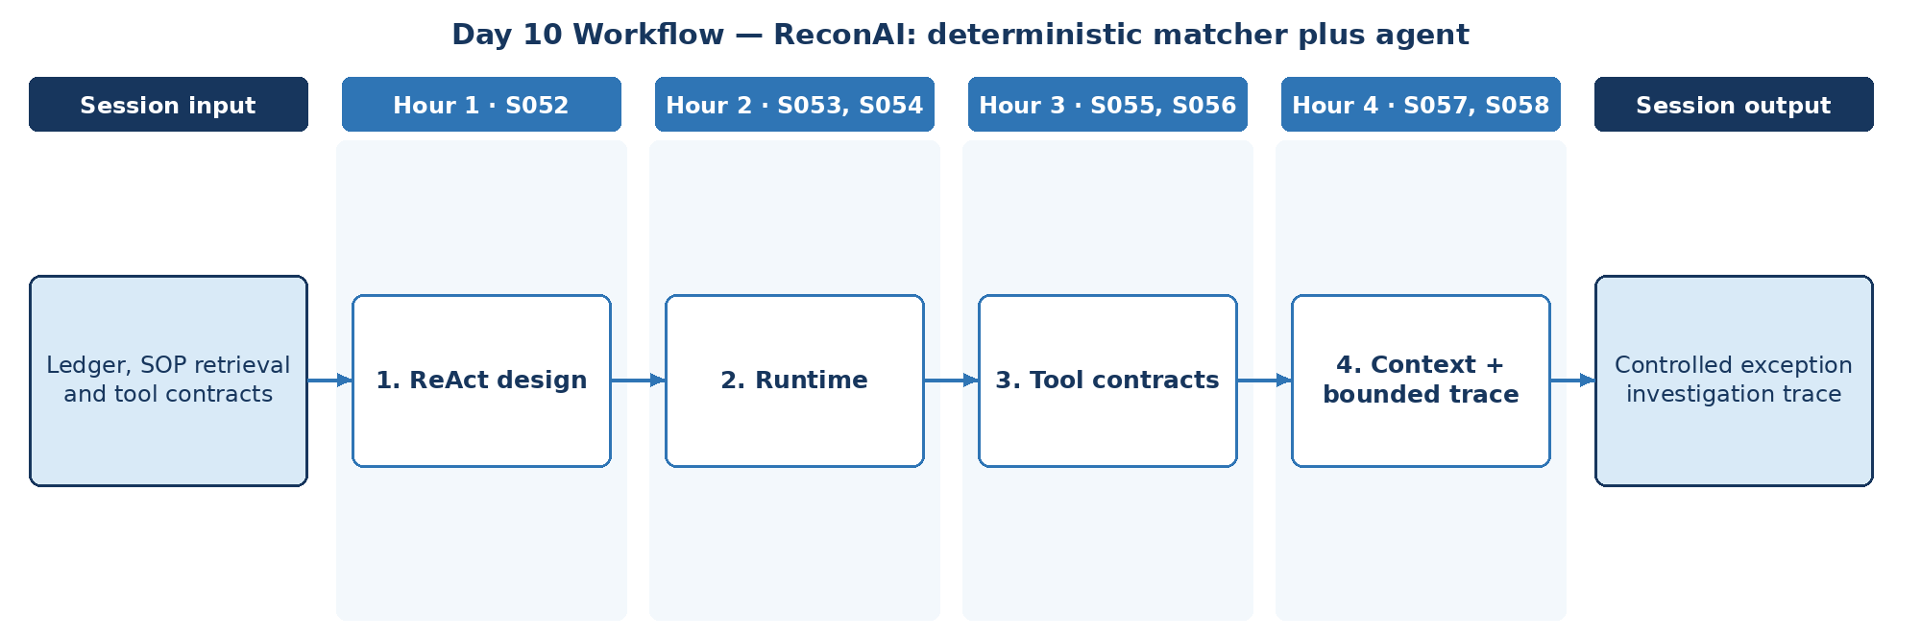

D. Steps to Perform the Work – and Why
Step | Hour · IDs | What to perform | Why this step is required | Expected output
1 | H1 · S052 | Design the ReAct loop for exception investigation. | Thought/action/observation turns make every evidence-gathering step traceable. | Loop design
2 | H2 · S053, S054 | Implement the runtime dispatching allowed tools. | Scope is enforced by code in the runtime, not by instructions to the model. | Runtime
3 | H3 · S055, S056 | Define function-calling contracts for matcher and SOP tools; contrast context vs prompt engineering. | Typed tool contracts stop malformed or out-of-scope calls to the matcher and SOP search. | Tool contracts
4 | H4 · S057, S058 | Apply context layering, choose long-context vs RAG, bound steps, and combine matcher result with agent evidence lookup. | Layered context and a step limit keep each investigation focused, cheap and bounded. | Controlled exception investigation trace

E. Detailed Execution Instructions
Step 1 – Design the ReAct loop for exception investigation.
Hour / source IDs: Hour 1 · S052
How to perform: Define Thought / Action / Action Input / Observation for 'investigate exception'; list allowed actions and the stop condition.
Why: Thought/action/observation turns make every evidence-gathering step traceable.
Output to retain: Loop design
Step 2 – Implement the runtime dispatching allowed tools.
Hour / source IDs: Hour 2 · S053, S054
How to perform: Implement a dispatcher that executes only allow-listed tools, enforces timeouts and converts errors into observations.
Why: Scope is enforced by code in the runtime, not by instructions to the model.
Output to retain: Runtime
Step 3 – Define function-calling contracts for matcher and SOP tools; contrast context vs prompt engineering.
Hour / source IDs: Hour 3 · S055, S056
How to perform: Write a JSON schema for get_match_result and search_sop; reject invalid arguments; list which context items enter each turn.
Why: Typed tool contracts stop malformed or out-of-scope calls to the matcher and SOP search.
Output to retain: Tool contracts
Step 4 – Apply context layering, choose long-context vs RAG, bound steps, and combine matcher result with agent evidence lookup.
Hour / source IDs: Hour 4 · S057, S058
How to perform: Layer system → developer → exception evidence → tool results; use RAG for SOPs rather than full-document context; set max_steps=5; save one trace per exception.
Why: Layered context and a step limit keep each investigation focused, cheap and bounded.
Output to retain: Controlled exception investigation trace

F. Session Input → Work → Output
Input | Work performed | Output
Ledger, SOP retrieval and tool contracts | ReAct design → Runtime → Tool contracts → Context + bounded trace | Controlled exception investigation trace

G. Validation / Exit Criteria
- The required output exists: Controlled exception investigation trace.
- Traces show only allow-listed tools.
- Investigations stop within the step limit.
- Every step traces to its hourly block and source IDs (S052, S053, S054, S055, S056, S057, S058); no TOC topic is skipped or re-worded.
- The workflow diagram matches the work actually performed.
- The human decision boundary is preserved wherever the session touches a consequential decision.
- Open gaps or assumptions (including tool or platform access) are recorded rather than silently filled.

H. Carry-Forward
Controlled exception investigation trace becomes an explicit input for Day 11 — ReconAI: reviewer-controlled disposition (Day 11 input: Agent investigation and exception record).

Day 11: Harness + HITL – reviewer-controlled disposition
Session duration | 4h = 1.25h concept + 2.75h lab (4 × 1-hour blocks)
Exact modules | Context, Harness & Loop Engineering
Source IDs (primary) | S059, S060, S061, S062, S063, S064, S065, S066
Repeated source IDs (application) | S052, S053, S054, S055, S056, S057, S058
Input | Agent investigation and exception record
Guided implementation (workbook) | Implement approve/reject/rework state model with audit events.
Primary output | Reviewer state transitions and evidence log
Human decision / governance | The deterministic matcher decides match status. ReconAI may investigate exceptions, link SOP evidence and draft non-authoritative narratives. Dispositions, adjustments, write-offs and ledger postings are made only by reconciliation analysts/reviewers, and every transition is audited.
Mapping ID / section locator | SOL-R11 | Day 11 / SOL-R11
Slide deck | Day11_SourceLocked_5W1H_Architecture.pptx
Code mapping / status | Reference app codebase + planned day-specific lab (not yet standalone)
Architecture / workflow (workbook) | Supervisor → Harness → Tools → Approval gate → Audit

A. Exact TOC Topics for This Session (unchanged)
Source ID | Exact topic + subtopic
S059 | *Context Compaction & Summarization Strategies*
S060 | *What is an Agent Harness — tools, memory, guardrails, execution environment*
S061 | *Building a Custom Harness vs Using a Framework (LangChain/LangGraph)*
S062 | *Sandboxing & Permission Boundaries in Harnesses*
S063 | *The Agent Loop — Perceive → Plan → Act → Observe*
S064 | *ReAct Loop vs Plan-and-Execute Loop*
S065 | *Loop Termination Conditions & Infinite-Loop Prevention*
S066 | *Human-in-the-Loop Checkpoints Inside the Loop*

B. Hourly Session Break-up (from the workbook Hourly Plan)
Hour | Intention | Source IDs | Exact source words | Revisit IDs | ReconAI activity | Steps
Hour 1  (00:00–01:00) | Theory and 5W1H | S059, S060 | *Context Compaction & Summarization Strategies*  *What is an Agent Harness — tools, memory, guardrails, execution environment* | — | ReconAI: reviewer-controlled disposition | 1
Hour 2  (01:00–02:00) | Instructor demonstration | S061, S062 | *Building a Custom Harness vs Using a Framework (LangChain/LangGraph)*  *Sandboxing & Permission Boundaries in Harnesses* | — | ReconAI: reviewer-controlled disposition | 2
Hour 3  (02:00–03:00) | Guided BankAssist implementation | S063, S064 | *The Agent Loop — Perceive → Plan → Act → Observe*  *ReAct Loop vs Plan-and-Execute Loop* | — | ReconAI: reviewer-controlled disposition | 3
Hour 4  (03:00–04:00) | ReconAI assignment launch and evidence | S065, S066 | *Loop Termination Conditions & Infinite-Loop Prevention*  *Human-in-the-Loop Checkpoints Inside the Loop* | — | Implement approve/reject/rework state model with audit events. | 4

C. Workflow Diagram for This Session
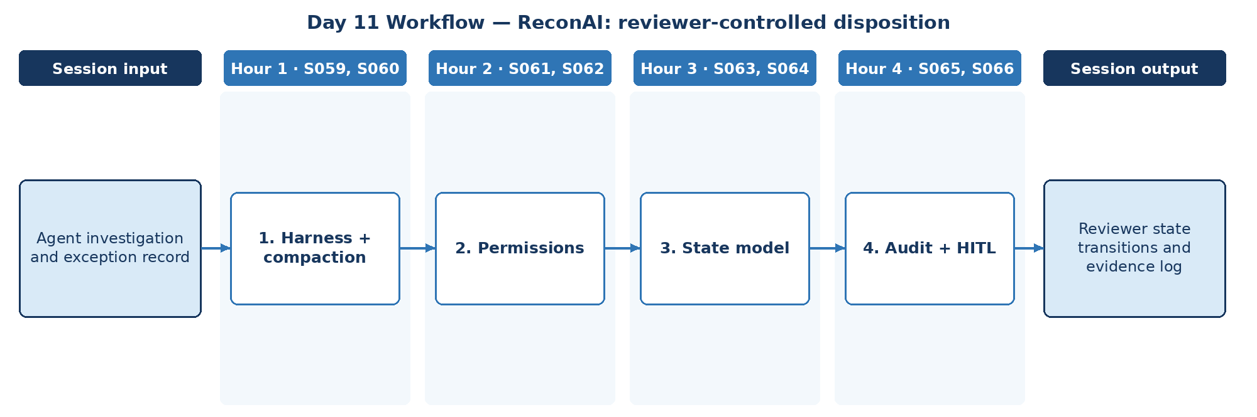

D. Steps to Perform the Work – and Why
Step | Hour · IDs | What to perform | Why this step is required | Expected output
1 | H1 · S059, S060 | Define the harness and compaction for long exception histories. | The harness is where governance is enforced; compaction keeps long histories usable. | Harness outline
2 | H2 · S061, S062 | Set sandbox and permission boundaries for analyst and reviewer roles. | Separation of duties between analyst, reviewer and agent is a reconciliation control requirement. | Permission matrix
3 | H3 · S063, S064 | Implement approve/reject/rework states within the loop. | Every exception needs a recorded disposition. | Reviewer state model
4 | H4 · S065, S066 | Add termination rules, human checkpoints and audit events. | Every disposition must be attributable to a person and reconstructable for audit. | Reviewer state transitions + evidence log

E. Detailed Execution Instructions
Step 1 – Define the harness and compaction for long exception histories.
Hour / source IDs: Hour 1 · S059, S060
How to perform: Diagram tools, memory, guardrails and runtime; summarise older investigation turns while keeping amounts, dates and IDs verbatim.
Why: The harness is where governance is enforced; compaction keeps long histories usable.
Output to retain: Harness outline
Step 2 – Set sandbox and permission boundaries for analyst and reviewer roles.
Hour / source IDs: Hour 2 · S061, S062
How to perform: Build a role × action matrix for analyst, reviewer and agent; enforce it in code; test that the agent cannot call a reviewer action.
Why: Separation of duties between analyst, reviewer and agent is a reconciliation control requirement.
Output to retain: Permission matrix
Step 3 – Implement approve/reject/rework states within the loop.
Hour / source IDs: Hour 3 · S063, S064
How to perform: Implement states open → investigated → pending_review → approved / rejected / rework; allow only listed transitions.
Why: Every exception needs a recorded disposition.
Output to retain: Reviewer state model
Step 4 – Add termination rules, human checkpoints and audit events.
Hour / source IDs: Hour 4 · S065, S066
How to perform: Write an audit event for every transition (actor, timestamp, from, to, reason, evidence_refs); stop the loop on max steps or repeated actions and hand off to a reviewer.
Why: Every disposition must be attributable to a person and reconstructable for audit.
Output to retain: Reviewer state transitions + evidence log

F. Session Input → Work → Output
Input | Work performed | Output
Agent investigation and exception record | Harness + compaction → Permissions → State model → Audit + HITL | Reviewer state transitions and evidence log

G. Validation / Exit Criteria
- The required output exists: Reviewer state transitions and evidence log.
- No transition to 'approved' occurs without a reviewer identity.
- Audit log records every transition.
- Every step traces to its hourly block and source IDs (S059, S060, S061, S062, S063, S064, S065, S066); no TOC topic is skipped or re-worded.
- The workflow diagram matches the work actually performed.
- The human decision boundary is preserved wherever the session touches a consequential decision.
- Open gaps or assumptions (including tool or platform access) are recorded rather than silently filled.

H. Carry-Forward
Reviewer state transitions and evidence log becomes an explicit input for Day 12 — ReconAI: graph-based reconciliation team (Day 12 input: Recon matcher and human review transition).

Day 12: LangGraph – graph-based reconciliation team
Session duration | 4h = 1.25h concept + 2.75h lab (4 × 1-hour blocks)
Exact modules | LangGraph/CrewAI/AutoGen – Advanced AI Agents
Source IDs (primary) | S067, S068, S069, S070, S071
Repeated source IDs (application) | S060, S061, S062, S063, S064, S065, S066
Input | Recon matcher and human review transition
Guided implementation (workbook) | Design ingest/match/explain/review node/edge graph.
Primary output | Recon graph and sample execution trace
Human decision / governance | The deterministic matcher decides match status. ReconAI may investigate exceptions, link SOP evidence and draft non-authoritative narratives. Dispositions, adjustments, write-offs and ledger postings are made only by reconciliation analysts/reviewers, and every transition is audited.
Mapping ID / section locator | SOL-R12 | Day 12 / SOL-R12
Slide deck | Day12_SourceLocked_5W1H_Architecture.pptx
Code mapping / status | Reference app codebase + planned day-specific lab (not yet standalone)
Architecture / workflow (workbook) | Graph START → Triage → Transaction → Policy → Review

A. Exact TOC Topics for This Session (unchanged)
Source ID | Exact topic + subtopic
S067 | LangGraph/CrewAI/AutoGen – Advanced AI Agents | Introduction to LangGraph, CrewAI, and AutoGen
S068 | Key Components of LangGraph (Nodes, Edges, States)
S069 | LangGraph/AutoGen for Autonomous LLM Applications
S070 | Real-Time Data Processing with LangGraph
S071 | Building Stateful AI Systems

B. Hourly Session Break-up (from the workbook Hourly Plan)
Hour | Intention | Source IDs | Exact source words | Revisit IDs | ReconAI activity | Steps
Hour 1  (00:00–01:00) | Theory and 5W1H | S067 | LangGraph/CrewAI/AutoGen – Advanced AI Agents | Introduction to LangGraph, CrewAI, and AutoGen | — | ReconAI: graph-based reconciliation team | 1
Hour 2  (01:00–02:00) | Instructor demonstration | S068 | Key Components of LangGraph (Nodes, Edges, States) | — | ReconAI: graph-based reconciliation team | 2
Hour 3  (02:00–03:00) | Guided BankAssist implementation | S069 | LangGraph/AutoGen for Autonomous LLM Applications | — | ReconAI: graph-based reconciliation team | 3
Hour 4  (03:00–04:00) | ReconAI assignment launch and evidence | S070, S071 | Real-Time Data Processing with LangGraph  Building Stateful AI Systems | — | Design ingest/match/explain/review node/edge graph. | 4

C. Workflow Diagram for This Session
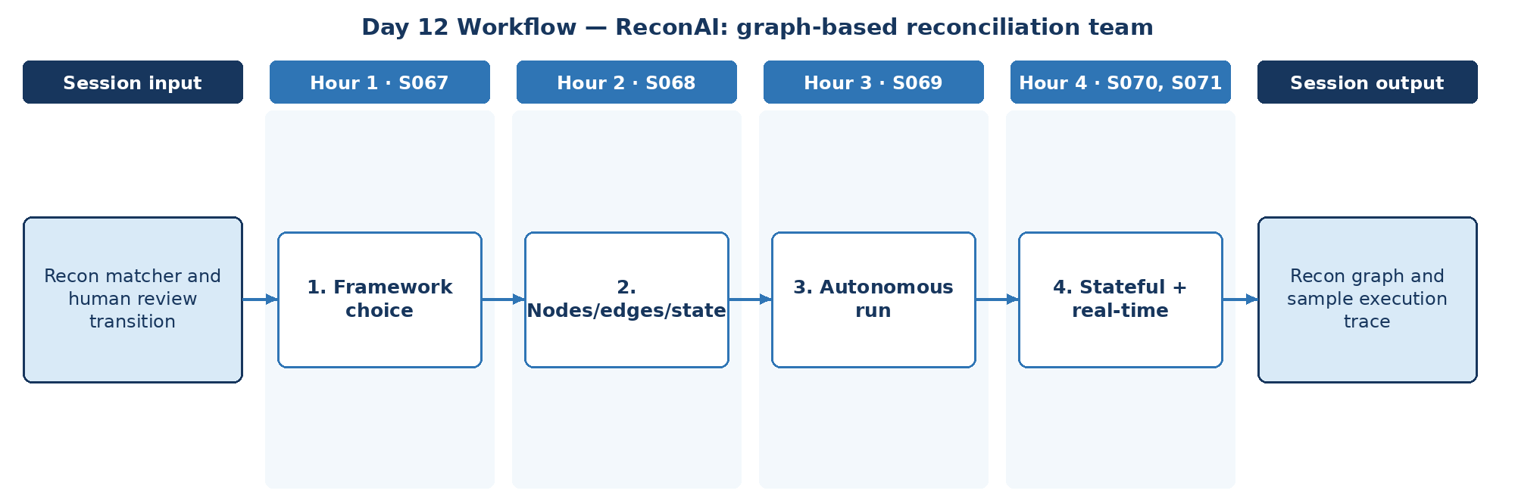

D. Steps to Perform the Work – and Why
Step | Hour · IDs | What to perform | Why this step is required | Expected output
1 | H1 · S067 | Choose LangGraph/CrewAI/AutoGen for the reconciliation team. | The framework choice affects how well state and audit events can be controlled. | Framework choice
2 | H2 · S068 | Design ingest/match/explain/review nodes, edges and state. | Explicit nodes and edges make the reconciliation flow visible and testable. | Recon graph
3 | H3 · S069 | Run the graph on the exception batch. | A full-batch run proves the graph works end to end, not just on single cases. | Execution trace
4 | H4 · S070, S071 | Persist state and handle new settlement files arriving. | Settlement files arrive continuously; the graph must resume and pick up new batches. | Recon graph + sample execution trace

E. Detailed Execution Instructions
Step 1 – Choose LangGraph/CrewAI/AutoGen for the reconciliation team.
Hour / source IDs: Hour 1 · S067
How to perform: Score LangGraph, CrewAI and AutoGen on state control, HITL support and audit logging; record the decision.
Why: The framework choice affects how well state and audit events can be controlled.
Output to retain: Framework choice
Step 2 – Design ingest/match/explain/review nodes, edges and state.
Hour / source IDs: Hour 2 · S068
How to perform: Define state fields (batch_id, exception, match_result, evidence, narrative, disposition); add ingest, match, explain and review nodes with a conditional edge to review.
Why: Explicit nodes and edges make the reconciliation flow visible and testable.
Output to retain: Recon graph
Step 3 – Run the graph on the exception batch.
Hour / source IDs: Hour 3 · S069
How to perform: Run the graph on the full Day 1 exception batch; save node-by-node traces; count exceptions reaching review.
Why: A full-batch run proves the graph works end to end, not just on single cases.
Output to retain: Execution trace
Step 4 – Persist state and handle new settlement files arriving.
Hour / source IDs: Hour 4 · S070, S071
How to perform: Add a checkpointer; restart mid-batch and confirm resume; simulate a new settlement file arriving and document how the graph picks it up.
Why: Settlement files arrive continuously; the graph must resume and pick up new batches.
Output to retain: Recon graph + sample execution trace

F. Session Input → Work → Output
Input | Work performed | Output
Recon matcher and human review transition | Framework choice → Nodes/edges/state → Autonomous run → Stateful + real-time | Recon graph and sample execution trace

G. Validation / Exit Criteria
- The required output exists: Recon graph and sample execution trace.
- The graph resumes from persisted state.
- Review node is mandatory before closure.
- Every step traces to its hourly block and source IDs (S067, S068, S069, S070, S071); no TOC topic is skipped or re-worded.
- The workflow diagram matches the work actually performed.
- The human decision boundary is preserved wherever the session touches a consequential decision.
- Open gaps or assumptions (including tool or platform access) are recorded rather than silently filled.

H. Carry-Forward
Recon graph and sample execution trace becomes an explicit input for Day 13 — ReconAI: event and tool integration outline (Day 13 input: Recon graph plus reconciliation event sample).

Day 13: Graph + Protocol intro – event and tool integration outline
Session duration | 4h = 1.25h concept + 2.75h lab (4 × 1-hour blocks)
Exact modules | LangGraph/CrewAI/AutoGen – Advanced AI Agents | Architecting Agentic Systems – MCP & A2A Protocols | Applied Data Processing — Batch Fundamentals & Streaming Fundamentals
Source IDs (primary) | S072, S073, S074, S075, S076, S077, S078
Repeated source IDs (application) | S067, S068, S069, S070, S071
Input | Recon graph plus reconciliation event sample
Guided implementation (workbook) | Draft streaming exception notification and MCP/A2A integration boundary.
Primary output | Boundary diagram and message examples
Human decision / governance | The deterministic matcher decides match status. ReconAI may investigate exceptions, link SOP evidence and draft non-authoritative narratives. Dispositions, adjustments, write-offs and ledger postings are made only by reconciliation analysts/reviewers, and every transition is audited.
Mapping ID / section locator | SOL-R13 | Day 13 / SOL-R13
Slide deck | Day13_SourceLocked_5W1H_Architecture.pptx
Code mapping / status | Runnable local source code is provided in the ZIP and mapped in the master workbook. See source path in the applied-module section below.
Architecture / workflow (workbook) | LangGraph → MCP client → Banking tools; A2A → Agents

A. Exact TOC Topics for This Session (unchanged)
Source ID | Exact topic + subtopic
S072 | Advanced Orchestration Techniques
S073 | Building Multi-Actor Applications
S074 | Cycles and Branching; Memory/Persistence; Human in the Loop (HITL); Streaming
S075 | Guidelines and Best Practices
S076 | Architecting Agentic Systems – MCP & A2A Protocols | Principles of Agentic AI Application Design (Architecture level)
S077 | MCP (Model Context Protocol) — MCP Server / Host / Client
S078 | A2A (Agent-to-Agent Protocol)

B. Hourly Session Break-up (from the workbook Hourly Plan)
Hour | Intention | Source IDs | Exact source words | Revisit IDs | ReconAI activity | Steps
Hour 1  (00:00–01:00) | Theory and 5W1H | S072 | Advanced Orchestration Techniques | — | ReconAI: event and tool integration outline | 1
Hour 2  (01:00–02:00) | Instructor demonstration | S073, S074 | Building Multi-Actor Applications  Cycles and Branching; Memory/Persistence; Human in the Loop (HITL); Streaming | — | ReconAI: event and tool integration outline | 2
Hour 3  (02:00–03:00) | Guided BankAssist implementation | S075, S076 | Guidelines and Best Practices  Architecting Agentic Systems – MCP & A2A Protocols | Principles of Agentic AI Application Design (Architecture level) | — | ReconAI: event and tool integration outline | 3
Hour 4  (03:00–04:00) | ReconAI assignment launch and evidence | S077, S078 | MCP (Model Context Protocol) — MCP Server / Host / Client  A2A (Agent-to-Agent Protocol) | — | Draft streaming exception notification and MCP/A2A integration boundary. | 4

C. Workflow Diagram for This Session
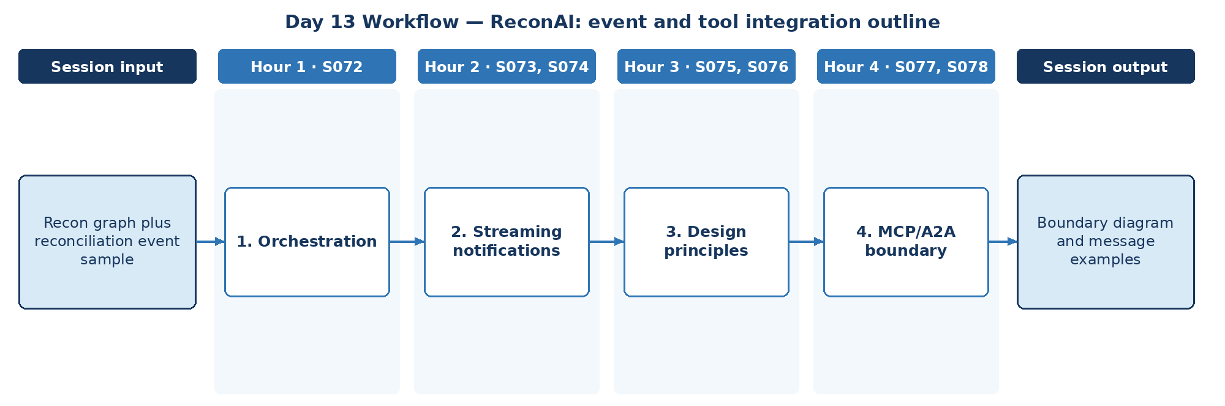

D. Steps to Perform the Work – and Why
Step | Hour · IDs | What to perform | Why this step is required | Expected output
1 | H1 · S072 | Plan orchestration for ingest, matcher, exception and reviewer actors. | Clear actor responsibilities prevent overlapping work and unclear ownership. | Actor plan
2 | H2 · S073, S074 | Draft streaming exception notifications with cycles and HITL. | Reviewers need timely alerts on new or ageing exceptions. | Notification design
3 | H3 · S075, S076 | Apply best practices and architecture principles. | Architecture principles keep protocol boundaries safe as the design grows. | Principles list
4 | H4 · S077, S078 | Draft the MCP tool boundary and A2A messages. | Separates tool access from agent collaboration. | Boundary diagram + message examples

E. Detailed Execution Instructions
Step 1 – Plan orchestration for ingest, matcher, exception and reviewer actors.
Hour / source IDs: Hour 1 · S072
How to perform: Define goals, tools and handoff triggers for ingest, matcher, exception and reviewer actors.
Why: Clear actor responsibilities prevent overlapping work and unclear ownership.
Output to retain: Actor plan
Step 2 – Draft streaming exception notifications with cycles and HITL.
Hour / source IDs: Hour 2 · S073, S074
How to perform: Design an exception-created event payload (exception_id, type, amount band, correlation_id); show where rework cycles and human interrupts occur.
Why: Reviewers need timely alerts on new or ageing exceptions.
Output to retain: Notification design
Step 3 – Apply best practices and architecture principles.
Hour / source IDs: Hour 3 · S075, S076
How to perform: Apply least privilege, explicit state, bounded loops and human authority to each boundary.
Why: Architecture principles keep protocol boundaries safe as the design grows.
Output to retain: Principles list
Step 4 – Draft the MCP tool boundary and A2A messages.
Hour / source IDs: Hour 4 · S077, S078
How to perform: Place matcher and SOP search behind an MCP server; write one A2A task message from the exception agent to the reviewer agent with correlation_id.
Why: Separates tool access from agent collaboration.
Output to retain: Boundary diagram + message examples

F. Session Input → Work → Output
Input | Work performed | Output
Recon graph plus reconciliation event sample | Orchestration → Streaming notifications → Design principles → MCP/A2A boundary | Boundary diagram and message examples

G. Validation / Exit Criteria
- The required output exists: Boundary diagram and message examples.
- Boundary diagram separates MCP and A2A.
- Message examples include correlation IDs.
- Every step traces to its hourly block and source IDs (S072, S073, S074, S075, S076, S077, S078); no TOC topic is skipped or re-worded.
- The workflow diagram matches the work actually performed.
- The human decision boundary is preserved wherever the session touches a consequential decision.
- Open gaps or assumptions (including tool or platform access) are recorded rather than silently filled.

H. Carry-Forward
Boundary diagram and message examples becomes an explicit input for Day 14 — ReconAI: specialist-agent interaction (Day 14 input: Ingest/matcher/exception/reviewer roles and audit constraints).

Day 14: Architecting + Gemini intro – specialist-agent interaction
Session duration | 4h = 1.25h concept + 2.75h lab (4 × 1-hour blocks)
Exact modules | Architecting Agentic Systems – MCP & A2A Protocols | Gemini Enterprise Agent Development | Cloud Batch & Event-Streaming Architecture — Pub/Sub, Dataflow/Apache Beam & BigQuery
Source IDs (primary) | S079, S080, S081, S082, S083, S084, S085, S086
Repeated source IDs (application) | S076, S077, S078
Input | Ingest/matcher/exception/reviewer roles and audit constraints
Guided implementation (workbook) | Specify coordination, escalation and adaptive threshold policies.
Primary output | Recon agent design and approval checklist
Human decision / governance | The deterministic matcher decides match status. ReconAI may investigate exceptions, link SOP evidence and draft non-authoritative narratives. Dispositions, adjustments, write-offs and ledger postings are made only by reconciliation analysts/reviewers, and every transition is audited.
Mapping ID / section locator | SOL-R14 | Day 14 / SOL-R14
Slide deck | Day14_SourceLocked_5W1H_Architecture.pptx
Code mapping / status | Runnable local source code is provided in the ZIP and mapped in the master workbook. See source path in the applied-module section below.
Architecture / workflow (workbook) | A2A coordinator → Specialist agents → Reviewer → Case outcome

A. Exact TOC Topics for This Session (unchanged)
Source ID | Exact topic + subtopic
S079 | Multi-Agent Coordination Strategies
S080 | Architecting AI Workflows with Autonomous Agents
S081 | Designing Human-in-the-Loop Agentic Systems
S082 | Adaptive Agents for Dynamic Environments
S083 | Evaluating and Deploying Agents — LLMs as Judge
S084 | Ethical & Regulatory Considerations in AI Agents
S085 | Guidelines and Best Practices
S086 | Gemini Enterprise Agent Development | *Use Agents to Build Agents*

B. Hourly Session Break-up (from the workbook Hourly Plan)
Hour | Intention | Source IDs | Exact source words | Revisit IDs | ReconAI activity | Steps
Hour 1  (00:00–01:00) | Theory and 5W1H | S079, S080 | Multi-Agent Coordination Strategies  Architecting AI Workflows with Autonomous Agents | — | ReconAI: specialist-agent interaction | 1
Hour 2  (01:00–02:00) | Instructor demonstration | S081, S082 | Designing Human-in-the-Loop Agentic Systems  Adaptive Agents for Dynamic Environments | — | ReconAI: specialist-agent interaction | 2
Hour 3  (02:00–03:00) | Guided BankAssist implementation | S083, S084 | Evaluating and Deploying Agents — LLMs as Judge  Ethical & Regulatory Considerations in AI Agents | — | ReconAI: specialist-agent interaction | 3
Hour 4  (03:00–04:00) | ReconAI assignment launch and evidence | S085, S086 | Guidelines and Best Practices  Gemini Enterprise Agent Development | *Use Agents to Build Agents* | — | Specify coordination, escalation and adaptive threshold policies. | 4

C. Workflow Diagram for This Session
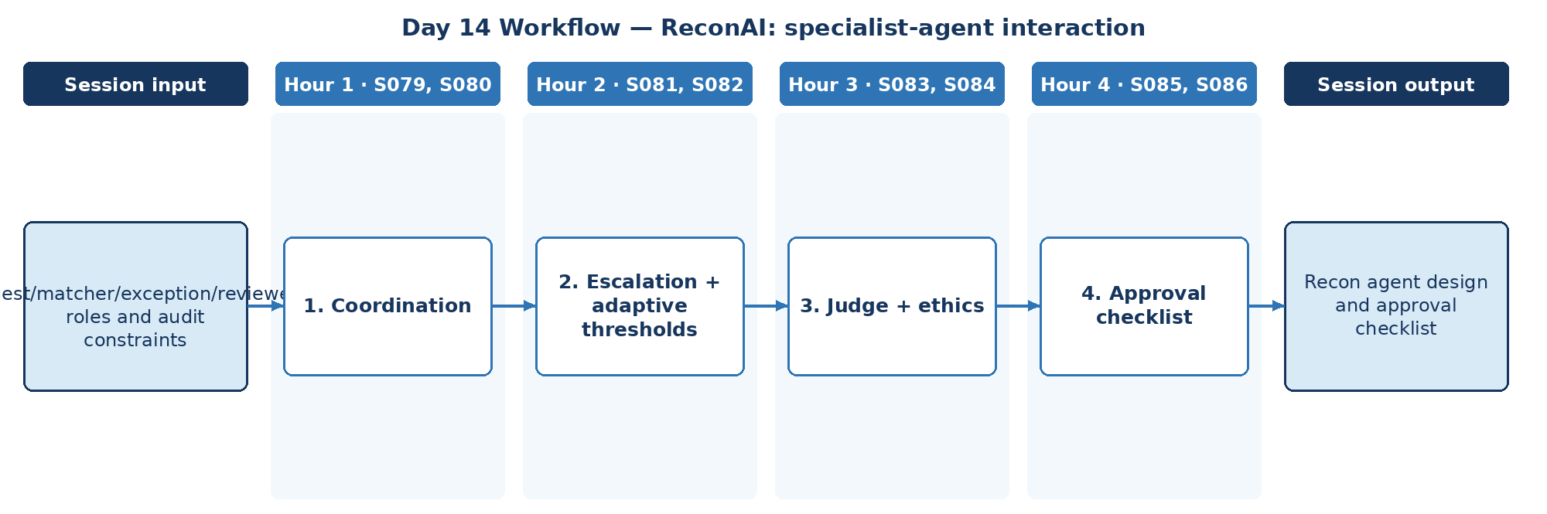

D. Steps to Perform the Work – and Why
Step | Hour · IDs | What to perform | Why this step is required | Expected output
1 | H1 · S079, S080 | Specify coordination among ingest, matcher, exception and reviewer roles. | Clear coordination avoids duplicate investigation and conflicting exception states. | Coordination spec
2 | H2 · S081, S082 | Define escalation and adaptive threshold policies. | Thresholds must adapt to volume without silently weakening the control. | Threshold policy
3 | H3 · S083, S084 | Define LLM-as-judge checks and regulatory considerations. | Narrative quality and neutrality must be measured, and regulated records need review. | Judge rubric
4 | H4 · S085, S086 | Apply best practices; note Gemini agent-building assumptions; finalise design. | A checklist makes the design reviewable and approvable by control owners. | Recon agent design + approval checklist

E. Detailed Execution Instructions
Step 1 – Specify coordination among ingest, matcher, exception and reviewer roles.
Hour / source IDs: Hour 1 · S079, S080
How to perform: Choose supervisor or sequential coordination; document message order and who owns each exception state.
Why: Clear coordination avoids duplicate investigation and conflicting exception states.
Output to retain: Coordination spec
Step 2 – Define escalation and adaptive threshold policies.
Hour / source IDs: Hour 2 · S081, S082
How to perform: Define escalation triggers (amount above threshold, repeated exception, ageing); allow threshold changes only with named approval and audit.
Why: Thresholds must adapt to volume without silently weakening the control.
Output to retain: Threshold policy
Step 3 – Define LLM-as-judge checks and regulatory considerations.
Hour / source IDs: Hour 3 · S083, S084
How to perform: Write a judge rubric for narrative accuracy and neutrality; calibrate on 10 human-scored samples; list regulatory considerations (audit, record retention).
Why: Narrative quality and neutrality must be measured, and regulated records need review.
Output to retain: Judge rubric
Step 4 – Apply best practices; note Gemini agent-building assumptions; finalise design.
Hour / source IDs: Hour 4 · S085, S086
How to perform: Complete the approval checklist with owner per item; record assumptions about Gemini Enterprise agent building.
Why: A checklist makes the design reviewable and approvable by control owners.
Output to retain: Recon agent design + approval checklist

F. Session Input → Work → Output
Input | Work performed | Output
Ingest/matcher/exception/reviewer roles and audit constraints | Coordination → Escalation + adaptive thresholds → Judge + ethics → Approval checklist | Recon agent design and approval checklist

G. Validation / Exit Criteria
- The required output exists: Recon agent design and approval checklist.
- Threshold changes require named approval.
- The checklist covers audit constraints.
- Every step traces to its hourly block and source IDs (S079, S080, S081, S082, S083, S084, S085, S086); no TOC topic is skipped or re-worded.
- The workflow diagram matches the work actually performed.
- The human decision boundary is preserved wherever the session touches a consequential decision.
- Open gaps or assumptions (including tool or platform access) are recorded rather than silently filled.

H. Carry-Forward
Recon agent design and approval checklist becomes an explicit input for Day 15 — ReconAI: compare tuning choices (Day 15 input: Recon prompt regression set and sample cases).

Day 15: ADK + Fine-tuning – compare tuning choices
Session duration | 4h = 1.25h concept + 2.75h lab (4 × 1-hour blocks)
Exact modules | Gemini Enterprise Agent Development | LLM Fine-Tuning & Evaluation | Batch Validation & Publisher Batching — Event Time, Windows, Watermarks & Late Data
Source IDs (primary) | S087, S088, S089, S090, S091, S092, S093
Repeated source IDs (application) | S086
Input | Recon prompt regression set and sample cases
Guided implementation (workbook) | Build prompt/eval comparisons; decide if fine tuning is justified or not.
Primary output | Recon evaluation notes and tuning recommendation
Human decision / governance | The deterministic matcher decides match status. ReconAI may investigate exceptions, link SOP evidence and draft non-authoritative narratives. Dispositions, adjustments, write-offs and ledger postings are made only by reconciliation analysts/reviewers, and every transition is audited.
Mapping ID / section locator | SOL-R15 | Day 15 / SOL-R15
Slide deck | Day15_SourceLocked_5W1H_Architecture.pptx
Code mapping / status | Runnable local source code is provided in the ZIP and mapped in the master workbook. See source path in the applied-module section below.
Architecture / workflow (workbook) | ADK agents → Dataset → Evaluation → Improvement → Repeat

A. Exact TOC Topics for This Session (unchanged)
Source ID | Exact topic + subtopic
S087 | *Build and Deploy Agents with Agent Development Kit (ADK)*
S088 | *Agent Evaluation and Hill Climbing*
S089 | LLM Fine-Tuning & Evaluation | Instruction vs Task-Specific Fine-Tuning
S090 | Parameter Efficient Tuning (LoRA, QLoRA, FLAN)
S091 | Avoiding Catastrophic Forgetting
S092 | Evaluation Metrics: ROUGE, BLEU, MMLU, BIG-Bench, GLUE, HELM
S093 | Fine-tuning for Function Calling

B. Hourly Session Break-up (from the workbook Hourly Plan)
Hour | Intention | Source IDs | Exact source words | Revisit IDs | ReconAI activity | Steps
Hour 1  (00:00–01:00) | Theory and 5W1H | S087 | *Build and Deploy Agents with Agent Development Kit (ADK)* | — | ReconAI: compare tuning choices | 1
Hour 2  (01:00–02:00) | Instructor demonstration | S088, S089 | *Agent Evaluation and Hill Climbing*  LLM Fine-Tuning & Evaluation | Instruction vs Task-Specific Fine-Tuning | — | ReconAI: compare tuning choices | 2
Hour 3  (02:00–03:00) | Guided BankAssist implementation | S090, S091 | Parameter Efficient Tuning (LoRA, QLoRA, FLAN)  Avoiding Catastrophic Forgetting | — | ReconAI: compare tuning choices | 3
Hour 4  (03:00–04:00) | ReconAI assignment launch and evidence | S092, S093 | Evaluation Metrics: ROUGE, BLEU, MMLU, BIG-Bench, GLUE, HELM  Fine-tuning for Function Calling | — | Build prompt/eval comparisons; decide if fine tuning is justified or not. | 4

C. Workflow Diagram for This Session
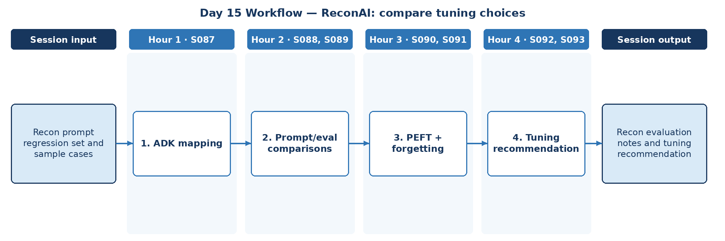

D. Steps to Perform the Work – and Why
Step | Hour · IDs | What to perform | Why this step is required | Expected output
1 | H1 · S087 | Map ReconAI to ADK concepts. | Mapping to ADK shows how ReconAI would run on the target agent platform. | ADK mapping
2 | H2 · S088, S089 | Run prompt and evaluation comparisons on the regression set; compare instruction vs task tuning. | Prompting may already meet targets; comparisons show whether tuning is needed at all. | Comparison results
3 | H3 · S090, S091 | Assess PEFT options and forgetting risk. | Tuning has data, cost and forgetting risks that must be weighed first. | PEFT assessment
4 | H4 · S092, S093 | Select metrics and decide whether fine-tuning is justified. | An evidence-based recommendation avoids unnecessary or harmful fine-tuning. | Recon evaluation notes + tuning recommendation

E. Detailed Execution Instructions
Step 1 – Map ReconAI to ADK concepts.
Hour / source IDs: Hour 1 · S087
How to perform: Map ReconAI actors to ADK agents, tools and sessions; record access status (approved or mock only).
Why: Mapping to ADK shows how ReconAI would run on the target agent platform.
Output to retain: ADK mapping
Step 2 – Run prompt and evaluation comparisons on the regression set; compare instruction vs task tuning.
Hour / source IDs: Hour 2 · S088, S089
How to perform: Run prompt variants on the Day 4 regression set; record scores; note whether instruction or task-specific tuning would address remaining failures.
Why: Prompting may already meet targets; comparisons show whether tuning is needed at all.
Output to retain: Comparison results
Step 3 – Assess PEFT options and forgetting risk.
Hour / source IDs: Hour 3 · S090, S091
How to perform: Estimate labelled data needed for LoRA/QLoRA; identify forgetting risk; plan a check on general tasks.
Why: Tuning has data, cost and forgetting risks that must be weighed first.
Output to retain: PEFT assessment
Step 4 – Select metrics and decide whether fine-tuning is justified.
Hour / source IDs: Hour 4 · S092, S093
How to perform: Choose metrics suitable for short factual narratives (exact-field accuracy, judge score) and explain why ROUGE/BLEU alone mislead; recommend tune or do not tune.
Why: An evidence-based recommendation avoids unnecessary or harmful fine-tuning.
Output to retain: Recon evaluation notes + tuning recommendation

F. Session Input → Work → Output
Input | Work performed | Output
Recon prompt regression set and sample cases | ADK mapping → Prompt/eval comparisons → PEFT + forgetting → Tuning recommendation | Recon evaluation notes and tuning recommendation

G. Validation / Exit Criteria
- The required output exists: Recon evaluation notes and tuning recommendation.
- The recommendation cites comparison evidence.
- Metrics suit short factual narratives.
- Every step traces to its hourly block and source IDs (S087, S088, S089, S090, S091, S092, S093); no TOC topic is skipped or re-worded.
- The workflow diagram matches the work actually performed.
- The human decision boundary is preserved wherever the session touches a consequential decision.
- Open gaps or assumptions (including tool or platform access) are recorded rather than silently filled.

H. Carry-Forward
Recon evaluation notes and tuning recommendation becomes an explicit input for Day 16 — ReconAI: protocol and trace assignment (Day 16 input: Recon role contracts, sample exception queue and reviewer workflow).

Day 16: MCP/A2A advanced + Observability – protocol and trace assignment
Session duration | 4h = 0.75h concept + 3.25h lab (4 × 1-hour blocks)
Instructor emphasis | MCP/A2A advanced + Observability
Exact modules | Deployment, Evaluation & Observability | Streaming Observability & Delivery Semantics — Correlation, Acknowledgement & Durable Processing
Source IDs (primary) | S094, S095, S096, S097, S098, S099, S100
Repeated source IDs (application) | S076, S077, S078, S079, S080, S081, S082, S083, S084, S085
Input | Recon role contracts, sample exception queue and reviewer workflow
Guided implementation (workbook) | Specify typed MCP tool boundary and A2A message trace; instrument event/log evidence.
Primary output | Recon integration trace and contract tests
Human decision / governance | The deterministic matcher decides match status. ReconAI may investigate exceptions, link SOP evidence and draft non-authoritative narratives. Dispositions, adjustments, write-offs and ledger postings are made only by reconciliation analysts/reviewers, and every transition is audited.
Mapping ID / section locator | SOL-R16 | Day 16 / SOL-R16
Slide deck | Day16_SourceLocked_5W1H_Architecture.pptx
Code mapping / status | Runnable local source code is provided in the ZIP and mapped in the master workbook. See source path in the applied-module section below.
Architecture / workflow (workbook) | MCP host ↔ MCP client ↔ tool server; A2A → agent peers → telemetry

A. Exact TOC Topics for This Session (unchanged)
Source ID | Exact topic + subtopic
S094 | Deployment, Evaluation & Observability | Observability: Understanding System Insights — Logs / Metrics / Traces
S095 | Observability: Issue Detection; Debugging; System Optimization; Security/Compliance
S096 | Integration Best Practices with CI/CD and Developer Workflows
S097 | Evaluation — System Metrics, Task Completion, Quality Control, Tool Interaction Metrics
S098 | Evaluation — LLM/Agents as Judge
S099 | Development Issues — Poorly Defined Prompts, etc.
S100 | LLM Issues — High Cost of Running; Planning/Reasoning/Tool Calling Failures

B. Hourly Session Break-up (from the workbook Hourly Plan)
Hour | Intention | Source IDs | Exact source words | Revisit IDs | ReconAI activity | Steps
Hour 1  (00:00–01:00) | MCP/A2A applied architecture (revisit Days 13–14) | S094 | Deployment, Evaluation & Observability | Observability: Understanding System Insights — Logs / Metrics / Traces | S076, S077 | ReconAI: protocol and trace assignment | 1
Hour 2  (01:00–02:00) | MCP/A2A role/message lab + new observability | S095, S096 | Observability: Issue Detection; Debugging; System Optimization; Security/Compliance  Integration Best Practices with CI/CD and Developer Workflows | S078, S079, S080 | ReconAI: protocol and trace assignment | 2
Hour 3  (02:00–03:00) | Operational observability and CI/CD | S097, S098 | Evaluation — System Metrics, Task Completion, Quality Control, Tool Interaction Metrics  Evaluation — LLM/Agents as Judge | S081, S082 | ReconAI: protocol and trace assignment | 3
Hour 4  (03:00–04:00) | Operational evaluation and development failure modes | S099, S100 | Development Issues — Poorly Defined Prompts, etc.  LLM Issues — High Cost of Running; Planning/Reasoning/Tool Calling Failures | S083, S084, S085 | Specify typed MCP tool boundary and A2A message trace; instrument event/log evidence. | 4

C. Workflow Diagram for This Session
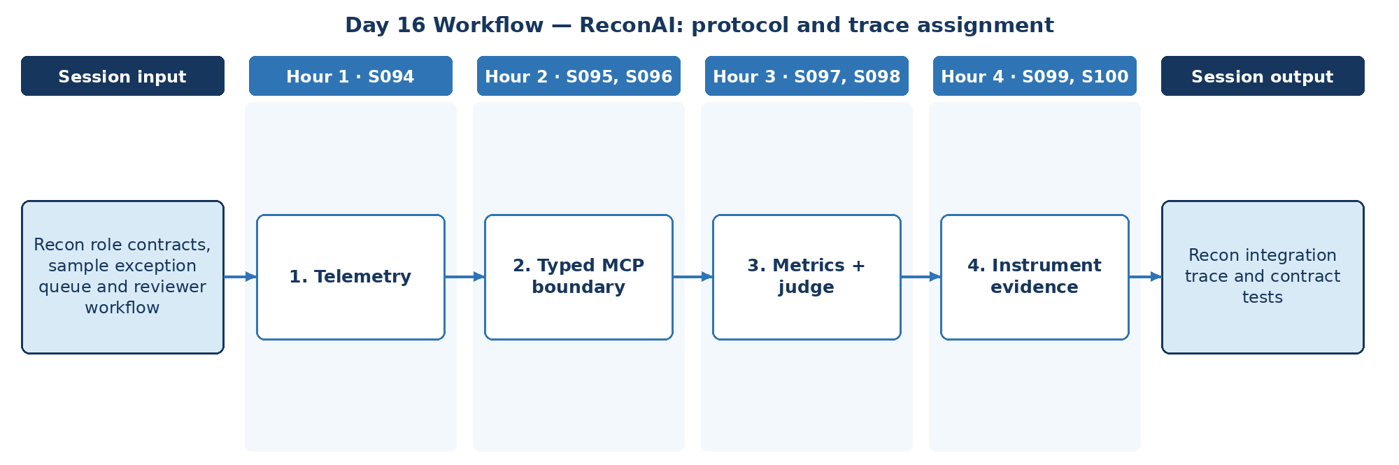

D. Steps to Perform the Work – and Why
Step | Hour · IDs | What to perform | Why this step is required | Expected output
1 | H1 · S094 | Define logs, metrics and traces for the recon flow. | Integration across agents and tools is only governable if it is observable. | Telemetry spec
2 | H2 · S095, S096 | Specify the typed MCP tool boundary and A2A message trace; add CI checks. | Typed contracts enforced in CI stop silent schema drift between components. | MCP/A2A contract
3 | H3 · S097, S098 | Define task and tool-interaction metrics. | Task and tool metrics show whether the integrated system is reliable. | Metric set
4 | H4 · S099, S100 | Instrument event/log evidence and catalogue failure modes. | Instrumented evidence supports audit, debugging and incident review. | Recon integration trace + contract tests

E. Detailed Execution Instructions
Step 1 – Define logs, metrics and traces for the recon flow.
Hour / source IDs: Hour 1 · S094
How to perform: Define events, metrics and trace spans for ingest → match → explain → review; propagate correlation_id across every hop.
Why: Integration across agents and tools is only governable if it is observable.
Output to retain: Telemetry spec
Step 2 – Specify the typed MCP tool boundary and A2A message trace; add CI checks.
Hour / source IDs: Hour 2 · S095, S096
How to perform: Write typed schemas for MCP tools and A2A messages; add a CI contract test that fails on schema drift.
Why: Typed contracts enforced in CI stop silent schema drift between components.
Output to retain: MCP/A2A contract
Step 3 – Define task and tool-interaction metrics.
Hour / source IDs: Hour 3 · S097, S098
How to perform: Define exception-closure rate, tool-call success rate, judge score and time-to-review, each with a target.
Why: Task and tool metrics show whether the integrated system is reliable.
Output to retain: Metric set
Step 4 – Instrument event/log evidence and catalogue failure modes.
Hour / source IDs: Hour 4 · S099, S100
How to perform: Instrument the flow; capture a full trace; list failure modes (poor prompts, cost spikes, tool-call failures) and the signal that detects each.
Why: Instrumented evidence supports audit, debugging and incident review.
Output to retain: Recon integration trace + contract tests

F. Session Input → Work → Output
Input | Work performed | Output
Recon role contracts, sample exception queue and reviewer workflow | Telemetry → Typed MCP boundary → Metrics + judge → Instrument evidence | Recon integration trace and contract tests

G. Validation / Exit Criteria
- The required output exists: Recon integration trace and contract tests.
- Contract tests fail on schema drift.
- Trace spans all hops.
- Every step traces to its hourly block and source IDs (S094, S095, S096, S097, S098, S099, S100); no TOC topic is skipped or re-worded.
- The workflow diagram matches the work actually performed.
- The human decision boundary is preserved wherever the session touches a consequential decision.
- Open gaps or assumptions (including tool or platform access) are recorded rather than silently filled.

H. Carry-Forward
Recon integration trace and contract tests becomes an explicit input for Day 17 — ReconAI: golden tests and controlled release (Day 17 input: Recon prompt, reviewer flow and approved golden records).

Day 17: ADK + Production controls – golden tests and controlled release
Session duration | 4h = 0.75h concept + 3.25h lab (4 × 1-hour blocks)
Instructor emphasis | ADK + Production controls
Exact modules | Deployment, Evaluation & Observability | AI Validation/ Testing | Batch Backfill/Replay & Stream Recovery — Idempotency, Duplicate Handling & Failure Recovery
Source IDs (primary) | S101, S102, S103, S104, S105, S106, S107, S108, S109
Repeated source IDs (application) | S086, S087, S088, S089, S090, S091, S092, S093
Input | Recon prompt, reviewer flow and approved golden records
Guided implementation (workbook) | Add prompt/chain unit test, regression cases and observability/rollback checklist.
Primary output | Recon regression evidence and rollback plan
Human decision / governance | The deterministic matcher decides match status. ReconAI may investigate exceptions, link SOP evidence and draft non-authoritative narratives. Dispositions, adjustments, write-offs and ledger postings are made only by reconciliation analysts/reviewers, and every transition is audited.
Mapping ID / section locator | SOL-R17 | Day 17 / SOL-R17
Slide deck | Day17_SourceLocked_5W1H_Architecture.pptx
Code mapping / status | Runnable local source code is provided in the ZIP and mapped in the master workbook. See source path in the applied-module section below.
Architecture / workflow (workbook) | ADK candidate → Eval → Guardrails → CI gate → Canary/rollback

A. Exact TOC Topics for This Session (unchanged)
Source ID | Exact topic + subtopic
S101 | Production Issues — Guardrails, Agent Scaling, Infinite Looping
S102 | Productionalization Challenges & Best Practices
S103 | Model Production Readiness: Latency, Cost, Reliability
S104 | Governance: Audit Trails, Explainability, Compliance Standards
S105 | Scaling Approaches: Containerization, Serverless vs On-Prem Deployments
S106 | Guardrails in Production: Structured Outputs, Fallbacks, Circuit Breakers
S107 | Versioning, Rollback, and Feature Flags
S108 | AI Validation/ Testing | *Unit Testing LLM Prompts & Chains*
S109 | *Regression Testing for Prompt/Model Changes*

B. Hourly Session Break-up (from the workbook Hourly Plan)
Hour | Intention | Source IDs | Exact source words | Revisit IDs | ReconAI activity | Steps
Hour 1  (00:00–01:00) | Google ADK + tuning evaluation revisit | S101, S102 | Production Issues — Guardrails, Agent Scaling, Infinite Looping  Productionalization Challenges & Best Practices | S086, S087 | ReconAI: golden tests and controlled release | 1
Hour 2  (01:00–02:00) | Production issue patterns and guardrails | S103, S104 | Model Production Readiness: Latency, Cost, Reliability  Governance: Audit Trails, Explainability, Compliance Standards | S088, S089 | ReconAI: golden tests and controlled release | 2
Hour 3  (02:00–03:00) | Production readiness / governance / scaling | S105, S106 | Scaling Approaches: Containerization, Serverless vs On-Prem Deployments  Guardrails in Production: Structured Outputs, Fallbacks, Circuit Breakers | S090, S091 | ReconAI: golden tests and controlled release | 3
Hour 4  (03:00–04:00) | Validation basics and release acceptance | S107, S108, S109 | Versioning, Rollback, and Feature Flags  AI Validation/ Testing | *Unit Testing LLM Prompts & Chains*  *Regression Testing for Prompt/Model Changes* | S092, S093 | Add prompt/chain unit test, regression cases and observability/rollback checklist. | 4

C. Workflow Diagram for This Session
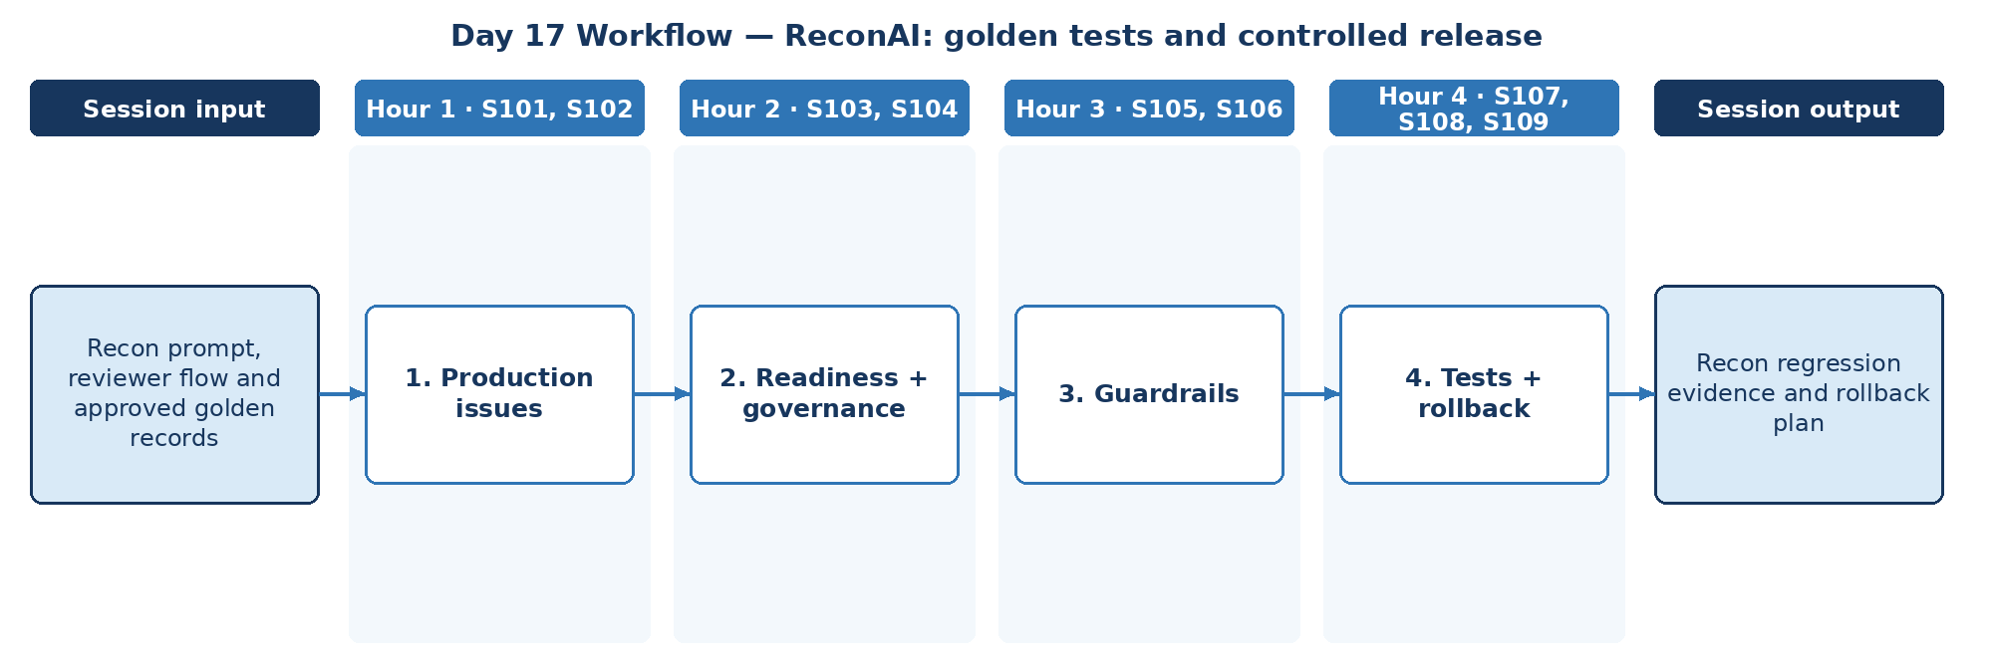

D. Steps to Perform the Work – and Why
Step | Hour · IDs | What to perform | Why this step is required | Expected output
1 | H1 · S101, S102 | Review guardrails, scaling and looping issues for ReconAI. | Known production risks must be rated before a release decision. | Issue list
2 | H2 · S103, S104 | Measure latency and cost; confirm audit trail. | Release requires measured latency, cost and complete audit evidence. | Readiness metrics
3 | H3 · S105, S106 | Add structured outputs, fallbacks and circuit breakers. | When the model or tools fail, work must fall back safely to the manual queue. | Hardening controls
4 | H4 · S107, S108, S109 | Add prompt/chain unit tests, regression cases, observability and rollback checklist. | Unit and regression tests stop silent behaviour changes; rollback limits damage. | Recon regression evidence + rollback plan

E. Detailed Execution Instructions
Step 1 – Review guardrails, scaling and looping issues for ReconAI.
Hour / source IDs: Hour 1 · S101, S102
How to perform: List guardrail, scaling and looping risks for daily batch volumes; rate each.
Why: Known production risks must be rated before a release decision.
Output to retain: Issue list
Step 2 – Measure latency and cost; confirm audit trail.
Hour / source IDs: Hour 2 · S103, S104
How to perform: Measure p95 latency and cost per exception; confirm every disposition has an audit record.
Why: Release requires measured latency, cost and complete audit evidence.
Output to retain: Readiness metrics
Step 3 – Add structured outputs, fallbacks and circuit breakers.
Hour / source IDs: Hour 3 · S105, S106
How to perform: Validate outputs against the schema; on model or tool failure fall back to the manual queue; open a circuit breaker after repeated failures.
Why: When the model or tools fail, work must fall back safely to the manual queue.
Output to retain: Hardening controls
Step 4 – Add prompt/chain unit tests, regression cases, observability and rollback checklist.
Hour / source IDs: Hour 4 · S107, S108, S109
How to perform: Write unit tests for prompts and chain steps; add Day 4 regression cases to CI; write rollback steps with trigger and owner.
Why: Unit and regression tests stop silent behaviour changes; rollback limits damage.
Output to retain: Recon regression evidence + rollback plan

F. Session Input → Work → Output
Input | Work performed | Output
Recon prompt, reviewer flow and approved golden records | Production issues → Readiness + governance → Guardrails → Tests + rollback | Recon regression evidence and rollback plan

G. Validation / Exit Criteria
- The required output exists: Recon regression evidence and rollback plan.
- Regression suite passes in CI.
- Rollback plan names trigger and owner.
- Every step traces to its hourly block and source IDs (S101, S102, S103, S104, S105, S106, S107, S108, S109); no TOC topic is skipped or re-worded.
- The workflow diagram matches the work actually performed.
- The human decision boundary is preserved wherever the session touches a consequential decision.
- Open gaps or assumptions (including tool or platform access) are recorded rather than silently filled.

H. Carry-Forward
Recon regression evidence and rollback plan becomes an explicit input for Day 18 — ReconAI: complete assignment sign-off (Day 18 input: Recon test suite, traces and evidence pack).

Day 18: Testing + Gemini deployment – complete assignment sign-off
Session duration | 4h = 0.75h concept + 3.25h lab (4 × 1-hour blocks)
Instructor emphasis | Testing + Gemini deployment
Exact modules | AI Validation/ Testing | Gemini Enterprise Deployment | Batch/Stream Production Readiness — Cutover, Rollback, Governance & Release Validation
Source IDs (primary) | S110, S111, S112, S113, S114, S115
Repeated source IDs (application) | S094, S095, S096, S097, S098, S099, S100, S101, S102, S103, S104, S105, S106, S107
Input | Recon test suite, traces and evidence pack
Guided implementation (workbook) | Evaluate against gold set, document shadow rollout and record sign-off criteria.
Primary output | Final assignment report and reviewer sign-off
Human decision / governance | The deterministic matcher decides match status. ReconAI may investigate exceptions, link SOP evidence and draft non-authoritative narratives. Dispositions, adjustments, write-offs and ledger postings are made only by reconciliation analysts/reviewers, and every transition is audited.
Mapping ID / section locator | SOL-R18 | Day 18 / SOL-R18
Slide deck | Day18_SourceLocked_5W1H_Architecture.pptx
Code mapping / status | Runnable local source code is provided in the ZIP and mapped in the master workbook. See source path in the applied-module section below.
Architecture / workflow (workbook) | Code → CI tests → Shadow → Deploy gate → Observability → Governance

A. Exact TOC Topics for This Session (unchanged)
Source ID | Exact topic + subtopic
S110 | *Red-Teaming & Adversarial Test Suites*
S111 | *Golden Dataset Creation for Agent/RAG Validation*
S112 | *A/B Testing & Shadow Deployment for Model Changes*
S113 | Gemini Enterprise Deployment | *Prepare and Deliver Gemini Enterprise Deployments*
S114 | *Govern, Secure, and Scale the Agent Ecosystem*
S115 | *Drive Impact with Agents using Gemini Enterprise*

B. Hourly Session Break-up (from the workbook Hourly Plan)
Hour | Intention | Source IDs | Exact source words | Revisit IDs | ReconAI activity | Steps
Hour 1  (00:00–01:00) | Red-teaming and golden datasets | S110 | *Red-Teaming & Adversarial Test Suites* | S094, S095, S096 | ReconAI: complete assignment sign-off | 1
Hour 2  (01:00–02:00) | Shadow release and Gemini deployment | S111, S112 | *Golden Dataset Creation for Agent/RAG Validation*  *A/B Testing & Shadow Deployment for Model Changes* | S097, S098, S099, S100 | ReconAI: complete assignment sign-off | 2
Hour 3  (02:00–03:00) | Production telemetry and failure lab (revisit) | S113 | Gemini Enterprise Deployment | *Prepare and Deliver Gemini Enterprise Deployments* | S101, S102, S103 | ReconAI: complete assignment sign-off | 3
Hour 4  (03:00–04:00) | Integrated evidence review, readiness and capstone | S114, S115 | *Govern, Secure, and Scale the Agent Ecosystem*  *Drive Impact with Agents using Gemini Enterprise* | S104, S105, S106, S107 | Evaluate against gold set, document shadow rollout and record sign-off criteria. | 4

C. Workflow Diagram for This Session
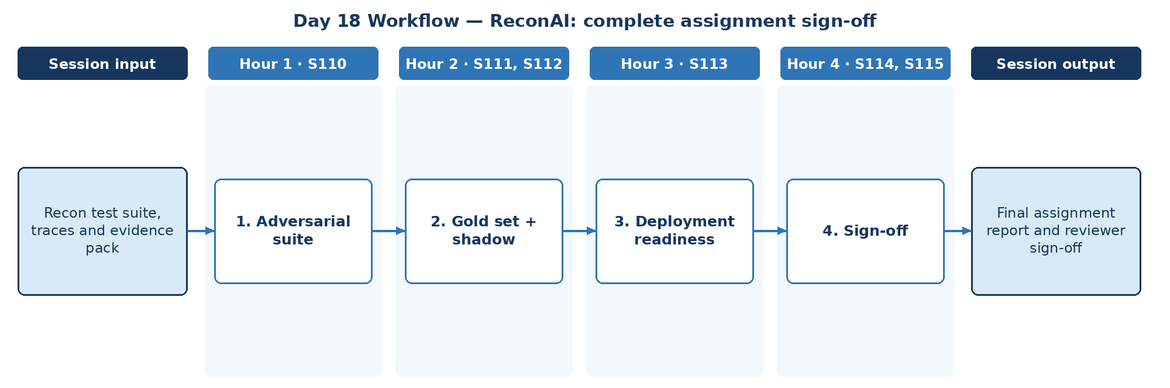

D. Steps to Perform the Work – and Why
Step | Hour · IDs | What to perform | Why this step is required | Expected output
1 | H1 · S110 | Run adversarial tests on ReconAI. | Final adversarial testing validates security before sign-off. | Red-team results
2 | H2 · S111, S112 | Evaluate against the gold set and document shadow rollout. | Gold-set scores and shadow comparison prove quality without ledger impact. | Gold-set results + shadow plan
3 | H3 · S113 | Record deployment assumptions for Gemini Enterprise. | Deployment depends on access and environment assumptions that must be explicit. | Deployment note
4 | H4 · S114, S115 | Record sign-off criteria and compile the final report. | Sign-off criteria and linked evidence complete the assignment objectively. | Final assignment report + reviewer sign-off

E. Detailed Execution Instructions
Step 1 – Run adversarial tests on ReconAI.
Hour / source IDs: Hour 1 · S110
How to perform: Run injection, manipulation and data-exfiltration tests; record findings, severity and fixes.
Why: Final adversarial testing validates security before sign-off.
Output to retain: Red-team results
Step 2 – Evaluate against the gold set and document shadow rollout.
Hour / source IDs: Hour 2 · S111, S112
How to perform: Score the release candidate on the gold set; define shadow rollout (compare drafts with analyst outcomes, no customer or ledger impact) and promotion criteria.
Why: Gold-set scores and shadow comparison prove quality without ledger impact.
Output to retain: Gold-set results + shadow plan
Step 3 – Record deployment assumptions for Gemini Enterprise.
Hour / source IDs: Hour 3 · S113
How to perform: List environment, identity and data-connection assumptions for a Gemini Enterprise deployment.
Why: Deployment depends on access and environment assumptions that must be explicit.
Output to retain: Deployment note
Step 4 – Record sign-off criteria and compile the final report.
Hour / source IDs: Hour 4 · S114, S115
How to perform: Compile the final report linking all Day 1–17 evidence; list sign-off criteria and record the reviewer decision.
Why: Sign-off criteria and linked evidence complete the assignment objectively.
Output to retain: Final assignment report + reviewer sign-off

F. Session Input → Work → Output
Input | Work performed | Output
Recon test suite, traces and evidence pack | Adversarial suite → Gold set + shadow → Deployment readiness → Sign-off | Final assignment report and reviewer sign-off

G. Validation / Exit Criteria
- The required output exists: Final assignment report and reviewer sign-off.
- Sign-off criteria are met or gaps are listed.
- The report links to all prior evidence.
- Every step traces to its hourly block and source IDs (S110, S111, S112, S113, S114, S115); no TOC topic is skipped or re-worded.
- The workflow diagram matches the work actually performed.
- The human decision boundary is preserved wherever the session touches a consequential decision.
- Open gaps or assumptions (including tool or platform access) are recorded rather than silently filled.

H. Carry-Forward
Final assignment report and reviewer sign-off is the final evidence for the ReconAI assignment sign-off.

5. Completion Checklist
Day | Map ID | Required output | Hourly | Diagram | Steps | Why | Evidence
1 | SOL-R01 | ReconAI schema manifest and control-total report | □ | □ | □ | □ | □
2 | SOL-R02 | Two reviewed exception examples | □ | □ | □ | □ | □
3 | SOL-R03 | Recon prompt library v1 and test matrix | □ | □ | □ | □ | □
4 | SOL-R04 | Recon JSON contract and prompt regression cases | □ | □ | □ | □ | □
5 | SOL-R05 | Recon vector-data plan | □ | □ | □ | □ | □
6 | SOL-R06 | Chain implementation brief | □ | □ | □ | □ | □
7 | SOL-R07 | Recon evidence-backed retrieval examples | □ | □ | □ | □ | □
8 | SOL-R08 | Recon retrieval evaluation pack | □ | □ | □ | □ | □
9 | SOL-R09 | Agent role and action policy | □ | □ | □ | □ | □
10 | SOL-R10 | Controlled exception investigation trace | □ | □ | □ | □ | □
11 | SOL-R11 | Reviewer state transitions and evidence log | □ | □ | □ | □ | □
12 | SOL-R12 | Recon graph and sample execution trace | □ | □ | □ | □ | □
13 | SOL-R13 | Boundary diagram and message examples | □ | □ | □ | □ | □
14 | SOL-R14 | Recon agent design and approval checklist | □ | □ | □ | □ | □
15 | SOL-R15 | Recon evaluation notes and tuning recommendation | □ | □ | □ | □ | □
16 | SOL-R16 | Recon integration trace and contract tests | □ | □ | □ | □ | □
17 | SOL-R17 | Recon regression evidence and rollback plan | □ | □ | □ | □ | □
18 | SOL-R18 | Final assignment report and reviewer sign-off | □ | □ | □ | □ | □

Appendix A. Source ID Traceability
Each of the 114 source lines has exactly one primary day. The mapping below is copied from the workbook Coverage sheet and links each source ID to the day and mapping ID in this pack.
Source ID | Day | Map ID | Exact source topic
S001 | 1 | SOL-R01 | Python for AI | Python Basics & Syntax
S003 | 1 | SOL-R01 | Variables, Operators, Conditional Statements, Loops
S004 | 1 | SOL-R01 | Data Structures: Lists, Tuples, Sets, Dictionaries
S005 | 1 | SOL-R01 | *Functions, FAST API, File Handling & Error Handling*
S006 | 2 | SOL-R02 | Gen AI & Challenges | AI vs ML vs GenAI
S007 | 2 | SOL-R02 | Core Principles of GenAI
S008 | 2 | SOL-R02 | Types of GenAI Models
S009 | 2 | SOL-R02 | How Generative Models Create Data; Key Challenges: Bias, Hallucination, Stochasticity
S010 | 2 | SOL-R02 | Business and Technical Challenges in Deployment
S011 | 3 | SOL-R03 | Guardrail Solutions: Bias Mitigation (balanced datasets, fairness metrics, post-processing)
S012 | 3 | SOL-R03 | Security Approaches (prompt injection defense, data anonymization, differential privacy)
S013 | 3 | SOL-R03 | Guardrail Techniques (RLHF, Constitutional AI, red-teaming, moderation APIs)
S014 | 3 | SOL-R03 | Prompt Engineering | Prompt Anatomy & Context Types
S015 | 3 | SOL-R03 | Zero-shot, One-shot, Few-shot Prompting
S016 | 3 | SOL-R03 | Chain-of-Thought Prompting
S017 | 4 | SOL-R04 | Prompt Interventions & Prompt Tuning
S018 | 4 | SOL-R04 | Adversarial Prompting & Prompt Security
S019 | 4 | SOL-R04 | Prompts for Agents & ReAct-style Prompting
S020 | 4 | SOL-R04 | *Structured Output Prompting (JSON mode, schemas, function-call prompts)*
S021 | 4 | SOL-R04 | LLM/LRM/LMM | LLMs vs LRMs vs LMMs
S022 | 4 | SOL-R04 | Transformers Architecture, Scaling Laws
S023 | 5 | SOL-R05 | Tokenization & Embedding Techniques (Byte Pair Encoding)
S024 | 5 | SOL-R05 | Reasoning Tokens & Inference Strategies
S025 | 5 | SOL-R05 | Max New Tokens, Sampling, Temperature, Top_K, Top_P
S026 | 5 | SOL-R05 | LMMs: DALL-E, Imagen, Diffusion Models
S027 | 5 | SOL-R05 | Agentic Workflows – LangChain Essentials | Introduction to LangChain Architecture
S028 | 6 | SOL-R06 | Model I/O & Integration
S029 | 6 | SOL-R06 | Chains, Prompt Templates, Sequential Flows
S030 | 6 | SOL-R06 | Memory & Context Handling
S031 | 6 | SOL-R06 | Tool/Agent Integration
S032 | 6 | SOL-R06 | Hands-on Workflow Creation
S033 | 6 | SOL-R06 | Retrieval-Augmented Generation (RAG) | Introduction to RAG & Its Importance
S034 | 7 | SOL-R07 | Vector Databases for RAG (FAISS, Chroma)
S035 | 7 | SOL-R07 | Chunking Strategies in RAG Applications
S036 | 7 | SOL-R07 | Semantic Search vs. Exact Matching
S037 | 7 | SOL-R07 | RAG for Domain-Specific Applications
S038 | 7 | SOL-R07 | Optimizing RAG for Large-Scale AI Models
S039 | 7 | SOL-R07 | Real-Time Information Retrieval Using RAG
S040 | 8 | SOL-R08 | Challenges in RAG Implementation
S041 | 8 | SOL-R08 | Hybrid Search & Multi-Query RAG Systems
S042 | 8 | SOL-R08 | Multi-modal RAG
S043 | 8 | SOL-R08 | Agentic RAG: using an agent to determine how to retrieve the most relevant information before answering
S044 | 8 | SOL-R08 | *RAG Evaluation (faithfulness, retrieval precision/recall)*
S045 | 8 | SOL-R08 | Guidelines and Best Practices
S046 | 9 | SOL-R09 | Demystifying Agentic AI | Understanding Agentic vs. Non-Agentic AI Systems
S047 | 9 | SOL-R09 | Overview of Autonomous Agents
S048 | 9 | SOL-R09 | Agents vs. Models
S049 | 9 | SOL-R09 | What is an LLM Agent — Role of LLMs in Autonomous Systems
S050 | 9 | SOL-R09 | When (and When Not) to Use Agents
S051 | 9 | SOL-R09 | Questions to Ask Before Considering an AI Agent
S052 | 10 | SOL-R10 | ReAct Framework — Concept of Thought, Action, Input and Observation
S053 | 10 | SOL-R10 | Language-Action Agents
S054 | 10 | SOL-R10 | Agent Runtime — Orchestration Layer
S055 | 10 | SOL-R10 | Tools — Function Calling / Extensions
S056 | 10 | SOL-R10 | Context, Harness & Loop Engineering | *Context Engineering vs Prompt Engineering — what's the difference*
S057 | 10 | SOL-R10 | *Context Window Management (system/developer/user context layering)*
S058 | 10 | SOL-R10 | *Long-context Windows vs RAG — when to use which*
S059 | 11 | SOL-R11 | *Context Compaction & Summarization Strategies*
S060 | 11 | SOL-R11 | *What is an Agent Harness — tools, memory, guardrails, execution environment*
S061 | 11 | SOL-R11 | *Building a Custom Harness vs Using a Framework (LangChain/LangGraph)*
S062 | 11 | SOL-R11 | *Sandboxing & Permission Boundaries in Harnesses*
S063 | 11 | SOL-R11 | *The Agent Loop — Perceive → Plan → Act → Observe*
S064 | 11 | SOL-R11 | *ReAct Loop vs Plan-and-Execute Loop*
S065 | 11 | SOL-R11 | *Loop Termination Conditions & Infinite-Loop Prevention*
S066 | 11 | SOL-R11 | *Human-in-the-Loop Checkpoints Inside the Loop*
S067 | 12 | SOL-R12 | LangGraph/CrewAI/AutoGen – Advanced AI Agents | Introduction to LangGraph, CrewAI, and AutoGen
S068 | 12 | SOL-R12 | Key Components of LangGraph (Nodes, Edges, States)
S069 | 12 | SOL-R12 | LangGraph/AutoGen for Autonomous LLM Applications
S070 | 12 | SOL-R12 | Real-Time Data Processing with LangGraph
S071 | 12 | SOL-R12 | Building Stateful AI Systems
S072 | 13 | SOL-R13 | Advanced Orchestration Techniques
S073 | 13 | SOL-R13 | Building Multi-Actor Applications
S074 | 13 | SOL-R13 | Cycles and Branching; Memory/Persistence; Human in the Loop (HITL); Streaming
S075 | 13 | SOL-R13 | Guidelines and Best Practices
S076 | 13 | SOL-R13 | Architecting Agentic Systems – MCP & A2A Protocols | Principles of Agentic AI Application Design (Architecture level)
S077 | 13 | SOL-R13 | MCP (Model Context Protocol) — MCP Server / Host / Client
S078 | 13 | SOL-R13 | A2A (Agent-to-Agent Protocol)
S079 | 14 | SOL-R14 | Multi-Agent Coordination Strategies
S080 | 14 | SOL-R14 | Architecting AI Workflows with Autonomous Agents
S081 | 14 | SOL-R14 | Designing Human-in-the-Loop Agentic Systems
S082 | 14 | SOL-R14 | Adaptive Agents for Dynamic Environments
S083 | 14 | SOL-R14 | Evaluating and Deploying Agents — LLMs as Judge
S084 | 14 | SOL-R14 | Ethical & Regulatory Considerations in AI Agents
S085 | 14 | SOL-R14 | Guidelines and Best Practices
S086 | 14 | SOL-R14 | Gemini Enterprise Agent Development | *Use Agents to Build Agents*
S087 | 15 | SOL-R15 | *Build and Deploy Agents with Agent Development Kit (ADK)*
S088 | 15 | SOL-R15 | *Agent Evaluation and Hill Climbing*
S089 | 15 | SOL-R15 | LLM Fine-Tuning & Evaluation | Instruction vs Task-Specific Fine-Tuning
S090 | 15 | SOL-R15 | Parameter Efficient Tuning (LoRA, QLoRA, FLAN)
S091 | 15 | SOL-R15 | Avoiding Catastrophic Forgetting
S092 | 15 | SOL-R15 | Evaluation Metrics: ROUGE, BLEU, MMLU, BIG-Bench, GLUE, HELM
S093 | 15 | SOL-R15 | Fine-tuning for Function Calling
S094 | 16 | SOL-R16 | Deployment, Evaluation & Observability | Observability: Understanding System Insights — Logs / Metrics / Traces
S095 | 16 | SOL-R16 | Observability: Issue Detection; Debugging; System Optimization; Security/Compliance
S096 | 16 | SOL-R16 | Integration Best Practices with CI/CD and Developer Workflows
S097 | 16 | SOL-R16 | Evaluation — System Metrics, Task Completion, Quality Control, Tool Interaction Metrics
S098 | 16 | SOL-R16 | Evaluation — LLM/Agents as Judge
S099 | 16 | SOL-R16 | Development Issues — Poorly Defined Prompts, etc.
S100 | 16 | SOL-R16 | LLM Issues — High Cost of Running; Planning/Reasoning/Tool Calling Failures
S101 | 17 | SOL-R17 | Production Issues — Guardrails, Agent Scaling, Infinite Looping
S102 | 17 | SOL-R17 | Productionalization Challenges & Best Practices
S103 | 17 | SOL-R17 | Model Production Readiness: Latency, Cost, Reliability
S104 | 17 | SOL-R17 | Governance: Audit Trails, Explainability, Compliance Standards
S105 | 17 | SOL-R17 | Scaling Approaches: Containerization, Serverless vs On-Prem Deployments
S106 | 17 | SOL-R17 | Guardrails in Production: Structured Outputs, Fallbacks, Circuit Breakers
S107 | 17 | SOL-R17 | Versioning, Rollback, and Feature Flags
S108 | 17 | SOL-R17 | AI Validation/ Testing | *Unit Testing LLM Prompts & Chains*
S109 | 17 | SOL-R17 | *Regression Testing for Prompt/Model Changes*
S110 | 18 | SOL-R18 | *Red-Teaming & Adversarial Test Suites*
S111 | 18 | SOL-R18 | *Golden Dataset Creation for Agent/RAG Validation*
S112 | 18 | SOL-R18 | *A/B Testing & Shadow Deployment for Model Changes*
S113 | 18 | SOL-R18 | Gemini Enterprise Deployment | *Prepare and Deliver Gemini Enterprise Deployments*
S114 | 18 | SOL-R18 | *Govern, Secure, and Scale the Agent Ecosystem*
S115 | 18 | SOL-R18 | *Drive Impact with Agents using Gemini Enterprise*

Applied Streaming & Batching Module — Detailed Implementation, Reasoning and Evidence
Curriculum change note: The original source-locked modules remain intact. The following applied modules are explicit additions requested for implementation depth; they do not replace the original source IDs.
How to use this section: For Days 13–18, follow each step in order. Do not mark a step complete only because code runs; retain the expected output and validation evidence. The same module names are present in the updated master Excel TOC.
Day | Added applied module | Learning purpose | Primary evidence
13 | Applied Data Processing — Batch Fundamentals & Streaming Fundamentals | Establish correct batch and stream mental models and a deterministic local baseline. | Batch controls + event trace + reconciliation
14 | Cloud Batch & Event-Streaming Architecture — Pub/Sub, Dataflow/Apache Beam & BigQuery | Map the same business contracts to cloud-scale batch and event streaming. | Architecture + contracts + IAM/failure design
15 | Batch Validation & Publisher Batching — Event Time, Windows, Watermarks & Late Data | Make behavior testable with golden data, publisher batching and event-time semantics. | Golden tests + timing/windowing evidence
16 | Streaming Observability & Delivery Semantics — Correlation, Acknowledgement & Durable Processing | Make the pipeline observable and define safe delivery/acknowledgement semantics. | Logs/metrics/traces + ack evidence
17 | Batch Backfill/Replay & Stream Recovery — Idempotency, Duplicate Handling & Failure Recovery | Prove replay, idempotency and recovery under realistic failure conditions. | Replay/idempotency/recovery evidence
18 | Batch/Stream Production Readiness — Cutover, Rollback, Governance & Release Validation | Combine functional, reliability, security and governance evidence for release readiness. | Acceptance matrix + cutover/rollback + sign-off
Day 13 — Applied Data Processing — Batch Fundamentals & Streaming Fundamentals
Project context: ReconAI. Source code: 04_SOURCE_CODE/src/projects/reconai/assignment_pipeline.py. Cloud mapping: Cloud Storage/BigQuery + Dataflow batch; Pub/Sub/Dataflow stream; BigQuery sink.
Step | What to perform | How to perform | Why this step is required | Expected output | Validation / acceptance evidence
1 | Freeze reconciliation batch inputs | Version ledger and settlement extracts; record counts, totals and run IDs. | Reconciliation must be reproducible against the exact source files used. | Batch manifest | Versions, counts and totals are captured.
2 | Build indexes and duplicate quarantine | Index unique keys and quarantine duplicate settlement records before matching. | Duplicates can create false matches and false exceptions if not isolated first. | Indexes + quarantine | Duplicate fixture is isolated.
3 | Classify outcomes deterministically | Assign MATCHED, missing, mismatch and duplicate-review states with deterministic code. | AI may explain, but deterministic control logic must remain authoritative for match status. | Recon result set | Each input lands in one controlled state.
4 | Emit exception_created events | Emit only actionable non-MATCHED results with stable exception_id/correlation_id. | Streaming should represent work that requires action, not create noise for matched items. | Exception stream | MATCHED emits no exception; actionable items do.
5 | Reconcile statuses to events | Compare batch statuses and emitted exception IDs. | The event layer must faithfully reflect authoritative reconciliation results. | Control/event reconciliation | Every actionable status has one expected event.
Execution logic and reasoning chain: define the processing/control boundary → create deterministic evidence → introduce event flow without changing business authority → validate with measurable controls → retain artefacts for replay, audit and the next day. This ordering is intentional: observability and cloud scale are added only after correctness is measurable.
Minimum evidence to retain: Batch controls + event trace + reconciliation; test output; one representative trace; any failure/recovery evidence; and the source/config version used.
Day 14 — Cloud Batch & Event-Streaming Architecture — Pub/Sub, Dataflow/Apache Beam & BigQuery
Project context: ReconAI. Source code: 04_SOURCE_CODE/src/projects/reconai/assignment_pipeline.py. Cloud mapping: Cloud Storage/BigQuery + Dataflow batch; Pub/Sub/Dataflow stream; BigQuery sink.
Step | What to perform | How to perform | Why this step is required | Expected output | Validation / acceptance evidence
1 | Design Beam/Dataflow batch stages | Define read, validate, deduplicate, join, classify and write stages. | Explicit stages make control logic testable and scalable. | Batch pipeline design | Each stage has schema and failure output.
2 | Design Pub/Sub exception stream | Define producer, topic, subscription, payload and consumer responsibility. | Ownership avoids ambiguous retry and acknowledgement behavior. | Stream contract | Responsibilities are explicit.
3 | Choose durable sinks | Map results and exceptions to BigQuery tables with keys/partitioning. | Audit and replay require durable queryable state. | Sink design | Keys support audit/replay.
4 | Define ack-after-durability | Ack after durable sink/business case commit. | This prevents loss between receipt and persistence. | Ack rule | Ack point equals durable success.
5 | Define dead-letter and reprocessing | Route malformed/repeated failures to controlled storage/queue with operator owner. | Failures need a recoverable terminal state. | DLQ/reprocess design | Owner and replay process are documented.
Execution logic and reasoning chain: define the processing/control boundary → create deterministic evidence → introduce event flow without changing business authority → validate with measurable controls → retain artefacts for replay, audit and the next day. This ordering is intentional: observability and cloud scale are added only after correctness is measurable.
Minimum evidence to retain: Architecture + contracts + IAM/failure design; test output; one representative trace; any failure/recovery evidence; and the source/config version used.
Day 15 — Batch Validation & Publisher Batching — Event Time, Windows, Watermarks & Late Data
Project context: ReconAI. Source code: 04_SOURCE_CODE/src/projects/reconai/assignment_pipeline.py. Cloud mapping: Cloud Storage/BigQuery + Dataflow batch; Pub/Sub/Dataflow stream; BigQuery sink.
Step | What to perform | How to perform | Why this step is required | Expected output | Validation / acceptance evidence
1 | Create golden reconciliation cases | Build fixtures for every supported status including duplicates and bad amounts. | Tests must cover all control outcomes, not only happy path. | Golden fixtures | Every status has a fixture.
2 | Record expected batch results | Specify status, tolerance result and control totals before running code. | Predefined expectations keep validation unbiased. | Expected batch manifest | Actual can be automatically compared.
3 | Record expected event behavior | Specify whether each case emits an exception and expected reason/key. | Batch and event correctness are related but separate acceptance dimensions. | Expected event manifest | Emission rules are testable.
4 | Add event-time policy | Carry source event time and define allowed lateness. | Settlement feeds can arrive late; time semantics must be explicit. | Time policy | Event time and lateness are stated.
5 | Run automated regression | Execute packaged tests against all fixtures. | Regression protects financial-control behavior while code evolves. | Regression report | All statuses and event rules pass.
Execution logic and reasoning chain: define the processing/control boundary → create deterministic evidence → introduce event flow without changing business authority → validate with measurable controls → retain artefacts for replay, audit and the next day. This ordering is intentional: observability and cloud scale are added only after correctness is measurable.
Minimum evidence to retain: Golden tests + timing/windowing evidence; test output; one representative trace; any failure/recovery evidence; and the source/config version used.
Day 16 — Streaming Observability & Delivery Semantics — Correlation, Acknowledgement & Durable Processing
Project context: ReconAI. Source code: 04_SOURCE_CODE/src/projects/reconai/assignment_pipeline.py. Cloud mapping: Cloud Storage/BigQuery + Dataflow batch; Pub/Sub/Dataflow stream; BigQuery sink.
Step | What to perform | How to perform | Why this step is required | Expected output | Validation / acceptance evidence
1 | Instrument run controls | Log run_id, input versions, counts, totals and status counts. | Operations need evidence of exactly what was processed. | Run-control log | Counts/totals are queryable.
2 | Trace exception lifecycle | Propagate exception_id/correlation_id through event, sink and review. | Every exception must be traceable end to end. | Exception trace | One exception is reconstructable.
3 | Measure lag and latency | Track event age, consumer lag and time to durable sink. | Delayed exceptions can breach reconciliation SLAs. | Latency metrics | Thresholds are defined.
4 | Verify ack-after-sink | Simulate sink failure and confirm event remains recoverable/redeliverable. | Ack timing must not allow silent loss. | Ack failure test | Failed sink is not treated as complete.
5 | Create alert thresholds | Define alerts for imbalance, duplicates, backlog and dead-letter growth. | Financial control failures need early detection. | Alert catalogue | Threshold, owner and response exist.
Execution logic and reasoning chain: define the processing/control boundary → create deterministic evidence → introduce event flow without changing business authority → validate with measurable controls → retain artefacts for replay, audit and the next day. This ordering is intentional: observability and cloud scale are added only after correctness is measurable.
Minimum evidence to retain: Logs/metrics/traces + ack evidence; test output; one representative trace; any failure/recovery evidence; and the source/config version used.
Day 17 — Batch Backfill/Replay & Stream Recovery — Idempotency, Duplicate Handling & Failure Recovery
Project context: ReconAI. Source code: 04_SOURCE_CODE/src/projects/reconai/assignment_pipeline.py. Cloud mapping: Cloud Storage/BigQuery + Dataflow batch; Pub/Sub/Dataflow stream; BigQuery sink.
Step | What to perform | How to perform | Why this step is required | Expected output | Validation / acceptance evidence
1 | Replay a prior batch | Re-run a historical input version with controlled run ID. | Late feeds and logic corrections require replay. | Replay run | Historical result is reproducible.
2 | Inject duplicate settlement rows | Use duplicate_settlement.csv and verify quarantine. | Known fixture tests a major recon failure mode. | Duplicate test | No false match occurs.
3 | Inject duplicate exception messages | Redeliver same exception_id and verify one durable case. | Message redelivery must not duplicate investigation work. | Idempotency evidence | One exception_id = one case.
4 | Verify rollback/recovery | Revert a bad config/deployment and reprocess from known inputs/events. | Rollback must restore correctness without losing audit trail. | Rollback evidence | Controls reconcile after rollback.
5 | Document operator replay | Write approvals, pre-checks, replay method and post-checks. | Financial replays need controlled authorization and validation. | Replay runbook | Procedure is complete and auditable.
Execution logic and reasoning chain: define the processing/control boundary → create deterministic evidence → introduce event flow without changing business authority → validate with measurable controls → retain artefacts for replay, audit and the next day. This ordering is intentional: observability and cloud scale are added only after correctness is measurable.
Minimum evidence to retain: Replay/idempotency/recovery evidence; test output; one representative trace; any failure/recovery evidence; and the source/config version used.
Day 18 — Batch/Stream Production Readiness — Cutover, Rollback, Governance & Release Validation
Project context: ReconAI. Source code: 04_SOURCE_CODE/src/projects/reconai/assignment_pipeline.py. Cloud mapping: Cloud Storage/BigQuery + Dataflow batch; Pub/Sub/Dataflow stream; BigQuery sink.
Step | What to perform | How to perform | Why this step is required | Expected output | Validation / acceptance evidence
1 | Run final golden/regression | Execute all match, duplicate, amount and stream tests. | Final sign-off needs complete deterministic and event evidence. | Final test report | All mandatory cases pass.
2 | Reconcile batch and event outputs | Compare status counts, exception IDs and durable sink rows. | The stream must neither miss nor invent exceptions. | Final control report | All actionable states reconcile.
3 | Validate GCP IAM/resource map | Review Dataflow, Pub/Sub, BigQuery and identities per environment. | Production readiness includes least privilege and environment separation. | Cloud control matrix | No undefined identity/permission.
4 | Validate replay/rollback evidence | Demonstrate recovery without duplicate business effect. | Recoverability must be proven. | Recovery evidence | Replay/rollback passes controls.
5 | Obtain reviewer sign-off | Package controls, tests, architecture, gaps and human boundary. | Reconciliation changes require accountable approval. | Assignment sign-off pack | Every claim traces to evidence.
Execution logic and reasoning chain: define the processing/control boundary → create deterministic evidence → introduce event flow without changing business authority → validate with measurable controls → retain artefacts for replay, audit and the next day. This ordering is intentional: observability and cloud scale are added only after correctness is measurable.
Minimum evidence to retain: Acceptance matrix + cutover/rollback + sign-off; test output; one representative trace; any failure/recovery evidence; and the source/config version used.
Source / Folder Mapping for the Applied Module
Item | ZIP-relative location | Why it is needed
Project source | 04_SOURCE_CODE/src/projects/reconai/assignment_pipeline.py | Runnable local implementation used for the applied steps.
Automated tests | 04_SOURCE_CODE/tests/test_pipelines.py | Provides repeatable regression evidence for the local pipelines.
Detailed workbook steps | 01_MASTER_WORKBOOK/AI_Banking_Master_Project_Access_Map_v4_Explicit_Batch_Streaming.xlsx → STREAM-BATCH DETAILED STEPS | Single navigation point for day/project/module/step/reasoning mapping.
GCP manual | 06_GCP_GUIDE/GCP_Step_by_Step_Usage_Manual.docx | Optional cloud execution path for Pub/Sub, Dataflow/Beam and BigQuery.
Training data | 05_DATA/ | Synthetic datasets used for deterministic local execution and test fixtures.

