Capstone Case Study – Complete Session Work Pack
ChargebackIQ | 18 Days × 4 Hours (72 h) | Every Session Includes Hourly Break-up + Workflow + Steps + Why
Source-locked to: AI_Banking_SourceLocked_18_Day_72_Hour_TOC_and_Project_Mapping.xlsx

1. How This Pack Maps to the Source-Locked TOC
This work pack follows the Session Work Pack pattern (workflow diagram, steps with reasons, detailed execution, input → work → output, exit criteria and carry-forward for every session) and applies it to the 18-day banking curriculum. The TOC, day structure, hourly blocks, source IDs and topic wording are taken unchanged from the mapping workbook; nothing in the curriculum has been re-sequenced or re-worded.
Each day is one session of 4 hours. Inside each session, every step is pinned to the hourly block (and therefore the exact source IDs) in which it is taught, so the workflow diagram, the hourly break-up and the step table all line up.
Case | ChargebackIQ
Use | Final Capstone Case Study
Workbook mapping IDs | CAP-01 … CAP-18
Delivery mode | Team capstone. Each day produces one milestone artefact that applies that day’s TOC topics to the capstone; Day 18 is the capstone submission gate.
Programme | 18 days × 4 hours = 72 hours; 114 source lines (S002 absent in the supplied workbook)
Companion cases | BankAssist 360 (guided) | ReconAI (assignment) | ChargebackIQ (capstone)
Human decision boundary | ChargebackIQ may assemble evidence, track deadlines and draft recommendations. Accept/represent decisions, customer credits and network submissions are made by authorised dispute investigators and approvers; high-value or near-deadline disputes require approver sign-off.
Access & honesty notes | Gemini Enterprise / ADK steps run only where access is approved; otherwise use mocks and record the design. Code status per day is copied from the workbook ("Reference app codebase + planned day-specific lab (not yet standalone)" for Days 1–15; named daywise demo files for Days 16–18) and is not claimed as a finished implementation.

2. Case Background
ChargebackIQ supports a card issuer’s dispute (chargeback) operations. It takes in customer disputes, tracks response deadlines, assembles and checks evidence (receipts, merchant letters, delivery proofs), retrieves the applicable card-network and bank policy, and drafts a recommendation (accept, represent or request more information) for a human decision.
Because dispute outcomes move money between customers, merchants and the bank, the capstone is judged as much on controls, evidence provenance and human decision rights as on AI capability.
Training data and templates (names as listed in the workbook File Index; all synthetic):
File | Use in this case
data/disputes.csv | Synthetic dispute records (reason codes, amounts, deadlines)
data/evidence.csv | Synthetic evidence inventory per dispute
data/policies.json | Dispute and chargeback policy snippets
data/golden.json | Golden examples for evaluation and acceptance
templates/* | Handoff, ADR, evaluation, evidence, release, risk and tool-contract templates

3. Session Coverage
Day | Exact modules | Source IDs | Concept | Lab | Primary output | Map ID
1 | Python for AI | S001, S003, S004, S005 | 1.25h | 2.75h | Approved scope and initial backlog | CAP-01
2 | Gen AI & Challenges | S006, S007, S008, S009, S010 | 1.25h | 2.75h | Human-versus-AI responsibility table | CAP-02
3 | Gen AI & Challenges | Prompt Engineering | S011, S012, S013, S014, S015, S016 | 1.25h | 2.75h | Security acceptance checklist | CAP-03
4 | Prompt Engineering | LLM/LRM/LMM | S017, S018, S019, S020, S021, S022 | 1.25h | 2.75h | Model decision record | CAP-04
5 | LLM/LRM/LMM | Agentic Workflows – LangChain Essentials | S023, S024, S025, S026, S027 | 1.25h | 2.75h | Data-processing design note | CAP-05
6 | Agentic Workflows – LangChain Essentials | Retrieval-Augmented Generation (RAG) | S028, S029, S030, S031, S032, S033 | 1.25h | 2.75h | Service responsibility chart | CAP-06
7 | Retrieval-Augmented Generation (RAG) | S034, S035, S036, S037, S038, S039 | 1.25h | 2.75h | Policy index specification | CAP-07
8 | Retrieval-Augmented Generation (RAG) | S040, S041, S042, S043, S044, S045 | 1.25h | 2.75h | RAG quality-gate specification | CAP-08
9 | Demystifying Agentic AI | S046, S047, S048, S049, S050, S051 | 1.25h | 2.75h | Agent governance map | CAP-09
10 | Demystifying Agentic AI | Context, Harness & Loop Engineering | S052, S053, S054, S055, S056, S057, S058 | 1.25h | 2.75h | Escalation policy | CAP-10
11 | Context, Harness & Loop Engineering | S059, S060, S061, S062, S063, S064, S065, S066 | 1.25h | 2.75h | Control matrix | CAP-11
12 | LangGraph/CrewAI/AutoGen – Advanced AI Agents | S067, S068, S069, S070, S071 | 1.25h | 2.75h | Agent interaction blueprint | CAP-12
13 | LangGraph/CrewAI/AutoGen – Advanced AI Agents | Architecting Agentic Systems – MCP & A2A Protocols | Applied Data Processing — Batch Fundamentals & Streaming Fundamentals | S072, S073, S074, S075, S076, S077, S078 | 1.25h | 2.75h | A2A message contract draft | CAP-13
14 | Architecting Agentic Systems – MCP & A2A Protocols | Gemini Enterprise Agent Development | Cloud Batch & Event-Streaming Architecture — Pub/Sub, Dataflow/Apache Beam & BigQuery | S079, S080, S081, S082, S083, S084, S085, S086 | 1.25h | 2.75h | Review-ready architecture | CAP-14
15 | Gemini Enterprise Agent Development | LLM Fine-Tuning & Evaluation | Batch Validation & Publisher Batching — Event Time, Windows, Watermarks & Late Data | S087, S088, S089, S090, S091, S092, S093 | 1.25h | 2.75h | Capstone evaluation plan | CAP-15
16 | Deployment, Evaluation & Observability | Streaming Observability & Delivery Semantics — Correlation, Acknowledgement & Durable Processing | S094, S095, S096, S097, S098, S099, S100 | 0.75h | 3.25h | Protocol governance checklist | CAP-16
17 | Deployment, Evaluation & Observability | AI Validation/ Testing | Batch Backfill/Replay & Stream Recovery — Idempotency, Duplicate Handling & Failure Recovery | S101, S102, S103, S104, S105, S106, S107, S108, S109 | 0.75h | 3.25h | Readiness gap register | CAP-17
18 | AI Validation/ Testing | Gemini Enterprise Deployment | Batch/Stream Production Readiness — Cutover, Rollback, Governance & Release Validation | S110, S111, S112, S113, S114, S115 | 0.75h | 3.25h | Capstone acceptance matrix | CAP-18

4. Session-by-Session Detailed Work

Day 1: Python/Data – define dispute intake data
Session duration | 4h = 1.25h concept + 2.75h lab (4 × 1-hour blocks)
Exact modules | Python for AI
Source IDs (primary) | S001, S003, S004, S005
Repeated source IDs (application) | —
Input | Synthetic disputes and business-process brief
Guided implementation (workbook) | Create problem statement, roles, security assumptions.
Primary output | Approved scope and initial backlog
Human decision / governance | ChargebackIQ may assemble evidence, track deadlines and draft recommendations. Accept/represent decisions, customer credits and network submissions are made by authorised dispute investigators and approvers; high-value or near-deadline disputes require approver sign-off.
Mapping ID / section locator | CAP-01 | Day 01 / CAP-01
Slide deck | Day01_SourceLocked_5W1H_Architecture.pptx
Code mapping / status | Reference app codebase + planned day-specific lab (not yet standalone)
Architecture / workflow (workbook) | Data → Python validation → Banking API → Audit log

A. Exact TOC Topics for This Session (unchanged)
Source ID | Exact topic + subtopic
S001 | Python for AI | Python Basics & Syntax
S003 | Variables, Operators, Conditional Statements, Loops
S004 | Data Structures: Lists, Tuples, Sets, Dictionaries
S005 | *Functions, FAST API, File Handling & Error Handling*

B. Hourly Session Break-up (from the workbook Hourly Plan)
Hour | Intention | Source IDs | Exact source words | Revisit IDs | Capstone work in this hour | Steps
Hour 1  (00:00–01:00) | Theory and 5W1H | S001 | Python for AI | Python Basics & Syntax | — | Problem statement | 1
Hour 2  (01:00–02:00) | Instructor demonstration | S003 | Variables, Operators, Conditional Statements, Loops | — | Roles | 2
Hour 3  (02:00–03:00) | Guided BankAssist implementation | S004 | Data Structures: Lists, Tuples, Sets, Dictionaries | — | Intake data profile | 3
Hour 4  (03:00–04:00) | ReconAI assignment launch and evidence | S005 | *Functions, FAST API, File Handling & Error Handling* | — | Security assumptions; Scope + backlog | 4, 5

C. Workflow Diagram for This Session
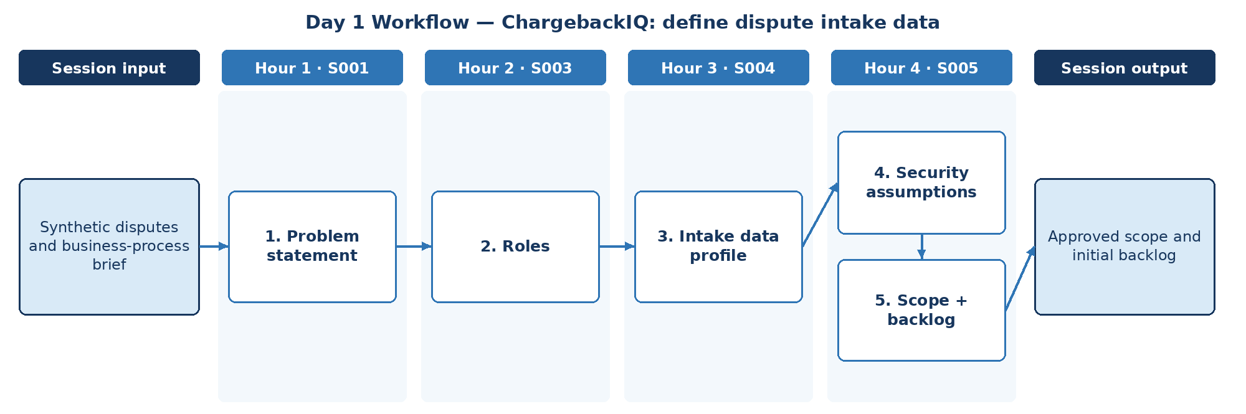

D. Steps to Perform the Work – and Why
Step | Hour · IDs | What to perform | Why this step is required | Expected output
1 | H1 · S001 | Write the ChargebackIQ problem statement using 5W1H from the business-process brief. | A capstone without a measurable problem cannot be accepted. | Problem statement
2 | H2 · S003 | Identify roles: dispute investigator, reviewer, approver, customer-service agent, risk/compliance. | Decision rights shape every later control, permission and escalation rule. | Role list
3 | H3 · S004 | Profile synthetic disputes.csv with Python data structures: counts by reason code, amount bands, deadline distribution. | Scope must be grounded in the data actually available. | Dispute data profile
4 | H4 · S005 | Record security and privacy assumptions (masked PAN, no live card data, synthetic only). | Stating assumptions up front prevents unsafe use of card or customer data. | Security assumptions
5 | H4 · S005 | Obtain scope approval and create the initial backlog. | A backlog turns scope into deliverable milestones. | Approved scope + initial backlog

E. Detailed Execution Instructions
Step 1 – Write the ChargebackIQ problem statement using 5W1H from the business-process brief.
Hour / source IDs: Hour 1 · S001
How to perform: State the dispute lifecycle pain (time to respond, missed deadlines, evidence gaps) and the measurable target.
Why: A capstone without a measurable problem cannot be accepted.
Output to retain: Problem statement
Step 2 – Identify roles: dispute investigator, reviewer, approver, customer-service agent, risk/compliance.
Hour / source IDs: Hour 2 · S003
How to perform: One line per role: responsibility and decision authority.
Why: Decision rights shape every later control, permission and escalation rule.
Output to retain: Role list
Step 3 – Profile synthetic disputes.csv with Python data structures: counts by reason code, amount bands, deadline distribution.
Hour / source IDs: Hour 3 · S004
How to perform: Use dicts/Counters by reason code; flag missing fields; note sensitive fields to mask.
Why: Scope must be grounded in the data actually available.
Output to retain: Dispute data profile
Step 4 – Record security and privacy assumptions (masked PAN, no live card data, synthetic only).
Hour / source IDs: Hour 4 · S005
How to perform: List assumptions with owner and verification method.
Why: Stating assumptions up front prevents unsafe use of card or customer data.
Output to retain: Security assumptions
Step 5 – Obtain scope approval and create the initial backlog.
Hour / source IDs: Hour 4 · S005
How to perform: Backlog items mapped to Days 2–18 milestones; record approver.
Why: A backlog turns scope into deliverable milestones.
Output to retain: Approved scope + initial backlog

F. Session Input → Work → Output
Input | Work performed | Output
Synthetic disputes and business-process brief | Problem statement → Roles → Intake data profile → Security assumptions → Scope + backlog | Approved scope and initial backlog

G. Validation / Exit Criteria
- The required output exists: Approved scope and initial backlog.
- The problem statement contains a measurable target.
- Every backlog item traces to the approved scope.
- Every step traces to its hourly block and source IDs (S001, S003, S004, S005); no TOC topic is skipped or re-worded.
- The workflow diagram matches the work actually performed.
- The human decision boundary is preserved wherever the session touches a consequential decision.
- Open gaps or assumptions (including tool or platform access) are recorded rather than silently filled.

H. Carry-Forward
Approved scope and initial backlog becomes an explicit input for Day 2 — ChargebackIQ: establish AI suitability (Day 2 input: Sample dispute records and roles).

Day 2: GenAI – establish AI suitability
Session duration | 4h = 1.25h concept + 2.75h lab (4 × 1-hour blocks)
Exact modules | Gen AI & Challenges
Source IDs (primary) | S006, S007, S008, S009, S010
Repeated source IDs (application) | S001, S003, S004, S005
Input | Sample dispute records and roles
Guided implementation (workbook) | Decide which tasks need deterministic code versus GenAI.
Primary output | Human-versus-AI responsibility table
Human decision / governance | ChargebackIQ may assemble evidence, track deadlines and draft recommendations. Accept/represent decisions, customer credits and network submissions are made by authorised dispute investigators and approvers; high-value or near-deadline disputes require approver sign-off.
Mapping ID / section locator | CAP-02 | Day 02 / CAP-02
Slide deck | Day02_SourceLocked_5W1H_Architecture.pptx
Code mapping / status | Reference app codebase + planned day-specific lab (not yet standalone)
Architecture / workflow (workbook) | Banking record → AI task boundary → Draft explanation → Reviewer

A. Exact TOC Topics for This Session (unchanged)
Source ID | Exact topic + subtopic
S006 | Gen AI & Challenges | AI vs ML vs GenAI
S007 | Core Principles of GenAI
S008 | Types of GenAI Models
S009 | How Generative Models Create Data; Key Challenges: Bias, Hallucination, Stochasticity
S010 | Business and Technical Challenges in Deployment

B. Hourly Session Break-up (from the workbook Hourly Plan)
Hour | Intention | Source IDs | Exact source words | Revisit IDs | Capstone work in this hour | Steps
Hour 1  (00:00–01:00) | Theory and 5W1H | S006 | Gen AI & Challenges | AI vs ML vs GenAI | — | Task inventory | 1
Hour 2  (01:00–02:00) | Instructor demonstration | S007 | Core Principles of GenAI | — | GenAI principles fit | 2
Hour 3  (02:00–03:00) | Guided BankAssist implementation | S008 | Types of GenAI Models | — | Model types | 3
Hour 4  (03:00–04:00) | ReconAI assignment launch and evidence | S009, S010 | How Generative Models Create Data; Key Challenges: Bias, Hallucination, Stochasticity  Business and Technical Challenges in Deployment | — | Risk + deployment challenges; Responsibility table | 4, 5

C. Workflow Diagram for This Session
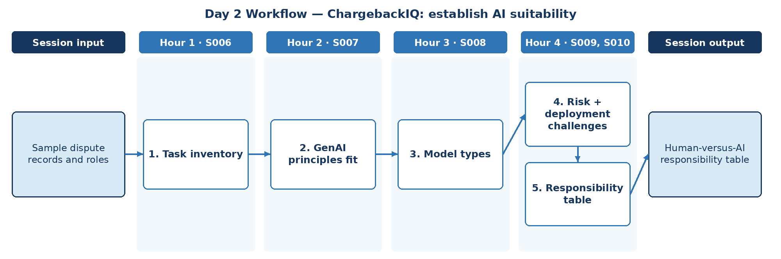

D. Steps to Perform the Work – and Why
Step | Hour · IDs | What to perform | Why this step is required | Expected output
1 | H1 · S006 | List every dispute-handling task from intake to closure. | AI suitability can only be judged task by task, not for the whole process. | Task inventory
2 | H2 · S007 | Apply core GenAI principles to decide where generation helps (drafting, summarising evidence). | GenAI should be used for drafting and summarising, not for rule-based steps. | GenAI fit notes
3 | H3 · S008 | Identify GenAI model types relevant to text and document evidence. | Receipts, letters and images may need different model capabilities. | Model type shortlist
4 | H4 · S009, S010 | Record bias, hallucination, stochasticity and deployment challenges for dispute decisions. | Dispute outcomes affect customers and merchants financially. | Risk notes
5 | H4 · S009, S010 | Decide deterministic code vs GenAI vs human per task. | Establishes the human decision boundary that the capstone is assessed against. | Human-versus-AI responsibility table

E. Detailed Execution Instructions
Step 1 – List every dispute-handling task from intake to closure.
Hour / source IDs: Hour 1 · S006
How to perform: Intake, eligibility, deadline tracking, evidence gathering, narrative drafting, decision, submission.
Why: AI suitability can only be judged task by task, not for the whole process.
Output to retain: Task inventory
Step 2 – Apply core GenAI principles to decide where generation helps (drafting, summarising evidence).
Hour / source IDs: Hour 2 · S007
How to perform: Mark each task generative/non-generative with a reason.
Why: GenAI should be used for drafting and summarising, not for rule-based steps.
Output to retain: GenAI fit notes
Step 3 – Identify GenAI model types relevant to text and document evidence.
Hour / source IDs: Hour 3 · S008
How to perform: Text LLM, document/vision-capable model; note constraints.
Why: Receipts, letters and images may need different model capabilities.
Output to retain: Model type shortlist
Step 4 – Record bias, hallucination, stochasticity and deployment challenges for dispute decisions.
Hour / source IDs: Hour 4 · S009, S010
How to perform: One risk per task with mitigation.
Why: Dispute outcomes affect customers and merchants financially.
Output to retain: Risk notes
Step 5 – Decide deterministic code vs GenAI vs human per task.
Hour / source IDs: Hour 4 · S009, S010
How to perform: Columns: task, code, AI draft, human decision; approver named.
Why: Establishes the human decision boundary that the capstone is assessed against.
Output to retain: Human-versus-AI responsibility table

F. Session Input → Work → Output
Input | Work performed | Output
Sample dispute records and roles | Task inventory → GenAI principles fit → Model types → Risk + deployment challenges → Responsibility table | Human-versus-AI responsibility table

G. Validation / Exit Criteria
- The required output exists: Human-versus-AI responsibility table.
- Every dispute decision is assigned to a human role.
- Deadline calculation is deterministic code.
- Every step traces to its hourly block and source IDs (S006, S007, S008, S009, S010); no TOC topic is skipped or re-worded.
- The workflow diagram matches the work actually performed.
- The human decision boundary is preserved wherever the session touches a consequential decision.
- Open gaps or assumptions (including tool or platform access) are recorded rather than silently filled.

H. Carry-Forward
Human-versus-AI responsibility table becomes an explicit input for Day 3 — ChargebackIQ: policy and privacy requirements (Day 3 input: Dispute sample plus masked identities).

Day 3: GenAI + Prompts – policy and privacy requirements
Session duration | 4h = 1.25h concept + 2.75h lab (4 × 1-hour blocks)
Exact modules | Gen AI & Challenges | Prompt Engineering
Source IDs (primary) | S011, S012, S013, S014, S015, S016
Repeated source IDs (application) | S006, S007, S008, S009, S010
Input | Dispute sample plus masked identities
Guided implementation (workbook) | Create safe prompt/data-handling acceptance criteria.
Primary output | Security acceptance checklist
Human decision / governance | ChargebackIQ may assemble evidence, track deadlines and draft recommendations. Accept/represent decisions, customer credits and network submissions are made by authorised dispute investigators and approvers; high-value or near-deadline disputes require approver sign-off.
Mapping ID / section locator | CAP-03 | Day 03 / CAP-03
Slide deck | Day03_SourceLocked_5W1H_Architecture.pptx
Code mapping / status | Reference app codebase + planned day-specific lab (not yet standalone)
Architecture / workflow (workbook) | Masked records → Prompt contract → Model → Rule validation

A. Exact TOC Topics for This Session (unchanged)
Source ID | Exact topic + subtopic
S011 | Guardrail Solutions: Bias Mitigation (balanced datasets, fairness metrics, post-processing)
S012 | Security Approaches (prompt injection defense, data anonymization, differential privacy)
S013 | Guardrail Techniques (RLHF, Constitutional AI, red-teaming, moderation APIs)
S014 | Prompt Engineering | Prompt Anatomy & Context Types
S015 | Zero-shot, One-shot, Few-shot Prompting
S016 | Chain-of-Thought Prompting

B. Hourly Session Break-up (from the workbook Hourly Plan)
Hour | Intention | Source IDs | Exact source words | Revisit IDs | Capstone work in this hour | Steps
Hour 1  (00:00–01:00) | Theory and 5W1H | S011 | Guardrail Solutions: Bias Mitigation (balanced datasets, fairness metrics, post-processing) | — | Fairness criteria | 1
Hour 2  (01:00–02:00) | Instructor demonstration | S012, S013 | Security Approaches (prompt injection defense, data anonymization, differential privacy)  Guardrail Techniques (RLHF, Constitutional AI, red-teaming, moderation APIs) | — | Data-handling criteria | 2
Hour 3  (02:00–03:00) | Guided BankAssist implementation | S014 | Prompt Engineering | Prompt Anatomy & Context Types | — | Prompt contract | 3
Hour 4  (03:00–04:00) | ReconAI assignment launch and evidence | S015, S016 | Zero-shot, One-shot, Few-shot Prompting  Chain-of-Thought Prompting | — | Prompt tests; Checklist | 4, 5

C. Workflow Diagram for This Session
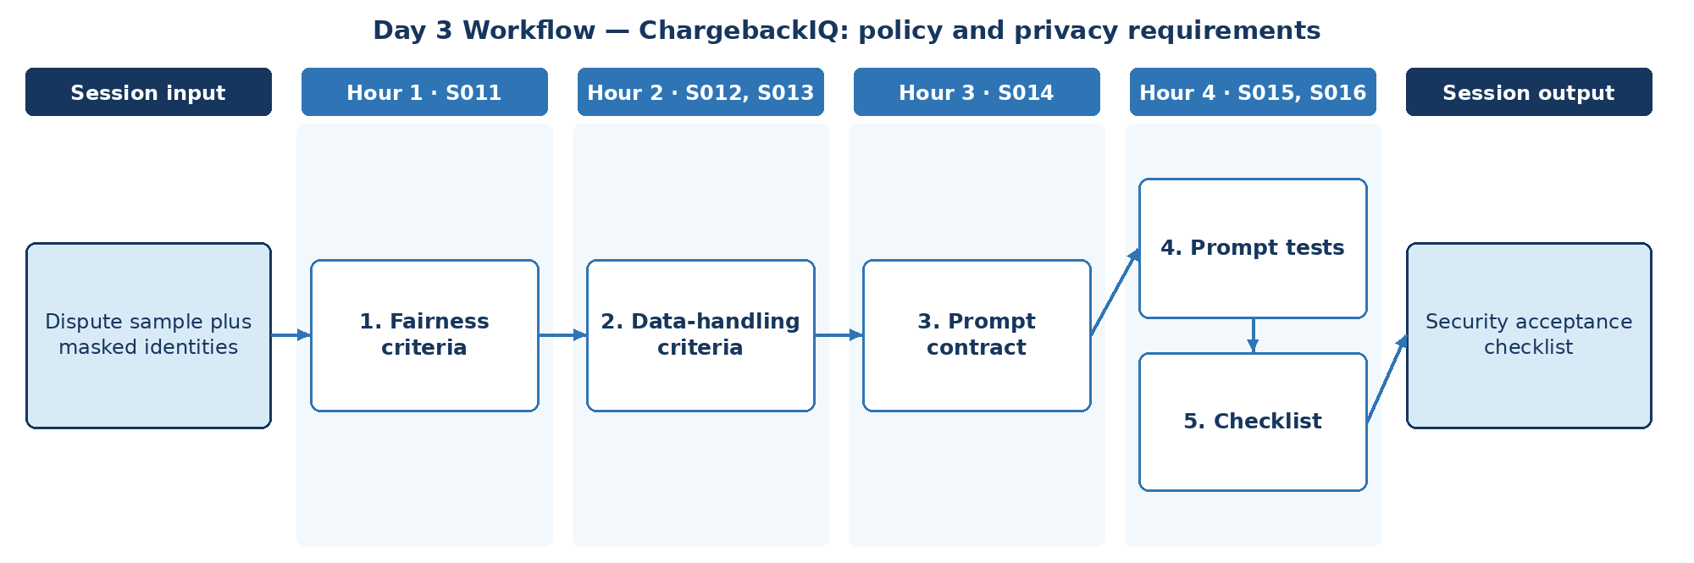

D. Steps to Perform the Work – and Why
Step | Hour · IDs | What to perform | Why this step is required | Expected output
1 | H1 · S011 | Define fairness acceptance criteria for dispute narratives across customer and merchant types. | Consistent treatment is a regulatory expectation. | Fairness criteria
2 | H2 · S012, S013 | Define masking, injection defence and guardrail acceptance criteria. | Dispute text and merchant evidence are untrusted. | Data-handling criteria
3 | H3 · S014 | Specify required prompt anatomy for the capstone. | A prompt contract makes prompts reviewable at acceptance. | Prompt contract
4 | H4 · S015, S016 | Define zero/one/few-shot and CoT tests that must pass. | Acceptance requires test evidence, not claims of prompt quality. | Prompt test criteria
5 | H4 · S015, S016 | Assemble the security acceptance checklist. | A single checklist gives reviewers one artefact for security sign-off. | Security acceptance checklist

E. Detailed Execution Instructions
Step 1 – Define fairness acceptance criteria for dispute narratives across customer and merchant types.
Hour / source IDs: Hour 1 · S011
How to perform: Balanced test set; tone and outcome-language checks.
Why: Consistent treatment is a regulatory expectation.
Output to retain: Fairness criteria
Step 2 – Define masking, injection defence and guardrail acceptance criteria.
Hour / source IDs: Hour 2 · S012, S013
How to perform: Mask PAN/names; delimit evidence text; injection tests must pass.
Why: Dispute text and merchant evidence are untrusted.
Output to retain: Data-handling criteria
Step 3 – Specify required prompt anatomy for the capstone.
Hour / source IDs: Hour 3 · S014
How to perform: Role, task, context, constraints, output format, escalation.
Why: A prompt contract makes prompts reviewable at acceptance.
Output to retain: Prompt contract
Step 4 – Define zero/one/few-shot and CoT tests that must pass.
Hour / source IDs: Hour 4 · S015, S016
How to perform: Define zero-, one-, few-shot and CoT test sets from masked disputes; set a pass threshold per test type (e.g., ≥ 90% correct reason-code handling, 100% escalation on trigger cases).
Why: Acceptance requires test evidence, not claims of prompt quality.
Output to retain: Prompt test criteria
Step 5 – Assemble the security acceptance checklist.
Hour / source IDs: Hour 4 · S015, S016
How to perform: Combine fairness, data-handling, prompt and test criteria into one checklist with columns: item, test, pass threshold, evidence location, owner.
Why: A single checklist gives reviewers one artefact for security sign-off.
Output to retain: Security acceptance checklist

F. Session Input → Work → Output
Input | Work performed | Output
Dispute sample plus masked identities | Fairness criteria → Data-handling criteria → Prompt contract → Prompt tests → Checklist | Security acceptance checklist

G. Validation / Exit Criteria
- The required output exists: Security acceptance checklist.
- Each checklist item has a test and pass threshold.
- Masking is verified on the sample.
- Every step traces to its hourly block and source IDs (S011, S012, S013, S014, S015, S016); no TOC topic is skipped or re-worded.
- The workflow diagram matches the work actually performed.
- The human decision boundary is preserved wherever the session touches a consequential decision.
- Open gaps or assumptions (including tool or platform access) are recorded rather than silently filled.

H. Carry-Forward
Security acceptance checklist becomes an explicit input for Day 4 — ChargebackIQ: model choice decision record (Day 4 input: Document and image evidence mock examples).

Day 4: Prompts + Models – model choice decision record
Session duration | 4h = 1.25h concept + 2.75h lab (4 × 1-hour blocks)
Exact modules | Prompt Engineering | LLM/LRM/LMM
Source IDs (primary) | S017, S018, S019, S020, S021, S022
Repeated source IDs (application) | S014, S015, S016
Input | Document and image evidence mock examples
Guided implementation (workbook) | Choose suitable model interfaces and identify unsupported evidence types.
Primary output | Model decision record
Human decision / governance | ChargebackIQ may assemble evidence, track deadlines and draft recommendations. Accept/represent decisions, customer credits and network submissions are made by authorised dispute investigators and approvers; high-value or near-deadline disputes require approver sign-off.
Mapping ID / section locator | CAP-04 | Day 04 / CAP-04
Slide deck | Day04_SourceLocked_5W1H_Architecture.pptx
Code mapping / status | Reference app codebase + planned day-specific lab (not yet standalone)
Architecture / workflow (workbook) | Prompt → Structured model I/O → JSON schema → Escalation

A. Exact TOC Topics for This Session (unchanged)
Source ID | Exact topic + subtopic
S017 | Prompt Interventions & Prompt Tuning
S018 | Adversarial Prompting & Prompt Security
S019 | Prompts for Agents & ReAct-style Prompting
S020 | *Structured Output Prompting (JSON mode, schemas, function-call prompts)*
S021 | LLM/LRM/LMM | LLMs vs LRMs vs LMMs
S022 | Transformers Architecture, Scaling Laws

B. Hourly Session Break-up (from the workbook Hourly Plan)
Hour | Intention | Source IDs | Exact source words | Revisit IDs | Capstone work in this hour | Steps
Hour 1  (00:00–01:00) | Theory and 5W1H | S017 | Prompt Interventions & Prompt Tuning | — | Prompt change control | 1
Hour 2  (01:00–02:00) | Instructor demonstration | S018, S019 | Adversarial Prompting & Prompt Security  Prompts for Agents & ReAct-style Prompting | — | Adversarial + agent prompts | 2
Hour 3  (02:00–03:00) | Guided BankAssist implementation | S020 | *Structured Output Prompting (JSON mode, schemas, function-call prompts)* | — | Structured output | 3
Hour 4  (03:00–04:00) | ReconAI assignment launch and evidence | S021, S022 | LLM/LRM/LMM | LLMs vs LRMs vs LMMs  Transformers Architecture, Scaling Laws | — | Model decision record | 4

C. Workflow Diagram for This Session
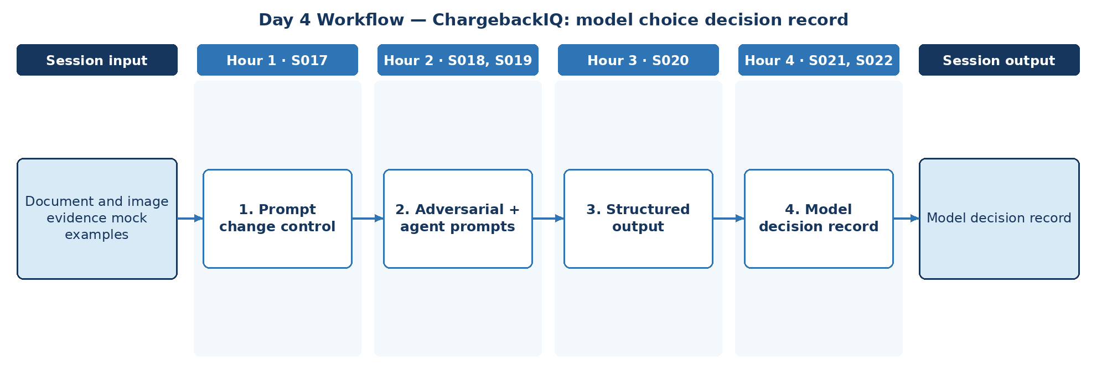

D. Steps to Perform the Work – and Why
Step | Hour · IDs | What to perform | Why this step is required | Expected output
1 | H1 · S017 | Define prompt versioning and change control for the capstone. | Prompt changes must be traceable when the capstone is accepted. | Change-control rule
2 | H2 · S018, S019 | Specify adversarial tests and agent-style prompt requirements for evidence gathering. | Merchant documents may contain manipulative text. | Adversarial test list
3 | H3 · S020 | Define structured output for dispute recommendations. | Reviewers and downstream systems need validated, predictable fields. | Recommendation schema
4 | H4 · S021, S022 | Choose model interfaces (LLM/LRM/LMM) and identify unsupported evidence types. | Some evidence cannot be processed reliably and must go to humans. | Model decision record

E. Detailed Execution Instructions
Step 1 – Define prompt versioning and change control for the capstone.
Hour / source IDs: Hour 1 · S017
How to perform: Assign version IDs to prompts; require a change-log entry and re-run of tests for every change.
Why: Prompt changes must be traceable when the capstone is accepted.
Output to retain: Change-control rule
Step 2 – Specify adversarial tests and agent-style prompt requirements for evidence gathering.
Hour / source IDs: Hour 2 · S018, S019
How to perform: List attack cases hidden in merchant documents (instructions to accept, fake approvals); specify read-only agent actions for evidence gathering.
Why: Merchant documents may contain manipulative text.
Output to retain: Adversarial test list
Step 3 – Define structured output for dispute recommendations.
Hour / source IDs: Hour 3 · S020
How to perform: Fields: dispute_id, reason_code, evidence_refs, recommendation (accept/represent/need-info), deadline, requires_approval=true.
Why: Reviewers and downstream systems need validated, predictable fields.
Output to retain: Recommendation schema
Step 4 – Choose model interfaces (LLM/LRM/LMM) and identify unsupported evidence types.
Hour / source IDs: Hour 4 · S021, S022
How to perform: Options, choice, unsupported types (e.g., handwritten receipts) routed to humans.
Why: Some evidence cannot be processed reliably and must go to humans.
Output to retain: Model decision record

F. Session Input → Work → Output
Input | Work performed | Output
Document and image evidence mock examples | Prompt change control → Adversarial + agent prompts → Structured output → Model decision record | Model decision record

G. Validation / Exit Criteria
- The required output exists: Model decision record.
- requires_approval is always true in the schema.
- Unsupported evidence types are routed to humans.
- Every step traces to its hourly block and source IDs (S017, S018, S019, S020, S021, S022); no TOC topic is skipped or re-worded.
- The workflow diagram matches the work actually performed.
- The human decision boundary is preserved wherever the session touches a consequential decision.
- Open gaps or assumptions (including tool or platform access) are recorded rather than silently filled.

H. Carry-Forward
Model decision record becomes an explicit input for Day 5 — ChargebackIQ: document input planning (Day 5 input: Receipt/merchant evidence examples).

Day 5: Models + LangChain – document input planning
Session duration | 4h = 1.25h concept + 2.75h lab (4 × 1-hour blocks)
Exact modules | LLM/LRM/LMM | Agentic Workflows – LangChain Essentials
Source IDs (primary) | S023, S024, S025, S026, S027
Repeated source IDs (application) | S021, S022
Input | Receipt/merchant evidence examples
Guided implementation (workbook) | Decide evidence handling for text versus multimodal sources.
Primary output | Data-processing design note
Human decision / governance | ChargebackIQ may assemble evidence, track deadlines and draft recommendations. Accept/represent decisions, customer credits and network submissions are made by authorised dispute investigators and approvers; high-value or near-deadline disputes require approver sign-off.
Mapping ID / section locator | CAP-05 | Day 05 / CAP-05
Slide deck | Day05_SourceLocked_5W1H_Architecture.pptx
Code mapping / status | Reference app codebase + planned day-specific lab (not yet standalone)
Architecture / workflow (workbook) | Banking SOP → Tokenizer/Embeddings → LLM config

A. Exact TOC Topics for This Session (unchanged)
Source ID | Exact topic + subtopic
S023 | Tokenization & Embedding Techniques (Byte Pair Encoding)
S024 | Reasoning Tokens & Inference Strategies
S025 | Max New Tokens, Sampling, Temperature, Top_K, Top_P
S026 | LMMs: DALL-E, Imagen, Diffusion Models
S027 | Agentic Workflows – LangChain Essentials | Introduction to LangChain Architecture

B. Hourly Session Break-up (from the workbook Hourly Plan)
Hour | Intention | Source IDs | Exact source words | Revisit IDs | Capstone work in this hour | Steps
Hour 1  (00:00–01:00) | Theory and 5W1H | S023 | Tokenization & Embedding Techniques (Byte Pair Encoding) | — | Evidence token/embedding | 1
Hour 2  (01:00–02:00) | Instructor demonstration | S024 | Reasoning Tokens & Inference Strategies | — | Inference strategy | 2
Hour 3  (02:00–03:00) | Guided BankAssist implementation | S025 | Max New Tokens, Sampling, Temperature, Top_K, Top_P | — | Generation settings | 3
Hour 4  (03:00–04:00) | ReconAI assignment launch and evidence | S026, S027 | LMMs: DALL-E, Imagen, Diffusion Models  Agentic Workflows – LangChain Essentials | Introduction to LangChain Architecture | — | Text vs multimodal | 4

C. Workflow Diagram for This Session
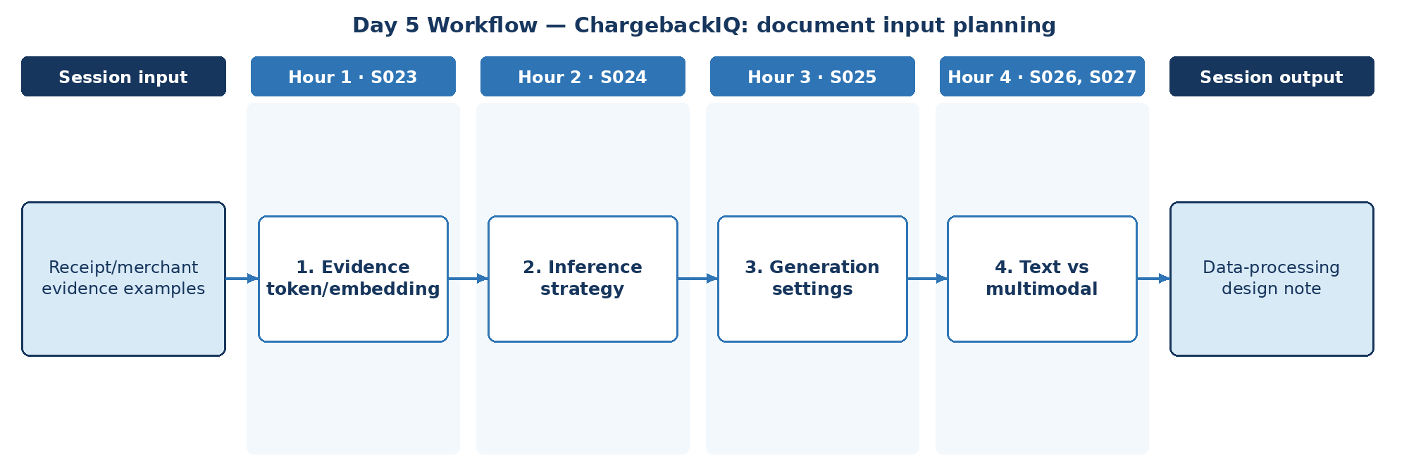

D. Steps to Perform the Work – and Why
Step | Hour · IDs | What to perform | Why this step is required | Expected output
1 | H1 · S023 | Estimate token sizes and embedding approach for receipt and merchant text evidence. | Evidence size drives cost, context limits and chunking. | Evidence sizing note
2 | H2 · S024 | Decide where reasoning is needed (complex multi-document disputes). | Reasoning adds cost and latency; enable it only for complex disputes. | Inference decision
3 | H3 · S025 | Set generation parameters for recommendations and narratives. | Recommendations feed regulated decisions and must be stable. | Generation settings
4 | H4 · S026, S027 | Decide evidence handling for text vs multimodal sources and map to LangChain components. | Image evidence needs a different pipeline and a human fallback. | Data-processing design note

E. Detailed Execution Instructions
Step 1 – Estimate token sizes and embedding approach for receipt and merchant text evidence.
Hour / source IDs: Hour 1 · S023
How to perform: Estimate tokens per evidence type (receipts, merchant letters, delivery proofs); choose an embedding approach for text evidence.
Why: Evidence size drives cost, context limits and chunking.
Output to retain: Evidence sizing note
Step 2 – Decide where reasoning is needed (complex multi-document disputes).
Hour / source IDs: Hour 2 · S024
How to perform: Define criteria for enabling reasoning (multiple documents, conflicting dates); disable it for simple reason codes.
Why: Reasoning adds cost and latency; enable it only for complex disputes.
Output to retain: Inference decision
Step 3 – Set generation parameters for recommendations and narratives.
Hour / source IDs: Hour 3 · S025
How to perform: Set low temperature and bounded max tokens for recommendations; record rationale.
Why: Recommendations feed regulated decisions and must be stable.
Output to retain: Generation settings
Step 4 – Decide evidence handling for text vs multimodal sources and map to LangChain components.
Hour / source IDs: Hour 4 · S026, S027
How to perform: Per evidence type: extraction method, model, human fallback.
Why: Image evidence needs a different pipeline and a human fallback.
Output to retain: Data-processing design note

F. Session Input → Work → Output
Input | Work performed | Output
Receipt/merchant evidence examples | Evidence token/embedding → Inference strategy → Generation settings → Text vs multimodal | Data-processing design note

G. Validation / Exit Criteria
- The required output exists: Data-processing design note.
- Every evidence type has a processing route.
- Generation settings are justified.
- Every step traces to its hourly block and source IDs (S023, S024, S025, S026, S027); no TOC topic is skipped or re-worded.
- The workflow diagram matches the work actually performed.
- The human decision boundary is preserved wherever the session touches a consequential decision.
- Open gaps or assumptions (including tool or platform access) are recorded rather than silently filled.

H. Carry-Forward
Data-processing design note becomes an explicit input for Day 6 — ChargebackIQ: workflow scaffolding (Day 6 input: Case phases and document inventory).

Day 6: LangChain + RAG – workflow scaffolding
Session duration | 4h = 1.25h concept + 2.75h lab (4 × 1-hour blocks)
Exact modules | Agentic Workflows – LangChain Essentials | Retrieval-Augmented Generation (RAG)
Source IDs (primary) | S028, S029, S030, S031, S032, S033
Repeated source IDs (application) | S027
Input | Case phases and document inventory
Guided implementation (workbook) | Specify modular intake/retrieval/review services.
Primary output | Service responsibility chart
Human decision / governance | ChargebackIQ may assemble evidence, track deadlines and draft recommendations. Accept/represent decisions, customer credits and network submissions are made by authorised dispute investigators and approvers; high-value or near-deadline disputes require approver sign-off.
Mapping ID / section locator | CAP-06 | Day 06 / CAP-06
Slide deck | Day06_SourceLocked_5W1H_Architecture.pptx
Code mapping / status | Reference app codebase + planned day-specific lab (not yet standalone)
Architecture / workflow (workbook) | Request → LangChain chain → Mock tools → RAG retriever

A. Exact TOC Topics for This Session (unchanged)
Source ID | Exact topic + subtopic
S028 | Model I/O & Integration
S029 | Chains, Prompt Templates, Sequential Flows
S030 | Memory & Context Handling
S031 | Tool/Agent Integration
S032 | Hands-on Workflow Creation
S033 | Retrieval-Augmented Generation (RAG) | Introduction to RAG & Its Importance

B. Hourly Session Break-up (from the workbook Hourly Plan)
Hour | Intention | Source IDs | Exact source words | Revisit IDs | Capstone work in this hour | Steps
Hour 1  (00:00–01:00) | Theory and 5W1H | S028 | Model I/O & Integration | — | Service I/O | 1
Hour 2  (01:00–02:00) | Instructor demonstration | S029, S030 | Chains, Prompt Templates, Sequential Flows  Memory & Context Handling | — | Chains + memory | 2
Hour 3  (02:00–03:00) | Guided BankAssist implementation | S031 | Tool/Agent Integration | — | Tool integration | 3
Hour 4  (03:00–04:00) | ReconAI assignment launch and evidence | S032, S033 | Hands-on Workflow Creation  Retrieval-Augmented Generation (RAG) | Introduction to RAG & Its Importance | — | Responsibility chart | 4

C. Workflow Diagram for This Session
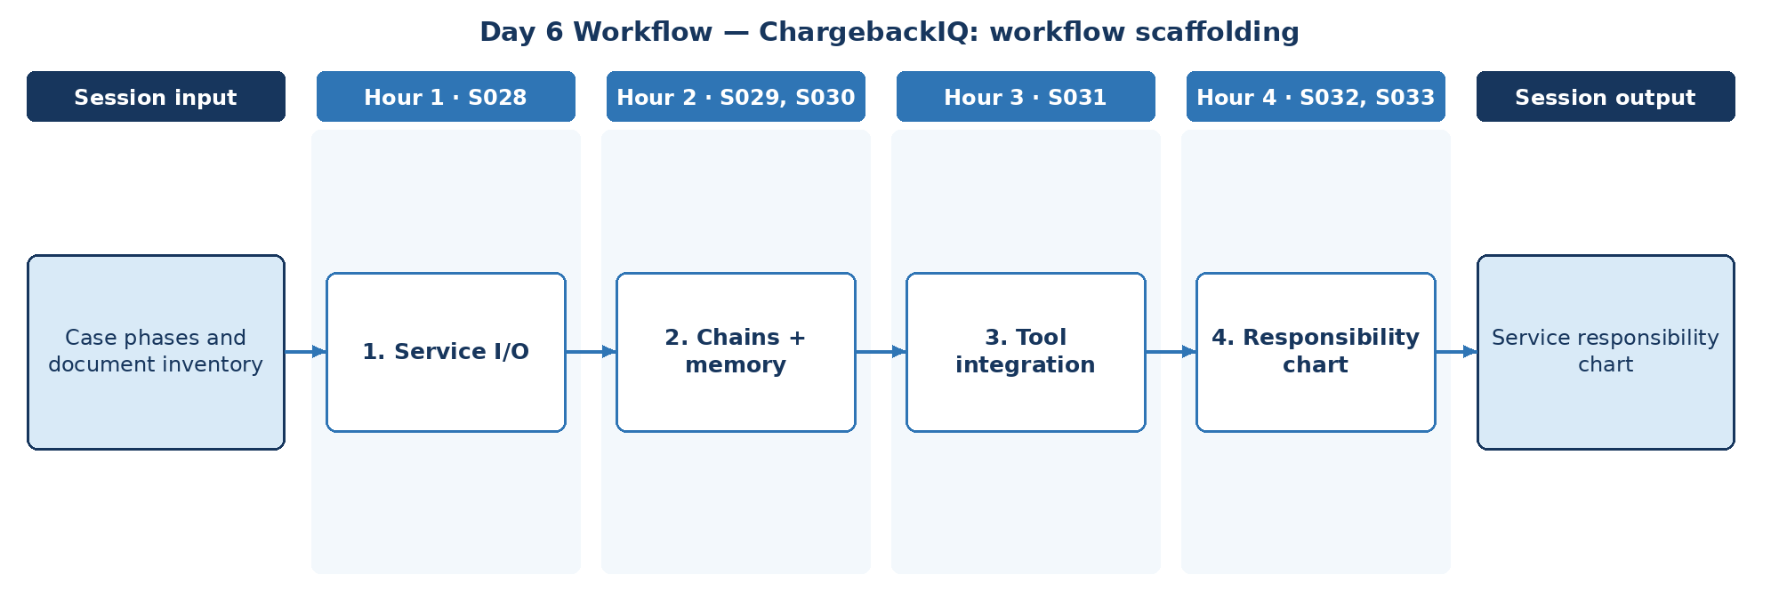

D. Steps to Perform the Work – and Why
Step | Hour · IDs | What to perform | Why this step is required | Expected output
1 | H1 · S028 | Define I/O contracts between intake, retrieval and review services. | Modular services can only be integrated and tested with clear contracts. | Service I/O contracts
2 | H2 · S029, S030 | Specify chain flow and case memory across phases. | Disputes span days; memory must be per case, masked and retained correctly. | Chain + memory spec
3 | H3 · S031 | List tools each service may call. | Declaring tools per service limits what each service can do. | Tool list per service
4 | H4 · S032, S033 | Produce the service responsibility chart including the RAG component. | One chart gives reviewers the whole service design at a glance. | Service responsibility chart

E. Detailed Execution Instructions
Step 1 – Define I/O contracts between intake, retrieval and review services.
Hour / source IDs: Hour 1 · S028
How to perform: Write request/response schemas for intake, retrieval and review services, including error responses and the correlation_id each call must carry.
Why: Modular services can only be integrated and tested with clear contracts.
Output to retain: Service I/O contracts
Step 2 – Specify chain flow and case memory across phases.
Hour / source IDs: Hour 2 · S029, S030
How to perform: Specify chain order per phase and per-case memory with retention and masking rules.
Why: Disputes span days; memory must be per case, masked and retained correctly.
Output to retain: Chain + memory spec
Step 3 – List tools each service may call.
Hour / source IDs: Hour 3 · S031
How to perform: List tools per service and mark each read-only or write; write tools only for the review service with approval.
Why: Declaring tools per service limits what each service can do.
Output to retain: Tool list per service
Step 4 – Produce the service responsibility chart including the RAG component.
Hour / source IDs: Hour 4 · S032, S033
How to perform: Build a chart: service, owner, inputs, outputs, tools, RAG contract reference.
Why: One chart gives reviewers the whole service design at a glance.
Output to retain: Service responsibility chart

F. Session Input → Work → Output
Input | Work performed | Output
Case phases and document inventory | Service I/O → Chains + memory → Tool integration → Responsibility chart | Service responsibility chart

G. Validation / Exit Criteria
- The required output exists: Service responsibility chart.
- No service has undeclared tools.
- The RAG component has a defined contract.
- Every step traces to its hourly block and source IDs (S028, S029, S030, S031, S032, S033); no TOC topic is skipped or re-worded.
- The workflow diagram matches the work actually performed.
- The human decision boundary is preserved wherever the session touches a consequential decision.
- Open gaps or assumptions (including tool or platform access) are recorded rather than silently filled.

H. Carry-Forward
Service responsibility chart becomes an explicit input for Day 7 — ChargebackIQ: dispute policy index design (Day 7 input: Chargeback policy and evidence list).

Day 7: RAG indexing – dispute policy index design
Session duration | 4h = 1.25h concept + 2.75h lab (4 × 1-hour blocks)
Exact modules | Retrieval-Augmented Generation (RAG)
Source IDs (primary) | S034, S035, S036, S037, S038, S039
Repeated source IDs (application) | S033
Input | Chargeback policy and evidence list
Guided implementation (workbook) | Build retrieval evaluation questions and index design.
Primary output | Policy index specification
Human decision / governance | ChargebackIQ may assemble evidence, track deadlines and draft recommendations. Accept/represent decisions, customer credits and network submissions are made by authorised dispute investigators and approvers; high-value or near-deadline disputes require approver sign-off.
Mapping ID / section locator | CAP-07 | Day 07 / CAP-07
Slide deck | Day07_SourceLocked_5W1H_Architecture.pptx
Code mapping / status | Reference app codebase + planned day-specific lab (not yet standalone)
Architecture / workflow (workbook) | Documents → Chunking → Vector store → Retrieval → Citations

A. Exact TOC Topics for This Session (unchanged)
Source ID | Exact topic + subtopic
S034 | Vector Databases for RAG (FAISS, Chroma)
S035 | Chunking Strategies in RAG Applications
S036 | Semantic Search vs. Exact Matching
S037 | RAG for Domain-Specific Applications
S038 | Optimizing RAG for Large-Scale AI Models
S039 | Real-Time Information Retrieval Using RAG

B. Hourly Session Break-up (from the workbook Hourly Plan)
Hour | Intention | Source IDs | Exact source words | Revisit IDs | Capstone work in this hour | Steps
Hour 1  (00:00–01:00) | Theory and 5W1H | S034 | Vector Databases for RAG (FAISS, Chroma) | — | Store choice | 1
Hour 2  (01:00–02:00) | Instructor demonstration | S035, S036 | Chunking Strategies in RAG Applications  Semantic Search vs. Exact Matching | — | Chunk + match plan | 2
Hour 3  (02:00–03:00) | Guided BankAssist implementation | S037 | RAG for Domain-Specific Applications | — | Evaluation questions | 3
Hour 4  (03:00–04:00) | ReconAI assignment launch and evidence | S038, S039 | Optimizing RAG for Large-Scale AI Models  Real-Time Information Retrieval Using RAG | — | Index specification | 4

C. Workflow Diagram for This Session
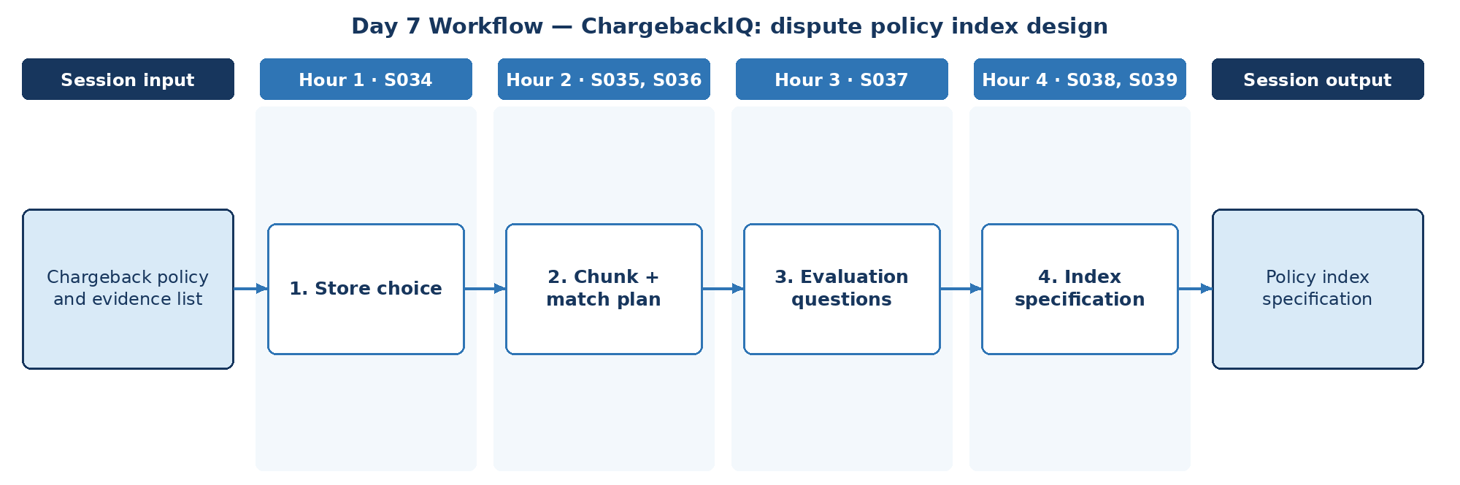

D. Steps to Perform the Work – and Why
Step | Hour · IDs | What to perform | Why this step is required | Expected output
1 | H1 · S034 | Choose a vector store for the dispute policy index. | Policy retrieval must filter by reason code and card network. | Store decision
2 | H2 · S035, S036 | Plan chunking of chargeback policy and exact matching for reason codes. | Reason codes and network rule IDs must match exactly, not approximately. | Chunk + match plan
3 | H3 · S037 | Build retrieval evaluation questions for dispute scenarios. | Index quality must be measurable before it is trusted. | Retrieval questions
4 | H4 · S038, S039 | Specify the policy index including scale and freshness rules. | Card-network rules change; the index must stay current. | Policy index specification

E. Detailed Execution Instructions
Step 1 – Choose a vector store for the dispute policy index.
Hour / source IDs: Hour 1 · S034
How to perform: Compare stores on metadata filtering by reason code and card network; record choice.
Why: Policy retrieval must filter by reason code and card network.
Output to retain: Store decision
Step 2 – Plan chunking of chargeback policy and exact matching for reason codes.
Hour / source IDs: Hour 2 · S035, S036
How to perform: Choose heading-aware chunking for policy rules; require exact match on reason codes and network rule IDs.
Why: Reason codes and network rule IDs must match exactly, not approximately.
Output to retain: Chunk + match plan
Step 3 – Build retrieval evaluation questions for dispute scenarios.
Hour / source IDs: Hour 3 · S037
How to perform: Write 20 dispute questions, each with the expected policy section.
Why: Index quality must be measurable before it is trusted.
Output to retain: Retrieval questions
Step 4 – Specify the policy index including scale and freshness rules.
Hour / source IDs: Hour 4 · S038, S039
How to perform: Specify fields, metadata (network, reason_code, version, effective_date), update cadence and re-index trigger.
Why: Card-network rules change; the index must stay current.
Output to retain: Policy index specification

F. Session Input → Work → Output
Input | Work performed | Output
Chargeback policy and evidence list | Store choice → Chunk + match plan → Evaluation questions → Index specification | Policy index specification

G. Validation / Exit Criteria
- The required output exists: Policy index specification.
- Every evaluation question has an expected section.
- Freshness rule names a trigger.
- Every step traces to its hourly block and source IDs (S034, S035, S036, S037, S038, S039); no TOC topic is skipped or re-worded.
- The workflow diagram matches the work actually performed.
- The human decision boundary is preserved wherever the session touches a consequential decision.
- Open gaps or assumptions (including tool or platform access) are recorded rather than silently filled.

H. Carry-Forward
Policy index specification becomes an explicit input for Day 8 — ChargebackIQ: evidence retrieval constraints (Day 8 input: Gold dispute questions, doc set).

Day 8: RAG advanced – evidence retrieval constraints
Session duration | 4h = 1.25h concept + 2.75h lab (4 × 1-hour blocks)
Exact modules | Retrieval-Augmented Generation (RAG)
Source IDs (primary) | S040, S041, S042, S043, S044, S045
Repeated source IDs (application) | S034, S035, S036, S037, S038, S039
Input | Gold dispute questions, doc set
Guided implementation (workbook) | Define evidence provenance and retrieval pass/fail gates.
Primary output | RAG quality-gate specification
Human decision / governance | ChargebackIQ may assemble evidence, track deadlines and draft recommendations. Accept/represent decisions, customer credits and network submissions are made by authorised dispute investigators and approvers; high-value or near-deadline disputes require approver sign-off.
Mapping ID / section locator | CAP-08 | Day 08 / CAP-08
Slide deck | Day08_SourceLocked_5W1H_Architecture.pptx
Code mapping / status | Reference app codebase + planned day-specific lab (not yet standalone)
Architecture / workflow (workbook) | Hybrid retrieval → Evidence selection → Faithfulness test

A. Exact TOC Topics for This Session (unchanged)
Source ID | Exact topic + subtopic
S040 | Challenges in RAG Implementation
S041 | Hybrid Search & Multi-Query RAG Systems
S042 | Multi-modal RAG
S043 | Agentic RAG: using an agent to determine how to retrieve the most relevant information before answering
S044 | *RAG Evaluation (faithfulness, retrieval precision/recall)*
S045 | Guidelines and Best Practices

B. Hourly Session Break-up (from the workbook Hourly Plan)
Hour | Intention | Source IDs | Exact source words | Revisit IDs | Capstone work in this hour | Steps
Hour 1  (00:00–01:00) | Theory and 5W1H | S040 | Challenges in RAG Implementation | — | Challenges | 1
Hour 2  (01:00–02:00) | Instructor demonstration | S041, S042 | Hybrid Search & Multi-Query RAG Systems  Multi-modal RAG | — | Retrieval options | 2
Hour 3  (02:00–03:00) | Guided BankAssist implementation | S043 | Agentic RAG: using an agent to determine how to retrieve the most relevant information before answering | — | Agentic retrieval | 3
Hour 4  (03:00–04:00) | ReconAI assignment launch and evidence | S044, S045 | *RAG Evaluation (faithfulness, retrieval precision/recall)*  Guidelines and Best Practices | — | Quality gates | 4

C. Workflow Diagram for This Session
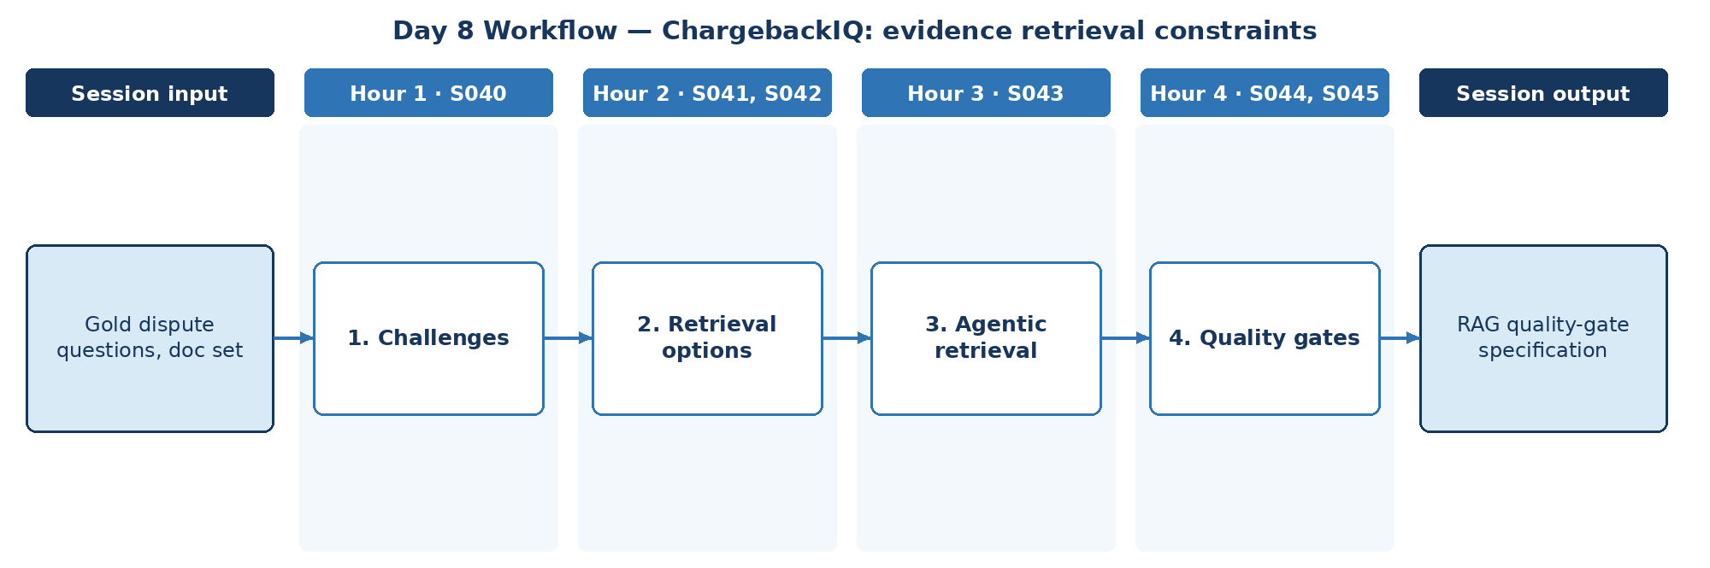

D. Steps to Perform the Work – and Why
Step | Hour · IDs | What to perform | Why this step is required | Expected output
1 | H1 · S040 | Identify RAG challenges specific to disputes (similar reason codes, outdated rules). | Gate design must target the challenges disputes actually present. | Challenge list
2 | H2 · S041, S042 | Decide hybrid/multi-query and multimodal retrieval requirements. | Dispute evidence spans text, documents and images. | Retrieval requirements
3 | H3 · S043 | Decide whether agentic retrieval is allowed and under what limits. | Autonomous retrieval must be bounded to approved sources. | Agentic retrieval rule
4 | H4 · S044, S045 | Define evidence provenance and retrieval pass/fail gates. | Acceptance needs objective, numeric retrieval thresholds. | RAG quality-gate specification

E. Detailed Execution Instructions
Step 1 – Identify RAG challenges specific to disputes (similar reason codes, outdated rules).
Hour / source IDs: Hour 1 · S040
How to perform: List dispute-specific RAG challenges (similar reason codes, outdated network rules, long merchant files) with mitigation.
Why: Gate design must target the challenges disputes actually present.
Output to retain: Challenge list
Step 2 – Decide hybrid/multi-query and multimodal retrieval requirements.
Hour / source IDs: Hour 2 · S041, S042
How to perform: State where hybrid and multi-query retrieval are required and where multimodal evidence needs extraction first.
Why: Dispute evidence spans text, documents and images.
Output to retain: Retrieval requirements
Step 3 – Decide whether agentic retrieval is allowed and under what limits.
Hour / source IDs: Hour 3 · S043
How to perform: Allow agentic source selection only across approved indexes with max steps; log every routing decision.
Why: Autonomous retrieval must be bounded to approved sources.
Output to retain: Agentic retrieval rule
Step 4 – Define evidence provenance and retrieval pass/fail gates.
Hour / source IDs: Hour 4 · S044, S045
How to perform: Set thresholds (e.g., faithfulness ≥ 0.9, precision@3 ≥ 0.8); require provenance fields (source, section, version, retrieved_at) on every evidence item.
Why: Acceptance needs objective, numeric retrieval thresholds.
Output to retain: RAG quality-gate specification

F. Session Input → Work → Output
Input | Work performed | Output
Gold dispute questions, doc set | Challenges → Retrieval options → Agentic retrieval → Quality gates | RAG quality-gate specification

G. Validation / Exit Criteria
- The required output exists: RAG quality-gate specification.
- Gates have numeric thresholds.
- Provenance is required for every evidence item.
- Every step traces to its hourly block and source IDs (S040, S041, S042, S043, S044, S045); no TOC topic is skipped or re-worded.
- The workflow diagram matches the work actually performed.
- The human decision boundary is preserved wherever the session touches a consequential decision.
- Open gaps or assumptions (including tool or platform access) are recorded rather than silently filled.

H. Carry-Forward
RAG quality-gate specification becomes an explicit input for Day 9 — ChargebackIQ: agent scope and permissions (Day 9 input: Dispute workflow and decision rights).

Day 9: Agent foundations – agent scope and permissions
Session duration | 4h = 1.25h concept + 2.75h lab (4 × 1-hour blocks)
Exact modules | Demystifying Agentic AI
Source IDs (primary) | S046, S047, S048, S049, S050, S051
Repeated source IDs (application) | S044, S045
Input | Dispute workflow and decision rights
Guided implementation (workbook) | Document investigator/reviewer/approver authority.
Primary output | Agent governance map
Human decision / governance | ChargebackIQ may assemble evidence, track deadlines and draft recommendations. Accept/represent decisions, customer credits and network submissions are made by authorised dispute investigators and approvers; high-value or near-deadline disputes require approver sign-off.
Mapping ID / section locator | CAP-09 | Day 09 / CAP-09
Slide deck | Day09_SourceLocked_5W1H_Architecture.pptx
Code mapping / status | Reference app codebase + planned day-specific lab (not yet standalone)
Architecture / workflow (workbook) | Case intake → Suitability decision → Read-only agent

A. Exact TOC Topics for This Session (unchanged)
Source ID | Exact topic + subtopic
S046 | Demystifying Agentic AI | Understanding Agentic vs. Non-Agentic AI Systems
S047 | Overview of Autonomous Agents
S048 | Agents vs. Models
S049 | What is an LLM Agent — Role of LLMs in Autonomous Systems
S050 | When (and When Not) to Use Agents
S051 | Questions to Ask Before Considering an AI Agent

B. Hourly Session Break-up (from the workbook Hourly Plan)
Hour | Intention | Source IDs | Exact source words | Revisit IDs | Capstone work in this hour | Steps
Hour 1  (00:00–01:00) | Theory and 5W1H | S046 | Demystifying Agentic AI | Understanding Agentic vs. Non-Agentic AI Systems | — | Agentic scope | 1
Hour 2  (01:00–02:00) | Instructor demonstration | S047, S048 | Overview of Autonomous Agents  Agents vs. Models | — | Agent components | 2
Hour 3  (02:00–03:00) | Guided BankAssist implementation | S049 | What is an LLM Agent — Role of LLMs in Autonomous Systems | — | LLM role | 3
Hour 4  (03:00–04:00) | ReconAI assignment launch and evidence | S050, S051 | When (and When Not) to Use Agents  Questions to Ask Before Considering an AI Agent | — | Authority map | 4

C. Workflow Diagram for This Session
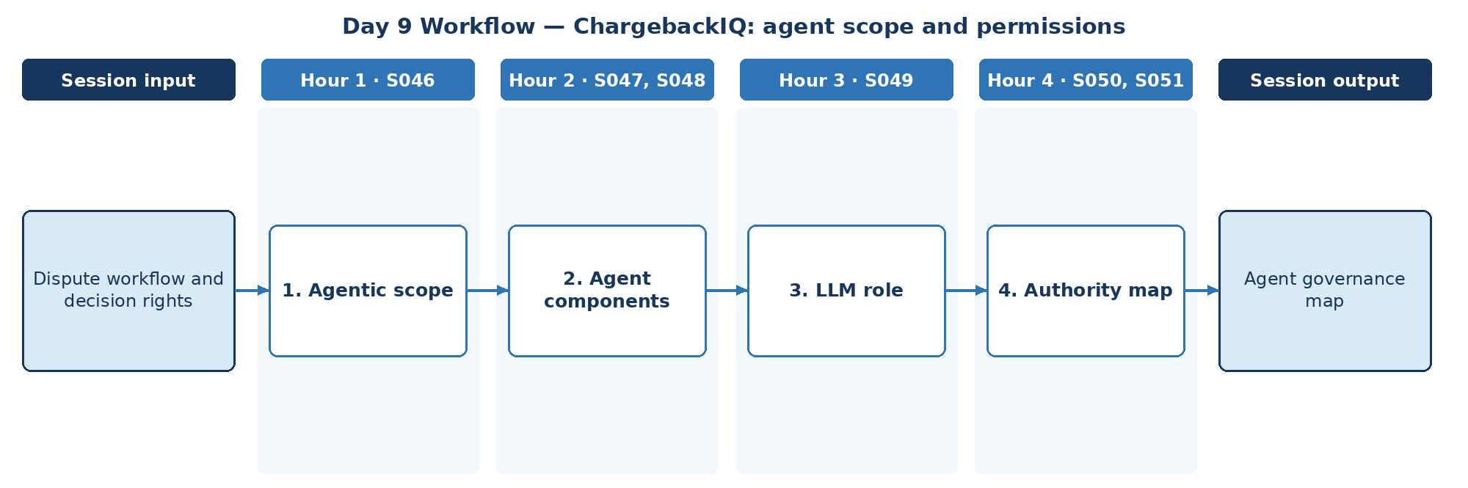

D. Steps to Perform the Work – and Why
Step | Hour · IDs | What to perform | Why this step is required | Expected output
1 | H1 · S046 | Decide which dispute steps may be agentic. | Autonomy is limited to low-risk evidence tasks. | Agentic scope
2 | H2 · S047, S048 | Identify agent vs model components for investigation. | Each component is a separate governance and test target. | Component map
3 | H3 · S049 | Define the LLM role in dispute investigation. | Dispute outcomes stay with authorised humans. | LLM role
4 | H4 · S050, S051 | Document investigator, reviewer and approver authority. | Separation of duties between investigator, reviewer and approver is mandatory. | Agent governance map

E. Detailed Execution Instructions
Step 1 – Decide which dispute steps may be agentic.
Hour / source IDs: Hour 1 · S046
How to perform: List dispute steps and mark agentic, deterministic or human; keep decisions and submissions out of agent scope.
Why: Autonomy is limited to low-risk evidence tasks.
Output to retain: Agentic scope
Step 2 – Identify agent vs model components for investigation.
Hour / source IDs: Hour 2 · S047, S048
How to perform: Label loop, tools, memory and model on the investigation flow.
Why: Each component is a separate governance and test target.
Output to retain: Component map
Step 3 – Define the LLM role in dispute investigation.
Hour / source IDs: Hour 3 · S049
How to perform: State the LLM gathers and summarises evidence and drafts narratives; it never decides outcomes.
Why: Dispute outcomes stay with authorised humans.
Output to retain: LLM role
Step 4 – Document investigator, reviewer and approver authority.
Hour / source IDs: Hour 4 · S050, S051
How to perform: Build a map: role, may do, may not do, evidence required, approver.
Why: Separation of duties between investigator, reviewer and approver is mandatory.
Output to retain: Agent governance map

F. Session Input → Work → Output
Input | Work performed | Output
Dispute workflow and decision rights | Agentic scope → Agent components → LLM role → Authority map | Agent governance map

G. Validation / Exit Criteria
- The required output exists: Agent governance map.
- The agent has no approval authority.
- Each role's authority is explicit.
- Every step traces to its hourly block and source IDs (S046, S047, S048, S049, S050, S051); no TOC topic is skipped or re-worded.
- The workflow diagram matches the work actually performed.
- The human decision boundary is preserved wherever the session touches a consequential decision.
- Open gaps or assumptions (including tool or platform access) are recorded rather than silently filled.

H. Carry-Forward
Agent governance map becomes an explicit input for Day 10 — ChargebackIQ: escalation trigger design (Day 10 input: Case lifecycle and action inventory).

Day 10: Agent runtime – escalation trigger design
Session duration | 4h = 1.25h concept + 2.75h lab (4 × 1-hour blocks)
Exact modules | Demystifying Agentic AI | Context, Harness & Loop Engineering
Source IDs (primary) | S052, S053, S054, S055, S056, S057, S058
Repeated source IDs (application) | S046, S047, S048, S049, S050, S051
Input | Case lifecycle and action inventory
Guided implementation (workbook) | Choose decisions requiring human approval.
Primary output | Escalation policy
Human decision / governance | ChargebackIQ may assemble evidence, track deadlines and draft recommendations. Accept/represent decisions, customer credits and network submissions are made by authorised dispute investigators and approvers; high-value or near-deadline disputes require approver sign-off.
Mapping ID / section locator | CAP-10 | Day 10 / CAP-10
Slide deck | Day10_SourceLocked_5W1H_Architecture.pptx
Code mapping / status | Reference app codebase + planned day-specific lab (not yet standalone)
Architecture / workflow (workbook) | Perceive → Plan → Allowed tool → Observe → Stop

A. Exact TOC Topics for This Session (unchanged)
Source ID | Exact topic + subtopic
S052 | ReAct Framework — Concept of Thought, Action, Input and Observation
S053 | Language-Action Agents
S054 | Agent Runtime — Orchestration Layer
S055 | Tools — Function Calling / Extensions
S056 | Context, Harness & Loop Engineering | *Context Engineering vs Prompt Engineering — what's the difference*
S057 | *Context Window Management (system/developer/user context layering)*
S058 | *Long-context Windows vs RAG — when to use which*

B. Hourly Session Break-up (from the workbook Hourly Plan)
Hour | Intention | Source IDs | Exact source words | Revisit IDs | Capstone work in this hour | Steps
Hour 1  (00:00–01:00) | Theory and 5W1H | S052 | ReAct Framework — Concept of Thought, Action, Input and Observation | — | Lifecycle | 1
Hour 2  (01:00–02:00) | Instructor demonstration | S053, S054 | Language-Action Agents  Agent Runtime — Orchestration Layer | — | Action inventory | 2
Hour 3  (02:00–03:00) | Guided BankAssist implementation | S055, S056 | Tools — Function Calling / Extensions  Context, Harness & Loop Engineering | *Context Engineering vs Prompt Engineering — what's the difference* | — | Tool + context rules | 3
Hour 4  (03:00–04:00) | ReconAI assignment launch and evidence | S057, S058 | *Context Window Management (system/developer/user context layering)*  *Long-context Windows vs RAG — when to use which* | — | Escalation policy | 4

C. Workflow Diagram for This Session
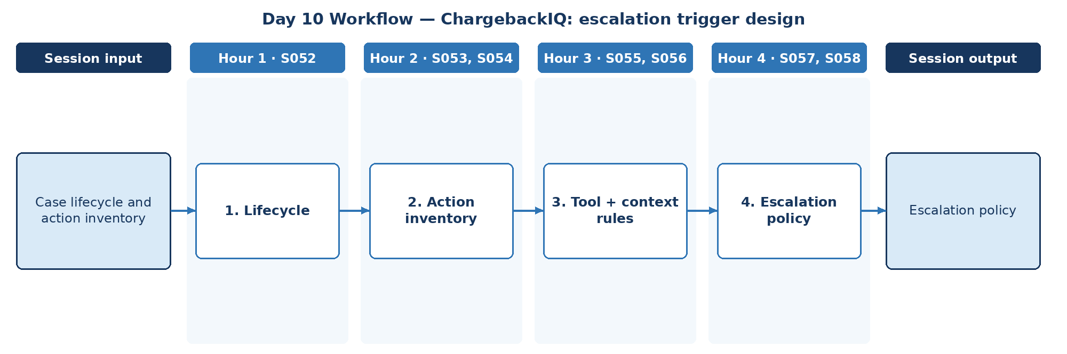

D. Steps to Perform the Work – and Why
Step | Hour · IDs | What to perform | Why this step is required | Expected output
1 | H1 · S052 | Map the case lifecycle with ReAct-style investigation steps. | The lifecycle shows where actions and decisions occur. | Lifecycle map
2 | H2 · S053, S054 | Inventory actions available to the runtime. | Every runtime action needs a control decision based on risk and reversibility. | Action inventory
3 | H3 · S055, S056 | Define tool contracts and context rules for investigation. | Tool and context rules constrain what the agent can do and see. | Tool/context rules
4 | H4 · S057, S058 | Choose decisions requiring human approval and escalation triggers. | Consequential or time-critical actions need a person. | Escalation policy

E. Detailed Execution Instructions
Step 1 – Map the case lifecycle with ReAct-style investigation steps.
Hour / source IDs: Hour 1 · S052
How to perform: Map states (received → investigating → pending_review → decided → submitted) and the actions in each.
Why: The lifecycle shows where actions and decisions occur.
Output to retain: Lifecycle map
Step 2 – Inventory actions available to the runtime.
Hour / source IDs: Hour 2 · S053, S054
How to perform: List every runtime action with risk rating and reversibility.
Why: Every runtime action needs a control decision based on risk and reversibility.
Output to retain: Action inventory
Step 3 – Define tool contracts and context rules for investigation.
Hour / source IDs: Hour 3 · S055, S056
How to perform: Write tool schemas and the list of context items allowed per turn.
Why: Tool and context rules constrain what the agent can do and see.
Output to retain: Tool/context rules
Step 4 – Choose decisions requiring human approval and escalation triggers.
Hour / source IDs: Hour 4 · S057, S058
How to perform: Define triggers (amount threshold, deadline < 48h, conflicting evidence, fraud indicators) and the role each escalates to.
Why: Consequential or time-critical actions need a person.
Output to retain: Escalation policy

F. Session Input → Work → Output
Input | Work performed | Output
Case lifecycle and action inventory | Lifecycle → Action inventory → Tool + context rules → Escalation policy | Escalation policy

G. Validation / Exit Criteria
- The required output exists: Escalation policy.
- Every irreversible action requires approval.
- Triggers are testable.
- Every step traces to its hourly block and source IDs (S052, S053, S054, S055, S056, S057, S058); no TOC topic is skipped or re-worded.
- The workflow diagram matches the work actually performed.
- The human decision boundary is preserved wherever the session touches a consequential decision.
- Open gaps or assumptions (including tool or platform access) are recorded rather than silently filled.

H. Carry-Forward
Escalation policy becomes an explicit input for Day 11 — ChargebackIQ: policy-based review gate (Day 11 input: High-value disputes and escalation rules).

Day 11: Harness + HITL – policy-based review gate
Session duration | 4h = 1.25h concept + 2.75h lab (4 × 1-hour blocks)
Exact modules | Context, Harness & Loop Engineering
Source IDs (primary) | S059, S060, S061, S062, S063, S064, S065, S066
Repeated source IDs (application) | S052, S053, S054, S055, S056, S057, S058
Input | High-value disputes and escalation rules
Guided implementation (workbook) | Specify permission matrix and approver workflow.
Primary output | Control matrix
Human decision / governance | ChargebackIQ may assemble evidence, track deadlines and draft recommendations. Accept/represent decisions, customer credits and network submissions are made by authorised dispute investigators and approvers; high-value or near-deadline disputes require approver sign-off.
Mapping ID / section locator | CAP-11 | Day 11 / CAP-11
Slide deck | Day11_SourceLocked_5W1H_Architecture.pptx
Code mapping / status | Reference app codebase + planned day-specific lab (not yet standalone)
Architecture / workflow (workbook) | Supervisor → Harness → Tools → Approval gate → Audit

A. Exact TOC Topics for This Session (unchanged)
Source ID | Exact topic + subtopic
S059 | *Context Compaction & Summarization Strategies*
S060 | *What is an Agent Harness — tools, memory, guardrails, execution environment*
S061 | *Building a Custom Harness vs Using a Framework (LangChain/LangGraph)*
S062 | *Sandboxing & Permission Boundaries in Harnesses*
S063 | *The Agent Loop — Perceive → Plan → Act → Observe*
S064 | *ReAct Loop vs Plan-and-Execute Loop*
S065 | *Loop Termination Conditions & Infinite-Loop Prevention*
S066 | *Human-in-the-Loop Checkpoints Inside the Loop*

B. Hourly Session Break-up (from the workbook Hourly Plan)
Hour | Intention | Source IDs | Exact source words | Revisit IDs | Capstone work in this hour | Steps
Hour 1  (00:00–01:00) | Theory and 5W1H | S059, S060 | *Context Compaction & Summarization Strategies*  *What is an Agent Harness — tools, memory, guardrails, execution environment* | — | Harness | 1
Hour 2  (01:00–02:00) | Instructor demonstration | S061, S062 | *Building a Custom Harness vs Using a Framework (LangChain/LangGraph)*  *Sandboxing & Permission Boundaries in Harnesses* | — | Permission matrix | 2
Hour 3  (02:00–03:00) | Guided BankAssist implementation | S063, S064 | *The Agent Loop — Perceive → Plan → Act → Observe*  *ReAct Loop vs Plan-and-Execute Loop* | — | Loop choice | 3
Hour 4  (03:00–04:00) | ReconAI assignment launch and evidence | S065, S066 | *Loop Termination Conditions & Infinite-Loop Prevention*  *Human-in-the-Loop Checkpoints Inside the Loop* | — | Approver workflow | 4

C. Workflow Diagram for This Session
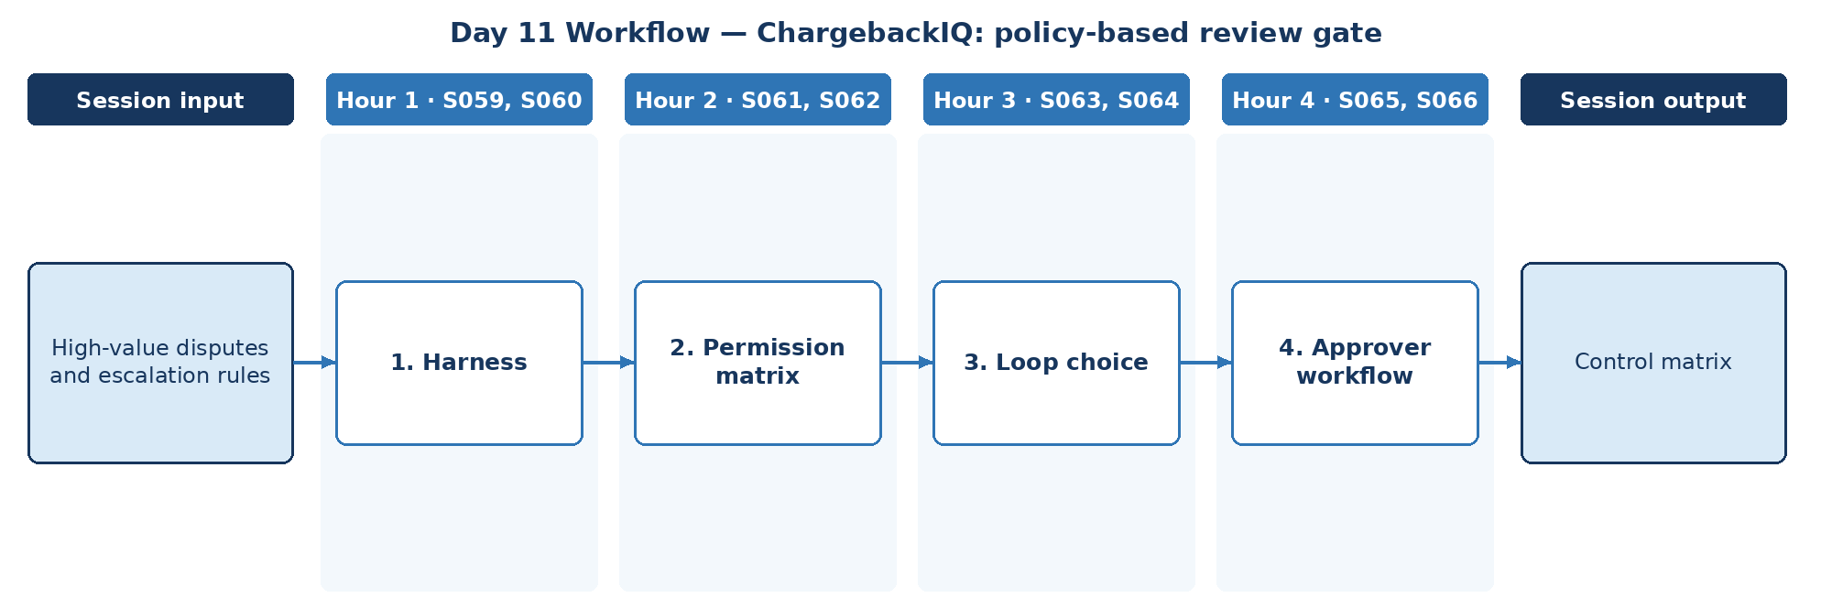

D. Steps to Perform the Work – and Why
Step | Hour · IDs | What to perform | Why this step is required | Expected output
1 | H1 · S059, S060 | Define the capstone harness and compaction for long dispute files. | The harness is where the capstone's controls actually run. | Harness spec
2 | H2 · S061, S062 | Specify permission matrix and sandbox boundaries. | Permissions must enforce separation of duties in code. | Permission matrix
3 | H3 · S063, S064 | Choose loop pattern (ReAct vs plan-and-execute) for investigation. | The loop pattern must fit the investigation task. | Loop decision
4 | H4 · S065, S066 | Specify termination rules and the approver workflow for high-value disputes. | High-value outcomes need a documented review gate. | Control matrix

E. Detailed Execution Instructions
Step 1 – Define the capstone harness and compaction for long dispute files.
Hour / source IDs: Hour 1 · S059, S060
How to perform: Specify harness components and owners; define compaction for long merchant files keeping amounts and dates verbatim.
Why: The harness is where the capstone's controls actually run.
Output to retain: Harness spec
Step 2 – Specify permission matrix and sandbox boundaries.
Hour / source IDs: Hour 2 · S061, S062
How to perform: Create role × action matrix; state how denial is enforced in code.
Why: Permissions must enforce separation of duties in code.
Output to retain: Permission matrix
Step 3 – Choose loop pattern (ReAct vs plan-and-execute) for investigation.
Hour / source IDs: Hour 3 · S063, S064
How to perform: Compare ReAct and plan-and-execute for investigation; record choice and reason.
Why: The loop pattern must fit the investigation task.
Output to retain: Loop decision
Step 4 – Specify termination rules and the approver workflow for high-value disputes.
Hour / source IDs: Hour 4 · S065, S066
How to perform: Specify max steps and repeat-action stops; define approver workflow for high-value disputes; compile the control matrix (control, owner, frequency, evidence).
Why: High-value outcomes need a documented review gate.
Output to retain: Control matrix

F. Session Input → Work → Output
Input | Work performed | Output
High-value disputes and escalation rules | Harness → Permission matrix → Loop choice → Approver workflow | Control matrix

G. Validation / Exit Criteria
- The required output exists: Control matrix.
- High-value disputes always reach an approver.
- Loop termination is specified.
- Every step traces to its hourly block and source IDs (S059, S060, S061, S062, S063, S064, S065, S066); no TOC topic is skipped or re-worded.
- The workflow diagram matches the work actually performed.
- The human decision boundary is preserved wherever the session touches a consequential decision.
- Open gaps or assumptions (including tool or platform access) are recorded rather than silently filled.

H. Carry-Forward
Control matrix becomes an explicit input for Day 12 — ChargebackIQ: multi-role graph design (Day 12 input: Agent charter and data contracts).

Day 12: LangGraph – multi-role graph design
Session duration | 4h = 1.25h concept + 2.75h lab (4 × 1-hour blocks)
Exact modules | LangGraph/CrewAI/AutoGen – Advanced AI Agents
Source IDs (primary) | S067, S068, S069, S070, S071
Repeated source IDs (application) | S060, S061, S062, S063, S064, S065, S066
Input | Agent charter and data contracts
Guided implementation (workbook) | Draft multi-agent state diagram.
Primary output | Agent interaction blueprint
Human decision / governance | ChargebackIQ may assemble evidence, track deadlines and draft recommendations. Accept/represent decisions, customer credits and network submissions are made by authorised dispute investigators and approvers; high-value or near-deadline disputes require approver sign-off.
Mapping ID / section locator | CAP-12 | Day 12 / CAP-12
Slide deck | Day12_SourceLocked_5W1H_Architecture.pptx
Code mapping / status | Reference app codebase + planned day-specific lab (not yet standalone)
Architecture / workflow (workbook) | Graph START → Triage → Transaction → Policy → Review

A. Exact TOC Topics for This Session (unchanged)
Source ID | Exact topic + subtopic
S067 | LangGraph/CrewAI/AutoGen – Advanced AI Agents | Introduction to LangGraph, CrewAI, and AutoGen
S068 | Key Components of LangGraph (Nodes, Edges, States)
S069 | LangGraph/AutoGen for Autonomous LLM Applications
S070 | Real-Time Data Processing with LangGraph
S071 | Building Stateful AI Systems

B. Hourly Session Break-up (from the workbook Hourly Plan)
Hour | Intention | Source IDs | Exact source words | Revisit IDs | Capstone work in this hour | Steps
Hour 1  (00:00–01:00) | Theory and 5W1H | S067 | LangGraph/CrewAI/AutoGen – Advanced AI Agents | Introduction to LangGraph, CrewAI, and AutoGen | — | Framework | 1
Hour 2  (01:00–02:00) | Instructor demonstration | S068 | Key Components of LangGraph (Nodes, Edges, States) | — | State schema | 2
Hour 3  (02:00–03:00) | Guided BankAssist implementation | S069 | LangGraph/AutoGen for Autonomous LLM Applications | — | Roles in graph | 3
Hour 4  (03:00–04:00) | ReconAI assignment launch and evidence | S070, S071 | Real-Time Data Processing with LangGraph  Building Stateful AI Systems | — | Blueprint | 4

C. Workflow Diagram for This Session
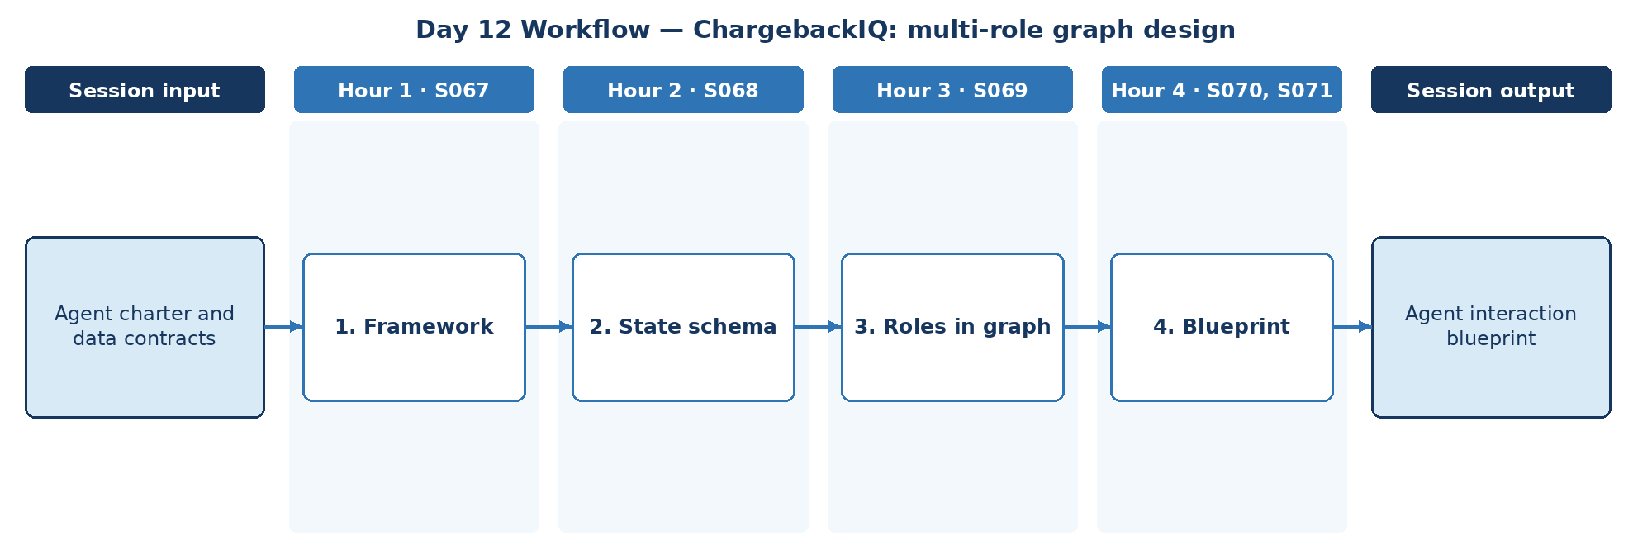

D. Steps to Perform the Work – and Why
Step | Hour · IDs | What to perform | Why this step is required | Expected output
1 | H1 · S067 | Select a multi-agent framework for the capstone. | A single framework keeps the build consistent across the team. | Framework decision
2 | H2 · S068 | Define dispute state and data contracts. | Explicit state is required for audit and resume. | State schema
3 | H3 · S069 | Place intake, evidence, policy, drafting and review roles as nodes. | Named roles structure collaboration between agents. | Role nodes
4 | H4 · S070, S071 | Draft the multi-agent state diagram with real-time deadline events. | Response deadlines drive urgency and must change routing. | Agent interaction blueprint

E. Detailed Execution Instructions
Step 1 – Select a multi-agent framework for the capstone.
Hour / source IDs: Hour 1 · S067
How to perform: Score frameworks on state control, HITL and audit; record choice.
Why: A single framework keeps the build consistent across the team.
Output to retain: Framework decision
Step 2 – Define dispute state and data contracts.
Hour / source IDs: Hour 2 · S068
How to perform: Define dispute state fields and the data contract each node reads and writes.
Why: Explicit state is required for audit and resume.
Output to retain: State schema
Step 3 – Place intake, evidence, policy, drafting and review roles as nodes.
Hour / source IDs: Hour 3 · S069
How to perform: Place intake, evidence, policy, drafting and review roles as graph nodes; state each node's inputs, outputs and allowed tools.
Why: Named roles structure collaboration between agents.
Output to retain: Role nodes
Step 4 – Draft the multi-agent state diagram with real-time deadline events.
Hour / source IDs: Hour 4 · S070, S071
How to perform: Draw the state diagram with a mandatory review node and deadline events that raise priority.
Why: Response deadlines drive urgency and must change routing.
Output to retain: Agent interaction blueprint

F. Session Input → Work → Output
Input | Work performed | Output
Agent charter and data contracts | Framework → State schema → Roles in graph → Blueprint | Agent interaction blueprint

G. Validation / Exit Criteria
- The required output exists: Agent interaction blueprint.
- The blueprint shows a mandatory review node.
- Deadline events are handled.
- Every step traces to its hourly block and source IDs (S067, S068, S069, S070, S071); no TOC topic is skipped or re-worded.
- The workflow diagram matches the work actually performed.
- The human decision boundary is preserved wherever the session touches a consequential decision.
- Open gaps or assumptions (including tool or platform access) are recorded rather than silently filled.

H. Carry-Forward
Agent interaction blueprint becomes an explicit input for Day 13 — ChargebackIQ: orchestration baseline (Day 13 input: Dispute state chart and policy sources).

Day 13: Graph + Protocol intro – orchestration baseline
Session duration | 4h = 1.25h concept + 2.75h lab (4 × 1-hour blocks)
Exact modules | LangGraph/CrewAI/AutoGen – Advanced AI Agents | Architecting Agentic Systems – MCP & A2A Protocols | Applied Data Processing — Batch Fundamentals & Streaming Fundamentals
Source IDs (primary) | S072, S073, S074, S075, S076, S077, S078
Repeated source IDs (application) | S067, S068, S069, S070, S071
Input | Dispute state chart and policy sources
Guided implementation (workbook) | Create agent-to-agent handoff specification.
Primary output | A2A message contract draft
Human decision / governance | ChargebackIQ may assemble evidence, track deadlines and draft recommendations. Accept/represent decisions, customer credits and network submissions are made by authorised dispute investigators and approvers; high-value or near-deadline disputes require approver sign-off.
Mapping ID / section locator | CAP-13 | Day 13 / CAP-13
Slide deck | Day13_SourceLocked_5W1H_Architecture.pptx
Code mapping / status | Runnable local source code is provided in the ZIP and mapped in the master workbook. See source path in the applied-module section below.
Architecture / workflow (workbook) | LangGraph → MCP client → Banking tools; A2A → Agents

A. Exact TOC Topics for This Session (unchanged)
Source ID | Exact topic + subtopic
S072 | Advanced Orchestration Techniques
S073 | Building Multi-Actor Applications
S074 | Cycles and Branching; Memory/Persistence; Human in the Loop (HITL); Streaming
S075 | Guidelines and Best Practices
S076 | Architecting Agentic Systems – MCP & A2A Protocols | Principles of Agentic AI Application Design (Architecture level)
S077 | MCP (Model Context Protocol) — MCP Server / Host / Client
S078 | A2A (Agent-to-Agent Protocol)

B. Hourly Session Break-up (from the workbook Hourly Plan)
Hour | Intention | Source IDs | Exact source words | Revisit IDs | Capstone work in this hour | Steps
Hour 1  (00:00–01:00) | Theory and 5W1H | S072 | Advanced Orchestration Techniques | — | Orchestration baseline | 1
Hour 2  (01:00–02:00) | Instructor demonstration | S073, S074 | Building Multi-Actor Applications  Cycles and Branching; Memory/Persistence; Human in the Loop (HITL); Streaming | — | Cycles + HITL | 2
Hour 3  (02:00–03:00) | Guided BankAssist implementation | S075, S076 | Guidelines and Best Practices  Architecting Agentic Systems – MCP & A2A Protocols | Principles of Agentic AI Application Design (Architecture level) | — | Principles | 3
Hour 4  (03:00–04:00) | ReconAI assignment launch and evidence | S077, S078 | MCP (Model Context Protocol) — MCP Server / Host / Client  A2A (Agent-to-Agent Protocol) | — | A2A contract | 4

C. Workflow Diagram for This Session
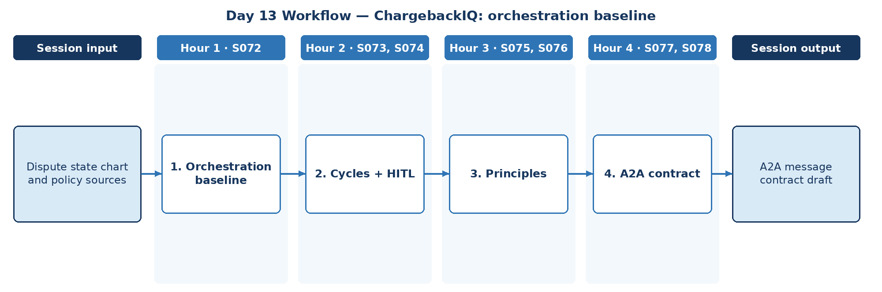

D. Steps to Perform the Work – and Why
Step | Hour · IDs | What to perform | Why this step is required | Expected output
1 | H1 · S072 | Define the orchestration baseline across roles. | All roles need a common, predictable control flow. | Orchestration baseline
2 | H2 · S073, S074 | Specify cycles, persistence, HITL and streaming points. | Rework and review loops must be designed, not improvised. | Flow controls
3 | H3 · S075, S076 | Apply design principles and best practices. | Principles keep handoffs safe as the design grows. | Principles
4 | H4 · S077, S078 | Create the agent-to-agent handoff specification and MCP tool boundary. | Standard handoff messages make agent collaboration auditable. | A2A message contract draft

E. Detailed Execution Instructions
Step 1 – Define the orchestration baseline across roles.
Hour / source IDs: Hour 1 · S072
How to perform: Define the supervisor, execution order across roles and what happens when a role fails or times out.
Why: All roles need a common, predictable control flow.
Output to retain: Orchestration baseline
Step 2 – Specify cycles, persistence, HITL and streaming points.
Hour / source IDs: Hour 2 · S073, S074
How to perform: Mark where rework cycles, persistence, human review and streaming updates apply.
Why: Rework and review loops must be designed, not improvised.
Output to retain: Flow controls
Step 3 – Apply design principles and best practices.
Hour / source IDs: Hour 3 · S075, S076
How to perform: Apply least privilege, explicit state, bounded loops and human authority to every handoff; record exceptions to these principles with justification.
Why: Principles keep handoffs safe as the design grows.
Output to retain: Principles
Step 4 – Create the agent-to-agent handoff specification and MCP tool boundary.
Hour / source IDs: Hour 4 · S077, S078
How to perform: Write agent cards, a task message and a result message with correlation_id; place policy and evidence tools behind MCP.
Why: Standard handoff messages make agent collaboration auditable.
Output to retain: A2A message contract draft

F. Session Input → Work → Output
Input | Work performed | Output
Dispute state chart and policy sources | Orchestration baseline → Cycles + HITL → Principles → A2A contract | A2A message contract draft

G. Validation / Exit Criteria
- The required output exists: A2A message contract draft.
- Each handoff has a message schema.
- MCP tools are separate from A2A messages.
- Every step traces to its hourly block and source IDs (S072, S073, S074, S075, S076, S077, S078); no TOC topic is skipped or re-worded.
- The workflow diagram matches the work actually performed.
- The human decision boundary is preserved wherever the session touches a consequential decision.
- Open gaps or assumptions (including tool or platform access) are recorded rather than silently filled.

H. Carry-Forward
A2A message contract draft becomes an explicit input for Day 14 — ChargebackIQ: agent architecture review (Day 14 input: Agent boundaries, audit obligations).

Day 14: Architecting + Gemini intro – agent architecture review
Session duration | 4h = 1.25h concept + 2.75h lab (4 × 1-hour blocks)
Exact modules | Architecting Agentic Systems – MCP & A2A Protocols | Gemini Enterprise Agent Development | Cloud Batch & Event-Streaming Architecture — Pub/Sub, Dataflow/Apache Beam & BigQuery
Source IDs (primary) | S079, S080, S081, S082, S083, S084, S085, S086
Repeated source IDs (application) | S076, S077, S078
Input | Agent boundaries, audit obligations
Guided implementation (workbook) | Produce architecture with protocol boundaries and risks.
Primary output | Review-ready architecture
Human decision / governance | ChargebackIQ may assemble evidence, track deadlines and draft recommendations. Accept/represent decisions, customer credits and network submissions are made by authorised dispute investigators and approvers; high-value or near-deadline disputes require approver sign-off.
Mapping ID / section locator | CAP-14 | Day 14 / CAP-14
Slide deck | Day14_SourceLocked_5W1H_Architecture.pptx
Code mapping / status | Runnable local source code is provided in the ZIP and mapped in the master workbook. See source path in the applied-module section below.
Architecture / workflow (workbook) | A2A coordinator → Specialist agents → Reviewer → Case outcome

A. Exact TOC Topics for This Session (unchanged)
Source ID | Exact topic + subtopic
S079 | Multi-Agent Coordination Strategies
S080 | Architecting AI Workflows with Autonomous Agents
S081 | Designing Human-in-the-Loop Agentic Systems
S082 | Adaptive Agents for Dynamic Environments
S083 | Evaluating and Deploying Agents — LLMs as Judge
S084 | Ethical & Regulatory Considerations in AI Agents
S085 | Guidelines and Best Practices
S086 | Gemini Enterprise Agent Development | *Use Agents to Build Agents*

B. Hourly Session Break-up (from the workbook Hourly Plan)
Hour | Intention | Source IDs | Exact source words | Revisit IDs | Capstone work in this hour | Steps
Hour 1  (00:00–01:00) | Theory and 5W1H | S079, S080 | Multi-Agent Coordination Strategies  Architecting AI Workflows with Autonomous Agents | — | Coordination | 1
Hour 2  (01:00–02:00) | Instructor demonstration | S081, S082 | Designing Human-in-the-Loop Agentic Systems  Adaptive Agents for Dynamic Environments | — | HITL + adaptive | 2
Hour 3  (02:00–03:00) | Guided BankAssist implementation | S083, S084 | Evaluating and Deploying Agents — LLMs as Judge  Ethical & Regulatory Considerations in AI Agents | — | Judge + ethics | 3
Hour 4  (03:00–04:00) | ReconAI assignment launch and evidence | S085, S086 | Guidelines and Best Practices  Gemini Enterprise Agent Development | *Use Agents to Build Agents* | — | Architecture review | 4

C. Workflow Diagram for This Session
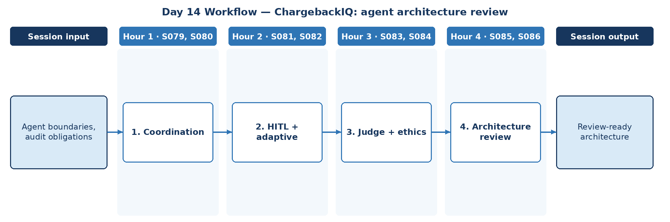

D. Steps to Perform the Work – and Why
Step | Hour · IDs | What to perform | Why this step is required | Expected output
1 | H1 · S079, S080 | Select coordination strategy and workflow architecture. | The coordination pattern is the foundation of the architecture. | Coordination choice
2 | H2 · S081, S082 | Design HITL points and adaptive behaviour for changing rules. | Rule and tool changes must be handled safely. | HITL/adaptive design
3 | H3 · S083, S084 | Define judge-based evaluation and ethical/regulatory review. | Outcomes must be fair, compliant and measurably good. | Evaluation + ethics notes
4 | H4 · S085, S086 | Produce architecture with protocol boundaries and risks. | A complete architecture is required before peer review. | Review-ready architecture

E. Detailed Execution Instructions
Step 1 – Select coordination strategy and workflow architecture.
Hour / source IDs: Hour 1 · S079, S080
How to perform: Compare supervisor, hierarchical and sequential patterns for ChargebackIQ; choose one and document rationale and rejected alternatives.
Why: The coordination pattern is the foundation of the architecture.
Output to retain: Coordination choice
Step 2 – Design HITL points and adaptive behaviour for changing rules.
Hour / source IDs: Hour 2 · S081, S082
How to perform: Define review points and behaviour when network rules or tools change.
Why: Rule and tool changes must be handled safely.
Output to retain: HITL/adaptive design
Step 3 – Define judge-based evaluation and ethical/regulatory review.
Hour / source IDs: Hour 3 · S083, S084
How to perform: Write judge rubric with human calibration; list ethical and regulatory review items (fair treatment, transparency, record keeping).
Why: Outcomes must be fair, compliant and measurably good.
Output to retain: Evaluation + ethics notes
Step 4 – Produce architecture with protocol boundaries and risks.
Hour / source IDs: Hour 4 · S085, S086
How to perform: Produce the architecture diagram with MCP and A2A boundaries, an ADR (templates/architecture_decision.md) and a risk register (templates/risk_register.csv) with owners.
Why: A complete architecture is required before peer review.
Output to retain: Review-ready architecture

F. Session Input → Work → Output
Input | Work performed | Output
Agent boundaries, audit obligations | Coordination → HITL + adaptive → Judge + ethics → Architecture review | Review-ready architecture

G. Validation / Exit Criteria
- The required output exists: Review-ready architecture.
- All protocol boundaries are drawn.
- Risks have owners.
- Every step traces to its hourly block and source IDs (S079, S080, S081, S082, S083, S084, S085, S086); no TOC topic is skipped or re-worded.
- The workflow diagram matches the work actually performed.
- The human decision boundary is preserved wherever the session touches a consequential decision.
- Open gaps or assumptions (including tool or platform access) are recorded rather than silently filled.

H. Carry-Forward
Review-ready architecture becomes an explicit input for Day 15 — ChargebackIQ: evaluation plan (Day 15 input: Gold set and function-calling examples).

Day 15: ADK + Fine-tuning – evaluation plan
Session duration | 4h = 1.25h concept + 2.75h lab (4 × 1-hour blocks)
Exact modules | Gemini Enterprise Agent Development | LLM Fine-Tuning & Evaluation | Batch Validation & Publisher Batching — Event Time, Windows, Watermarks & Late Data
Source IDs (primary) | S087, S088, S089, S090, S091, S092, S093
Repeated source IDs (application) | S086
Input | Gold set and function-calling examples
Guided implementation (workbook) | Select task metrics, golden examples and tuning guardrails.
Primary output | Capstone evaluation plan
Human decision / governance | ChargebackIQ may assemble evidence, track deadlines and draft recommendations. Accept/represent decisions, customer credits and network submissions are made by authorised dispute investigators and approvers; high-value or near-deadline disputes require approver sign-off.
Mapping ID / section locator | CAP-15 | Day 15 / CAP-15
Slide deck | Day15_SourceLocked_5W1H_Architecture.pptx
Code mapping / status | Runnable local source code is provided in the ZIP and mapped in the master workbook. See source path in the applied-module section below.
Architecture / workflow (workbook) | ADK agents → Dataset → Evaluation → Improvement → Repeat

A. Exact TOC Topics for This Session (unchanged)
Source ID | Exact topic + subtopic
S087 | *Build and Deploy Agents with Agent Development Kit (ADK)*
S088 | *Agent Evaluation and Hill Climbing*
S089 | LLM Fine-Tuning & Evaluation | Instruction vs Task-Specific Fine-Tuning
S090 | Parameter Efficient Tuning (LoRA, QLoRA, FLAN)
S091 | Avoiding Catastrophic Forgetting
S092 | Evaluation Metrics: ROUGE, BLEU, MMLU, BIG-Bench, GLUE, HELM
S093 | Fine-tuning for Function Calling

B. Hourly Session Break-up (from the workbook Hourly Plan)
Hour | Intention | Source IDs | Exact source words | Revisit IDs | Capstone work in this hour | Steps
Hour 1  (00:00–01:00) | Theory and 5W1H | S087 | *Build and Deploy Agents with Agent Development Kit (ADK)* | — | ADK plan | 1
Hour 2  (01:00–02:00) | Instructor demonstration | S088, S089 | *Agent Evaluation and Hill Climbing*  LLM Fine-Tuning & Evaluation | Instruction vs Task-Specific Fine-Tuning | — | Eval approach | 2
Hour 3  (02:00–03:00) | Guided BankAssist implementation | S090, S091 | Parameter Efficient Tuning (LoRA, QLoRA, FLAN)  Avoiding Catastrophic Forgetting | — | Tuning guardrails | 3
Hour 4  (03:00–04:00) | ReconAI assignment launch and evidence | S092, S093 | Evaluation Metrics: ROUGE, BLEU, MMLU, BIG-Bench, GLUE, HELM  Fine-tuning for Function Calling | — | Evaluation plan | 4

C. Workflow Diagram for This Session
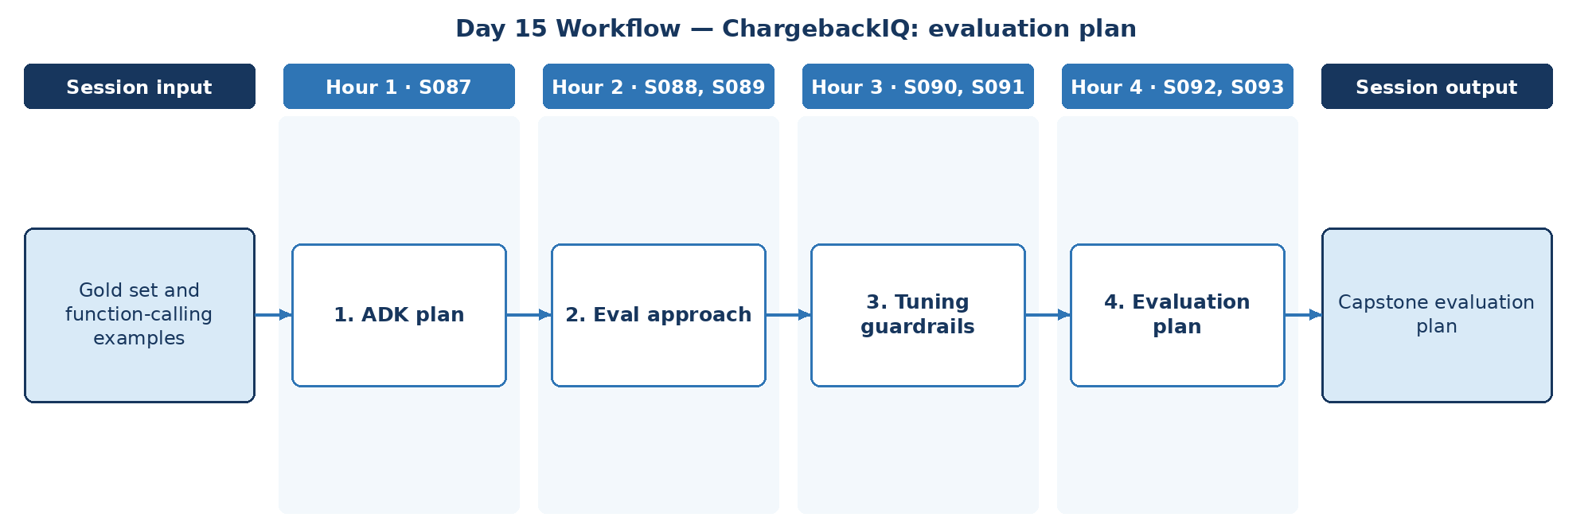

D. Steps to Perform the Work – and Why
Step | Hour · IDs | What to perform | Why this step is required | Expected output
1 | H1 · S087 | Plan ADK use for the capstone (subject to access). | ADK planning aligns the capstone with the target platform. | ADK plan
2 | H2 · S088, S089 | Define hill-climbing evaluation approach; decide instruction vs task tuning need. | Improvement must be structured and measured one change at a time. | Evaluation approach
3 | H3 · S090, S091 | Set tuning guardrails (PEFT choice, forgetting checks). | Guardrails prevent tuning that harms general capability. | Tuning guardrails
4 | H4 · S092, S093 | Select task metrics, golden examples and function-calling tests. | The evaluation plan defines what 'accepted' means. | Capstone evaluation plan

E. Detailed Execution Instructions
Step 1 – Plan ADK use for the capstone (subject to access).
Hour / source IDs: Hour 1 · S087
How to perform: Plan ADK agents, tools and sessions for the capstone; record which parts need approved access and which will be demonstrated with mocks.
Why: ADK planning aligns the capstone with the target platform.
Output to retain: ADK plan
Step 2 – Define hill-climbing evaluation approach; decide instruction vs task tuning need.
Hour / source IDs: Hour 2 · S088, S089
How to perform: Define dataset and one-change-per-cycle evaluation; decide whether instruction or task tuning is needed.
Why: Improvement must be structured and measured one change at a time.
Output to retain: Evaluation approach
Step 3 – Set tuning guardrails (PEFT choice, forgetting checks).
Hour / source IDs: Hour 3 · S090, S091
How to perform: Allow tuning only if prompting fails thresholds; require forgetting checks.
Why: Guardrails prevent tuning that harms general capability.
Output to retain: Tuning guardrails
Step 4 – Select task metrics, golden examples and function-calling tests.
Hour / source IDs: Hour 4 · S092, S093
How to perform: List metrics with thresholds, golden examples per reason code and function-calling tests.
Why: The evaluation plan defines what 'accepted' means.
Output to retain: Capstone evaluation plan

F. Session Input → Work → Output
Input | Work performed | Output
Gold set and function-calling examples | ADK plan → Eval approach → Tuning guardrails → Evaluation plan | Capstone evaluation plan

G. Validation / Exit Criteria
- The required output exists: Capstone evaluation plan.
- Every metric has a threshold.
- Golden examples cover each reason code.
- Every step traces to its hourly block and source IDs (S087, S088, S089, S090, S091, S092, S093); no TOC topic is skipped or re-worded.
- The workflow diagram matches the work actually performed.
- The human decision boundary is preserved wherever the session touches a consequential decision.
- Open gaps or assumptions (including tool or platform access) are recorded rather than silently filled.

H. Carry-Forward
Capstone evaluation plan becomes an explicit input for Day 16 — ChargebackIQ: cross-agent reliability (Day 16 input: Capstone architecture and SLA targets).

Day 16: MCP/A2A advanced + Observability – cross-agent reliability
Session duration | 4h = 0.75h concept + 3.25h lab (4 × 1-hour blocks)
Instructor emphasis | MCP/A2A advanced + Observability
Exact modules | Deployment, Evaluation & Observability | Streaming Observability & Delivery Semantics — Correlation, Acknowledgement & Durable Processing
Source IDs (primary) | S094, S095, S096, S097, S098, S099, S100
Repeated source IDs (application) | S076, S077, S078, S079, S080, S081, S082, S083, S084, S085
Input | Capstone architecture and SLA targets
Guided implementation (workbook) | Set correlation IDs, execution budgets and incident evidence requirements.
Primary output | Protocol governance checklist
Human decision / governance | ChargebackIQ may assemble evidence, track deadlines and draft recommendations. Accept/represent decisions, customer credits and network submissions are made by authorised dispute investigators and approvers; high-value or near-deadline disputes require approver sign-off.
Mapping ID / section locator | CAP-16 | Day 16 / CAP-16
Slide deck | Day16_SourceLocked_5W1H_Architecture.pptx
Code mapping / status | Runnable local source code is provided in the ZIP and mapped in the master workbook. See source path in the applied-module section below.
Architecture / workflow (workbook) | MCP host ↔ MCP client ↔ tool server; A2A → agent peers → telemetry

A. Exact TOC Topics for This Session (unchanged)
Source ID | Exact topic + subtopic
S094 | Deployment, Evaluation & Observability | Observability: Understanding System Insights — Logs / Metrics / Traces
S095 | Observability: Issue Detection; Debugging; System Optimization; Security/Compliance
S096 | Integration Best Practices with CI/CD and Developer Workflows
S097 | Evaluation — System Metrics, Task Completion, Quality Control, Tool Interaction Metrics
S098 | Evaluation — LLM/Agents as Judge
S099 | Development Issues — Poorly Defined Prompts, etc.
S100 | LLM Issues — High Cost of Running; Planning/Reasoning/Tool Calling Failures

B. Hourly Session Break-up (from the workbook Hourly Plan)
Hour | Intention | Source IDs | Exact source words | Revisit IDs | Capstone work in this hour | Steps
Hour 1  (00:00–01:00) | MCP/A2A applied architecture (revisit Days 13–14) | S094 | Deployment, Evaluation & Observability | Observability: Understanding System Insights — Logs / Metrics / Traces | S076, S077 | Correlation IDs | 1
Hour 2  (01:00–02:00) | MCP/A2A role/message lab + new observability | S095, S096 | Observability: Issue Detection; Debugging; System Optimization; Security/Compliance  Integration Best Practices with CI/CD and Developer Workflows | S078, S079, S080 | Budgets + CI | 2
Hour 3  (02:00–03:00) | Operational observability and CI/CD | S097, S098 | Evaluation — System Metrics, Task Completion, Quality Control, Tool Interaction Metrics  Evaluation — LLM/Agents as Judge | S081, S082 | Reliability metrics | 3
Hour 4  (03:00–04:00) | Operational evaluation and development failure modes | S099, S100 | Development Issues — Poorly Defined Prompts, etc.  LLM Issues — High Cost of Running; Planning/Reasoning/Tool Calling Failures | S083, S084, S085 | Incident evidence | 4

C. Workflow Diagram for This Session
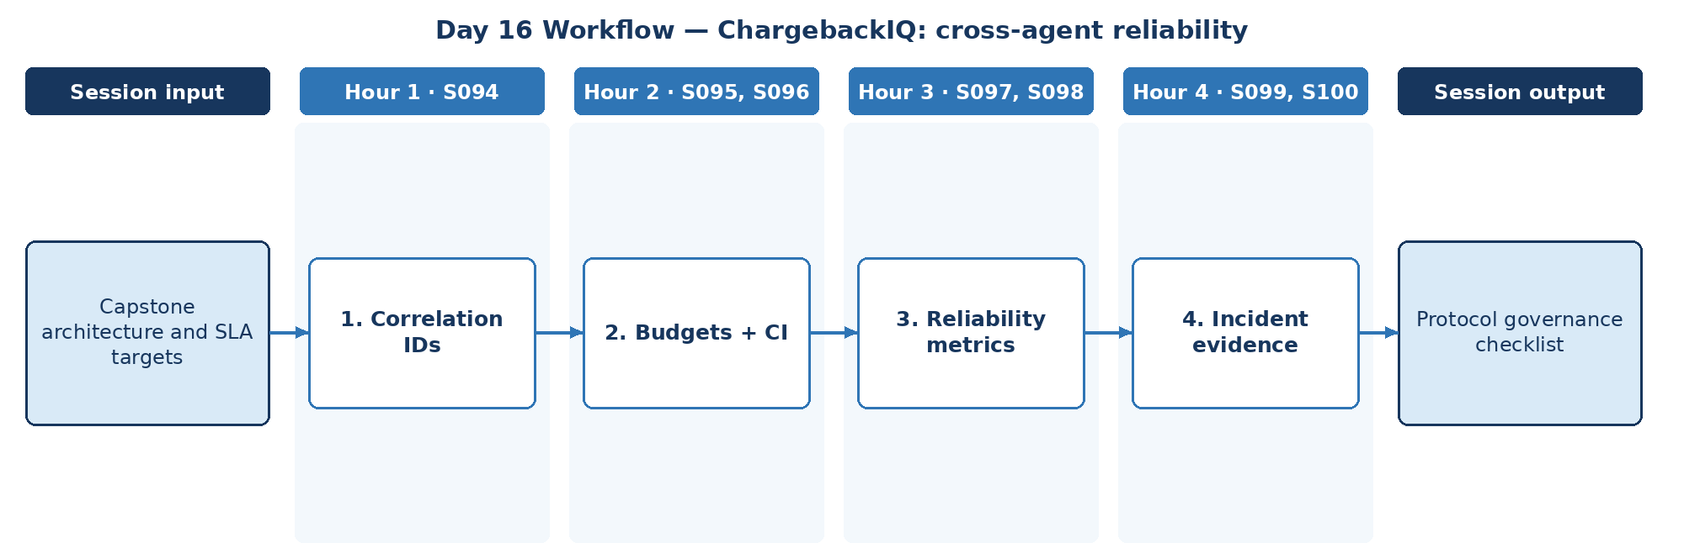

D. Steps to Perform the Work – and Why
Step | Hour · IDs | What to perform | Why this step is required | Expected output
1 | H1 · S094 | Set correlation IDs across services and agents. | Correlation IDs give end-to-end traceability for each dispute. | Correlation scheme
2 | H2 · S095, S096 | Set execution budgets and CI checks. | Budgets and CI checks control cost and prevent runaway loops. | Budgets + CI checks
3 | H3 · S097, S098 | Define cross-agent reliability metrics and judge checks. | Cross-agent reliability must be measured against targets. | Reliability metrics
4 | H4 · S099, S100 | Define incident evidence requirements and failure modes. | Defined incident evidence makes failures investigable. | Protocol governance checklist

E. Detailed Execution Instructions
Step 1 – Set correlation IDs across services and agents.
Hour / source IDs: Hour 1 · S094
How to perform: Define correlation_id creation at intake and propagation through services, MCP and A2A.
Why: Correlation IDs give end-to-end traceability for each dispute.
Output to retain: Correlation scheme
Step 2 – Set execution budgets and CI checks.
Hour / source IDs: Hour 2 · S095, S096
How to perform: Set token, step and time budgets per case; add CI checks for schemas and budgets.
Why: Budgets and CI checks control cost and prevent runaway loops.
Output to retain: Budgets + CI checks
Step 3 – Define cross-agent reliability metrics and judge checks.
Hour / source IDs: Hour 3 · S097, S098
How to perform: Define success rate, tool-call success, handoff latency and judge score targets.
Why: Cross-agent reliability must be measured against targets.
Output to retain: Reliability metrics
Step 4 – Define incident evidence requirements and failure modes.
Hour / source IDs: Hour 4 · S099, S100
How to perform: List incident evidence (trace, inputs, versions, approvals) and failure modes to detect.
Why: Defined incident evidence makes failures investigable.
Output to retain: Protocol governance checklist

F. Session Input → Work → Output
Input | Work performed | Output
Capstone architecture and SLA targets | Correlation IDs → Budgets + CI → Reliability metrics → Incident evidence | Protocol governance checklist

G. Validation / Exit Criteria
- The required output exists: Protocol governance checklist.
- Budgets are enforced, not advisory.
- Incident evidence is defined.
- Every step traces to its hourly block and source IDs (S094, S095, S096, S097, S098, S099, S100); no TOC topic is skipped or re-worded.
- The workflow diagram matches the work actually performed.
- The human decision boundary is preserved wherever the session touches a consequential decision.
- Open gaps or assumptions (including tool or platform access) are recorded rather than silently filled.

H. Carry-Forward
Protocol governance checklist becomes an explicit input for Day 17 — ChargebackIQ: acceptance rehearsal (Day 17 input: Capstone evaluation set and architecture).

Day 17: ADK + Production controls – acceptance rehearsal
Session duration | 4h = 0.75h concept + 3.25h lab (4 × 1-hour blocks)
Instructor emphasis | ADK + Production controls
Exact modules | Deployment, Evaluation & Observability | AI Validation/ Testing | Batch Backfill/Replay & Stream Recovery — Idempotency, Duplicate Handling & Failure Recovery
Source IDs (primary) | S101, S102, S103, S104, S105, S106, S107, S108, S109
Repeated source IDs (application) | S086, S087, S088, S089, S090, S091, S092, S093
Input | Capstone evaluation set and architecture
Guided implementation (workbook) | Rehearse failure injection and operator review.
Primary output | Readiness gap register
Human decision / governance | ChargebackIQ may assemble evidence, track deadlines and draft recommendations. Accept/represent decisions, customer credits and network submissions are made by authorised dispute investigators and approvers; high-value or near-deadline disputes require approver sign-off.
Mapping ID / section locator | CAP-17 | Day 17 / CAP-17
Slide deck | Day17_SourceLocked_5W1H_Architecture.pptx
Code mapping / status | Runnable local source code is provided in the ZIP and mapped in the master workbook. See source path in the applied-module section below.
Architecture / workflow (workbook) | ADK candidate → Eval → Guardrails → CI gate → Canary/rollback

A. Exact TOC Topics for This Session (unchanged)
Source ID | Exact topic + subtopic
S101 | Production Issues — Guardrails, Agent Scaling, Infinite Looping
S102 | Productionalization Challenges & Best Practices
S103 | Model Production Readiness: Latency, Cost, Reliability
S104 | Governance: Audit Trails, Explainability, Compliance Standards
S105 | Scaling Approaches: Containerization, Serverless vs On-Prem Deployments
S106 | Guardrails in Production: Structured Outputs, Fallbacks, Circuit Breakers
S107 | Versioning, Rollback, and Feature Flags
S108 | AI Validation/ Testing | *Unit Testing LLM Prompts & Chains*
S109 | *Regression Testing for Prompt/Model Changes*

B. Hourly Session Break-up (from the workbook Hourly Plan)
Hour | Intention | Source IDs | Exact source words | Revisit IDs | Capstone work in this hour | Steps
Hour 1  (00:00–01:00) | Google ADK + tuning evaluation revisit | S101, S102 | Production Issues — Guardrails, Agent Scaling, Infinite Looping  Productionalization Challenges & Best Practices | S086, S087 | Failure injection plan | 1
Hour 2  (01:00–02:00) | Production issue patterns and guardrails | S103, S104 | Model Production Readiness: Latency, Cost, Reliability  Governance: Audit Trails, Explainability, Compliance Standards | S088, S089 | Readiness measures | 2
Hour 3  (02:00–03:00) | Production readiness / governance / scaling | S105, S106 | Scaling Approaches: Containerization, Serverless vs On-Prem Deployments  Guardrails in Production: Structured Outputs, Fallbacks, Circuit Breakers | S090, S091 | Guardrail rehearsal | 3
Hour 4  (03:00–04:00) | Validation basics and release acceptance | S107, S108, S109 | Versioning, Rollback, and Feature Flags  AI Validation/ Testing | *Unit Testing LLM Prompts & Chains*  *Regression Testing for Prompt/Model Changes* | S092, S093 | Gap register | 4

C. Workflow Diagram for This Session
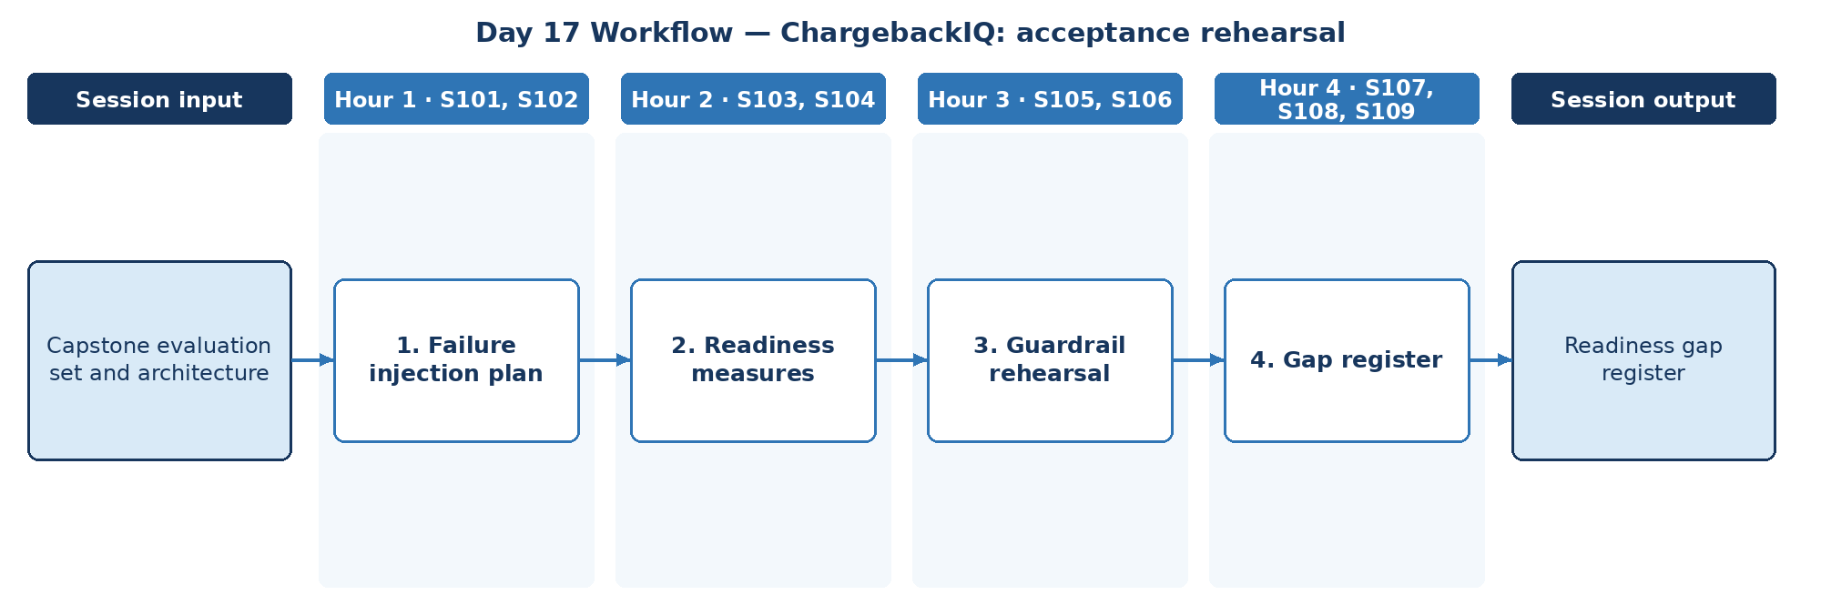

D. Steps to Perform the Work – and Why
Step | Hour · IDs | What to perform | Why this step is required | Expected output
1 | H1 · S101, S102 | Plan failure injection: tool outage, loop, bad evidence. | Injected failures test whether the system degrades safely. | Failure injection plan
2 | H2 · S103, S104 | Measure latency, cost, reliability; confirm audit trail. | Acceptance requires measured readiness, not assumptions. | Readiness measures
3 | H3 · S105, S106 | Rehearse fallbacks and circuit breakers. | Rehearsal proves fallbacks and circuit breakers actually work. | Rehearsal results
4 | H4 · S107, S108, S109 | Run operator review and record the readiness gap register with versioning and regression tests. | A gap register makes readiness transparent to reviewers. | Readiness gap register

E. Detailed Execution Instructions
Step 1 – Plan failure injection: tool outage, loop, bad evidence.
Hour / source IDs: Hour 1 · S101, S102
How to perform: Define scenarios (tool outage, loop, manipulated evidence) and expected safe behaviour.
Why: Injected failures test whether the system degrades safely.
Output to retain: Failure injection plan
Step 2 – Measure latency, cost, reliability; confirm audit trail.
Hour / source IDs: Hour 2 · S103, S104
How to perform: Record latency, cost per case and error rate; confirm audit records exist.
Why: Acceptance requires measured readiness, not assumptions.
Output to retain: Readiness measures
Step 3 – Rehearse fallbacks and circuit breakers.
Hour / source IDs: Hour 3 · S105, S106
How to perform: Trigger each fallback and circuit breaker deliberately (tool timeout, invalid output, repeated failure); record expected vs observed behaviour and pass/fail.
Why: Rehearsal proves fallbacks and circuit breakers actually work.
Output to retain: Rehearsal results
Step 4 – Run operator review and record the readiness gap register with versioning and regression tests.
Hour / source IDs: Hour 4 · S107, S108, S109
How to perform: Run operator review; record gaps with severity, owner and due date; confirm versioning and regression tests exist.
Why: A gap register makes readiness transparent to reviewers.
Output to retain: Readiness gap register

F. Session Input → Work → Output
Input | Work performed | Output
Capstone evaluation set and architecture | Failure injection plan → Readiness measures → Guardrail rehearsal → Gap register | Readiness gap register

G. Validation / Exit Criteria
- The required output exists: Readiness gap register.
- Every injected failure has an observed outcome.
- Gaps have owners.
- Every step traces to its hourly block and source IDs (S101, S102, S103, S104, S105, S106, S107, S108, S109); no TOC topic is skipped or re-worded.
- The workflow diagram matches the work actually performed.
- The human decision boundary is preserved wherever the session touches a consequential decision.
- Open gaps or assumptions (including tool or platform access) are recorded rather than silently filled.

H. Carry-Forward
Readiness gap register becomes an explicit input for Day 18 — ChargebackIQ: capstone submission gate (Day 18 input: All prior outputs plus final demo evidence).

Day 18: Testing + Gemini deployment – capstone submission gate
Session duration | 4h = 0.75h concept + 3.25h lab (4 × 1-hour blocks)
Instructor emphasis | Testing + Gemini deployment
Exact modules | AI Validation/ Testing | Gemini Enterprise Deployment | Batch/Stream Production Readiness — Cutover, Rollback, Governance & Release Validation
Source IDs (primary) | S110, S111, S112, S113, S114, S115
Repeated source IDs (application) | S094, S095, S096, S097, S098, S099, S100, S101, S102, S103, S104, S105, S106, S107
Input | All prior outputs plus final demo evidence
Guided implementation (workbook) | Review solution architecture, policies, QA results and business-outcome indicators.
Primary output | Capstone acceptance matrix
Human decision / governance | ChargebackIQ may assemble evidence, track deadlines and draft recommendations. Accept/represent decisions, customer credits and network submissions are made by authorised dispute investigators and approvers; high-value or near-deadline disputes require approver sign-off.
Mapping ID / section locator | CAP-18 | Day 18 / CAP-18
Slide deck | Day18_SourceLocked_5W1H_Architecture.pptx
Code mapping / status | Runnable local source code is provided in the ZIP and mapped in the master workbook. See source path in the applied-module section below.
Architecture / workflow (workbook) | Code → CI tests → Shadow → Deploy gate → Observability → Governance

A. Exact TOC Topics for This Session (unchanged)
Source ID | Exact topic + subtopic
S110 | *Red-Teaming & Adversarial Test Suites*
S111 | *Golden Dataset Creation for Agent/RAG Validation*
S112 | *A/B Testing & Shadow Deployment for Model Changes*
S113 | Gemini Enterprise Deployment | *Prepare and Deliver Gemini Enterprise Deployments*
S114 | *Govern, Secure, and Scale the Agent Ecosystem*
S115 | *Drive Impact with Agents using Gemini Enterprise*

B. Hourly Session Break-up (from the workbook Hourly Plan)
Hour | Intention | Source IDs | Exact source words | Revisit IDs | Capstone work in this hour | Steps
Hour 1  (00:00–01:00) | Red-teaming and golden datasets | S110 | *Red-Teaming & Adversarial Test Suites* | S094, S095, S096 | Red-team | 1
Hour 2  (01:00–02:00) | Shadow release and Gemini deployment | S111, S112 | *Golden Dataset Creation for Agent/RAG Validation*  *A/B Testing & Shadow Deployment for Model Changes* | S097, S098, S099, S100 | Golden + shadow | 2
Hour 3  (02:00–03:00) | Production telemetry and failure lab (revisit) | S113 | Gemini Enterprise Deployment | *Prepare and Deliver Gemini Enterprise Deployments* | S101, S102, S103 | Deployment plan | 3
Hour 4  (03:00–04:00) | Integrated evidence review, readiness and capstone | S114, S115 | *Govern, Secure, and Scale the Agent Ecosystem*  *Drive Impact with Agents using Gemini Enterprise* | S104, S105, S106, S107 | Acceptance | 4

C. Workflow Diagram for This Session
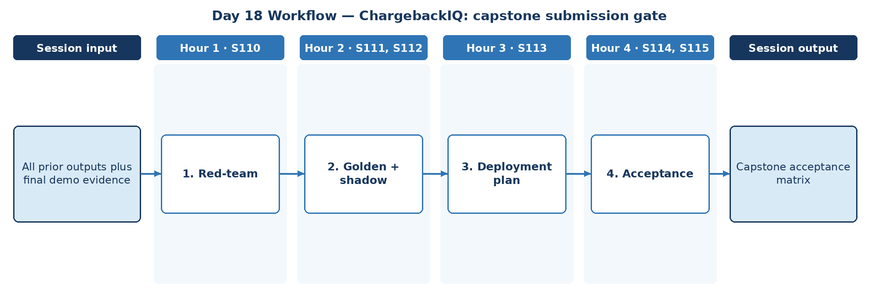

D. Steps to Perform the Work – and Why
Step | Hour · IDs | What to perform | Why this step is required | Expected output
1 | H1 · S110 | Run red-team suite on the capstone. | Final red-teaming validates security before submission. | Red-team results
2 | H2 · S111, S112 | Validate on golden set and define shadow deployment. | Golden-set and shadow results show quality without customer impact. | Validation results
3 | H3 · S113 | Prepare Gemini Enterprise deployment plan. | The deployment plan is the path to production. | Deployment plan
4 | H4 · S114, S115 | Review architecture, policies, QA results and business-outcome indicators. | The acceptance matrix is the capstone submission gate. | Capstone acceptance matrix

E. Detailed Execution Instructions
Step 1 – Run red-team suite on the capstone.
Hour / source IDs: Hour 1 · S110
How to perform: Run the adversarial suite (injection in merchant documents, fake approvals, data exfiltration, tool misuse); record findings, severity, fixes and retest results.
Why: Final red-teaming validates security before submission.
Output to retain: Red-team results
Step 2 – Validate on golden set and define shadow deployment.
Hour / source IDs: Hour 2 · S111, S112
How to perform: Score on golden set; define shadow deployment with promotion and abort criteria.
Why: Golden-set and shadow results show quality without customer impact.
Output to retain: Validation results
Step 3 – Prepare Gemini Enterprise deployment plan.
Hour / source IDs: Hour 3 · S113
How to perform: Record environments, identities, data connections and approvals for Gemini Enterprise deployment.
Why: The deployment plan is the path to production.
Output to retain: Deployment plan
Step 4 – Review architecture, policies, QA results and business-outcome indicators.
Hour / source IDs: Hour 4 · S114, S115
How to perform: Fill the acceptance matrix: criterion, evidence link, result, reviewer; include business-outcome indicators (time to respond, win rate, missed deadlines).
Why: The acceptance matrix is the capstone submission gate.
Output to retain: Capstone acceptance matrix

F. Session Input → Work → Output
Input | Work performed | Output
All prior outputs plus final demo evidence | Red-team → Golden + shadow → Deployment plan → Acceptance | Capstone acceptance matrix

G. Validation / Exit Criteria
- The required output exists: Capstone acceptance matrix.
- Each acceptance criterion links to evidence.
- Business-outcome indicators are measured.
- Every step traces to its hourly block and source IDs (S110, S111, S112, S113, S114, S115); no TOC topic is skipped or re-worded.
- The workflow diagram matches the work actually performed.
- The human decision boundary is preserved wherever the session touches a consequential decision.
- Open gaps or assumptions (including tool or platform access) are recorded rather than silently filled.

H. Carry-Forward
Capstone acceptance matrix is the final evidence for the ChargebackIQ capstone submission gate.

5. Completion Checklist
Day | Map ID | Required output | Hourly | Diagram | Steps | Why | Evidence
1 | CAP-01 | Approved scope and initial backlog | □ | □ | □ | □ | □
2 | CAP-02 | Human-versus-AI responsibility table | □ | □ | □ | □ | □
3 | CAP-03 | Security acceptance checklist | □ | □ | □ | □ | □
4 | CAP-04 | Model decision record | □ | □ | □ | □ | □
5 | CAP-05 | Data-processing design note | □ | □ | □ | □ | □
6 | CAP-06 | Service responsibility chart | □ | □ | □ | □ | □
7 | CAP-07 | Policy index specification | □ | □ | □ | □ | □
8 | CAP-08 | RAG quality-gate specification | □ | □ | □ | □ | □
9 | CAP-09 | Agent governance map | □ | □ | □ | □ | □
10 | CAP-10 | Escalation policy | □ | □ | □ | □ | □
11 | CAP-11 | Control matrix | □ | □ | □ | □ | □
12 | CAP-12 | Agent interaction blueprint | □ | □ | □ | □ | □
13 | CAP-13 | A2A message contract draft | □ | □ | □ | □ | □
14 | CAP-14 | Review-ready architecture | □ | □ | □ | □ | □
15 | CAP-15 | Capstone evaluation plan | □ | □ | □ | □ | □
16 | CAP-16 | Protocol governance checklist | □ | □ | □ | □ | □
17 | CAP-17 | Readiness gap register | □ | □ | □ | □ | □
18 | CAP-18 | Capstone acceptance matrix | □ | □ | □ | □ | □

Appendix A. Source ID Traceability
Each of the 114 source lines has exactly one primary day. The mapping below is copied from the workbook Coverage sheet and links each source ID to the day and mapping ID in this pack.
Source ID | Day | Map ID | Exact source topic
S001 | 1 | CAP-01 | Python for AI | Python Basics & Syntax
S003 | 1 | CAP-01 | Variables, Operators, Conditional Statements, Loops
S004 | 1 | CAP-01 | Data Structures: Lists, Tuples, Sets, Dictionaries
S005 | 1 | CAP-01 | *Functions, FAST API, File Handling & Error Handling*
S006 | 2 | CAP-02 | Gen AI & Challenges | AI vs ML vs GenAI
S007 | 2 | CAP-02 | Core Principles of GenAI
S008 | 2 | CAP-02 | Types of GenAI Models
S009 | 2 | CAP-02 | How Generative Models Create Data; Key Challenges: Bias, Hallucination, Stochasticity
S010 | 2 | CAP-02 | Business and Technical Challenges in Deployment
S011 | 3 | CAP-03 | Guardrail Solutions: Bias Mitigation (balanced datasets, fairness metrics, post-processing)
S012 | 3 | CAP-03 | Security Approaches (prompt injection defense, data anonymization, differential privacy)
S013 | 3 | CAP-03 | Guardrail Techniques (RLHF, Constitutional AI, red-teaming, moderation APIs)
S014 | 3 | CAP-03 | Prompt Engineering | Prompt Anatomy & Context Types
S015 | 3 | CAP-03 | Zero-shot, One-shot, Few-shot Prompting
S016 | 3 | CAP-03 | Chain-of-Thought Prompting
S017 | 4 | CAP-04 | Prompt Interventions & Prompt Tuning
S018 | 4 | CAP-04 | Adversarial Prompting & Prompt Security
S019 | 4 | CAP-04 | Prompts for Agents & ReAct-style Prompting
S020 | 4 | CAP-04 | *Structured Output Prompting (JSON mode, schemas, function-call prompts)*
S021 | 4 | CAP-04 | LLM/LRM/LMM | LLMs vs LRMs vs LMMs
S022 | 4 | CAP-04 | Transformers Architecture, Scaling Laws
S023 | 5 | CAP-05 | Tokenization & Embedding Techniques (Byte Pair Encoding)
S024 | 5 | CAP-05 | Reasoning Tokens & Inference Strategies
S025 | 5 | CAP-05 | Max New Tokens, Sampling, Temperature, Top_K, Top_P
S026 | 5 | CAP-05 | LMMs: DALL-E, Imagen, Diffusion Models
S027 | 5 | CAP-05 | Agentic Workflows – LangChain Essentials | Introduction to LangChain Architecture
S028 | 6 | CAP-06 | Model I/O & Integration
S029 | 6 | CAP-06 | Chains, Prompt Templates, Sequential Flows
S030 | 6 | CAP-06 | Memory & Context Handling
S031 | 6 | CAP-06 | Tool/Agent Integration
S032 | 6 | CAP-06 | Hands-on Workflow Creation
S033 | 6 | CAP-06 | Retrieval-Augmented Generation (RAG) | Introduction to RAG & Its Importance
S034 | 7 | CAP-07 | Vector Databases for RAG (FAISS, Chroma)
S035 | 7 | CAP-07 | Chunking Strategies in RAG Applications
S036 | 7 | CAP-07 | Semantic Search vs. Exact Matching
S037 | 7 | CAP-07 | RAG for Domain-Specific Applications
S038 | 7 | CAP-07 | Optimizing RAG for Large-Scale AI Models
S039 | 7 | CAP-07 | Real-Time Information Retrieval Using RAG
S040 | 8 | CAP-08 | Challenges in RAG Implementation
S041 | 8 | CAP-08 | Hybrid Search & Multi-Query RAG Systems
S042 | 8 | CAP-08 | Multi-modal RAG
S043 | 8 | CAP-08 | Agentic RAG: using an agent to determine how to retrieve the most relevant information before answering
S044 | 8 | CAP-08 | *RAG Evaluation (faithfulness, retrieval precision/recall)*
S045 | 8 | CAP-08 | Guidelines and Best Practices
S046 | 9 | CAP-09 | Demystifying Agentic AI | Understanding Agentic vs. Non-Agentic AI Systems
S047 | 9 | CAP-09 | Overview of Autonomous Agents
S048 | 9 | CAP-09 | Agents vs. Models
S049 | 9 | CAP-09 | What is an LLM Agent — Role of LLMs in Autonomous Systems
S050 | 9 | CAP-09 | When (and When Not) to Use Agents
S051 | 9 | CAP-09 | Questions to Ask Before Considering an AI Agent
S052 | 10 | CAP-10 | ReAct Framework — Concept of Thought, Action, Input and Observation
S053 | 10 | CAP-10 | Language-Action Agents
S054 | 10 | CAP-10 | Agent Runtime — Orchestration Layer
S055 | 10 | CAP-10 | Tools — Function Calling / Extensions
S056 | 10 | CAP-10 | Context, Harness & Loop Engineering | *Context Engineering vs Prompt Engineering — what's the difference*
S057 | 10 | CAP-10 | *Context Window Management (system/developer/user context layering)*
S058 | 10 | CAP-10 | *Long-context Windows vs RAG — when to use which*
S059 | 11 | CAP-11 | *Context Compaction & Summarization Strategies*
S060 | 11 | CAP-11 | *What is an Agent Harness — tools, memory, guardrails, execution environment*
S061 | 11 | CAP-11 | *Building a Custom Harness vs Using a Framework (LangChain/LangGraph)*
S062 | 11 | CAP-11 | *Sandboxing & Permission Boundaries in Harnesses*
S063 | 11 | CAP-11 | *The Agent Loop — Perceive → Plan → Act → Observe*
S064 | 11 | CAP-11 | *ReAct Loop vs Plan-and-Execute Loop*
S065 | 11 | CAP-11 | *Loop Termination Conditions & Infinite-Loop Prevention*
S066 | 11 | CAP-11 | *Human-in-the-Loop Checkpoints Inside the Loop*
S067 | 12 | CAP-12 | LangGraph/CrewAI/AutoGen – Advanced AI Agents | Introduction to LangGraph, CrewAI, and AutoGen
S068 | 12 | CAP-12 | Key Components of LangGraph (Nodes, Edges, States)
S069 | 12 | CAP-12 | LangGraph/AutoGen for Autonomous LLM Applications
S070 | 12 | CAP-12 | Real-Time Data Processing with LangGraph
S071 | 12 | CAP-12 | Building Stateful AI Systems
S072 | 13 | CAP-13 | Advanced Orchestration Techniques
S073 | 13 | CAP-13 | Building Multi-Actor Applications
S074 | 13 | CAP-13 | Cycles and Branching; Memory/Persistence; Human in the Loop (HITL); Streaming
S075 | 13 | CAP-13 | Guidelines and Best Practices
S076 | 13 | CAP-13 | Architecting Agentic Systems – MCP & A2A Protocols | Principles of Agentic AI Application Design (Architecture level)
S077 | 13 | CAP-13 | MCP (Model Context Protocol) — MCP Server / Host / Client
S078 | 13 | CAP-13 | A2A (Agent-to-Agent Protocol)
S079 | 14 | CAP-14 | Multi-Agent Coordination Strategies
S080 | 14 | CAP-14 | Architecting AI Workflows with Autonomous Agents
S081 | 14 | CAP-14 | Designing Human-in-the-Loop Agentic Systems
S082 | 14 | CAP-14 | Adaptive Agents for Dynamic Environments
S083 | 14 | CAP-14 | Evaluating and Deploying Agents — LLMs as Judge
S084 | 14 | CAP-14 | Ethical & Regulatory Considerations in AI Agents
S085 | 14 | CAP-14 | Guidelines and Best Practices
S086 | 14 | CAP-14 | Gemini Enterprise Agent Development | *Use Agents to Build Agents*
S087 | 15 | CAP-15 | *Build and Deploy Agents with Agent Development Kit (ADK)*
S088 | 15 | CAP-15 | *Agent Evaluation and Hill Climbing*
S089 | 15 | CAP-15 | LLM Fine-Tuning & Evaluation | Instruction vs Task-Specific Fine-Tuning
S090 | 15 | CAP-15 | Parameter Efficient Tuning (LoRA, QLoRA, FLAN)
S091 | 15 | CAP-15 | Avoiding Catastrophic Forgetting
S092 | 15 | CAP-15 | Evaluation Metrics: ROUGE, BLEU, MMLU, BIG-Bench, GLUE, HELM
S093 | 15 | CAP-15 | Fine-tuning for Function Calling
S094 | 16 | CAP-16 | Deployment, Evaluation & Observability | Observability: Understanding System Insights — Logs / Metrics / Traces
S095 | 16 | CAP-16 | Observability: Issue Detection; Debugging; System Optimization; Security/Compliance
S096 | 16 | CAP-16 | Integration Best Practices with CI/CD and Developer Workflows
S097 | 16 | CAP-16 | Evaluation — System Metrics, Task Completion, Quality Control, Tool Interaction Metrics
S098 | 16 | CAP-16 | Evaluation — LLM/Agents as Judge
S099 | 16 | CAP-16 | Development Issues — Poorly Defined Prompts, etc.
S100 | 16 | CAP-16 | LLM Issues — High Cost of Running; Planning/Reasoning/Tool Calling Failures
S101 | 17 | CAP-17 | Production Issues — Guardrails, Agent Scaling, Infinite Looping
S102 | 17 | CAP-17 | Productionalization Challenges & Best Practices
S103 | 17 | CAP-17 | Model Production Readiness: Latency, Cost, Reliability
S104 | 17 | CAP-17 | Governance: Audit Trails, Explainability, Compliance Standards
S105 | 17 | CAP-17 | Scaling Approaches: Containerization, Serverless vs On-Prem Deployments
S106 | 17 | CAP-17 | Guardrails in Production: Structured Outputs, Fallbacks, Circuit Breakers
S107 | 17 | CAP-17 | Versioning, Rollback, and Feature Flags
S108 | 17 | CAP-17 | AI Validation/ Testing | *Unit Testing LLM Prompts & Chains*
S109 | 17 | CAP-17 | *Regression Testing for Prompt/Model Changes*
S110 | 18 | CAP-18 | *Red-Teaming & Adversarial Test Suites*
S111 | 18 | CAP-18 | *Golden Dataset Creation for Agent/RAG Validation*
S112 | 18 | CAP-18 | *A/B Testing & Shadow Deployment for Model Changes*
S113 | 18 | CAP-18 | Gemini Enterprise Deployment | *Prepare and Deliver Gemini Enterprise Deployments*
S114 | 18 | CAP-18 | *Govern, Secure, and Scale the Agent Ecosystem*
S115 | 18 | CAP-18 | *Drive Impact with Agents using Gemini Enterprise*

Applied Streaming & Batching Module — Detailed Implementation, Reasoning and Evidence
Curriculum change note: The original source-locked modules remain intact. The following applied modules are explicit additions requested for implementation depth; they do not replace the original source IDs.
How to use this section: For Days 13–18, follow each step in order. Do not mark a step complete only because code runs; retain the expected output and validation evidence. The same module names are present in the updated master Excel TOC.
Day | Added applied module | Learning purpose | Primary evidence
13 | Applied Data Processing — Batch Fundamentals & Streaming Fundamentals | Establish correct batch and stream mental models and a deterministic local baseline. | Batch controls + event trace + reconciliation
14 | Cloud Batch & Event-Streaming Architecture — Pub/Sub, Dataflow/Apache Beam & BigQuery | Map the same business contracts to cloud-scale batch and event streaming. | Architecture + contracts + IAM/failure design
15 | Batch Validation & Publisher Batching — Event Time, Windows, Watermarks & Late Data | Make behavior testable with golden data, publisher batching and event-time semantics. | Golden tests + timing/windowing evidence
16 | Streaming Observability & Delivery Semantics — Correlation, Acknowledgement & Durable Processing | Make the pipeline observable and define safe delivery/acknowledgement semantics. | Logs/metrics/traces + ack evidence
17 | Batch Backfill/Replay & Stream Recovery — Idempotency, Duplicate Handling & Failure Recovery | Prove replay, idempotency and recovery under realistic failure conditions. | Replay/idempotency/recovery evidence
18 | Batch/Stream Production Readiness — Cutover, Rollback, Governance & Release Validation | Combine functional, reliability, security and governance evidence for release readiness. | Acceptance matrix + cutover/rollback + sign-off
Day 13 — Applied Data Processing — Batch Fundamentals & Streaming Fundamentals
Project context: ChargebackIQ. Source code: 04_SOURCE_CODE/src/projects/chargebackiq/capstone_pipeline.py. Cloud mapping: Cloud Storage/Dataflow batch + Pub/Sub/Dataflow stream + BigQuery + HITL review.
Step | What to perform | How to perform | Why this step is required | Expected output | Validation / acceptance evidence
1 | Define historical feature batch boundary | Choose historical period/source versions for dispute and transaction features. | Feature generation must be reproducible and explainable. | Feature batch contract | Time range, sources and versions are explicit.
2 | Build/version feature snapshot | Create deterministic features and stamp feature_version. | Versioning prevents historical/live feature confusion. | Feature snapshot | Every row has feature version and lineage.
3 | Define live scoring events | Specify dispute_received, dispute_scored and human_review_required schemas. | Live processing needs stable contracts and provenance. | Event schema | IDs, event time and feature version are required.
4 | Define human-review stream boundary | Emit review events but keep accept/represent/credit decisions human-controlled. | Chargeback outcomes move money; automation must preserve decision rights. | HITL flow | Consequential decisions include a human checkpoint.
5 | Define batch-to-stream cutover | Set timestamp/sequence separating historical backfill from live processing. | A clear boundary prevents gaps and double processing. | Cutover marker | No undefined overlap/gap.
Execution logic and reasoning chain: define the processing/control boundary → create deterministic evidence → introduce event flow without changing business authority → validate with measurable controls → retain artefacts for replay, audit and the next day. This ordering is intentional: observability and cloud scale are added only after correctness is measurable.
Minimum evidence to retain: Batch controls + event trace + reconciliation; test output; one representative trace; any failure/recovery evidence; and the source/config version used.
Day 14 — Cloud Batch & Event-Streaming Architecture — Pub/Sub, Dataflow/Apache Beam & BigQuery
Project context: ChargebackIQ. Source code: 04_SOURCE_CODE/src/projects/chargebackiq/capstone_pipeline.py. Cloud mapping: Cloud Storage/Dataflow batch + Pub/Sub/Dataflow stream + BigQuery + HITL review.
Step | What to perform | How to perform | Why this step is required | Expected output | Validation / acceptance evidence
1 | Map batch build to Cloud Storage/Dataflow | Define source layout, Beam transforms, output schema and sink. | Backfill must scale independently while producing compatible features. | Batch architecture | Stages/schema/persistence are explicit.
2 | Map live scoring to Pub/Sub/Dataflow | Define ingress, scoring transform, output topics/tables and review queue. | Live path needs bounded responsibilities and durable transitions. | Streaming architecture | Each component has a contract.
3 | Converge batch and stream features | Use same feature names/rules/versioning in both paths. | Batch/stream skew causes inconsistent decisions. | Feature parity matrix | Shared rules are identified/tested.
4 | Define IAM and sensitive-data boundary | Use least privilege and define masking/tokenization. | Dispute data is sensitive and financial. | Security matrix | No component receives unnecessary data/access.
5 | Define failure/review routing | Specify retries, dead-letter and manual-review escalation. | Recovery must not bypass human controls or silently discard disputes. | Failure/HITL routing | Every failure has owner and terminal path.
Execution logic and reasoning chain: define the processing/control boundary → create deterministic evidence → introduce event flow without changing business authority → validate with measurable controls → retain artefacts for replay, audit and the next day. This ordering is intentional: observability and cloud scale are added only after correctness is measurable.
Minimum evidence to retain: Architecture + contracts + IAM/failure design; test output; one representative trace; any failure/recovery evidence; and the source/config version used.
Day 15 — Batch Validation & Publisher Batching — Event Time, Windows, Watermarks & Late Data
Project context: ChargebackIQ. Source code: 04_SOURCE_CODE/src/projects/chargebackiq/capstone_pipeline.py. Cloud mapping: Cloud Storage/Dataflow batch + Pub/Sub/Dataflow stream + BigQuery + HITL review.
Step | What to perform | How to perform | Why this step is required | Expected output | Validation / acceptance evidence
1 | Create golden historical features | Choose disputes with known expected features. | Golden features catch plausible-but-wrong transformations. | Golden features | Feature values are deterministic.
2 | Define event time and lateness | Use business event time and explicit allowed-lateness threshold. | Evidence/payment events can arrive late. | Time policy | Event vs processing time is distinct.
3 | Define windows/triggers only where needed | Select fixed/sliding/session windows for justified time aggregations. | Windowing should serve a business requirement, not be added cosmetically. | Window design | Window/trigger rationale is stated.
4 | Define late-data correction | Specify update, correction event or human review behavior. | Late data can materially change evidence/risk state. | Late-data policy | Late event has deterministic outcome.
5 | Evaluate against golden disputes | Compare features, events and review routing to expectations. | Capstone validation must cover data processing and governance, not only AI output. | Evaluation report | Expected results are evidenced.
Execution logic and reasoning chain: define the processing/control boundary → create deterministic evidence → introduce event flow without changing business authority → validate with measurable controls → retain artefacts for replay, audit and the next day. This ordering is intentional: observability and cloud scale are added only after correctness is measurable.
Minimum evidence to retain: Golden tests + timing/windowing evidence; test output; one representative trace; any failure/recovery evidence; and the source/config version used.
Day 16 — Streaming Observability & Delivery Semantics — Correlation, Acknowledgement & Durable Processing
Project context: ChargebackIQ. Source code: 04_SOURCE_CODE/src/projects/chargebackiq/capstone_pipeline.py. Cloud mapping: Cloud Storage/Dataflow batch + Pub/Sub/Dataflow stream + BigQuery + HITL review.
Step | What to perform | How to perform | Why this step is required | Expected output | Validation / acceptance evidence
1 | Propagate dispute/correlation/feature IDs | Carry identifiers through batch, stream, scoring, review and logs. | Decision provenance requires exact linkage. | Trace IDs | One dispute is reconstructable.
2 | Instrument latency/lateness | Measure ingestion lag, scoring latency, late count and review age. | Delayed disputes/reviews create operational risk. | Operational metrics | Thresholds/owners are defined.
3 | Log decision evidence safely | Store reason codes/references without unnecessary sensitive raw data. | Auditability and privacy must coexist. | Audit-safe log | Evidence sufficient for review, minimal sensitive data.
4 | Define durable acknowledgement point | Ack after required state/evidence is durably stored. | Early ack can lose a dispute between scoring and review persistence. | Ack policy | Durable success condition is explicit.
5 | Build observability walkthrough | Trace one automatic and one human-review case. | Both system paths must be observable. | Trace evidence | Both lifecycles are complete.
Execution logic and reasoning chain: define the processing/control boundary → create deterministic evidence → introduce event flow without changing business authority → validate with measurable controls → retain artefacts for replay, audit and the next day. This ordering is intentional: observability and cloud scale are added only after correctness is measurable.
Minimum evidence to retain: Logs/metrics/traces + ack evidence; test output; one representative trace; any failure/recovery evidence; and the source/config version used.
Day 17 — Batch Backfill/Replay & Stream Recovery — Idempotency, Duplicate Handling & Failure Recovery
Project context: ChargebackIQ. Source code: 04_SOURCE_CODE/src/projects/chargebackiq/capstone_pipeline.py. Cloud mapping: Cloud Storage/Dataflow batch + Pub/Sub/Dataflow stream + BigQuery + HITL review.
Step | What to perform | How to perform | Why this step is required | Expected output | Validation / acceptance evidence
1 | Backfill a historical window | Reprocess selected period with new run_id and preserved provenance. | Rule fixes/new data require controlled backfills. | Backfill evidence | History is reprocessed with lineage.
2 | Rehearse cutover | Process history to cutoff then live events after cutoff. | Rehearsal exposes gap/overlap problems. | Cutover evidence | No missing/double-counted dispute.
3 | Inject late event | Send event older than allowed lateness and verify policy. | Time policy must be executable. | Late-event test | Observed behavior matches policy.
4 | Inject duplicate live event | Redeliver same stable key and verify no duplicate review/business effect. | Retries must not duplicate actions. | Idempotency test | One business effect per key.
5 | Execute recovery/rollback | Simulate failure, revert, replay from durable source and verify state. | Production readiness requires practiced recovery. | Recovery report | Counts/state/audit remain consistent.
Execution logic and reasoning chain: define the processing/control boundary → create deterministic evidence → introduce event flow without changing business authority → validate with measurable controls → retain artefacts for replay, audit and the next day. This ordering is intentional: observability and cloud scale are added only after correctness is measurable.
Minimum evidence to retain: Replay/idempotency/recovery evidence; test output; one representative trace; any failure/recovery evidence; and the source/config version used.
Day 18 — Batch/Stream Production Readiness — Cutover, Rollback, Governance & Release Validation
Project context: ChargebackIQ. Source code: 04_SOURCE_CODE/src/projects/chargebackiq/capstone_pipeline.py. Cloud mapping: Cloud Storage/Dataflow batch + Pub/Sub/Dataflow stream + BigQuery + HITL review.
Step | What to perform | How to perform | Why this step is required | Expected output | Validation / acceptance evidence
1 | Run end-to-end capstone acceptance | Execute historical build, live scoring, HITL and regression tests. | Final demo must prove combined batch/stream lifecycle. | Acceptance report | Functional/reliability gates pass.
2 | Validate cutover reconciliation | Compare historical cutoff, live start, counts, keys and feature versions. | Prevents production gaps/duplicates. | Cutover control report | No unexplained overlap/gap.
3 | Validate deployment/cleanup plan | Document resource creation, identities, config, monitoring and cleanup. | A deployable capstone includes operations and safe teardown. | Deployment runbook | Dependencies/cleanup are explicit.
4 | Validate governance/human rights | Confirm review thresholds, audit trail and prohibited autonomous actions. | Financial decisions require approved human control. | Governance evidence | Human boundary is enforced/auditable.
5 | Present production-readiness decision | Summarize passes, residual risks, owners and rollback readiness for authorised approvers. | Release decisions should be evidence-based and accountable. | Capstone acceptance matrix | Every gate has evidence/status/owner.
Execution logic and reasoning chain: define the processing/control boundary → create deterministic evidence → introduce event flow without changing business authority → validate with measurable controls → retain artefacts for replay, audit and the next day. This ordering is intentional: observability and cloud scale are added only after correctness is measurable.
Minimum evidence to retain: Acceptance matrix + cutover/rollback + sign-off; test output; one representative trace; any failure/recovery evidence; and the source/config version used.
Source / Folder Mapping for the Applied Module
Item | ZIP-relative location | Why it is needed
Project source | 04_SOURCE_CODE/src/projects/chargebackiq/capstone_pipeline.py | Runnable local implementation used for the applied steps.
Automated tests | 04_SOURCE_CODE/tests/test_pipelines.py | Provides repeatable regression evidence for the local pipelines.
Detailed workbook steps | 01_MASTER_WORKBOOK/AI_Banking_Master_Project_Access_Map_v4_Explicit_Batch_Streaming.xlsx → STREAM-BATCH DETAILED STEPS | Single navigation point for day/project/module/step/reasoning mapping.
GCP manual | 06_GCP_GUIDE/GCP_Step_by_Step_Usage_Manual.docx | Optional cloud execution path for Pub/Sub, Dataflow/Beam and BigQuery.
Training data | 05_DATA/ | Synthetic datasets used for deterministic local execution and test fixtures.

