SPRING BATCH
Banking Transaction Reconciliation
Workflow, Architecture & Implementation Guide
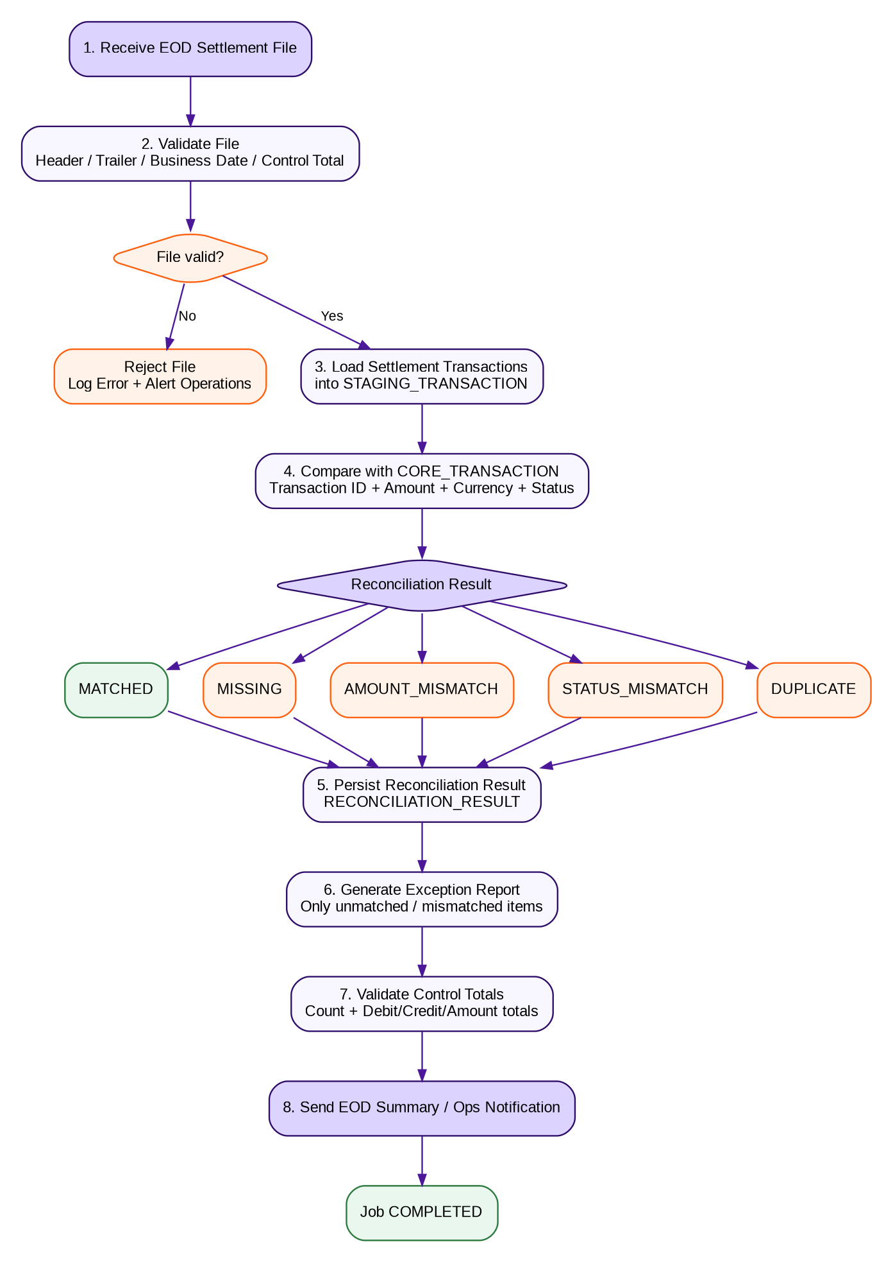
Use Case  End-of-Day Reconciliation | Pattern  Chunk-Oriented Processing | Audience  Java / Spring Boot Learners
Training-ready documentation

Contents
1. Purpose and Learning Objectives
2. Banking Business Scenario
3. End-to-End Workflow
4. Spring Batch Technical Architecture
5. Step-by-Step Job Design
6. Data Model and Reconciliation Rules
7. Chunk Processing and Transaction Boundaries
8. Fault Tolerance: Skip, Retry and Restart
9. Sample Spring Batch Implementation
10. Operational Controls and Auditability
11. Hands-on Exercise
12. Expected Outputs and Trainer Debrief

1. Purpose and Learning Objectives
This document demonstrates how Spring Batch can be applied to a realistic banking use case: End-of-Day (EOD) transaction reconciliation. The job compares internal core-banking transactions with an external settlement file, classifies differences, persists results, and produces an exception report for operations.
Learning Objective | What the learner should understand
Spring Batch model | Job, Step, JobRepository, JobLauncher and execution metadata.
Chunk processing | How ItemReader, ItemProcessor and ItemWriter cooperate inside a transactional chunk.
Banking reconciliation | How source systems are matched using transaction identifiers and business attributes.
Operational resilience | Restartability, idempotency, skip/retry, control totals and auditability.
Exception management | How mismatches are classified and reported without stopping valid processing unnecessarily.

2. Banking Business Scenario
At the end of a banking business day, the payment/settlement network provides a settlement file. The bank already has transactions posted in its core banking or transaction-processing system. Operations needs an automated process to verify that both sources agree before the business date is closed.

Business problem
- The core system may show a transaction that is absent from the settlement file.
- The settlement file may contain a transaction that is absent internally.
- The transaction may exist in both systems but the amount, currency or status may differ.
- A transaction may be duplicated in the settlement source.
- The file itself may be incomplete, for example when header/trailer control totals do not match.

Primary business outcome
Produce a reconciled population plus an exception population, with counts and monetary control totals that operations can independently verify.

3. End-to-End Workflow

Workflow explanation
# | Stage | Description
1 | Receive settlement file | Obtain the EOD file from an upstream payment/settlement source.
2 | Validate file | Validate file name, business date, header, trailer, row count and control amount.
3 | Stage records | Parse valid records and store them in a staging table.
4 | Reconcile | Compare staged data against core banking transactions.
5 | Classify | Assign MATCHED, MISSING, AMOUNT_MISMATCH, STATUS_MISMATCH or DUPLICATE.
6 | Persist result | Write reconciliation results with run ID/business date for traceability.
7 | Report exceptions | Produce an exception report for items requiring investigation.
8 | Close job | Validate totals, update status and notify operations.

4. Spring Batch Technical Architecture
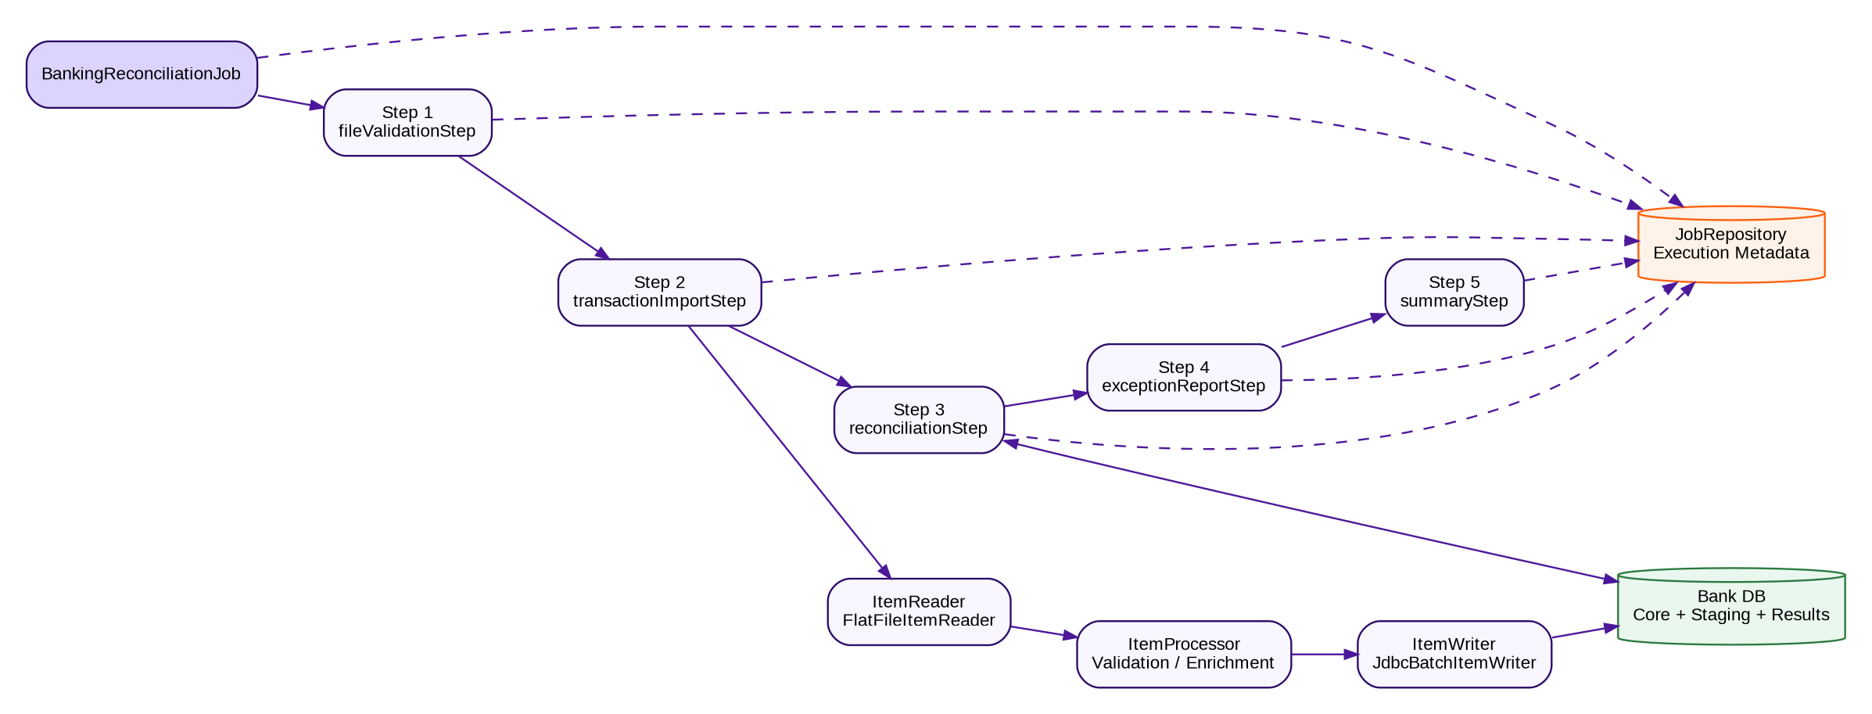

Core components
Component | Banking role
Job | Top-level unit representing the complete EOD reconciliation run.
Step | A stage in the job, such as validation, import, reconciliation or reporting.
ItemReader | Reads one settlement transaction at a time from the file.
ItemProcessor | Validates, cleans, enriches or transforms a transaction.
ItemWriter | Persists a chunk of valid transactions to the database.
JobRepository | Stores job instances, executions, step executions and execution context for restartability.
TransactionManager | Defines transactional boundaries for chunk commits.
JobLauncher / Scheduler | Starts the batch job, typically with business date and file name as parameters.

5. Step-by-Step Job Design
Step | Type | Responsibility
Step 1 - fileValidationStep | Tasklet | Validate file presence, business date, header/trailer, expected row count, expected total amount and duplicate file detection.
Step 2 - transactionImportStep | Chunk | Read settlement records, validate/normalize fields and write to STAGING_TRANSACTION.
Step 3 - reconciliationStep | Chunk or Tasklet | Compare staging records with CORE_TRANSACTION and create one reconciliation result per logical transaction.
Step 4 - exceptionReportStep | Tasklet | Generate CSV/DB report containing unresolved differences.
Step 5 - summaryStep | Tasklet | Compute control totals, mark job outcome and notify operations.

Recommended job parameters
businessDate=2026-09-17
settlementFile=/inbound/settlement_20260917.csv
sourceSystem=PAYMENT_NETWORK_A
runType=EOD

6. Data Model and Reconciliation Rules

Logical tables
Table | Purpose
CORE_TRANSACTION | Internal source-of-truth transaction data.
STAGING_TRANSACTION | Parsed external settlement records for the current run.
RECONCILIATION_RESULT | One row per comparison result, including reason/status.
BATCH_* tables | Spring Batch metadata tables used for execution tracking and restart.

Example matching rules
Condition | Rule | Result
Exact match | Transaction ID exists in both sources and amount, currency and status agree. | MATCHED
Internal-only | Exists in core system but not settlement source. | MISSING_IN_SETTLEMENT
External-only | Exists in settlement source but not core system. | MISSING_IN_CORE
Amount differs | Same transaction ID, different amount. | AMOUNT_MISMATCH
Currency differs | Same transaction ID, different currency. | CURRENCY_MISMATCH
Status differs | Same transaction ID/amount but different state. | STATUS_MISMATCH
Duplicate external record | Same settlement transaction appears more than once. | DUPLICATE

Example reconciliation data
Txn ID | Core Amt | Settlement Amt | Core Status | Settlement Status | Result
TXN001 | 10,000 | 10,000 | SUCCESS | SUCCESS | MATCHED
TXN002 | 5,000 | - | SUCCESS | - | MISSING_IN_SETTLEMENT
TXN003 | 7,500 | 7,000 | SUCCESS | SUCCESS | AMOUNT_MISMATCH
TXN004 | 2,000 | 2,000 x 2 | SUCCESS | SUCCESS | DUPLICATE
TXN005 | 3,200 | 3,200 | SUCCESS | FAILED | STATUS_MISMATCH

7. Chunk Processing and Transaction Boundaries
The import step should normally be chunk-oriented. For example, with a chunk size of 500, Spring Batch reads and processes 500 items and then writes/commits them as one transaction. If the chunk fails before commit, that chunk can be retried without losing the previously committed chunks.
reader -> item 1
processor -> item 1
reader -> item 2
processor -> item 2
...
reader -> item 500
processor -> item 500
writer -> 500 items
COMMIT
Chunk size is a performance and recoverability trade-off. Smaller chunks commit more often and reduce rework after failure; larger chunks can improve throughput but increase the amount of uncommitted work at risk.

8. Fault Tolerance: Skip, Retry and Restart

Restartability

Skip vs Retry
Mechanism | When to use | Example
Skip | Bad business/data record that should not stop the complete file. | Malformed optional reference field; log to reject table.
Retry | Transient technical failure that may succeed shortly. | Temporary database deadlock or network timeout.
Fail fast | Structural/file-level error that invalidates the full run. | Trailer count or control total does not match the actual file.

Idempotency requirement
Restarting a banking batch must not duplicate postings or results. Use a unique business key such as (source_system, business_date, transaction_id) and design writes as insert-once or deterministic upserts where appropriate. A restarted job should reproduce the same business outcome as the original successful execution.

9. Sample Spring Batch Implementation

Job definition
@Bean
public Job bankingReconciliationJob(
JobRepository jobRepository,
Step fileValidationStep,
Step transactionImportStep,
Step reconciliationStep,
Step exceptionReportStep,
Step summaryStep) {

return new JobBuilder("bankingReconciliationJob", jobRepository)
.start(fileValidationStep)
.next(transactionImportStep)
.next(reconciliationStep)
.next(exceptionReportStep)
.next(summaryStep)
.build();
}

Chunk step
@Bean
public Step transactionImportStep(
JobRepository jobRepository,
PlatformTransactionManager transactionManager) {

return new StepBuilder("transactionImportStep", jobRepository)
.<SettlementTransaction, SettlementTransaction>chunk(500, transactionManager)
.reader(transactionReader())
.processor(transactionProcessor())
.writer(transactionWriter())
.faultTolerant()
.retry(TransientDataAccessException.class)
.retryLimit(3)
.skip(FlatFileParseException.class)
.skipLimit(20)
.build();
}

Reconciliation logic - simplified
if (core == null) {
result = MISSING_IN_CORE;
} else if (settlement == null) {
result = MISSING_IN_SETTLEMENT;
} else if (core.amount().compareTo(settlement.amount()) != 0) {
result = AMOUNT_MISMATCH;
} else if (!core.currency().equals(settlement.currency())) {
result = CURRENCY_MISMATCH;
} else if (!core.status().equals(settlement.status())) {
result = STATUS_MISMATCH;
} else {
result = MATCHED;
}

10. Operational Controls and Auditability
Control | Implementation intent
Business date control | Every run is linked to an explicit business date; do not silently default to system date for EOD processing.
File identity | Store file name, checksum, source system and arrival timestamp to detect duplicate delivery.
Header/trailer controls | Validate row count and monetary totals before downstream reconciliation.
Run ID | Attach a batch run identifier to staged and result data.
Execution metadata | Retain JobExecution and StepExecution information for status, timing and restart trace.
Reject handling | Persist rejected records with reason and source line number.
Access/audit | Keep reports and logs appropriate for operational audit and investigation.
Data protection | Mask account numbers and sensitive identifiers in learner/demo logs and reports.

11. Hands-on Exercise
Build and execute the banking reconciliation job using a CSV settlement file and an H2/PostgreSQL database.
- Create 20 core transactions and 20 settlement records.
- Introduce at least one amount mismatch, one missing record, one status mismatch and one duplicate.
- Implement the file import as a chunk-oriented step.
- Write reconciliation results to RECONCILIATION_RESULT.
- Generate an exceptions.csv file containing only non-MATCHED records.
- Force a failure after several chunks, restart the job, and verify that committed chunks are not duplicated.
- Compare header/trailer control totals with processed totals before marking the job COMPLETED.

Suggested project structure
src/main/java/com/bank/recon/
config/
BatchConfig.java
domain/
CoreTransaction.java
SettlementTransaction.java
ReconciliationResult.java
reader/
SettlementFileReaderConfig.java
processor/
SettlementProcessor.java
ReconciliationProcessor.java
writer/
SettlementWriterConfig.java
tasklet/
FileValidationTasklet.java
ExceptionReportTasklet.java
SummaryTasklet.java
listener/
JobAuditListener.java

src/main/resources/
application.yml
schema.sql
data.sql
input/settlement.csv

12. Expected Outputs and Trainer Debrief

Example job summary
Business Date : 2026-09-17
Settlement Records : 20
Core Records : 20
Matched : 16
Missing : 1
Amount Mismatch : 1
Status Mismatch : 1
Duplicate : 1
Rejected Records : 0
Job Status : COMPLETED

Trainer discussion questions
- Why is reconciliation separated from transaction posting?
- What should happen if the file-level control total is wrong?
- Which errors should be skipped and which should fail the job?
- Why is a unique business key important for restartability?
- How would the design change for 10 million transactions?
- What data should be retained for an audit trail?
- Where would partitioning or parallel steps help, and what risks would they introduce?
Key takeaway: Spring Batch provides the processing lifecycle, transaction boundaries, restart metadata and fault-tolerance mechanisms; the banking application supplies the business validation, reconciliation rules, controls and audit requirements.

