COMBINED MACHINE-LEARNING CASE STUDY

Feature Selection, Encoding, PCA and Automated Data Pipelines
Automobile Service-Risk Prediction
Case study document + executable solution + system architecture
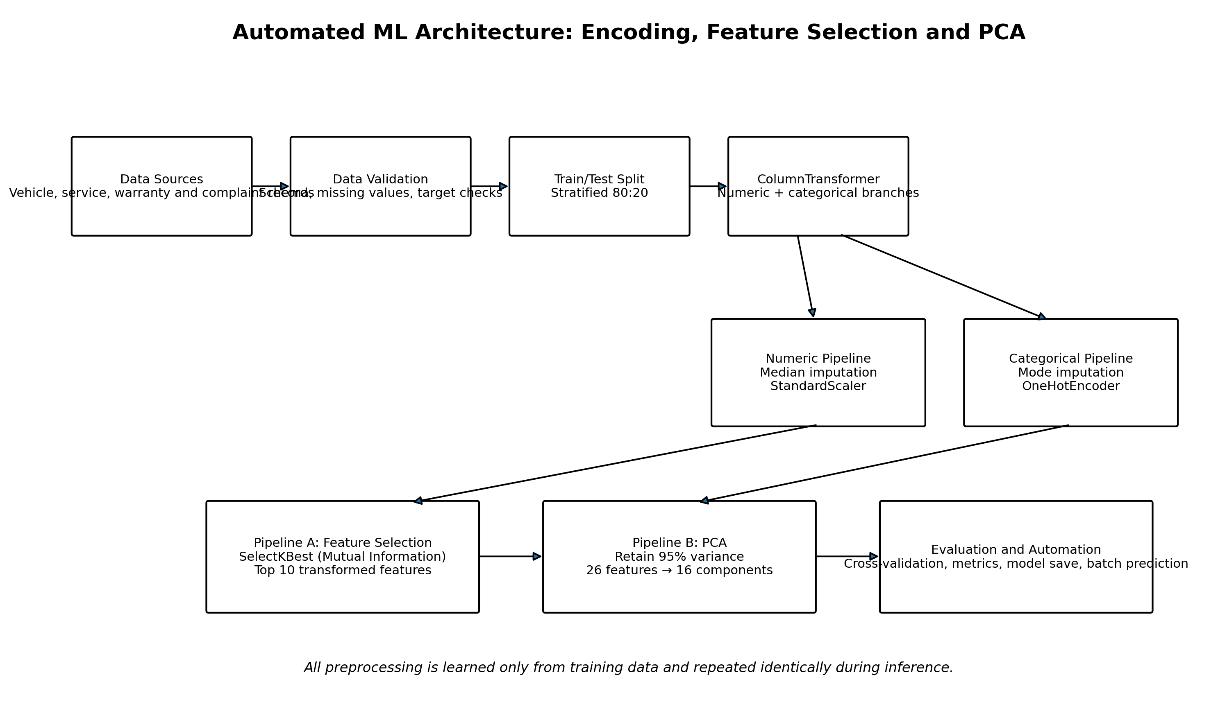
End-to-end architecture used in the case study
Package outcome: A reusable scikit-learn solution that safely handles missing values, one-hot encoding, label encoding, scaling, feature selection, PCA, model evaluation, model persistence and batch inference.

How to Use This Package
This document can be used as trainer notes, a participant case study, a guided lab, or a reference solution. The data is synthetic and is designed for learning rather than real vehicle-safety decisions.

Recommended File Order
Order | File | Purpose
1 | Vehicle_ML_Combined_Case_Study.docx | Read the business case, concepts, architecture and solution.
2 | docs/architecture.png | Review the processing and automation flow.
3 | data/vehicle_service_risk_dataset.csv | Inspect the 1,500-row training dataset.
4 | src/vehicle_risk_pipeline.py | Run data generation, training, evaluation and export.
5 | outputs/model_comparison.csv | Compare feature-selection and PCA pipelines.
6 | src/predict_new_data.py | Run saved-pipeline inference on new vehicles.

Document Map
- 1. Case-study brief and 5W1H
- 2. Dataset and business rules
- 3. Concept foundations
- 4. End-to-end architecture
- 5. Step-by-step implementation
- 6. Results and interpretation
- 7. Automation and new-data inference
- 8. Verification, mistakes and best practices
- 9. Guided lab and review questions

1. Case-Study Brief

Business Scenario
A multi-brand automobile service network wants to identify vehicles that are likely to require urgent service during the next 30 days. The organization receives data from vehicle telemetry, service history, warranty systems and customer complaints.
The raw data contains numerical values, nominal categories and missing values. After one-hot encoding, the number of model inputs increases. The team therefore needs a reproducible way to reduce unnecessary dimensions without allowing data leakage.

Business Objective
Goal: Predict High Risk versus Low Risk vehicles and produce a probability that service teams can use to prioritize customer outreach.

5W1H
Question | Case-study answer
What? | Build a binary classification pipeline for vehicle service risk.
Why? | Reduce unexpected breakdowns, improve workshop planning and contact high-risk customers early.
Who? | Data scientists, service operations analysts, workshop managers and customer-care teams.
When? | During scheduled daily or weekly scoring, and when new service or telemetry data arrives.
Where? | Central analytics platform, cloud ML environment or an enterprise batch-processing server.
How? | Impute, scale, encode, reduce dimensions, train, evaluate, save and reuse a complete pipeline.

Success Criteria
Criterion | Acceptance condition
Data consistency | The same transformations must be applied during training and prediction.
Leakage prevention | Imputation, encoding, scaling and reduction are fitted only on training folds.
Risk detection | Recall and F1 for High Risk vehicles must be reported, not accuracy alone.
Dimensionality control | Compare interpretable feature selection with compact PCA components.
Operational reuse | Persist the fitted pipeline and score new CSV records without manual preprocessing.

2. Dataset Design
The supplied synthetic dataset contains 1,500 vehicles. It has 15 model inputs, one identifier and one target. A small amount of missing data is intentionally introduced to test the pipeline's imputation stages.
Column | Type | Example | Meaning
vehicle_id | Identifier | VH100001 | Excluded from training
vehicle_age_years | Numeric | 8.2 | Vehicle age
mileage_km | Numeric | 112000 | Total distance travelled
service_gap_months | Numeric | 18 | Months since last service
engine_alerts | Numeric | 6 | Recent engine warning count
brake_wear_percent | Numeric | 84 | Estimated brake wear
avg_monthly_distance_km | Numeric | 1850 | Usage intensity
warranty_claims | Numeric | 2 | Historical claims
customer_complaints | Numeric | 4 | Complaint count
repair_cost_last_year | Numeric | 24500 | Recent repair expense
battery_voltage | Categorical | Low | Low or Normal
driving_pattern | Categorical | City | City, Highway or Mixed
fuel_type | Categorical | Diesel | Petrol, Diesel, CNG or Electric
region | Categorical | West | Operational region
transmission | Categorical | Manual | Manual or Automatic
service_center_type | Categorical | Independent | Authorized or Independent
service_risk | Target | High Risk | Class to predict

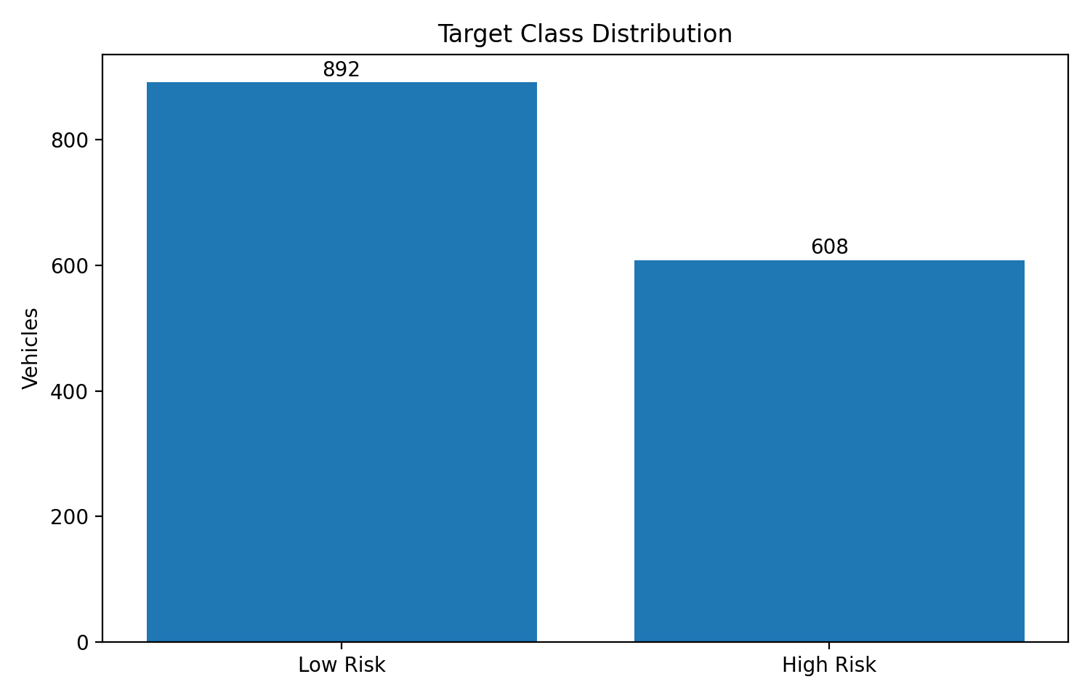
Target class distribution in the generated dataset
Important: The target distribution is not perfectly equal. Stratified splitting and class-weighted logistic regression are used so that the risk class is not ignored.

3. Concept Foundations

3.1 One-Hot Encoding
One-hot encoding creates a separate binary column for every category. For example, driving_pattern becomes driving_pattern_City, driving_pattern_Highway and driving_pattern_Mixed. It is appropriate because these categories do not have a meaningful order.
OneHotEncoder(
handle_unknown="ignore",
sparse_output=False
)

- handle_unknown='ignore' allows future categories to be processed without failing the complete prediction job.
- The output is dense because the PCA pipeline requires a dense numerical matrix in this example.
- One-hot encoding increases dimensionality: 15 source inputs become 26 transformed features.

3.2 Label Encoding
Label encoding converts the target text into numeric codes. In this run, High Risk is encoded as 0 and Low Risk as 1 because LabelEncoder sorts labels alphabetically.
label_encoder = LabelEncoder()
y = label_encoder.fit_transform(df["service_risk"])
high_risk_code = label_encoder.transform(["High Risk"])[0]

Rule: Use label encoding for the output label here. Do not use it for nominal inputs such as region or fuel type because artificial numbers would imply a false ordering.

3.3 Feature Selection
Feature selection keeps original transformed features and removes weaker ones. This case study uses SelectKBest with mutual information to select the 10 transformed features that have the strongest relationship with the target.
- Advantages: better interpretability, lower training cost and a direct list of retained inputs.
- Limitation: the selected list can vary when the training sample changes.

3.4 Principal Component Analysis
PCA creates new orthogonal components that summarize variance in the encoded and scaled matrix. The case study asks PCA to retain at least 95% of cumulative explained variance rather than hard-coding a component count.
PCA(n_components=0.95, svd_solver="full")

- Advantages: compresses correlated information and removes multicollinearity.
- Limitation: components are mathematical combinations and are less interpretable than named features.

3.5 Data Pipeline
A scikit-learn Pipeline chains every operation. During fit, each step learns only from training data. During predict, the already-fitted transformations are replayed in exactly the same order.
Why it matters: Manual preprocessing often causes inconsistent columns, leakage and production failures. A persisted pipeline packages preprocessing and the model as one deployable object.

Aspect | Feature Selection | PCA
Output | Named source/encoded features | Anonymous principal components
Interpretability | Higher | Lower
Reduction method | Target-aware | Variance-based, target-independent
Best when | Business explanation is important | Compression and correlated inputs are important
Risk | Can miss combined effects | Can retain variance unrelated to the target

4. End-to-End Architecture

Architecture: data ingestion through reusable inference

Architecture Walkthrough
- Source records are loaded from a CSV, database extract or operational data lake.
- Schema checks separate the identifier, target, numeric inputs and categorical inputs.
- A stratified 80:20 split creates 1,200 training records and 300 test records.
- ColumnTransformer sends numeric and categorical columns through different preprocessing branches.
- Numeric values receive median imputation and standard scaling.
- Categorical values receive most-frequent imputation and one-hot encoding.
- Pipeline A selects 10 transformed features; Pipeline B produces 16 principal components to retain 95% variance.
- Both branches train class-weighted logistic regression, run five-fold cross-validation, report test metrics and save the fitted pipeline.
- The saved feature-selection pipeline scores new vehicles without manually recreating preprocessing logic.

5. Step-by-Step Solution

Step 1 - Load and Separate the Data
df = pd.read_csv("data/vehicle_service_risk_dataset.csv")
label_encoder = LabelEncoder()
y = label_encoder.fit_transform(df["service_risk"])
X = df.drop(columns=["vehicle_id", "service_risk"])

The identifier is removed because it has no predictive meaning. The target is encoded separately so it is never passed through the feature preprocessor.

Step 2 - Detect Numeric and Categorical Inputs
numeric_features = X.select_dtypes(include=["number"]).columns.tolist()
categorical_features = X.select_dtypes(exclude=["number"]).columns.tolist()

This run detects 9 numeric and 6 categorical inputs. Automatic detection makes the training script easier to maintain when the schema is extended carefully.

Step 3 - Build the Preprocessing Branches
numeric_pipeline = Pipeline([
("imputer", SimpleImputer(strategy="median")),
("scaler", StandardScaler())
])
categorical_pipeline = Pipeline([
("imputer", SimpleImputer(strategy="most_frequent")),
("one_hot", OneHotEncoder(handle_unknown="ignore", sparse_output=False))
])
preprocessor = ColumnTransformer([
("numeric", numeric_pipeline, numeric_features),
("categorical", categorical_pipeline, categorical_features)
])

Median imputation is robust to large numerical outliers. Most-frequent imputation provides a valid category for missing categorical values. Standardization is essential before PCA because variance is affected by feature scale.

Step 4 - Split Before Learning Transformations
X_train, X_test, y_train, y_test = train_test_split(
X, y,
test_size=0.20,
random_state=42,
stratify=y
)

Leakage prevention: Do not one-hot encode, scale, select features or run PCA on the complete dataset before splitting. The pipeline must learn these transformations from training data only.

Step 5 - Build Two Competing Pipelines
feature_selection_pipeline = Pipeline([
("preprocessor", build_preprocessor(...)),
("selector", SelectKBest(mutual_info_classif, k=10)),
("model", LogisticRegression(class_weight="balanced", max_iter=3000))
])
pca_pipeline = Pipeline([
("preprocessor", build_preprocessor(...)),
("pca", PCA(n_components=0.95, svd_solver="full")),
("model", LogisticRegression(class_weight="balanced", max_iter=3000))
])

Separate preprocessor objects are created for the two pipelines. Reusing one already-fitted transformer across independent experiments can cause confusing state and should be avoided.

Step 6 - Fit, Cross-Validate and Evaluate
pipeline.fit(X_train, y_train)
predictions = pipeline.predict(X_test)
probabilities = pipeline.predict_proba(X_test)[:, high_risk_probability_index]
cv = StratifiedKFold(n_splits=5, shuffle=True, random_state=42)
cv_scores = cross_val_score(
pipeline, X_train, y_train,
cv=cv, scoring="f1_macro"
)

Five-fold cross-validation repeats the entire fitted pipeline inside each fold. The independent test set remains untouched until final evaluation.

Step 7 - Persist the Complete Objects
joblib.dump(pipeline, "artifacts/feature_selection_pipeline.joblib")
joblib.dump(label_encoder, "artifacts/target_label_encoder.joblib")

Saving only the classifier would be insufficient. The saved pipeline includes the imputers, scaler, one-hot encoder, selected feature mask and model.

6. Results and Interpretation
Pipeline | Accuracy | Precision | Recall | F1 | ROC-AUC | CV macro-F1
Feature Selection | 0.717 | 0.643 | 0.680 | 0.661 | 0.796 | 0.735 ± 0.021
PCA | 0.713 | 0.632 | 0.705 | 0.667 | 0.796 | 0.737 ± 0.024

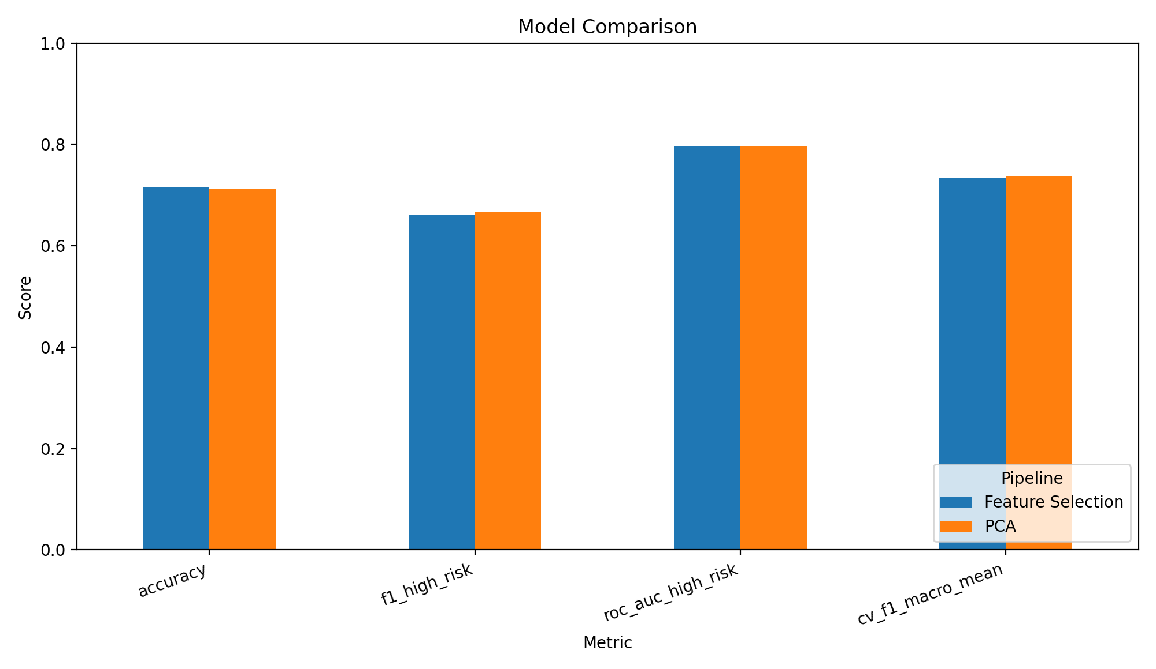
Test and cross-validation comparison

What the Metrics Mean
- Feature Selection has the slightly higher accuracy and ROC-AUC and was chosen as the saved inference model.
- PCA has the higher High Risk recall and F1 in this run, so it may be preferred when missed risky vehicles are more costly than additional service calls.
- The difference between the two pipelines is small. The business should select the threshold and model based on cost, capacity and validation on real data rather than one metric alone.

Confusion Matrices
Pipeline | Actual High → High | Actual High → Low | Actual Low → High | Actual Low → Low
Feature Selection | 83 | 39 | 46 | 132
PCA | 86 | 36 | 50 | 128

For the feature-selection pipeline, 83 of 122 High Risk test vehicles were detected and 39 were missed. The PCA pipeline detected 86 and missed 36. A threshold-tuning exercise can trade false negatives against false positives.

Selected Features
Selected transformed feature | Mutual information score
numeric__brake_wear_percent | 0.0991
numeric__mileage_km | 0.0950
numeric__repair_cost_last_year | 0.0759
numeric__vehicle_age_years | 0.0719
numeric__engine_alerts | 0.0524
numeric__warranty_claims | 0.0258
numeric__customer_complaints | 0.0185
categorical__fuel_type_Electric | 0.0175
numeric__service_gap_months | 0.0161
categorical__transmission_Automatic | 0.0103

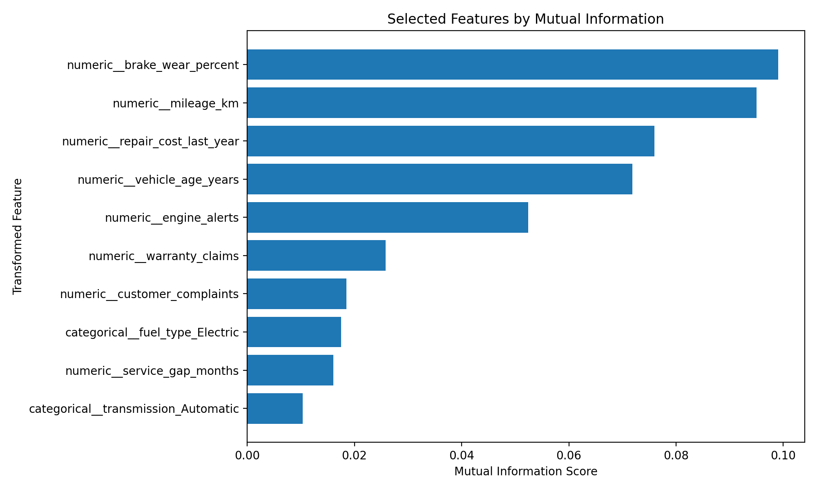
Top 10 transformed features selected by mutual information
Mileage, brake wear, repair cost, vehicle age and engine alerts dominate the selected set. The exact list should not be treated as universal because it reflects the generated sample and random variation.

PCA Reduction
The encoded matrix contains 26 columns. PCA keeps 16 components and reaches 95.5% cumulative explained variance.
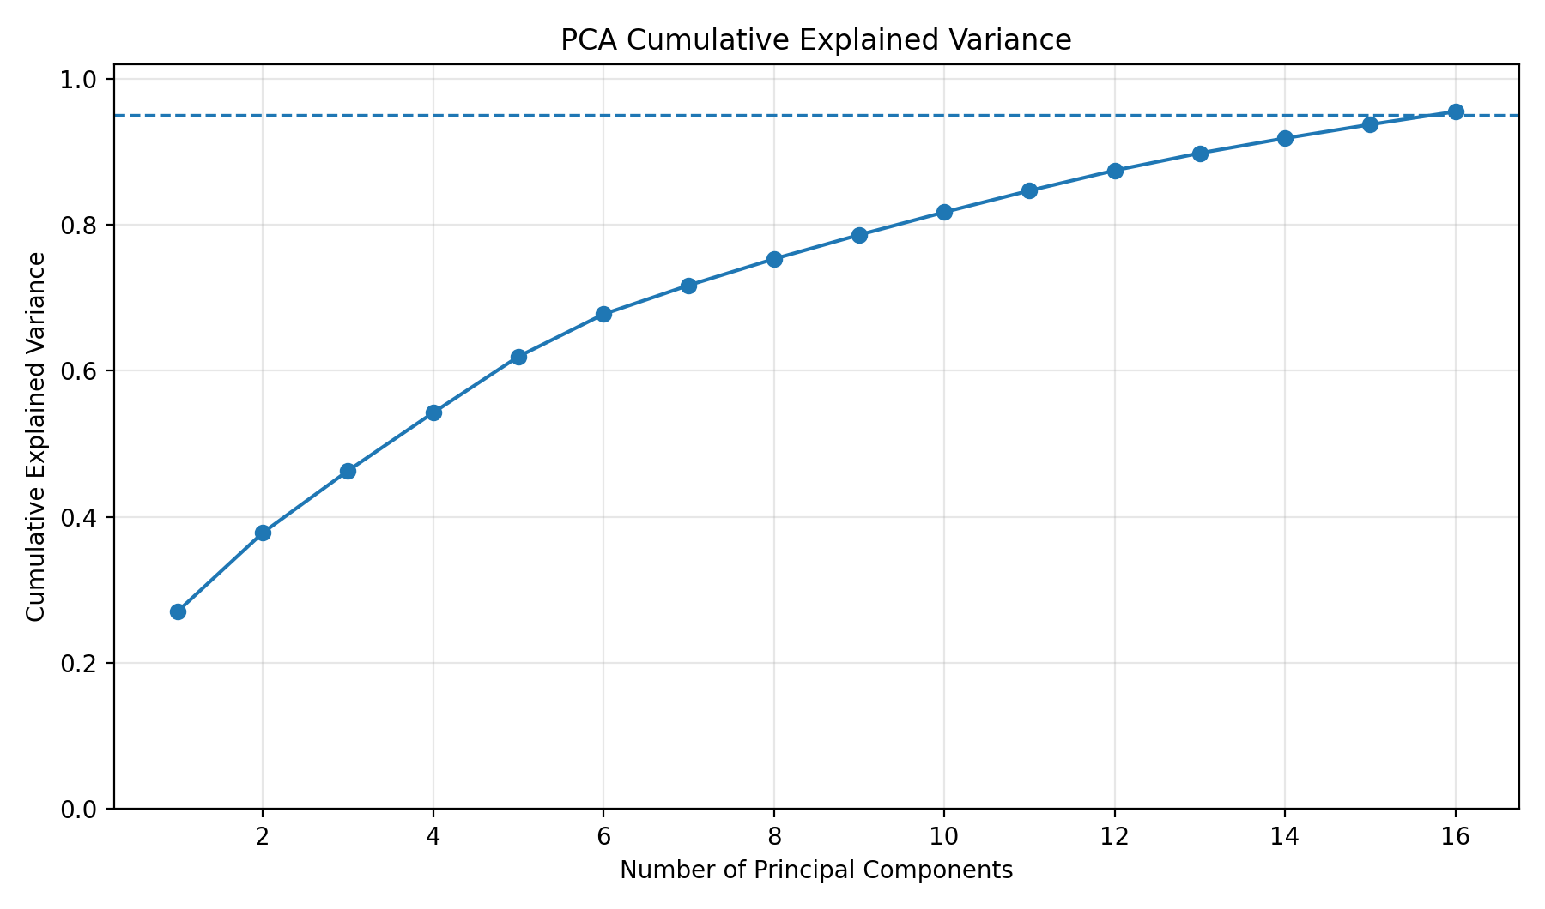
PCA cumulative explained variance; the dashed line marks 95%

7. Data Pipeline Automation and Inference

Training Automation
Automation stage | Action
Input | Read existing dataset or generate the synthetic training data.
Preparation | Identify feature types, label-encode the target and create the split.
Experiment | Fit feature-selection and PCA pipelines.
Validation | Calculate test metrics, confusion matrices and five-fold macro-F1.
Export | Write CSV/JSON reports and save fitted joblib artifacts.
Selection | Choose the highest ROC-AUC pipeline for the supplied inference example.

New-Data Inference
pipeline = joblib.load("artifacts/feature_selection_pipeline.joblib")
label_encoder = joblib.load("artifacts/target_label_encoder.joblib")
new_data = pd.read_csv("data/new_vehicle_input.csv")
prediction_codes = pipeline.predict(new_data)
probabilities = pipeline.predict_proba(new_data)[:, high_risk_probability_index]
labels = label_encoder.inverse_transform(prediction_codes)

No manual imputation, scaling, dummy-column creation or feature selection is required. The persisted pipeline performs those operations internally.
Mileage | Gap | Alerts | Battery | Pattern | Prediction | High-risk probability
112000 | 18 | 6 | Low | City | High Risk | 99.5%
23000 | 4 | 0 | Normal | Highway | Low Risk | 2.8%
68000 | 11 | 3 | Normal | Mixed | High Risk | 69.6%

Suggested Production Schedule
- Daily: validate and score new/updated vehicle records.
- Weekly: review prediction distribution, missing-data rates and service-team capacity.
- Monthly: evaluate labelled outcomes, threshold performance and drift indicators.
- Quarterly or after material drift: retrain, compare candidate pipelines and approve a new artifact version.

8. Verification and Best Practices

How to Verify the Solution
Check | Expected evidence
Dataset | CSV opens; 1,500 rows; target and feature columns are present.
Reproducibility | Running the training script with random_state=42 recreates the supplied metrics within environment-level numerical tolerance.
No leakage | All imputation, encoding, scaling and reduction steps are inside Pipeline.
Unknown categories | A new category does not crash inference because handle_unknown='ignore'.
Persistence | Saved joblib model predicts the same labels as the fitted in-memory object.
Output | Reports, selected-feature list, PCA variance and prediction CSVs are produced.
Business metric | High Risk recall and false negatives are reviewed alongside accuracy.

Common Mistakes
Mistake | Why it is a problem
Encoding before the split | Leaks category and distribution information from the test set.
Label-encoding nominal inputs | Creates false numeric order, for example West > South.
Running PCA without scaling | High-range variables dominate variance.
Saving only the classifier | Production cannot recreate the exact feature matrix.
Using accuracy alone | May hide missed High Risk vehicles.
Applying PCA to the target | PCA is for input features, never the output label.
Interpreting PCA components as original columns | A component is a weighted combination of many transformed features.

Production Enhancements
- Replace synthetic data with governed historical outcomes and define a precise 30-day risk label.
- Add schema validation, data-quality alerts and category-frequency monitoring.
- Tune SelectKBest k, logistic-regression C and classification threshold using nested cross-validation or a validation set.
- Compare tree-based models, which may capture non-linear interactions without PCA.
- Calibrate probabilities before using them as operational risk scores.
- Track model version, training data window, code version and evaluation approval.
- Monitor drift, delayed labels, false-negative cost and service-center workload.

9. Guided Lab and Review

Participant Tasks
- Run the training script and confirm that all output files are generated.
- Change SelectKBest from k=10 to k=6, k=15 and k='all'; compare test and cross-validation results.
- Change PCA retention from 95% to 90% and 99%; record component counts and metrics.
- Remove StandardScaler from the PCA branch and explain the impact.
- Add a new categorical column such as vehicle_segment and confirm one-hot encoding handles it.
- Tune the decision threshold to increase High Risk recall and report the new confusion matrix.
- Create a prediction input containing an unseen category and verify that inference completes.

Review Questions with Answers
Question | Answer
Why is one-hot encoding used for driving_pattern? | Its values are nominal and have no valid numeric rank.
Why is LabelEncoder used for service_risk? | The classifier needs a numeric target, while the encoder preserves reversible class labels.
Why must scaling occur before PCA? | PCA measures variance; unscaled high-range columns can dominate the components.
Why put SelectKBest inside Pipeline? | Feature scores must be learned only from each training fold to avoid leakage.
Does PCA select the best predictive features? | No. It preserves input variance without directly using the target.
Why save the full pipeline? | It guarantees identical preprocessing and feature layout during future predictions.
Which model is best here? | Feature Selection leads by ROC-AUC; PCA leads slightly on High Risk recall/F1. Business costs decide.

Run Commands
pip install -r requirements.txt
python src/vehicle_risk_pipeline.py
python src/predict_new_data.py

Final Takeaway
Core lesson: Encoding, feature selection and PCA should not be isolated notebook steps. They belong inside a validated, persisted pipeline so that training, evaluation and production inference use exactly the same transformations.

Appendix A - Generated Deliverables
Path | Contents
data/vehicle_service_risk_dataset.csv | Training dataset
data/new_vehicle_input.csv | Three inference examples
src/vehicle_risk_pipeline.py | Complete executable training workflow
src/predict_new_data.py | Saved-pipeline inference workflow
outputs/model_comparison.csv | Model metrics
outputs/selected_features.csv | Scores and selected flags
outputs/pca_explained_variance.csv | Per-component and cumulative variance
outputs/classification_reports_and_confusion_matrices.json | Detailed evaluation
outputs/sample_predictions.csv | Held-out sample predictions
artifacts/*.joblib | Persisted pipelines and label encoder
docs/*.png | Architecture and result visuals

Appendix B - Environment Note
The code uses pandas, NumPy, scikit-learn, joblib and Matplotlib. OneHotEncoder's sparse_output parameter requires a modern scikit-learn release. For an older release, replace sparse_output=False with sparse=False.
Because the data is generated, the reported performance demonstrates the workflow rather than a certified safety model. Real deployment requires representative data, domain review, governance and post-deployment monitoring.

