COMBINED MACHINE-LEARNING CASE STUDY
Telecom Customer Churn Intelligence
Feature Selection • Encoding • PCA • Pipelines • Automation
Learner Assignment Document
IMPORTANT
This document intentionally contains no source code, no model solution, no calculated metrics, no recommended feature list, and no final answer. Learners must design, implement, validate, and justify the complete solution.
Suggested duration: 4-6 hours individual lab or 1-day guided workshop
Item | Details
Domain | Telecommunications / Customer Retention
ML task | Binary classification
Primary target | Whether a customer is likely to churn
Expected methods | One-hot encoding, label encoding, feature selection, PCA, automated pipelines
Delivery format | Notebook or Python project plus reports and saved artifacts

1. Business Scenario
NovaTel is a national telecom provider offering prepaid, postpaid, broadband, and bundled digital services. Customer-acquisition costs have increased, while several regional teams report a rise in voluntary cancellations. Management wants an early-warning system that identifies customers who may leave within the next 30 days so that retention teams can prioritize outreach.
The organization currently uses broad campaign rules such as “contact every customer with two complaints” or “offer discounts to customers with falling usage.” These rules are expensive, inconsistent, and difficult to scale. The analytics team has therefore been asked to build a reproducible machine-learning workflow that can transform raw customer records into churn-risk predictions.

2. Business Problem
Problem statement
Design a machine-learning solution that predicts whether an active telecom customer will churn within the next 30 days. The workflow must handle numerical and categorical data, compare feature-selection and PCA approaches, and package the approved process as an automated reusable pipeline.

3. Business Objectives
- Identify high-risk customers early enough for a retention intervention.
- Reduce unnecessary offers to customers who are unlikely to leave.
- Create a consistent preprocessing and prediction workflow for future customer files.
- Compare an interpretable feature-selection approach with a dimensionality-reduction approach.
- Produce reusable model artifacts that can be loaded without retraining for every prediction batch.

4. Stakeholders
Stakeholder | Primary concern
Retention operations | A usable list of customers to contact first
Marketing | Campaign efficiency and offer targeting
Customer care | Impact of complaints, delays, and support interactions
Data science | Reliable evaluation and reproducible modelling
Data engineering | Repeatable batch workflow and schema consistency
Risk and governance | Fairness, explainability, privacy, and auditability

5. Available Dataset
The analytics team receives a customer-level CSV extract. Each row represents one active customer at the observation date. The target was created later by checking whether the customer cancelled service within the following 30 days.

5.1 Dataset dimensions
Property | Value supplied to learners
Approximate records | 5,000 customer rows
Input columns | 18 predictors
Target column | churn_status
Data types | Numerical, binary, ordinal-like, and nominal categorical
Known quality issues | Missing values, rare categories, unequal class distribution, different numerical scales

5.2 Data dictionary
Column | Type | Description
customer_id | Identifier | Unique customer reference; must not be used as a predictive signal.
age | Numerical | Customer age in years.
tenure_months | Numerical | Number of months since service activation.
monthly_bill_inr | Numerical | Current monthly billed amount.
avg_data_gb | Numerical | Average monthly data consumption.
avg_voice_minutes | Numerical | Average monthly outgoing voice minutes.
late_payments_6m | Numerical | Count of late payments in the previous six months.
support_calls_3m | Numerical | Support calls made in the previous three months.
network_issues_3m | Numerical | Network-related complaints in the previous three months.
discount_percent | Numerical | Current recurring discount percentage.
contract_type | Categorical | Monthly, annual, or two-year agreement.
payment_method | Categorical | Card, UPI, bank transfer, cash, or wallet.
plan_type | Categorical | Prepaid, postpaid, broadband, or bundle.
region | Categorical | Customer operating region.
device_type | Categorical | Feature phone, Android, iOS, router, or multiple devices.
auto_pay | Categorical/Binary | Whether automatic payment is enabled.
premium_support | Categorical/Binary | Whether premium support is active.
satisfaction_band | Categorical | Low, Medium, or High satisfaction category.
churn_status | Target | Churned or Stayed within the following 30 days.

6. Illustrative Sample Records
The following rows illustrate the expected structure only. They are not intended to reveal patterns, correct preprocessing choices, or a final model.
ID | Age | Tenure | Bill | Data | Voice | Late | Calls | Net | Disc | Contract | Payment | Plan | Region | Device | Auto | Premium | Sat. | Target
C1001 | 34 | 18 | 899 | 24.5 | 410 | 0 | 1 | 0 | 5 | Annual | UPI | Postpaid | West | Android | Yes | No | High | Stayed
C1002 | 51 | 7 | 1499 | 88.0 | 220 | 2 | 4 | 3 | 18 | Monthly | Card | Bundle | South | Multiple | No | Yes | Low | Churned
C1003 | 29 | 3 | 499 | 12.8 | 610 | 1 | 2 | 1 | 0 | Monthly | Wallet | Prepaid | North | Android | No | No | Medium | Stayed
C1004 | 43 | 46 | 1199 | 62.1 | 180 | 0 | 0 | 0 | 10 | Two-year | Bank | Broadband | East | Router | Yes | Yes | High | Stayed
C1005 | 38 |  | 999 | 41.3 | 350 | 3 | 5 | 4 | 25 | Monthly | Cash | Postpaid | West | iOS | No | No | Low | Churned
C1006 | 62 | 71 | 799 | 8.0 | 720 | 1 | 3 | 2 | 5 | Annual | Bank | Bundle | Central | Feature phone | Yes | Yes | Medium | Stayed

7. Known Data Challenges
- Some numerical columns contain blank values.
- Certain categorical fields contain uncommon categories that may appear only in validation or future data.
- The target classes are not perfectly balanced.
- Predictors use very different scales; for example, tenure is measured in months while data usage is measured in gigabytes.
- Several features may contain overlapping information.
- The customer identifier is operationally useful but may create memorization or leakage if treated as a feature.
- The final workflow must also process new files without requiring manual preprocessing steps.

8. Required ML Design
Learners must design two comparable modelling branches built from the same train/test split and evaluation policy.
Branch | Required concept | Purpose to be investigated
A | Preprocessing + feature selection + classifier | Determine whether a smaller set of transformed predictors can produce an effective and interpretable model.
B | Preprocessing + scaling + PCA + classifier | Determine whether principal components can reduce dimensionality while retaining useful predictive information.

9. Architecture
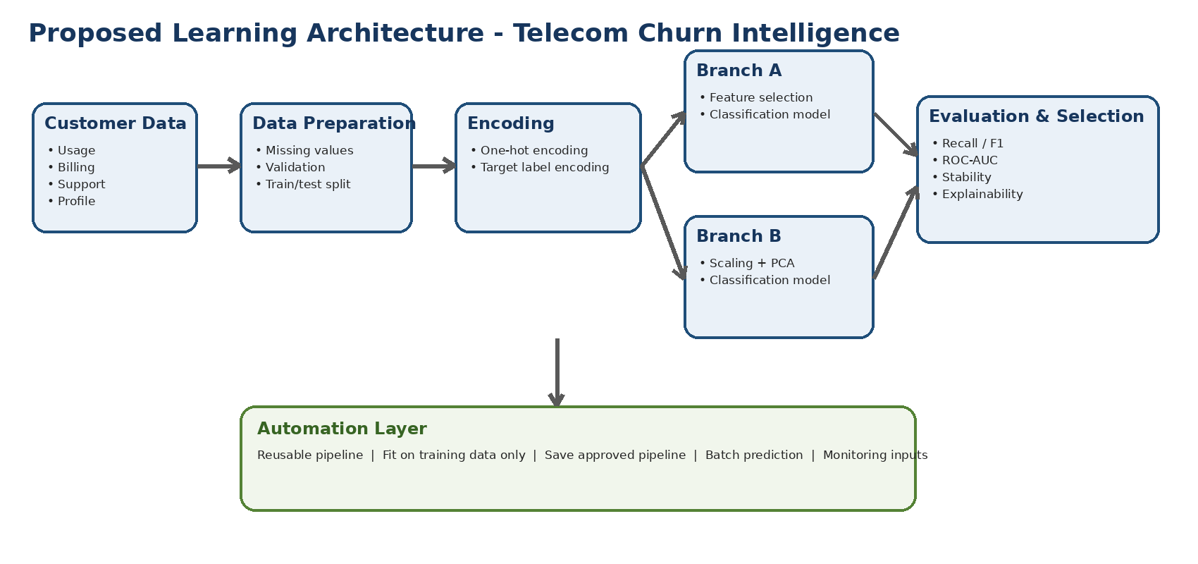
Figure 1. Required high-level workflow. Learners must decide and justify the detailed implementation.
Architecture constraint
All transformations used during prediction must be learned from the training data and stored inside the final pipeline. Future customer records must not be manually encoded or scaled outside the approved pipeline.

10. Learner Tasks

Task 1 - Business and target understanding
- Restate the prediction objective in measurable terms.
- Identify the positive class and explain why it matters operationally.
- List at least three business costs caused by false positives and false negatives.
- Identify columns that should be excluded from model training and justify the decision.

Task 2 - Data inspection and validation
- Inspect shape, data types, duplicates, missing values, target distribution, and category levels.
- Define validation rules for invalid or suspicious values.
- Document any assumptions made before model training.
- Create a concise data-quality summary for stakeholders.

Task 3 - Encoding strategy
- Separate input features from the target.
- Define which predictors require one-hot encoding and justify the choice.
- Encode the target using a reusable target encoder.
- Explain how the workflow will handle a category that appears in future data but not in training data.

Task 4 - Preprocessing pipeline
- Create separate numerical and categorical preprocessing paths.
- Choose and justify missing-value treatments.
- Apply scaling only where it is required by the downstream method.
- Combine the transformations using a column-based transformer.
- Ensure preprocessing is fitted only on training data.

Task 5 - Feature-selection branch
- Select a valid feature-selection method for the classification problem.
- Define how the number of retained features will be chosen.
- Build a complete pipeline containing preprocessing, feature selection, and a classifier.
- Extract and report the transformed feature names retained by the selector.
- Discuss how the selected features could support business explanation.

Task 6 - PCA branch
- Build a second complete pipeline containing preprocessing, required scaling, PCA, and a classifier.
- Choose a variance-retention rule or component-selection procedure and justify it.
- Report the number of principal components retained.
- Create a cumulative explained-variance visualization.
- Explain the trade-off between compact representation and interpretability.

Task 7 - Model evaluation
- Evaluate both branches using the same untouched test data.
- Report accuracy, precision, recall, F1-score, confusion matrix, and ROC-AUC.
- Use cross-validation to assess stability.
- Compare the branches using both technical and business criteria.
- Recommend one branch for operational use and defend the recommendation.

Task 8 - Automation and artifact generation
- Save both trained pipelines as joblib artifacts.
- Save the target label encoder separately.
- Create a prediction program that loads an approved pipeline and processes a new CSV file.
- Write predictions and churn probabilities to a new CSV report.
- Include file-path handling that works in both local Python and Google Colab environments.

Task 9 - Verification
- Delete or move the saved artifacts and rerun training to prove that the files are generated by code.
- Reload the artifacts in a fresh process and confirm that predictions can be produced without retraining.
- Confirm that output probabilities correspond to the correct encoded target class.
- Test at least one future record containing an unseen categorical level.

11. Required Deliverables
Deliverable | Minimum content
Case-study solution document | Business interpretation, design decisions, comparison, conclusion, and limitations.
Dataset | Original CSV plus a small new-customer input CSV.
Training program | Complete preprocessing, Branch A, Branch B, evaluation, and artifact saving.
Prediction program | Loads saved pipeline and label encoder; generates labels and probabilities.
Artifacts folder | Feature-selection pipeline, PCA pipeline, and target label encoder.
Outputs folder | Metrics table, confusion matrices, selected-feature report, PCA variance report, and new predictions.
Architecture diagram | Readable diagram showing the end-to-end workflow and two branches.
README | Environment setup and exact execution order, including Colab instructions.

12. Expected Project Structure
telecom_churn_case_study/
├── data/
│ ├── telecom_customer_churn.csv
│ └── new_customer_input.csv
├── src/
│ ├── train_pipelines.py
│ └── predict_new_customers.py
├── artifacts/
│ ├── feature_selection_pipeline.joblib
│ ├── pca_pipeline.joblib
│ └── target_label_encoder.joblib
├── outputs/
│ ├── model_comparison.csv
│ ├── selected_features.csv
│ ├── pca_explained_variance.csv
│ └── new_customer_predictions.csv
├── docs/
│ └── architecture.png
├── requirements.txt
└── README.md

13. Acceptance Criteria
Criterion | Evidence expected
Data leakage prevention | No preprocessing, feature selection, or PCA is fitted on test data.
Reproducibility | The same scripts regenerate outputs and artifacts from the raw dataset.
Encoding safety | New categories do not crash the prediction process.
Pipeline completeness | The saved object includes preprocessing and the trained estimator.
Branch comparison | Both branches use the same split and comparable evaluation procedure.
Artifact usability | A fresh prediction process works without calling fit or retraining.
Target decoding | Predicted numeric codes are converted back to business labels.
Documentation | Commands and folder structure are clear enough for another learner to execute.

14. Constraints and Governance Requirements
- Do not use customer_id as a model feature.
- Do not include information that becomes available only after cancellation.
- Do not manually edit encoded columns for production prediction.
- Do not select the final approach using accuracy alone.
- Do not expose personally identifiable data in screenshots or reports.
- Use a fixed random seed where reproducibility is required.
- Document library versions because serialized joblib artifacts depend on the Python environment.
- State that churn predictions support human decision-making and are not guaranteed outcomes.

15. Evaluation Rubric
Assessment area | Marks
Problem understanding and business framing | 10
Data inspection and leakage controls | 15
Encoding and preprocessing design | 15
Feature-selection branch | 15
PCA branch | 15
Evaluation and comparison | 15
Automation, artifacts, and inference | 10
Documentation and presentation quality | 5
Total: 100 marks

16. Submission Questions
- Why is one-hot encoding more appropriate than arbitrary integer codes for the nominal predictors in this dataset?
- Why should target label encoding be saved separately from the input pipeline?
- What is the difference between selecting original transformed features and creating principal components?
- Why can PCA require scaling before decomposition?
- How will the chosen evaluation metric influence retention-team workload?
- What evidence shows that the pipeline prevents train/test contamination?
- Why is saving the entire pipeline safer than saving only the classifier?
- What could cause a joblib artifact to fail when loaded in another environment?
- How should the system be monitored after deployment?
- Which ethical or fairness checks should be completed before retention offers are automated?

17. Optional Extension Challenges
- Add probability-threshold tuning based on retention capacity.
- Compare at least two classifiers inside each branch.
- Investigate class-weighting or resampling while avoiding leakage.
- Produce customer-level reason codes for the feature-selection branch.
- Add input-schema validation and a rejected-record report.
- Create a batch run summary with timestamp, row count, model version, and output path.
- Simulate model drift by changing usage patterns in a future dataset.

18. Final Instruction to Learners
Submission rule
Your submission must contain your own implementation, evidence, interpretation, and recommendation. Do not treat generated artifacts as manually authored files: they must be produced by the training program through serialization after successful model fitting.
END OF CASE STUDY - NO SOLUTION INCLUDED

