AUTOMOBILE ML CASE STUDY
Predicting Vehicle Service Risk
Understanding underfitting, good fitting, overfitting, bias, and variance
UNDERFITTING  High bias  Low variance | GOOD FIT  Balanced bias  and variance | OVERFITTING  Low bias  High variance
Trainer-ready case study | Concept + evidence + diagnosis + corrective actions

1. Business Scenario
A vehicle manufacturer wants to predict whether a connected car will require urgent service within the next 30 days. The prediction is used to contact customers early, reserve workshop capacity, and prevent roadside breakdowns.
Prediction target
Classify each vehicle as High Service Risk or Low Service Risk.

Why model fit matters
A model that is too simple can miss genuine risk patterns. A model that is too complex can memorize individual vehicles. The business needs a model that performs well not only on historical training records, but also on vehicles it has never seen.

Available input features
Feature | Meaning | Why it may matter
mileage_km | Total distance driven | High mileage can increase wear
service_gap_months | Months since last service | Long gaps can indicate neglected maintenance
engine_alerts | Engine warning count | Repeated alerts may signal a developing fault
brake_wear_percent | Estimated brake wear | Higher wear raises service urgency
battery_voltage | Low or Normal | Low voltage can indicate battery weakness
warranty_claims | Previous warranty claims | Repeated claims may indicate recurring issues
customer_complaints | Complaints raised | Recent complaints can be an early warning
driving_pattern | City, Highway, or Mixed | Stop-go city use may accelerate wear

Dataset setup
- 12,000 historical vehicle records are available.
- 80% of the data is used for training and 20% for testing.
- The same train-test split is used for all three models to ensure a fair comparison.
- A Decision Tree classifier is trained at three complexity levels.

2. Three Competing Models
Model | Configuration | Behaviour | Expected result
Model A: Very simple tree | max_depth = 1 | Can ask only one major question | Expected underfitting
Model B: Balanced tree | max_depth = 4 | Can combine several meaningful conditions | Expected good fit
Model C: Unlimited tree | max_depth = None | Can keep splitting until very small groups form | Expected overfitting

Illustrative learned rules
Model A — one-rule view
Is brake_wear_percent greater than 70%? This rule is too broad and ignores mileage, alerts, service gap, and battery condition.

Model B — combined pattern
High risk when brake wear is high AND service gap is long, or when repeated engine alerts occur with low battery voltage. These rules represent meaningful risk combinations.

Model C — record-level memorization
Creates narrow rules such as mileage between 52,140 and 52,190 km, exactly two complaints, and one particular driving pattern. Such rules may describe only a few training vehicles.

3. Evaluation Results
Model | Training accuracy | Testing accuracy | Gap | Initial observation
Model A: Underfitting | 66% | 63% | 3 points | Both scores are low
Model B: Good fit | 89% | 86% | 3 points | Both scores are strong
Model C: Overfitting | 100% | 73% | 27 points | Excellent train score, weak test score

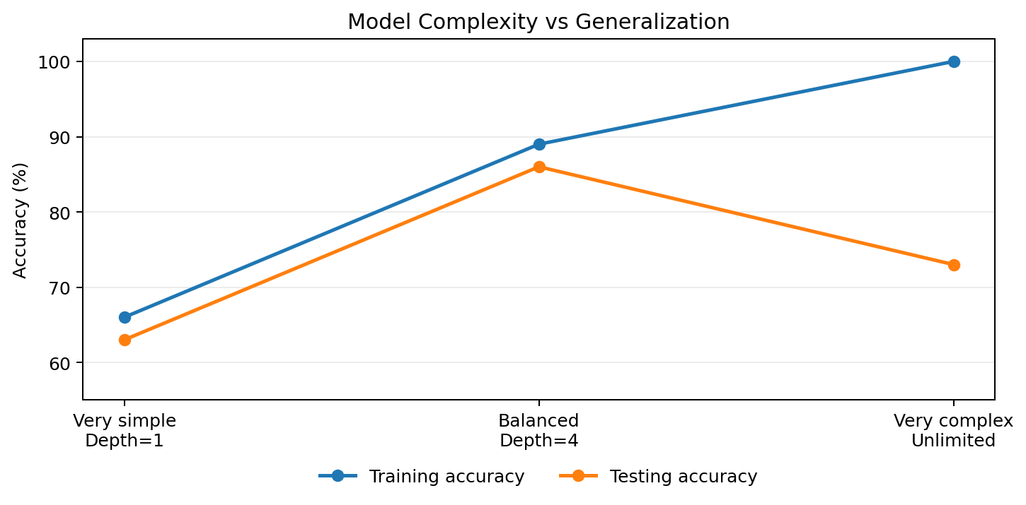
Figure 1. The balanced model keeps training and testing performance both high.

How to read the result
- First check whether training performance is acceptable.
- Then compare testing performance with training performance.
- A small gap is useful only when both scores are reasonably good.
- A very large train-test gap is a warning that the model may have memorized the training data.
Important observation
Model A and Model B both have a 3-point train-test gap, but they are not equally good. Model A is consistently poor, while Model B is consistently strong. Therefore, the gap must always be interpreted together with the actual accuracy levels.

4. Diagnosis: Underfitting, Good Fit, and Overfitting
Condition | Bias | Variance | Training result | Testing result | Meaning
Underfitting | High | Low | Poor | Poor | Model is too simple to learn the true relationships
Good fit | Controlled | Controlled | Good | Good | Model learns useful patterns and generalizes
Overfitting | Low on training data | High | Excellent | Poorer | Model learns noise and individual records

Model A: Why it is underfitting
- The tree has only one split and makes an overly simple assumption about service risk.
- It cannot combine brake wear with service gap, engine alerts, or battery condition.
- Its predictions remain similar even if the training sample changes, so variance is low.
- Because it repeatedly misses the real pattern, bias is high.

Model B: Why it is a good fit
- The tree has enough depth to combine important features.
- It avoids extremely specific rules that apply to only one or two vehicles.
- Training and testing accuracy are both high and close to each other.
- Its predictions remain useful on unseen vehicles, demonstrating good generalization.

Model C: Why it is overfitting
- The unlimited tree continues splitting until it can classify nearly every training record correctly.
- It learns random noise, rare combinations, and possibly data-entry quirks.
- A small change in the training vehicles can produce a very different tree, so variance is high.
- The model performs perfectly on known records but loses accuracy on unseen vehicles.

5. Business Impact
Model condition | Operational effect | Business consequence
Underfitting | Missed high-risk vehicles and unnecessary service alerts | Breakdowns, customer dissatisfaction, wasted workshop capacity
Good fit | More reliable early-risk identification | Better planning, timely customer contact, lower disruption
Overfitting | Unstable predictions for new vehicles | Inconsistent campaigns, poor trust, frequent model failures after deployment

6. Corrective Actions
Problem | Action | Why it helps
Underfitting | Increase tree depth gradually | Allows the model to learn interactions among features
Underfitting | Add useful features | Driving intensity, vehicle age, climate, road condition, and recent fault codes may improve learning
Underfitting | Try a more capable algorithm | Random Forest or Gradient Boosting may capture nonlinear patterns better
Overfitting | Limit max_depth | Prevents creation of excessively specific rules
Overfitting | Increase min_samples_leaf | Requires each final rule to represent more vehicles
Overfitting | Use cross-validation | Checks whether performance remains stable across multiple data splits
Overfitting | Prune the tree or use regularization | Removes branches that add little general value
Both | Collect representative data | Ensures different regions, climates, road conditions, and driving patterns are covered

Recommended final decision
Select Model B, subject to validation
Model B currently provides the best balance: 89% training accuracy and 86% testing accuracy. Before deployment, confirm the result using cross-validation, region-wise testing, and monitoring on live data.

7. Validation Before Production
1. Run 5-fold cross-validation and compare the variation in scores across folds.
2. Check confusion matrix, precision, recall, and especially recall for High Service Risk vehicles.
3. Test separately for city, highway, hot-climate, monsoon, and high-mileage vehicle groups.
4. Check for data leakage, such as using information recorded only after a service visit.
5. Monitor prediction quality after deployment and retrain when driving conditions or vehicle populations change.

8. Trainer Discussion Questions
1. Why is a 3-point train-test gap not enough to declare Model A a good model?
2. Which result provides the clearest evidence of high variance?
3. What new feature could reduce bias in the simple model?
4. Why might an unlimited Decision Tree change significantly when trained on a slightly different sample?
5. Which metric should receive special attention if missing a high-risk vehicle is very costly?

9. Key Takeaway
The goal is generalization, not memorization
Underfitting occurs when the model is too simple: high bias and poor performance on both training and testing data. Overfitting occurs when the model is too complex: high variance, near-perfect training performance, and weaker testing performance. A good-fit model learns the important pattern while remaining stable on unseen data.

Quick Reference
Condition | Typical evidence | Main issue | Main response
Underfitting | Train low, Test low | High bias | Increase useful complexity
Good fit | Train high, Test high, small gap | Balanced | Validate and monitor
Overfitting | Train extremely high, Test much lower | High variance | Reduce complexity and regularize

10. Worked Solution
This section solves the case study step by step and converts the model results into a practical deployment decision.

Step 1: Identify the machine-learning task
Problem definition
This is a supervised binary-classification problem. The model receives vehicle-condition features and predicts either High Service Risk or Low Service Risk for the next 30 days.

Step 2: Compare the three models
Model | Train | Test | Gap | Diagnosis | Reason
A: max_depth = 1 | 66% | 63% | 3 | Underfitting | Training and testing results are both too low.
B: max_depth = 4 | 89% | 86% | 3 | Good fit | Both results are strong and close to each other.
C: max_depth = None | 100% | 73% | 27 | Overfitting | The tree memorizes training records and generalizes poorly.
Key interpretation: a small train-test gap does not automatically mean a good model. Model A and Model B both have a 3-point gap, but Model A is poor on both datasets while Model B is strong on both.

Step 3: Diagnose bias and variance
Model | Bias | Variance | Evidence
Model A | High | Low | The one-level tree is too simple and repeatedly misses important relationships.
Model B | Controlled | Controlled | It captures useful interactions without creating record-specific rules.
Model C | Low on training data | High | A small change in training records can create a different deep tree.

Step 4: Select the current best model
Selected model: Model B
Model B is the best current choice because it achieves 89% training accuracy and 86% testing accuracy. It learns meaningful combinations of mileage, service gap, engine alerts, brake wear, battery condition, and complaints while retaining strong performance on unseen vehicles.
- Do not select Model A merely because its accuracy gap is small; its absolute performance is inadequate.
- Do not select Model C merely because it has 100% training accuracy; the 27-point gap indicates high variance.
- Treat Model B as a candidate for production, not an automatically approved production model.

Step 5: Correct the underfitting model
Action | How it solves underfitting
Increase max_depth gradually | Allows the tree to combine multiple service-risk conditions instead of using one broad rule.
Add useful features | Vehicle age, road condition, climate, recent fault codes, and driving intensity can reduce missing-pattern error.
Improve feature engineering | Create variables such as alerts_per_1000_km, months_overdue, or combined brake-and-mileage risk.
Try stronger models | Random Forest or Gradient Boosting can capture nonlinear relationships that a shallow tree misses.

Step 6: Correct the overfitting model
Action | How it controls variance
Set max_depth | Stops the tree from creating extremely specific branches.
Increase min_samples_leaf | Requires every final rule to represent a reasonable number of vehicles.
Increase min_samples_split | Prevents splitting very small groups.
Use cost-complexity pruning | Removes branches that add little validation value.
Use cross-validation | Checks whether the model remains stable across multiple training samples.

Step 7: Python implementation
The following code compares the three Decision Tree configurations on the same split.
import pandas as pd
from sklearn.model_selection import train_test_split
from sklearn.tree import DecisionTreeClassifier
from sklearn.metrics import accuracy_score, classification_report
# Load the case-study dataset
data = pd.read_csv("vehicle_service_risk.csv")
# Convert categorical values into numeric columns
data["battery_voltage"] = data["battery_voltage"].map({"Low": 0, "Normal": 1})
data = pd.get_dummies(data, columns=["driving_pattern"], drop_first=True)
data["target"] = data["target"].map({"Low Risk": 0, "High Risk": 1})
X = data.drop(columns=["target"])
y = data["target"]
X_train, X_test, y_train, y_test = train_test_split(
X, y, test_size=0.20, random_state=42, stratify=y
)
models = {
"Underfitting": DecisionTreeClassifier(max_depth=1, random_state=42),
"Good Fit": DecisionTreeClassifier(max_depth=4, random_state=42),
"Overfitting": DecisionTreeClassifier(max_depth=None, random_state=42)
}
for name, model in models.items():
model.fit(X_train, y_train)
train_accuracy = accuracy_score(y_train, model.predict(X_train))
test_predictions = model.predict(X_test)
test_accuracy = accuracy_score(y_test, test_predictions)
print(f"{name}: train={train_accuracy:.2%}, test={test_accuracy:.2%}, "
f"gap={(train_accuracy-test_accuracy):.2%}")
# Detailed report for the selected candidate model
selected_model = models["Good Fit"]
print(classification_report(y_test, selected_model.predict(X_test),
target_names=["Low Risk", "High Risk"]))

Step 8: Tune and validate the final tree
Use cross-validation to select complexity instead of fixing the final depth only by intuition.
from sklearn.model_selection import GridSearchCV
parameter_grid = {
"max_depth": [2, 3, 4, 5, 6],
"min_samples_split": [10, 20, 40],
"min_samples_leaf": [5, 10, 20]
}
grid = GridSearchCV(
DecisionTreeClassifier(random_state=42, class_weight="balanced"),
parameter_grid,
cv=5,
scoring="recall", # prioritise finding High Service Risk vehicles
n_jobs=-1
)
grid.fit(X_train, y_train)
final_model = grid.best_estimator_
print("Best parameters:", grid.best_params_)
print("Cross-validation recall:", grid.best_score_)
print("Test accuracy:", accuracy_score(y_test, final_model.predict(X_test)))
Why use recall for tuning? When missing a genuinely high-risk vehicle can lead to breakdowns or safety issues, recall for the High Service Risk class is often more important than accuracy alone.

Step 9: Production validation checklist
1. Confirm performance with 5-fold cross-validation and inspect variation across folds.
2. Review the confusion matrix, precision, recall, F1-score, and ROC-AUC.
3. Measure High Service Risk recall separately for city, highway, hot-climate, monsoon, and high-mileage groups.
4. Check that no feature contains information created after the service event, which would cause data leakage.
5. Choose an operating threshold based on the cost of missed breakdowns versus unnecessary service calls.
6. Monitor drift and retrain when vehicle populations, roads, climates, or service behaviour change.

Step 10: Answers to the trainer discussion questions
Question | Solution
Why is a 3-point gap not enough to declare Model A good? | Because both its training and testing accuracies are low. A small gap can mean the model is consistently poor.
Which result gives the clearest evidence of high variance? | Model C: 100% training accuracy, 73% testing accuracy, and a 27-point gap.
What new feature could reduce bias? | Examples include recent diagnostic fault codes, road condition, climate, vehicle age, harsh-braking frequency, or alerts per 1,000 km.
Why can an unlimited tree change after a small data change? | Deep trees make many decisions using small record groups. Replacing a few training records can change those splits and the final rules.
Which metric matters when missing high-risk vehicles is costly? | Recall for the High Service Risk class, supported by the confusion matrix and precision-recall analysis.

Final solution
Business recommendation
Proceed with Model B as the current candidate, then tune max_depth, min_samples_split, and min_samples_leaf through cross-validation. Approve deployment only after High Service Risk recall, subgroup performance, data leakage checks, and live monitoring meet the agreed business thresholds.

