**Abstract**

Cockroaches have been known to display intelligent swarm behavior. They rarely make individual decisions and are rather incapable of taking them at all. However, due to group dynamics, they are able to make decisions that seem to be beneficial for the entire group. Moreover, these decisions are not random. There seems to be a perfect pattern that emerges. One of the most interesting swarm behaviors of roaches is when they seek shelter on facing a threat. It has been shown that there are two criteria that they adhere to: Darkness of the shelter and it’s critical density of the shelter. The second criterion presents a very interesting possibility to manipulate behaviors of roaches. By changing the critical density of the shelter, it is possible to make that shelter more preferred over others. RoachSim is a simulator that has been designed to explore this possibility. This report is divided into a few sections. The first section gives an introduction of the problem being discussed. The second section presents the study with related work. The third section provides the algorithm and important parts of code that was used to accomplish the study. The fourth section has a few observations regarding the results that were generated from the simulator. Further, the shortcomings of the simulator and where it deviates from real life are explained in the last section of this report along with some concluding remarks.

**Keywords: Swarm behavior, cockroaches, shelters, rogue cockroaches, simulation, RoachSim**

**1 INTRODUCTION**

Swarm behaviors of animals, insects and birds have been studied to a great extent and have contributed in understanding the general behavioral patterns of living things. The most interesting aspect of studying these behaviors is that they have proven to be of use in real-life problems of optimization, organization and general problem solving. Ant colony optimization, boid flocking and other agent-based models have provided solutions to numerous problems and continue being used extensively. On the same lines, it makes sense to look at some other organisms that also display a certain form of swarm behavior. Cockroaches present a very interesting study. More specifically, it is their ability to quickly reorganize themselves into groups and hide that holds potential to understand swarm behavior.   To put things into perspective, let us consider a typical condition seen in most houses. When the lights in the kitchen are switched on in the night, it is likely to see multiple cockroaches randomly scurrying around to find a dark shelter to hide under. On initial inspection, it might seem that they use a greedy approach where they find the closest possible *relatively* dark place and enter it. However, according to a study that was conducted, there are 2 parameters that are apparently evaluated by cockroaches. These parameters are as follows:  

i) The darkness of the shelter: This factor is a pre-dominant measure of finding places to hide. Needless to say, darker the shelter, higher the possibility of a cockroach entering that particular shelter.

ii) The critical density of the shelter: This is a factor that was validated in the study (see section 2) where the experiments proved that more the cockroaches in a shelter, more the tendency of other cockroaches to swarm and that point.

The second factor presents a very interesting possibility: Is it possible to manipulate the critical density of a certain shelter and make it more preferred?

This project was divided into 2 parts:

a) To simulate this behavior of cockroaches based on this new preference

b) To manipulate the critical density of shelters and eventually manipulate preferences to trick cockroaches into shelters that they were less likely to get into.  The next section briefly explains the study that was done to find out the new parameter (ii).

**2 RELATED WORK AND STUDY**

[1]Jose Halloy and his colleagues at the Free University of Brussels and several other European institutions created a set of tiny robotic Pied Pipers that can trick roaches into following them — even to places where a sensible roach would never venture. This research increases our understanding of how roaches make decisions.

To observe ordinary roach behavior, Halloy and his colleagues created an enclosure with two "shelters" inside — red-tinted plastic disks mounted so that roaches could scurry underneath to avoid bright light, which they do instinctively. When the insects were dumped into the enclosure, they scrambled around randomly for a while, but eventually all huddled under the same shelter. That they huddled is no surprise, since roaches like to gather in crowds. But since cockroaches don't have enough intelligence to allow for leadership skills or even communication, the fact that they collectively decide on one shelter seemed to be a point of inquiry.

Veteran roach-watchers have a more mundane explanation. Cockroaches, they hypothesize, use just two pieces of information to decide where to go: how dark it is and how many of their friends are there. At first, the roaches will wander arbitrarily into one shelter or the other — but at some point, enough of them will end up under one shelter to reach a critical mass, which then becomes more attractive to the others.

Based on this, Halloy and his co-workers figured they should be able to trick the roaches into doing something unnatural. To do that, researchers recruited some engineers to build them roach robots that would slip into the crowd and manipulate it from within. Cockroaches accept anything of roughly the right size and smell. In the end, the engineers came up with little wheeled robots shaped like matchboxes and perfumed with *eau de roach.* They were programmed to have the same likes and dislikes as roaches — that is, to prefer crowds and darkness.

When introduced to the real roaches, the robots fit right in — the gathering behavior of the horde was pretty much unchanged. Researchers then reprogrammed the robots to prefer a less-dark hiding place — unnatural for a roach. The insects and the infiltrators were put back into the enclosure, except this time one of their hiding places was more lightly tinted than the other: It was brighter inside. Again, all the roaches scurried around randomly for a while, but the robots eventually settled under the lighter, less shadowy disk — and the real cockroaches followed. Which means that the hypothesis — that a group of individual bugs, each with just two cognitive “rules", can make a collective decision about shelter — appears to be correct.

**3 ALGORITHM AND RELATED CODE**

As stated earlier in the report, there were 2 simulations that were accomplished by the simulator. The first one was based on a standard simulation where the cockroaches were randomly distributed with shelters in the surrounding. There was no external influence on their decision.

Algorithm 1

Random_Walk (Roaches, Shelters):

If roaches in shelters is lesser than total

if occupied shelters is lesser than the total number of shelters

For every shelter in Shelters

For every roach in Roaches

Do movement towards shelter

if roach is within shelter,

remove roach from further consideration

//Once the shelters have been occupied at least one cockroach,

Design preference list based on the following formula

For every shelter,

preference of shelter = darkness of shelter * number of cockroaches in it.

Now, move cockroaches towards most preferred shelter

if capacity of that shelter has been reached,

Move towards the next preferred shelter

This is the initial configuration with 100 cockroaches (green circles), 3 shelters (red diamonds) with capacities 40, 30 and 30 respectively.

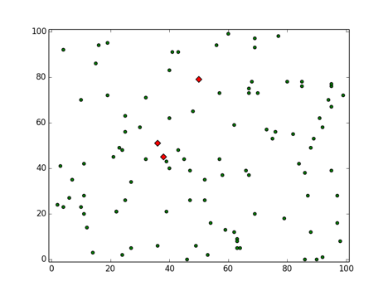

This is the simulation in motion while the cockroaches move towards respective shelters.

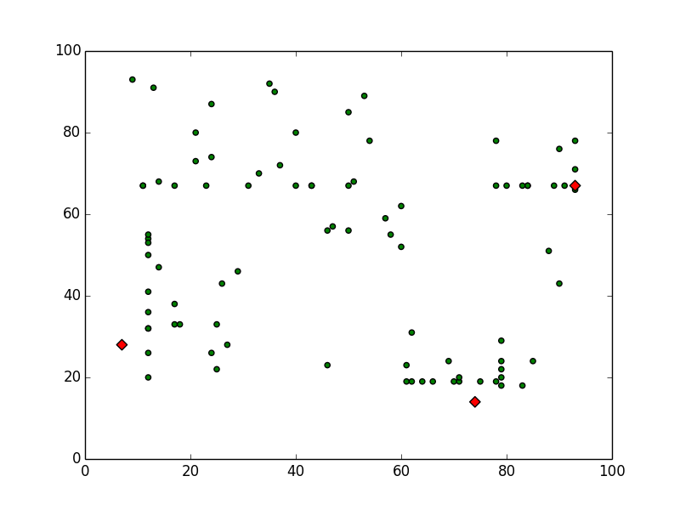

The second algorithm introduces the rogue cockroaches that basically go towards less preferred shelters. This dynamically changes the preference lists for other cockroaches since the critical density of initially less preferred shelters starts increasing.

Algorithm 2

Random_Walk (Roaches, Shelters):

If roaches in shelters is lesser than total

if occupied shel4ters is lesser than the total number of shelters

For every shelter in Shelters

For every roach in Roaches

Do movement towards shelter

if roach is within shelter,

remove roach from further consideration

//Once the shelters have been occupied at least one cockroach,

Design preference list based on the following formula

For every shelter,

preference of shelter = darkness of shelter * number of cockroaches in it.

Now, move cockroaches towards most preferred shelter

if capacity of that shelter has been reached,

Move towards the next preferred shelter

At the same time, move the rogue cockroaches towards less preferred shelter

Update the preference list for every run

This is the initial configuration with 100 cockroaches, 4 shelters and 20 rogue agents (yellow). The rogue agents are also randomly distributed in the entire universe so as to be as random as the cockroaches. It is important to note in the algorithm that the rogue agents start their movement only when the preference lists are made. We assume that once all the shelters have some occupants, through intelligent group decisions, cockroaches have somewhat a good idea of which shelter is more preferred.

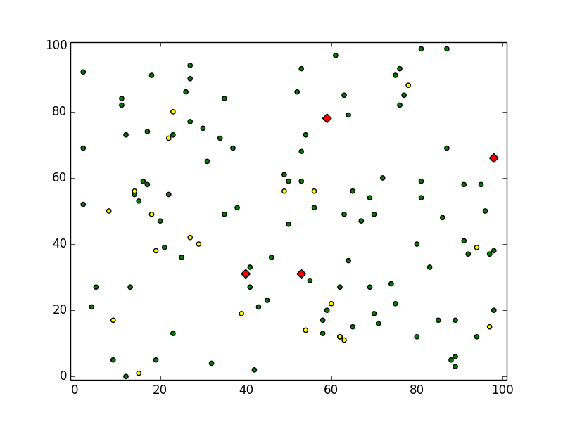

This is an intermediate run of the simulation. The shelters have already been occupied by some cockroaches, the preference lists have been made and all the cockroaches (including the rogue ones) are now under movement.

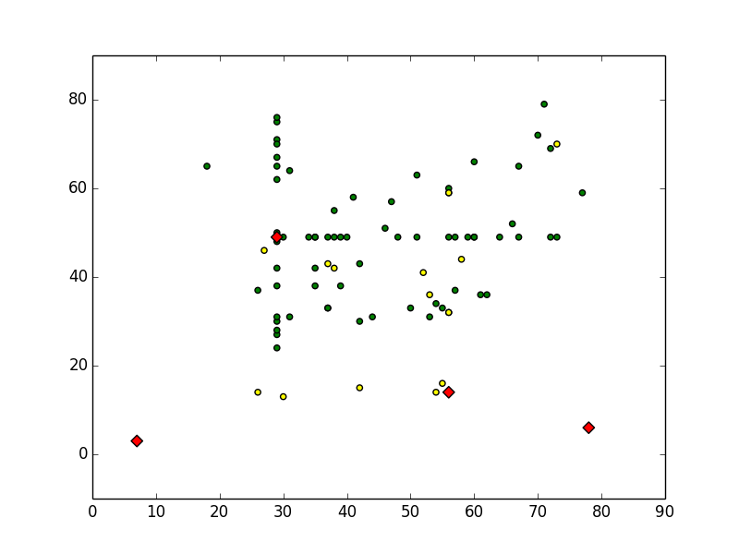

As an ending note to the algorithm, the simulation was programmed in Python with the plots and animations being prepared with the matplotlib package.

**4 OBSERVATIONS**

This section is divided into 2 parts.

**4. 1 General Simulations**

The general simulations are preliminary, in the sense that they display the normal behavior of cockroaches in an isolated system. As expected, roaches closer to the shelter enter it first while the others remain in random motion or remain static. In the simulator, they were shown to be static to ensure that the actual moving cockroaches can be identified easily and that the random movement of other roaches does not influence them. Once all shelters have a certain level of occupancy, a preference list is created for all shelters. We can then observe that this information passes globally in iterations. So, the roaches closer to the preferred shelter start entering it. At the same time, the other roaches in the vicinity notice this movement and follow it. This is propagated throughout the entire universe. Next, when the capacity of this shelter is reached, the roaches start moving towards next preferred shelter. This is a very interesting behavior and almost mimics the actual behavior of cockroaches.

It was noticed that the more the number of shelters, more the time it takes for the roaches to get organized. This seems to be counter-intuitive because cockroaches have a lot of choices now and can potentially enter any shelter. However, this is where the programming of the simulator comes into play. The roaches have been instructed to go to the most preferred shelter. Hence, even if the most preferred shelter were on the other side of the graph, the cockroaches would go there than go to a less preferred shelter. Real life observations from studies show that the cockroaches do not really follow a set pattern of movement in a scenario such as this.

**4.2 Simulations with rogue agents**

These simulations were very interesting because they provided an insight into how changing the number of roaches that enter the shelters can actually affect the decisions made by other roaches. The first observation is that the rogue cockroaches do not move (in the simulator) till the preference lists have been made (as in the general simulation). Once they are made, we observe that the rogues start moving towards the least preferred shelter. There are two different scenarios that were evaluated here.   
  
One is that the preference lists are updated regularly for every run. This means that the preference list for rogues is also changed and thus for every iteration, they move towards the least favored shelter. The implication of this is that they aren’t able to create an impact together but do so by working towards a shelter at first and then if the shelter is no longer preferred, the rogue agents that are outside the shelter now move towards the new least favored shelter. This is more of a distributed system where the rogue agents try to divert the cockroaches from entering a certain shelter.  
  
The second scenario is more prominent where the lists are updated regularly, except for the rogue agents. Once they are shown the least favored shelter, they go towards that shelter and all of them settle there. The important observation here is that all the rogue agents are responsible for the skewing of preferences towards a certain shelter. Of course, there are a few points to note here. There can come a point when the shelter preference has been artificially increased without all the rogue agents being in there. This will usually happen because there were too many agents. In this case, it is possible that the rogue agents cannot enter the shelter that they were allocated to and they’ll remain out. As a domino effect, the other roaches wouldn’t be able to occupy the shelter and will start moving to another shelter that comes next in the preference list.

**5 SHORTCOMINGS AND CONCLUDING REMARKS**

As is evident, there are a few shortcomings of this simulator. The most glaring one is that it does not entirely mimic the real roach behavior. In real life, cockroaches distribute them uniformly in the shelters. For example, if there were 50 cockroaches and 2 shelters with capacities of 30 and 40, each shelter would end up having 25 cockroaches. However, in the simulation, they randomly enter shelters and once the preference lists are made, all cockroaches try to move into that shelter. Hence, there is no guarantee that the roaches would distribute themselves as 25 + 25. It would only be a lucky coincidence if that were to happen.

Another shortcoming is that the simulator is unable re-route the cockroaches in case there is a conflict between two shelters. There are times when the random placement of the roaches eventually causes a competition between shelters. So in that case, the roaches just keep lingering between these two shelters. One way that was programmed into the simulator was to have them do random steps towards the shelters. In that case, it is possible that by some random chance, the roaches will enter the shelter and once and for all change the preference lists for some time so that more cockroaches start moving towards the shelter without there being a competition from another shelters.  
  
In conclusion, this study provided a preliminary, yet insightful understanding of how cockroaches behave in groups. Their biology and anatomy render them incapable of making individual decisions. But their behavior in swarms is highly counter-intuitive, yet very effective. It is possible that study of such behavior might give us a way of solving problems using a new, refreshed methodology.

**REFERENCES**  
  
1) Jennifer Viegas. ["Cockroaches Make Group Decisions"](http://animal.discovery.com/news/briefs/20060327/cockroach.html). [Discovery Channel](http://en.wikipedia.org/wiki/Discovery_Channel). Retrieved 10 June 2006.  
  
2) Lemonick, Michael D. (2007-11-15). ["Robotic Roaches Do the Trick"](http://www.time.com/time/health/article/0,8599,1684427,00.html?imw=Y). Time Magazine.

3) Halloy, J, et al. Social Integration of Robots into Groups of Cockroaches to Control Self-Organized Choices**,** Science 318, 1155-1158 (2007). doi:10.1126/science.1144259

4) Amé, J.- M., Halloy, J., Rivault, C., Detrain, C. & Deneubourg, J. L. Proc. Natl Acad. Sci. USA 103, 5835-5840 (2006). doi:10.1073/pnas.0507877103

5) Collegial decision making based on social amplification leads to optimal group formation, Jean-Marc Ame , Jose ́ Halloy, Colette Rivault, Claire Detrain, and Jean Louis Deneubourg