***Evidence***

K8’s deployments successful for both frontend and backend, PFB, screenshots for the EKS and svc showing created, up and running.

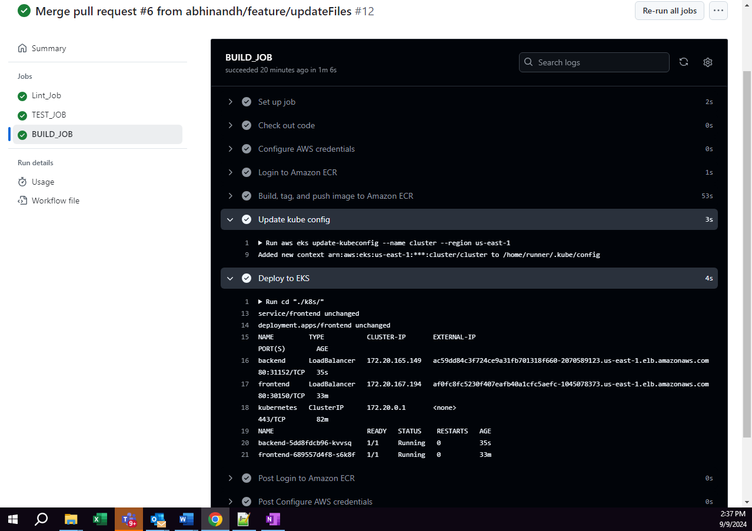

Frontend – push images to ECR:

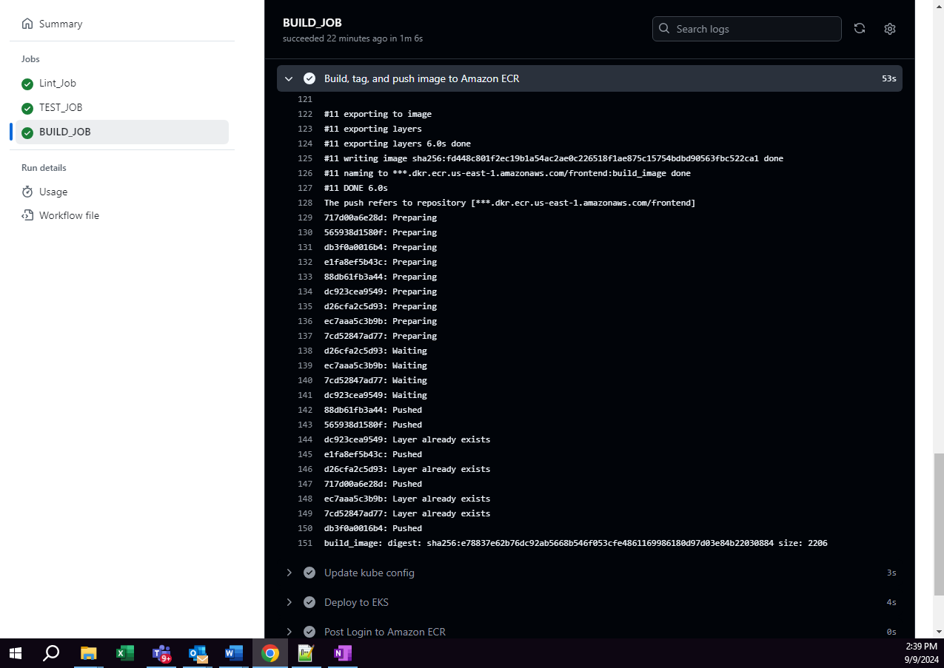

Backend – Push images to ECR:

