Docker error – permission denied

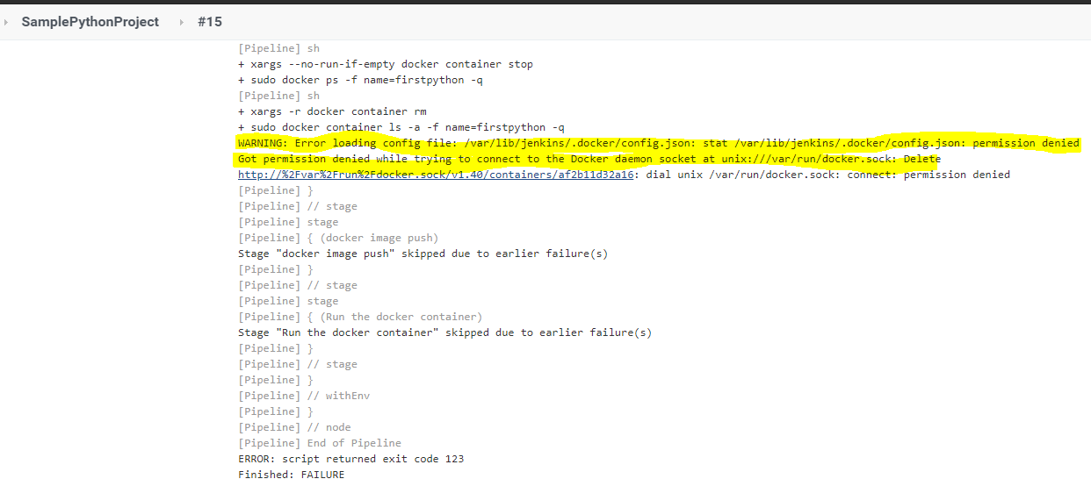

Resolution –

