Clinical Decision Making and Pattern Recognition in Health Care
A Retrieval-Augmented AI Assistant for Payment Integrity and HCC Coding Review
Problem
Payment integrity reviewers spend significant time navigating fragmented clinical documentation, coding guidelines, payer policies, and regulatory documents to determine whether submitted diagnoses are sufficiently supported for accurate HCC coding and claim review. As healthcare documentation continues to grow in volume and complexity, locating and synthesizing the right evidence has become a time-consuming bottleneck, impacting the efficiency, consistency, and accuracy of payment integrity workflows.
Background
The need for effective payment integrity has become increasingly important as healthcare spending continues to grow. In 2023, U.S. healthcare expenditures reached $4.9 trillion, while more than $900 billion is estimated to be lost annually due to fraud, waste, and abuse (HL7 International, 2025). Cotiviti identifies fragmented clinical information as one of the primary operational challenges affecting accurate HCC coding (Liu, 2026). Similarly, HL7 International (2025) notes that fragmented healthcare data and limited interoperability create barriers to efficient payment integrity review and recommends AI-assisted, evidence-based decision support that maintains human oversight.
These challenges highlight the need for AI solutions that can efficiently retrieve, synthesize, and present clinical evidence to support accurate and consistent review decisions.
Objective
- Develop a RAG-based AI decision support assistant for payment integrity review.
- Enable efficient retrieval and synthesis of fragmented clinical documentation.
- Support evidence-based HCC coding and claim validation.
- Improve review efficiency and consistency without replacing human decision-making.
Why did I choose this topic:
Aligning with Cotiviti's mission: This project supports Cotiviti's mission of improving payment accuracy by connecting data and workflows, reducing administrative complexity, enabling faster evidence-based decisions, and maintaining trust across the healthcare payment ecosystem.
Building on prior experience and interest in AI-assisted decision support: This topic closely aligns with my previous project at the Washington State Department of Licensing, where I developed an LLM based document retrieval and decision support solution. That experience strengthened my interest and inspired me to further develop my expertise in this domain.
Relevant Trends:
Healthcare organizations are increasingly adopting Retrieval-Augmented Generation (RAG) to retrieve and synthesize information from trusted documents rather than relying solely on an LLM's pretrained knowledge. RAG offers several advantages, including:
- Grounds responses in trusted documents rather than relying solely on pretrained knowledge.
- Reduces hallucinations and improves factual accuracy.
- Provides source references that users can verify.
- Improves explainability for AI-assisted decisions.
This architecture is becoming more popular because it enables AI to generate responses based on the latest clinical documentation, coding guidelines, and payer policies instead of potentially outdated model knowledge (U.S. Government Accountability Office, 2026).
Additionally, AI medical scribes are also increasingly being adopted to automatically generate clinical documentation, reducing documentation burden and improving clinician efficiency (Mess et al., 2025). Microsoft Dragon Copilot is one example that integrates AI-assisted documentation with EHR workflows.
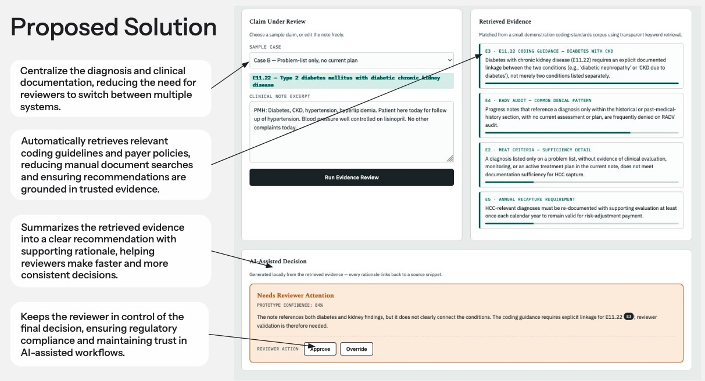
Solution:
Cotiviti could explore a secure RAG-based content intelligence platform that connects clinical documentation, coding standards, and payer policies. By retrieving relevant information from trusted healthcare sources before generating recommendations, the platform would help insurance reviewers, coders, and payment integrity teams quickly locate supporting evidence, interpret policy requirements, identify documentation gaps, and make faster, more consistent, and explainable review decisions while preserving human oversight and traceability.
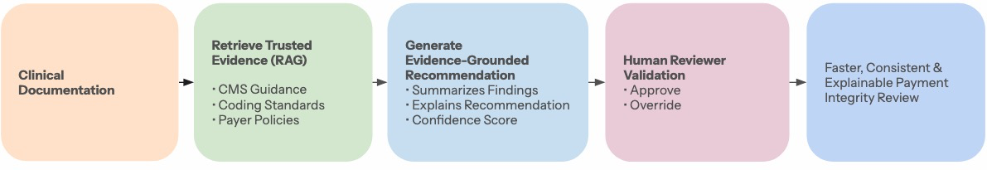
Opportunity:
- Build on existing AI capabilities: Complement existing AI and NLP technologies with a RAG-based decision support assistant that retrieves and synthesizes evidence from trusted clinical and regulatory documents.
- Address the evidence review gap: As AI medical scribes improve documentation generation, there is an opportunity to streamline the downstream review process by helping payment integrity reviewers efficiently locate and validate supporting evidence for HCC coding decisions.
- Differentiate through explainability: By grounding responses in source documents and providing citations, RAG can improve transparency, reviewer confidence, and audit readiness while maintaining human oversight.
- Support future AI innovation: A RAG-based assistant can provide a scalable foundation for expanding AI-driven decision support across claims validation, policy interpretation, compliance review, and other payment integrity workflows.
Challenges:
- Data availability: Access to payer contracts, clinical documentation, and proprietary coding resources may be limited.
- Privacy and compliance: Any production implementation must comply with HIPAA and organizational security requirements.
- Explainability and trust: Reviewers must be able to verify AI-generated responses through source citations.

Reference
Centers for Medicare & Medicaid Services. (2025). National health expenditure data. https://www.cms.gov/data-research/statistics-trends-and-reports/national-health-expenditure-data

HL7 International. (2025). Reducing fraud and improving payment integrity in healthcare through the use of AI. https://info.hl7.org/hubfs/HL7%20Reducing%20Fraud%20and%20Improving%20Payment%20Integrity%20in%20Healthcare%20Through%20the%20Use%20of%20AI_Final_5_7_25.pdf

Liu, A. (2026, June 19). Top 3 operational challenges for providers adopting HCC coding. Cotiviti. https://blog.cotiviti.com/top-3-operational-challenges-for-providers-adopting-hcc-coding

Mess, T., Pratap, M., Hall, A. J., Karanfil, E., Monfared, A., Baker, O., & Galassi, A. (2025). The impact of AI medical scribes on healthcare: A systematic review. Journal of Medical Artificial Intelligence. Microsoft. (2025). Dragon Copilot. https://www.microsoft.com/en-us/health-and-life-sciences/solutions/dragon-copilot

Scribing.io. (2025, June 24). Why RAG fails specialized AI scribes: The logic gap. https://www.scribing.io/blog/why-rag-fails-specialized-ai-scribes-logic-gap

U.S. Government Accountability Office. (2026). Artificial intelligence: Federal agencies' use of AI to improve mission delivery and recommendations for responsible implementation (GAO-26-109116). https://www.gao.gov/products/gao-26-109116

