Task1: Grade Checker

Take a score as input and print the grade based on the following:

90+ : "A"

80-89 : "B"

70-79 : "C"

60-69 : "D"

Below 60 : "F"

here we used a basic if else statement to carry out marks and all.

Code:

mark=int(input("Enter Mark:"))  
if mark>=90 and mark<=100:  
 print("Your grade is A")  
elif mark >=80 and mark <90:  
 print("Your grade is B")  
elif mark >=70 and mark <80:  
 print("Your grade is C")  
elif mark >=60 and mark <70:  
 print("Your grade is D")  
elif mark <= 60:  
 print("Your grade is F")  
else:  
 print("Enter a valid mark")

Output:

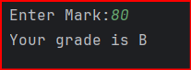

Task2: Student Grades

Create a dictionary where the keys are student names and the values are their grades. Allow the user to:

Add a new student and grade.

Update an existing student’s grade.

Print all student grades.

Used dictionary and basic operations. Using if else:

Code:

student = {}  
while True:  
 print("Choose 1 to Add a new student")  
 print("Choose 2 to Update an existing student grade")  
 print("Choose 3 to print all students grade")  
 print("Choose 4 to Exit the program\n")  
 game = input()  
 if game == "1":  
 name = input("Enter student name: ")  
 grade = input("Enter student grade: ")  
 student.update({name: grade})  
 print(student)  
 elif game == "2":  
 name = input("Enter student name: ")  
 if name in student:  
 grade = input("Enter student grade: ")  
 student.update({name: grade})  
 else:  
 print("Student not found")  
 elif game == "3":  
 print(student)  
 elif game == "4":  
 break  
 else:  
 print("Invalid input")

Output:

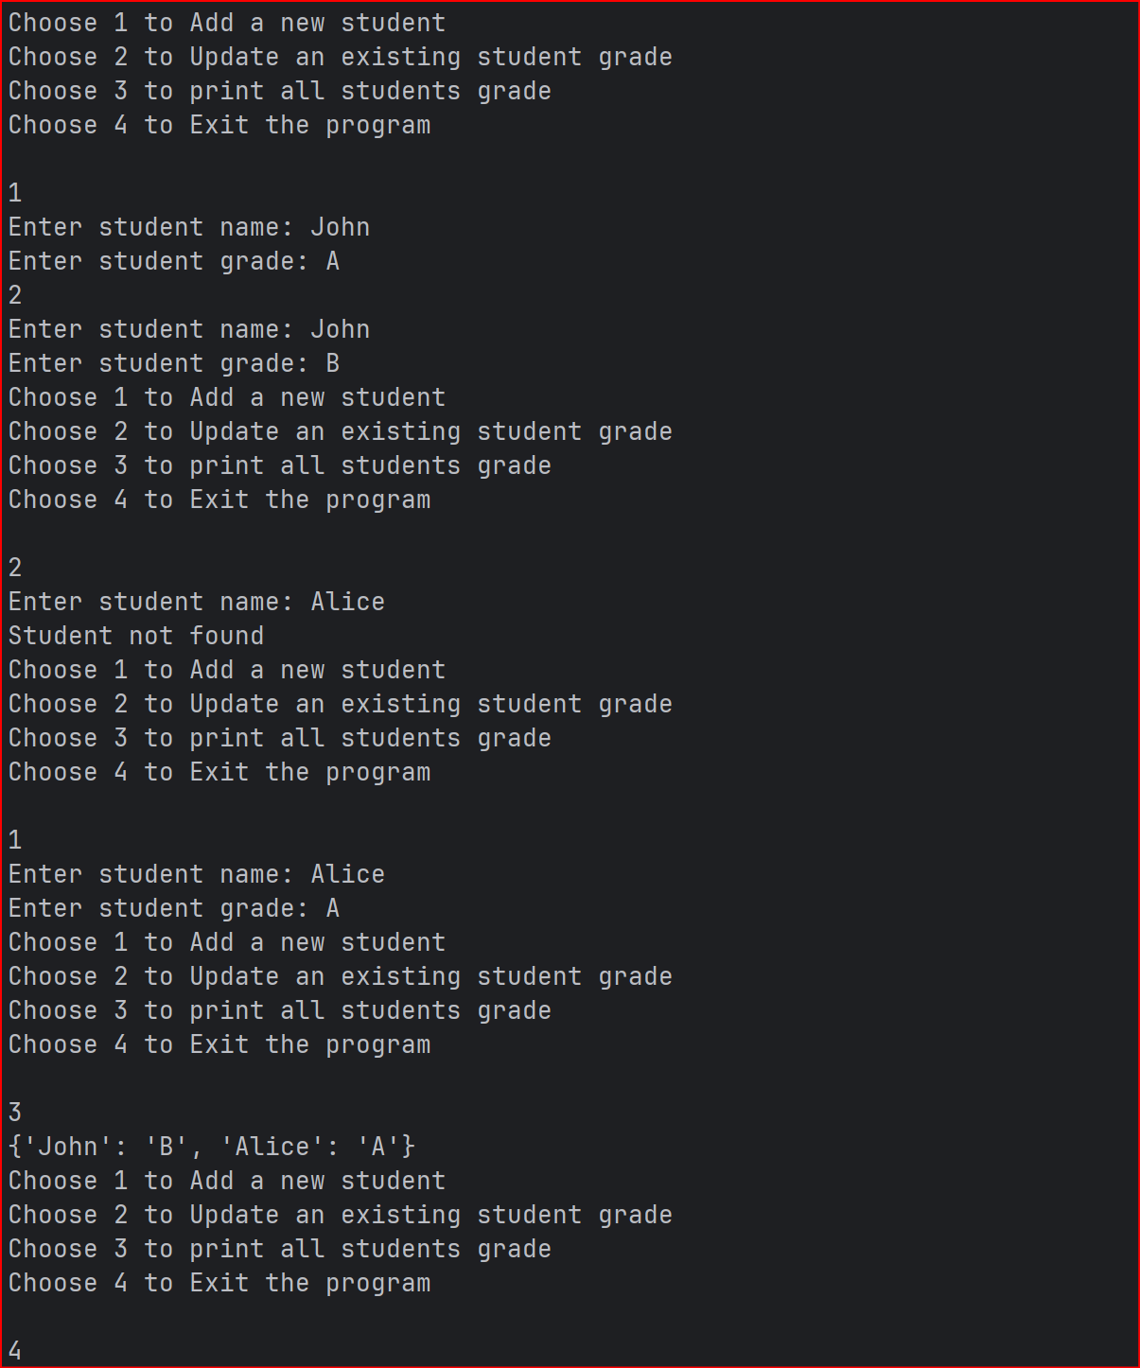

Task3.Write to a File

Write a program to create a text file and write some content to it.

Using file functions like write and open.

Code:

files = open('test2.txt','w+')  
data = files.read()  
files.write('This is a line!!')  
files.close()

Output:

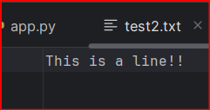

Task4. Read from a File

We used open in read mode and file.read to read and print to display.

Code:

files = open('test2.txt','r')  
data = files.read()  
print(data)  
files.close()

Output:

