1. Create a new GitHub repository.

* Clone the repository to your local machine using SSH (generate an SSH key if needed, add the public key to your GitHub account).
* Create a new branch named after your username (e.g., Tutedude).
* Add your Flask project files to this branch.
* Commit the changes and merge the branch into the main branch.

**Solution:**

New Github repository name: flask_dev

Repo URL: <https://github.com/abhinathts/flask_dev/tree/main>

Repo SSH URL: [git@github.com:abhinathts/flask_dev.git](mailto:git@github.com:abhinathts/flask_dev.git)

* To Clone:

git clone git@github.com:abhinathts/flask_dev.git

* To create a new branch:

git checkout -b abhi

where abhi is the name if the branch

* Add files and Commit in newly created branch:
  + ls Now we can see the files we have copied
  + git status
  + git add .
  + git status
  + git commit -m "falsk files added in branch abhi"

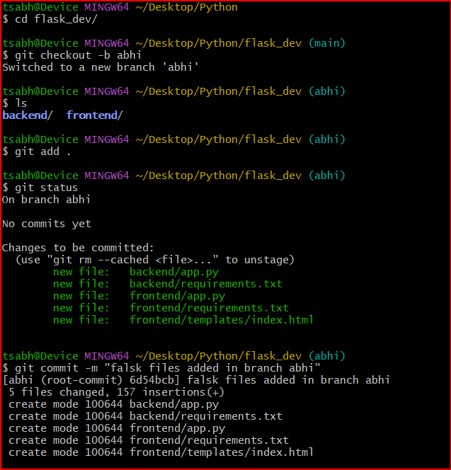

* Switch to the main branch:
  + git switch main
* Merge data from Branch abhi to main branch:
  + git merge abhi
  + ls

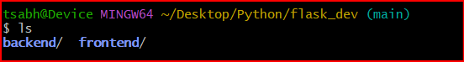

2. Create a new branch named <your_name>_new (e.g., Tutedude_new).

* Update the content of the JSON file used for the /api route in this branch.
* Merge the <your_name>_new branch into the main branch.
* If there are conflicts during the merge, resolve them by accepting the changes from the <your_name>_new branch.
* Add the resolved changes to the staging area, commit them, and push the updates to the remote repository.

Solution:

* To create a new branch and switch:

git checkout -b abhi_new

* Modified index.html since JSON file is not available in flask project
* To merge files from branch to main branch:
  + git switch main
  + git merge abhi_new
* To push to remote repository:
  + git push --set-upstream origin main

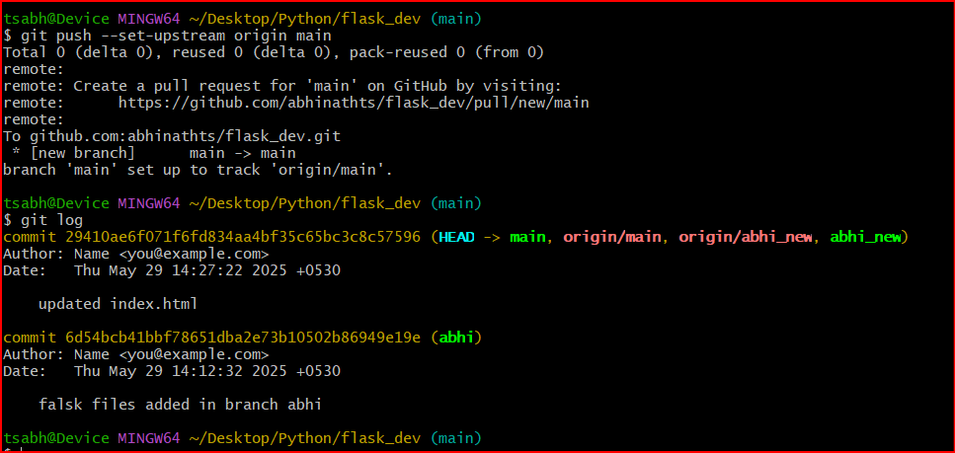

3. Branch Creation:

* Create two branches: master_1 and master_2 from the main branch.
* **Feature Development in** master_1:
* In the master_1 branch, create a **To-Do Page** in the frontend.
  + The page should contain a form with the following fields:
    - **Item Name**
    - **Item Description**
* **Backend API in** master_2:
* In the master_2 branch, create a backend route named /submittodoitem.
* This route will:
  + Accept itemName and itemDescription via a POST request.
  + Store these details in a MongoDB database.
* **Merging Changes**:
* Merge the changes from both master_1 and master_2 into the main branch.

Solution:

* To create master_1 & master_2 branch:
  + git branch master_1
  + git branch master_2
* Switch to master_1 branch:
  + git switch master_1
* Feature Development in master_1:

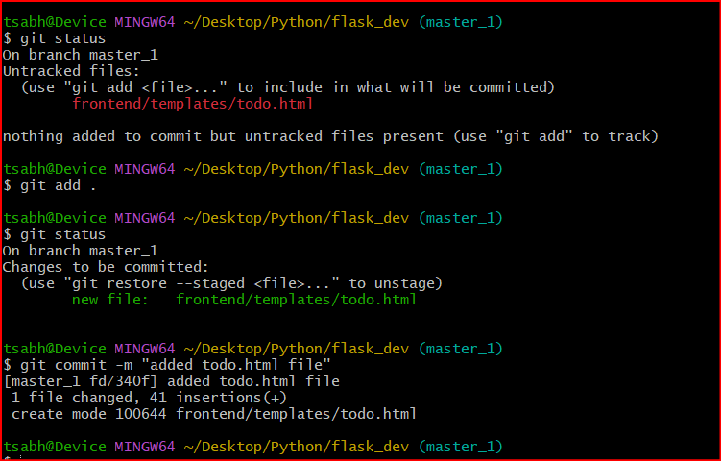

* Backend API in master_2:
  + Modified backend files and merged master_1 and master_2 to the main branch
  + Pushed code to remote repo.

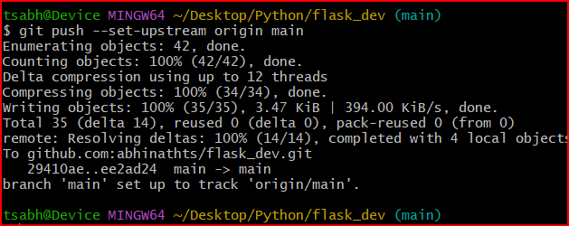

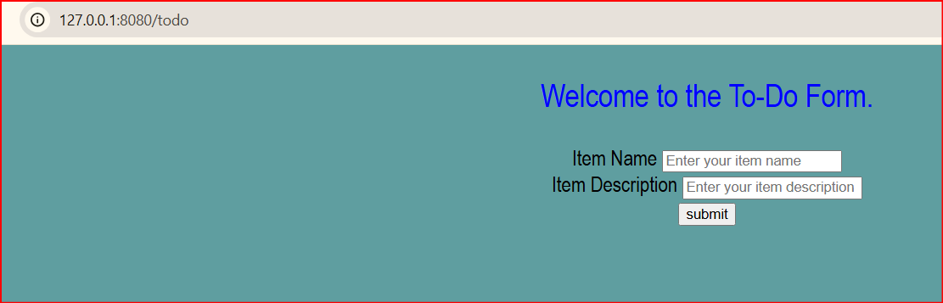

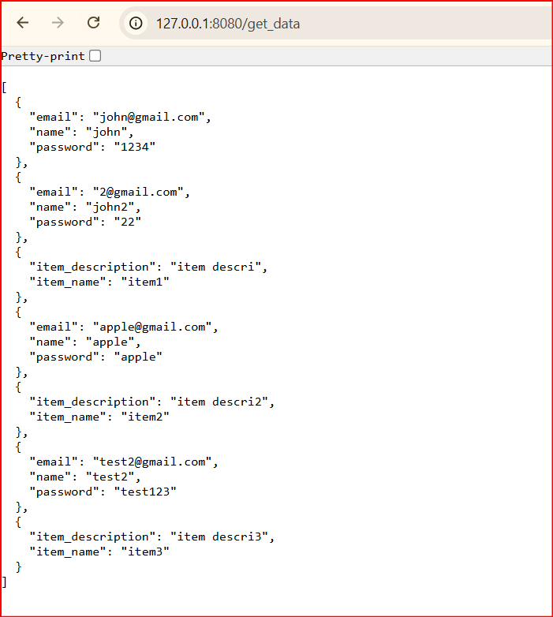

4. **Enhancing the To-Do Form in** master_1:

* In the master_1 branch, add the following fields to the To-Do form:
  + **Item ID**
  + **Item UUID**
  + **Item Hash**
* **Committing in Sequence**:
* Add and commit each field separately in the following order:
  + **First commit**: Add **Item ID** field.
  + **Second commit**: Add **Item UUID** field.
  + **Third commit**: Add **Item Hash** field.
* **Merging to** main:
* Merge the master_1 branch into the main branch.
* **Git Reset and Commit Deletion**:
* In the main branch, use **Git Reset** to roll back to the commit where only the **Item ID** field was added.
* Use git reset --soft to ensure changes remain staged.
* Re-commit this state to the main branch.
* Merge this updated state to the main branch.
* **Rebasing Changes**:
* Rebase the updated changes in the main branch to the master_1 branch.  
  **Clarification**:
  + During rebasing, **preserve individual commits** to maintain the commit history for each change (i.e., do not squash commits).
  + Use git rebase main master_1 to integrate changes from the main branch back into the master_1 branch.

Solution:

* + Switched to master branch and created **Item ID**, **Item UUID** and **Item Hash** field. Also committed while adding each field.

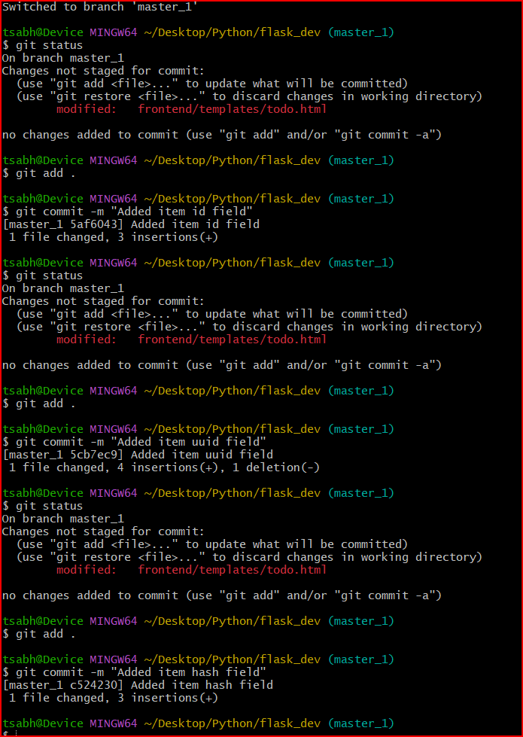

* + Merged to main branch:

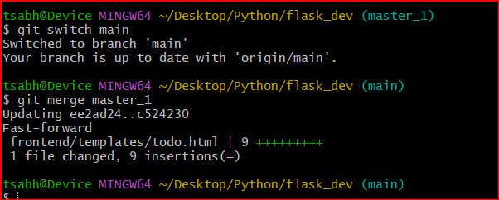

* + Git Reset and Commit Deletion:

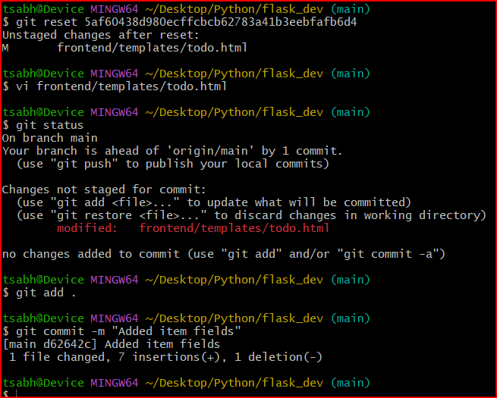

* + Rebasing Change:

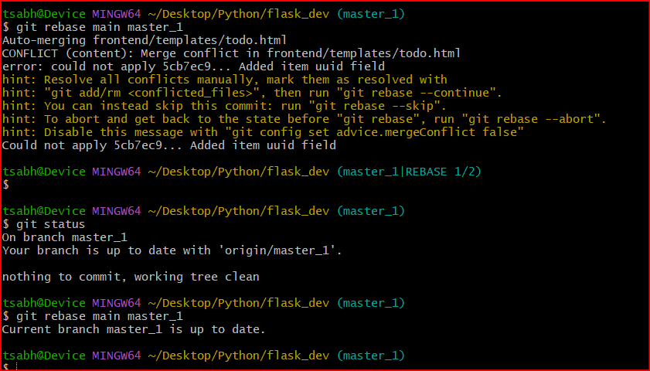

* + G

**Submission Guidelines -:** Attach Screenshots or command along with explanation and submit in doc(google doc or microsoft doc) format , also share link of your github repo