Name : Abhinav Agrawal
Class : A4-B1
Roll no. : 13
Subject : DAA Lab

Practical 6
Aim: Construction of OBST
Problem Statement: Smart Library Search Optimization

Task 1:
Scenario:
A university digital library system stores frequently accessed books using a binary search mechanism. The library admin wants to minimize the average search time for book lookups by arranging the book IDs optimally in a binary search tree. Each book ID has a probability of being searched successfully and an associated probability for unsuccessful searches (when a book ID does not exist between two keys). Your task is to determine the minimum expected cost of searching using an Optimal Binary Search Tree (OBST).
Input Format
First line: integer n — number of book IDs.
Second line: n integers representing the sorted book IDs (keys).
Third line: n real numbers — probabilities of successful searches (p[i]).
Fourth line: n+1 real numbers — probabilities of unsuccessful searches (q[i]).
Keys: 10 20 30 40
P[i]: 0.1 0.2 0.4 0.3
Q[i]: 0.05 0.1 0.05 0.05 0.1

Output Format
Print the minimum expected cost of the Optimal Binary Search Tree, rounded to 4 decimal
Places.
Code:-
#include <stdio.h>
#include <stdlib.h>
#include <float.h>

double Optimal_Binary_Search_Tree(int n, int m, double keys[], double prob[]) {
double e[n+2][n+2], w[n+2][n+2];
int i, j, l, r;

for(i = 0; i <= n+1; i++) {
for(j = 0; j <= n+1; j++) {
e[i][j] = 0;
w[i][j] = 0;
}
}

for(i = 1; i <= n+1; i++) {
e[i][i-1] = prob[i-1];
w[i][i-1] = prob[i-1];
}

for(l = 1; l <= n; l++) {
for(i = 1; i <= n-l+1; i++) {
j = i + l - 1;
e[i][j] = DBL_MAX;
w[i][j] = w[i][j-1] + keys[j-1] + prob[j];
for(r = i; r <= j; r++) {
double t = e[i][r-1] + e[r+1][j] + w[i][j];
if(t < e[i][j])
e[i][j] = t;
}
}
}

return e[1][n];
}

int main() {
int n, m, i;
printf("Enter the size of the successful array:-");
scanf("%d", &n);
printf("Enter the size of the unsuccessful array:-");
scanf("%d", &m);

double *p = (double*)malloc(n * sizeof(double));
double *q = (double*)malloc(m * sizeof(double));

printf("Enter the elements for successful keys:-\n");
for(i = 0; i < n; i++)
scanf("%lf", &p[i]);

printf("Enter the elements for unsuccessful search between keys:-\n");
for(i = 0; i < m; i++)
scanf("%lf", &q[i]);

double cost = Optimal_Binary_Search_Tree(n, m, p, q);
printf("%lf\n", cost);

free(p);
free(q);
return 0;
}

Output:-
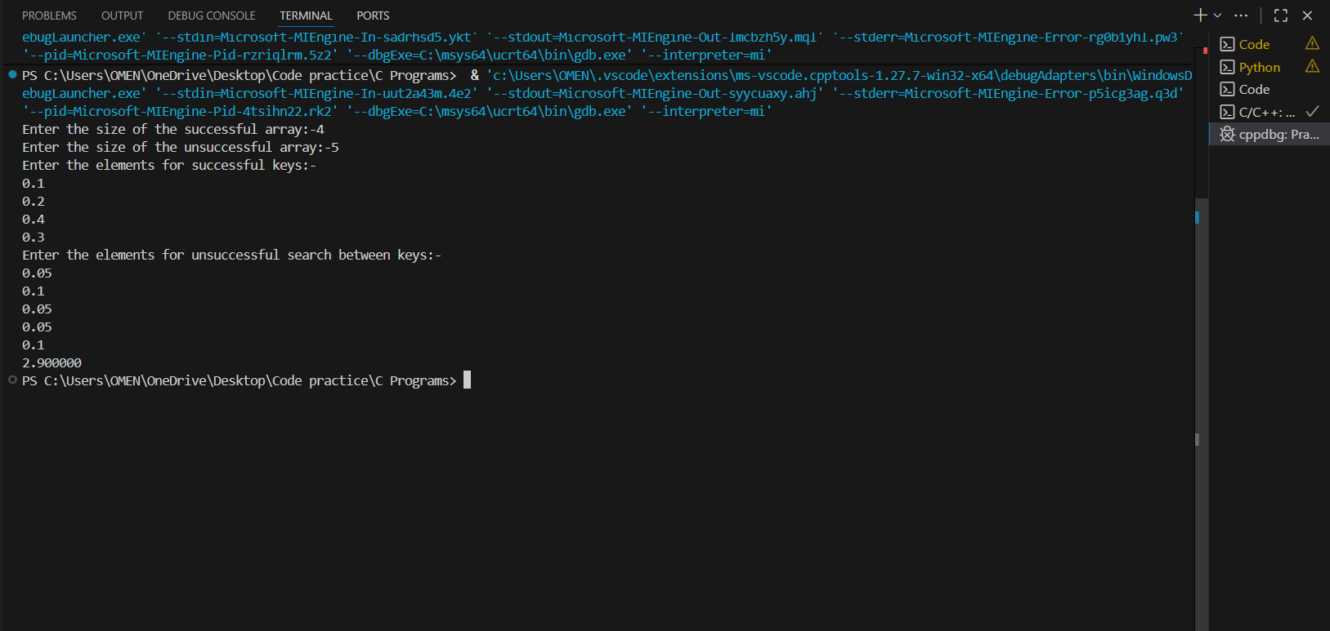

Task2:
https://www.geeksforgeeks.org/problems/optimal-binary-search-tree2214/1

Output:

