Name : Abhinav Agrawal
Class : A4-B1
Roll no. : 13
Subject : DAA lab

Practical 5

Aim: Implement a dynamic algorithm for Longest Common Subsequence
(LCS) to find the length and LCS for DNA sequences.

Problem Statement:
(i) DNA sequences can be viewed as strings of A, C, G, and T characters, which
represent nucleotides. Finding the similarities between two DNA sequences are
an important computation performed in bioinformatics.

TASK 1: Find the similarity between the given X and Y sequence. X=AGCCCTAAGGGCTACCTAGCTT
Y= GACAGCCTACAAGCGTTAGCTTG
Output: Cost matrix with all costs and direction, final cost of LCS and the LCS. Length of LCS=16

Code :

#include <stdio.h>
#include <string.h>

#define MAX 1000

void buildLCS(char str1[], char str2[], int table[MAX][MAX]) {
int len1 = strlen(str1);
int len2 = strlen(str2);

for (int i = 0; i <= len1; i++) {
for (int j = 0; j <= len2; j++) {
if (i == 0 || j == 0)
table[i][j] = 0;
else if (str1[i - 1] == str2[j - 1])
table[i][j] = table[i - 1][j - 1] + 1;
else
table[i][j] = (table[i - 1][j] > table[i][j - 1]) ? table[i - 1][j] : table[i][j - 1];
}
}
}

void printLCS(char str1[], char str2[], int table[MAX][MAX]) {
int i = strlen(str1);
int j = strlen(str2);
char lcsSeq[MAX];
int idx = 0;

while (i > 0 && j > 0) {
if (str1[i - 1] == str2[j - 1]) {
lcsSeq[idx++] = str1[i - 1];
i--;
j--;
} else if (table[i - 1][j] > table[i][j - 1]) {
i--;
} else {
j--;
}
}

lcsSeq[idx] = '\0';
for (int k = 0; k < idx / 2; k++) {
char temp = lcsSeq[k];
lcsSeq[k] = lcsSeq[idx - k - 1];
lcsSeq[idx - k - 1] = temp;
}

printf("LCS string: %s\n", lcsSeq);
}

int main() {
char firstStr[MAX], secondStr[MAX];
int dp[MAX][MAX];

scanf("%s", firstStr);
scanf("%s", secondStr);

buildLCS(firstStr, secondStr, dp);

int len1 = strlen(firstStr);
int len2 = strlen(secondStr);

printf("Length of LCS: %d\n", dp[len1][len2]);
printLCS(firstStr, secondStr, dp);

return 0;
}

Output

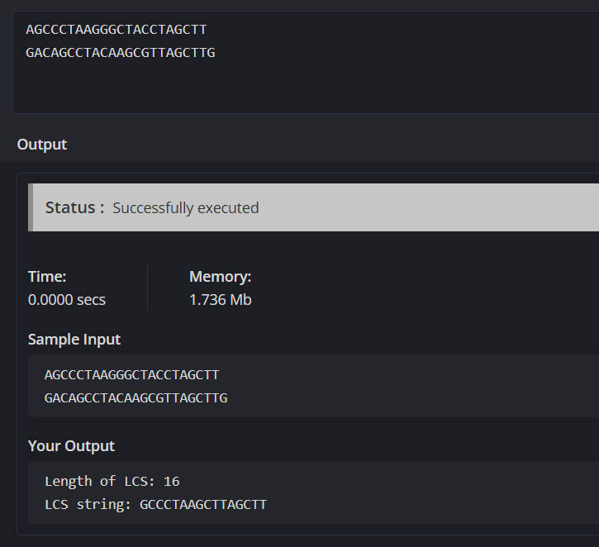

TASK-2: Find the longest repeating subsequence (LRS). Consider it as a variation of the longest common subsequence
(LCS) problem. Let the given string be S. You need to find the LRS within S. To
use the LCS framework, you effectively compare S with itself. So,
consider string1 = S and string2 = S.
Example:
AABCBDC
LRS= ABC or ABD

Code:

#include <stdio.h>
#include <string.h>

int arr[1001][1001];

int LRS_table(char str[]) {
int n = strlen(str);
for (int i = 0; i <= n; i++) {
for (int j = 0; j <= n; j++) {
if (i == 0 || j == 0)
arr[i][j] = 0;
else if (str[i-1] == str[j-1] && i != j)
arr[i][j] = arr[i-1][j-1] + 1;
else
arr[i][j] = arr[i-1][j] > arr[i][j-1] ? arr[i-1][j] : arr[i][j-1];
}
}
return arr[n][n];
}

void LRS_string(char str[]) {
int n = strlen(str);
int i = n, j = n;
char res[1001];
int idx = 0;
while (i > 0 && j > 0) {
if (str[i-1] == str[j-1] && i != j) {
res[idx++] = str[i-1];
i--;
j--;
}
else if (arr[i-1][j] > arr[i][j-1])
i--;
else
j--;
}
res[idx] = '\0';
for (int k = idx-1; k >= 0; k--) {
printf("%c", res[k]);
}
printf("\n");
}

int main() {
char str[1001];
scanf("%s", str);
printf("%d\n", LRS_table(str));
LRS_string(str);
return 0;
}

OUTPUT:

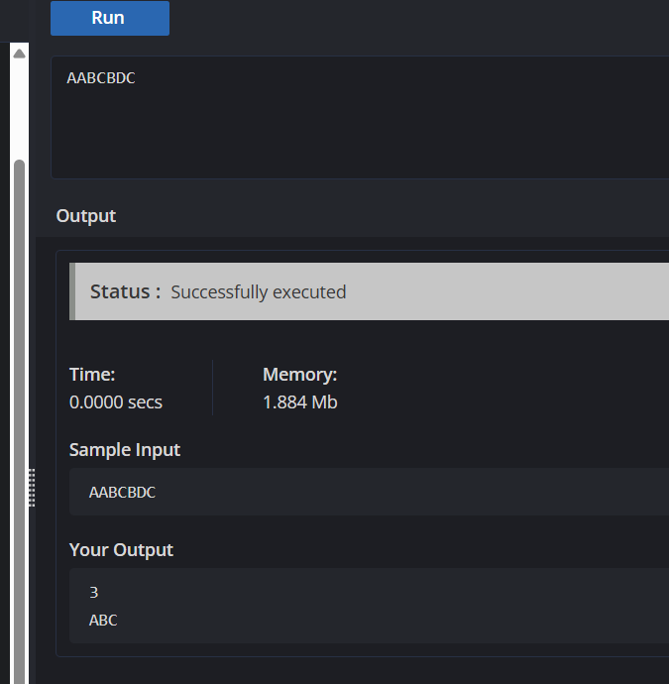

Leetcode:

https://leetcode.com/problems/longest-common-subsequence/description/

