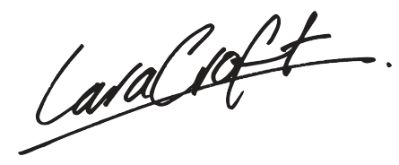



**Indra Pant**

Founder & CEO

[support@rapporthr.in](mailto:support@rapporthr.in)

rapporthr@gmail.com

95995 53911

To

**Maryam Farooqui**

A 6598 West media sponcer, usa-568

This is a sample letter that has been placed to demonstrate the typing format on the (Your Company) letterhead design. When positioned properly, it will serve to work in harmony with all of the core an other elements on the letterhead This letterhead design is meant to project an image of professionalism and reliability. By using simple alignments we have created a very spacious feeling uggests strength and the image of professionalism and reliability. By using simple alignments we have.

Been placed to demonstrate the typing format on the (Your Company) letterhead design. When positioned properly, it will serve to work in harmony with all of the core an other elements on the letterhead This letterhead design is meant to project an image of professionalism and reliability. By using simple alignments we have created.

Placed to demonstrate the typing format on the (Your Company) letterhead design. When positioned properly, it will serve to work in harmony with all of the core an other elements on the letterhead This letterhead design is meant to project an image.

Placed to demonstrate the typing format on the (Your Company) letterhead design. When positioned properly, it will serve to work in harmony with all of the core an other elements on the letterhead This letterhead design is meant to project an image.

Placed to demonstrate the typing format on the (Your Company) letterhead design. When positioned properly, it will serve to work in harmony with all of the core an other elements on the letterhead This letterhead design is meant to project an image.

P +1-222-333-444

W email@mailid.com, www.myweb.com

Director

Date : 14 March, 2020

S-214, Ground Floor, Pandav Nagar, New Delhi - 110092