(1500) Build & Deploy Full Stack Multi Restaurant Booking Platform | MERN Stack Project Tutorial - YouTube

- https://www.coderabbit.ai/ use this to review code
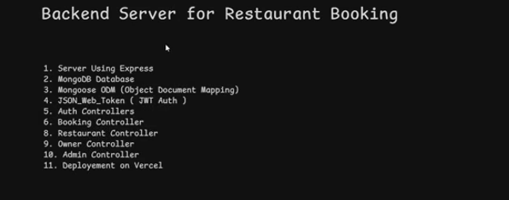

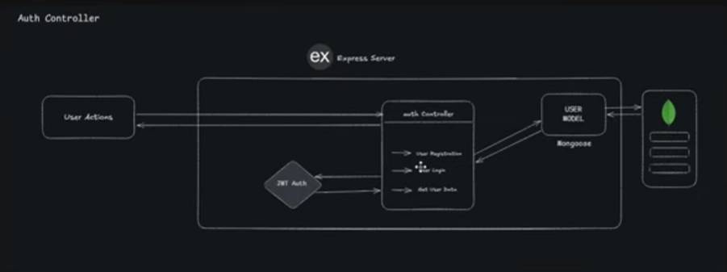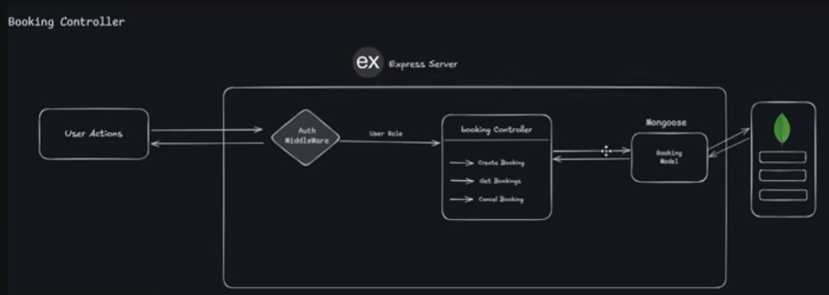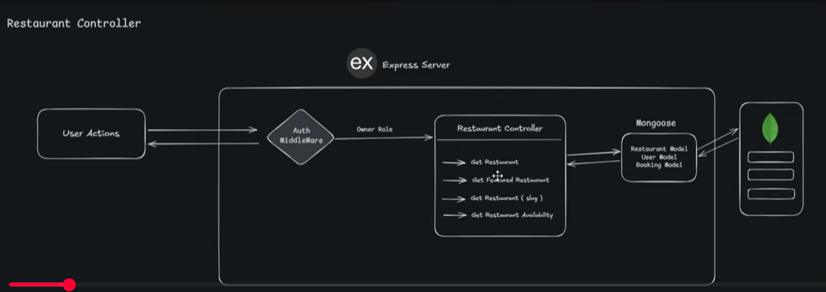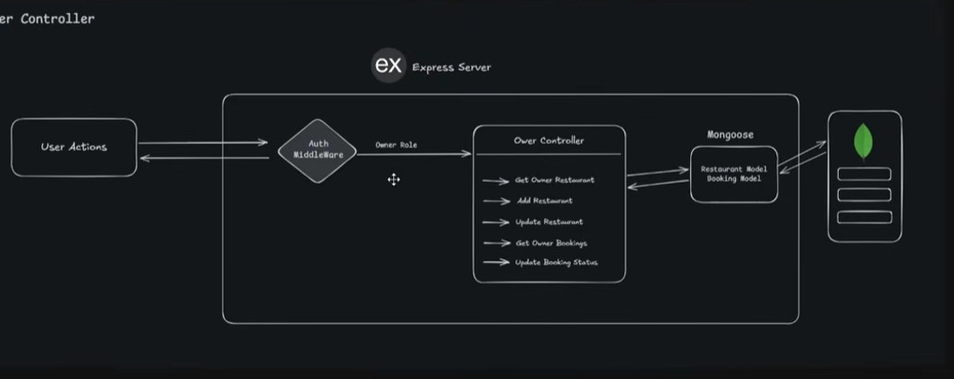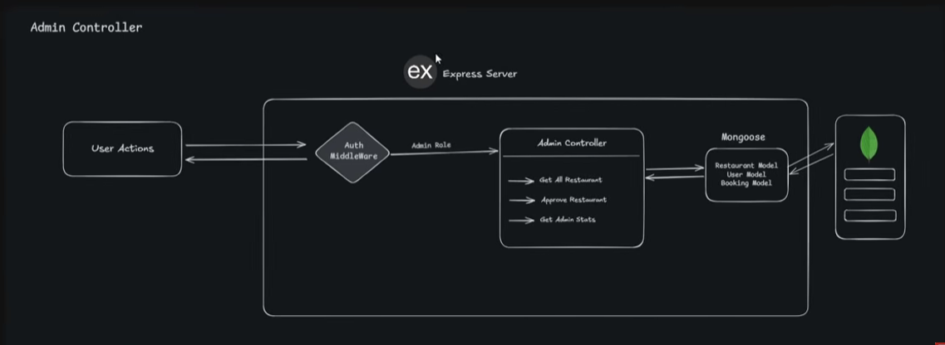

https://github.com/GreatStackDev/notes
we have to connect our db after complete setup of server. https://www.mongodb.com/products/platform/atlas-database

now we will have to run command
and then change the ip addr such that , any ip address can access
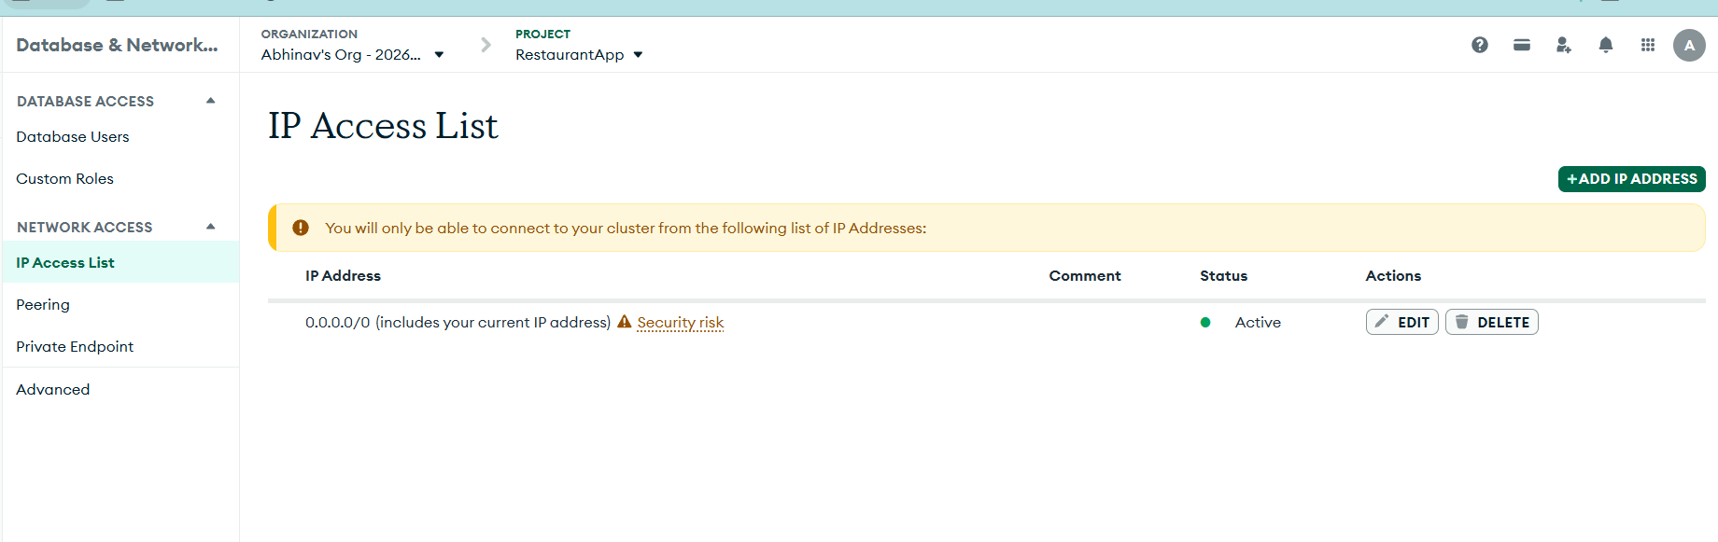
One our work is completed, we need to push our code to git hub by feature branch. But we need to compare and pull request by using github . so that we can review the code analysed by code Rabbit ai.

