

CERTIFICATE

CERTIFIED THAT THIS REPORT TITLED THE JUDICIAL CASE HANDLING SYSTEM IS A BONAFIDE RECORD OF THE MAJOR PROJECT WORK DONE BY ABHINAV CHANDRA A.R UNDER OUR SUPERVISION AND GUIDANCE, AT THE DEPARTMENT OF COMPUTER SCIENCE AND APPLICATIONS CHRIST NAGAR COLLEGE TOWARDS THE PARTIAL FULFILMENT OF THE REQUIREMENTS FOR THE AWARD OF THE DEGREE OF BACHELOR OF COMPUTER APPLICATIONS OF THE UNIVERSITY OF KERALA

PRINCIPAL HEAD OF THE DEPARTMENT INTERNALGUIDE

EXTERNAL EXAMINER

- …………………………………….

- ….…………………………………

ACKNOWLEDGEMENTS

I am using this opportunity to express our sincere gratitude to everyone who supported us throughout the course of this Computer Applications project. I would first like to thank the almighty for showering his blessings upon us.
I would like to thank our Manager, Rev.Fr. Cyriac Madathil CMI for the encouragement provided.
Then I would like to thank our Principal, Dr. Jolly Jacob for the support and encouragement provided.
I express our sincere gratitude towards our Head of the Department of Computer Applications, Mrs. Sunitha S Nair for providing an opportunity for undertaking this project.
I would also like to thank our project guide, Mrs.Ayswariya V J, Assistant Professor, for all the support given by her throughout the completion of the project.
I express our warm thanks to Mr. for his support and guidance at Bethel Computers.
Last but not least I would like to express our profound thanks to all our friends for their support. I thank all the above-mentioned people for their aspiring guidance, invaluably constructive criticism and friendly advice during the project work. I am sincerely grateful to them for sharing their truthful and illuminating views on a number of issues related to the project.

WITH GRATITUDE

ABSTRACT

The Judicial Management System is a comprehensive software solution designed to enhance the efficiency and accuracy of case management within the judicial system. By integrating multiple modules, the system enables a seamless electronic flow of case-related information across various judicial offices. This reduces redundant data entry, minimizes manual record-keeping errors, and accelerates the processing of case information. The system ensures that critical data is easily accessible while maintaining stringent security measures to protect confidential information.
From the moment a crime is reported, the system plays a crucial role in streamlining operations. Dispatchers can initiate case records, and law enforcement officers can input relevant details during investigations. Prosecutors can review and update case files online, eliminating the need for excessive paperwork. Clerks and court coordinators utilize the system to generate reports, prepare court dockets, and manage case numbers. Judges can record case dispositions in real time, ensuring that the necessary legal documents are instantly available to all relevant departments.
By automating key judicial processes, the system improves interdepartmental collaboration and ensures the smooth handling of cases from investigation to final judgment. It not only enhances accuracy and transparency but also significantly reduces administrative workload. The Judicial Management System modernizes traditional case management practices, contributing to a more efficient and reliable legal system.

INTRODUCTION
1.1 ABOUT THE PROJECT

The Judicial Management System has been continually enhanced since the software was developed. Each module of the system will work hand-in-hand with the other modules to create an electronic flow of case related information. The electronic flow of case related information from one judicial office to another reduces redundant data entry and/or manual record keeping processes. It also reduces the possibility of paper related errors and speeds the processing of information within the Judicial System. The following is an example of how our system works: When dispatch receives a call and dispatches an officer to the scene of a reported crime, the dispatcher may begin a computer case record of the offense. When the Criminal Investigation Division of the Sheriff’s Department receives the file, all information is input during the initial investigation, or booking of suspects, is available on-line. Any previous information on suspects arrested or investigated by the county will also be available on-line. When this case is presented to the District Attorney’s Office they will review the information on-line, adding anything necessary for their office. Once prepared for prosecution, the necessary forms for processing the case are printed using the information accumulated in the system. Confidential information is secured via a series of security levels so only information pertinent to an employee’s job may be accessed by that employee’s password. When the forms generated by the prosecuting attorney are filed with the clerk’s office, the clerk enters the case number, necessary codes for report generation and other information necessary for their office while confirming the accuracy of the existing case information. The Court Coordinators then utilize the system and accumulated information for generating court dockets. Upon completion of the case, the disposition of the case may be entered during court as rendered by the Judge. Court documents are printed and all necessary information is now available for the Probation Office.
1.2 ORGANISATION OVERVIEW

Bethel Computers Malayam is a distinguished educational institution, highly regarded for its commitment to providing top-tier computer education. As an affiliate of C-dit (Centre for Development of Imaging Technology), a Government of Kerala initiative, Bethel Computers Malayalam stands as a key player in the realm of skill development and digital literacy. They offer a diverse range of computer courses, catering to both beginners and advanced learners, and are known for their comprehensive curriculum that equips students with the necessary expertise to thrive in today's technology-driven world.
The institution has established a solid reputation in the educational sector due to its unwavering focus on delivering quality education. Over the years, it has built a loyal student base, with a remarkable track record of 100% client retention. This level of loyalty speaks volumes about the effectiveness and relevance of the programs offered, as well as the institution’s ability to foster a conducive learning environment that meets the evolving needs of the digital age. The core of Bethel Computers Malayalam's success is its commitment to quality. The institution recognizes that true quality requires more than just knowledge—it demands discipline, hard work, creativity, and innovation. Their educators and staff follow a work methodology that is both rigorous and flexible, ensuring that students receive not just theoretical knowledge but also practical, hands-on experience that is crucial for real-world application

SYSTEM ANALYSIS
INTRODUCTION TO SYSTEM ANALYSIS

System analysis is a systematic approach to understanding, designing, and improving systems to achieve specific goals and objectives. It is a multidisciplinary field that draws upon principles from computer science, engineering, management, and other relevant disciplines. The process of system analysis involves breaking down complex systems into smaller, more manageable components to analyze their structure, behavior, and interactions

The Judicial Management System (JMS) aims to improve case management and streamline workflows in the judicial system by incorporating different modules that facilitate smooth information sharing. This system helps eliminate duplicate data entry, reduces the likelihood of manual errors, and speeds up case processing through digitization. The analysis looks into the system’s requirements, features, advantages, and limitations to guarantee optimal performance.
  - EXISTING SYSTEM

The existing judicial structure presents several challenges that hinder its effectiveness and accessibility. One of the primary concerns is the limited interaction between the judiciary and the broader society, creating a disconnect that often leaves citizens feeling alienated from the legal system. Additionally, judicial procedures are often excessively time-consuming, leading to significant delays that cause frustration among all stakeholders. In some cases, even clients find it difficult to track the status of their cases, resulting in confusion and uncertainty.

Furthermore, the verification process for legal documents and judicial proceedings is often complex and time-intensive, making it difficult for litigants to navigate the system efficiently. This bureaucratic complexity adds to the burden on individuals seeking justice. Moreover, litigation remains costly due to high legal and court fees, which disproportionately affect marginalized communities, limiting their access to legal recourse.

Given these challenges, there is a pressing need for judicial reform to enhance efficiency, improve accessibility, and ensure that justice is delivered in a timely and transparent manner. By streamlining judicial processes, reducing bureaucratic hurdles, and making legal services more affordable, the judiciary can foster greater public confidence and ensure equal access to justice for all.
    - LIMITATIONS OF EXISTING SYSTEM

The existing judicial process functions with less interaction among different legal entities, resulting in inefficiency and case processing delays. Departments tend to work in isolation, and thus data sharing becomes time-consuming and error-prone.
Legal procedures are usually delayed because of heavy paperwork, prolonged verification, and bureaucratic obstacles. This leads to delayed case dispositions, leaving litigants and legal professionals frustrated.
Litigants and even lawyers find it difficult to follow the status of cases because record-keeping procedures are outdated. This transparency usually creates confusion, uncertainty, and an impression of inefficiency in the judicial process.
The costs of legal services, court costs, and certification of documents make justice unaffordable for the majority, especially those from vulnerable groups. The costs discourage people from seeking legal recourse, depriving them of access to justice.
Verification and documentation processes tend to be cyclical and needlessly complex, causing individuals to struggle to move through the judicial system. Manual record maintenance further contributes to human error and lag.
Judicial records are at risk of loss, tampering, or unauthorized access due to paper-based record systems and underdeveloped digital infrastructure. Without a secure, centralized digital environment, there is substantial risk to case confidentiality and data integrity.
The judiciary has minimal interaction with the general public and the majority of citizens are not aware of legal processes and their rights. Such disconnection between the legal system and society leads to a lack of trust and involvement in judicial processes.

  - PROPOSED SYSTEM

The envisioned system intends to completely automate the judiciary, including courts, judges, attorneys, and citizens. The innovation is meant to improve both administrative functions as well as case management, providing an end-to-end solution suited to Judiciary, Court Administration, Case Management, and Court Reporting Services. With the adoption of contemporary technology, the system aims to simplify judicial processes, increase efficiency, and achieve a more responsive legal system.

One of the most notable aspects of this automated system is its friendly interface that is accommodated for all stakeholders irrespective of their technical background. The intuitive interface is meant to help make legal procedures easy to use and also minimize the learning curve for all levels of users.

Aside from usability, the system also minimizes procedural delays, where cases could be processed and settled at a much quicker pace. By minimizing inefficiencies, it also reduces the overall expense of legal proceedings, making justice more accessible to individuals and families. This modernization initiative not only enhances the speed and efficiency of judicial processes but also amplifies public access to justice, making the legal system more inclusive.

The system also has an online case registration component, where users can start and follow up on their cases remotely. This improves accessibility and provides a way for people to interact with the judicial system without the inconvenience or physical travel to court offices.

Further, the system simplifies police verification procedures, minimizing the time spent on conducting background checks and validation of cases. This not only accelerates the judicial process but also releases the law enforcement agencies from the administrative load, allowing them to carry out more important functions.

Overall, the plan of an automated judiciary is a revolutionary solution to the endemic problems of India's judiciary.

    - ADVANTAGES OF PROPOSED SYSTEM

- Enhanced Accessibility – People can register and track cases over the internet from anywhere, reducing the need to physically visit court offices.
- Faster Processing of Cases – Automation minimizes procedural lags, and the cases are processed faster.
- User-Friendly Interface – Simple and intuitive to access by all stakeholders regardless of technical expertise.
- Lower Legal Costs – Effective processes reduce administrative costs, and justice costs less for citizens and families.
- Efficient Police Verification – Simplified and speeded-up verification procedures lighten the load on police organizations.
- Fewer Papers – Digital records eliminate redundant paperwork, cutting down on errors and enhancing document management.
- Increased Transparency – Litigants, attorneys, and other parties can easily obtain information about cases, increasing transparency in court proceedings.
- Secure Data Management – Multi-level security controls guard sensitive legal data from misuse.
- Enhanced Coordination Among Judicial Organizations – Coordination among courts, prosecutors, police agencies, and other departments allows for easy sharing of information.
- Green Approach – Minimizing paper-based record reliance promotes environmental conservation and sustainability.
- Enhanced Court Scheduling – Automated docket management facilitates better and more streamlined scheduling of hearings.
- Less Court Staff Burden – Automation reduces tedious administrative tasks, allowing judicial staff to focus on critical tasks.
- Scalability for Future Growth – The system is scalable and expandable with increasing legal requirements and case volumes.

Through the elimination of inefficiencies in the current judicial system, the new system redefines the legal environment so that speedy, equitable, and affordable justice is made available to everyone.

  - REQUIREMENT SPECIFICATIONS

    - Hardware requirements

1. Processor: Dual Core 1.60 GHz or higher
2. Hard Disk: 500 GB
3. RAM: 4 GB
4. Monitor: 17” Colour Monitor
5. Mouse: Microsoft
6. Keyboard: Microsoft multimedia keyboard

2.3.2 Software Requirements

1. Operating System: Windows 10 or higher
2. Framework: Microsoft .Net Framework 4.5
3. Environment: Visual Studio 2022
4. Front End: C#.NET
5. Back End: Microsoft SQL Server 2022 or higher
6. Documentation: Microsoft Word 2010 or higher

    - FUNCTIONAL REQUIREMENTS

A Functional Requirement (FR) is a description of the service that the software must offer. It describes a software system or its component. A function is nothing but inputs to the software system, its behavior and outputs. It can be a calculation, data manipulation, business process, user interaction, or any other specific functionality which defines what function a system is likely to perform. Functional Requirements are also called Functional Specification.

System Administrator Module
The system administrator module is responsible for verifying users who register on the website. Once a new user registers to the website, the system administrator receives a notification indicating the same. He/she can then decide on approving or declining the new user. Once the System administrator approves a user, the user will receive mail to the email ID that was provided during the registration process and the mail will contain a system generated password for the user to log into the system. The user can then decide on changing this password after the first login.

Functions
• Login: The admin should login to the system using valid login credentials to monitor and carry out various functionality.
• Approve or reject Users: The system administrator can identify valid users and can approve the users to log into the website and make use of the website’s services and can also reject the request of a fraudulent or invalid user.
• Delete Users: The system administrator can delete users that are registered into the website if required.
• View Users: can view various users in the system and their credentials.
• Mail users: The system administrator can mail users if necessary.

Petitioner Module
The petitioner module represents the general public. Upon registering into the website and then logging into the website, he/she can report the incident to the website after which the user will be provided with a system-generated incident ID. The petitioner then has the provision to select lawyers to represent their case before the court. The user can select a lawyer from the list of registered lawyers on the website based on their profiles and can send a request to that lawyer along with the previously generated incident ID. Once the lawyer approves the request and shares the e-vakalat, the petitioner will be able to download the same and then carry out further communications with the lawyer through the website. If the request was declined by the lawyer, the petitioner will be informed of the same and will be able to select a different lawyer from the list of profiles.

Functions
• Registration: The petitioner register information such as the username and also update his/her profile
• Login: The petitioner can log on to the system using valid login credentials and make use of the functionalities provided by the website.
• Report Incident: Enables the petitioner to report the incident and after doing so will receive a system generated incident ID.
• Select Lawyer: Used to select a lawyer from the list of lawyers after viewing each of their profile in order to represent their case in court.
• Mail: used to communicate with the other users of the website.
• View e-vakalat: enables users to view the digitally generated e-vakalat that is being shared by the lawyer and download it if required.

Police Officer
The police module represents the general police station. Upon registering into the website and then logging into the website, he/she can verify upload by the petitioner, the incident to the website after which the user will be provided with a system-generated incident ID. The police verify the complaint and generate FIR and send to the court for the further procedures.

Functions
• Registration: The police register information such as the username, station, etc and also update his/her profile
• Login: The police can log on to the system using valid login credentials and make use of the functionalities provided by the website Case management
• View case status: The police can view status of various cases by their case id
• Verify petitions: The police verify the petition and petitioner.
• Mail: used to communicate with the other users of the website.

Court Officer Module
The court officer module is responsible for scheduling the duties of the judge. He/She is a designated court official. He/she will be responsible for notifying the judge about the cases to the attended on a particular day, sending reminders to the judge for upcoming important cases as well as passing any additional information to the judge like case transfers between courts, etc.

Functions
• Registration: The court admin register information such as the username, court, etc and also update his/her profile.
• Login: The admin should login to the system using valid login credentials to monitor and carry out various functionalities.
• Approve petitions: The court officer approves petitions as submitted by the petitioner.
• Hearing scheduling: enables to schedule hearing of various cases and can view the datails of hearing as well as update them as the case forwards.
• View evidence: The evidence submitted by lawyer is directly accessible by the court officer which is submitted to court.
• Mail: Enables court officer to communicate with various user as required.
Lawyer Module
The lawyer module can accept or decline petitioner request thereby enabling the lawyer to decide on whether to represent a case on court. Upon accepting the petitioner request, he/she can access the details of the incident that was reported by the client using the incident ID provided by the petitioner. He/she can also generate an e-vakalat, a document that is to be presented before the court digitally, a copy of which is sent to the petitioner. He/she can also communicate with the petitioner or other lawyers and can also access details regarding previous case details which are present in the website’s database.

Functions
• Login: The lawyer can log on to the system using valid login credentials and make use of the functionalities provided by the website.
• Accept/decline client requests: Enables the lawyers to accept or decline the request put forward by petitioners to attend their cases.
• Search Incident: Enables the lawyer to access the details of an incident reported by the petitioner using the incident ID shared by the petitioner.
• Add Evidence: Lawyer helps to submit evidence to court.
• Status of case: used to view status of the case.
• Hearing details: Lawyer can view the details of case hearing as declared by the judge through court admin.
• Mail: enables the user to communicate with other users of the website.
    - Non-Functional Requirements

In systems, a non-functional requirement (NFR) is a requirement that specifies criteria that can be used to judge the operation of a system, rather than specific behaviour. They are contrasted with functional requirements that define specific behaviour or functions:

• Usability: Usability defines how difficult it will be for a user to learn and operate the system. Efficiency of use: the average time it takes to accomplish a user’s goals, how many tasks a user can complete without any help, the number of transactions completed without errors
• Authenticity: The system meets authenticity as only those users with a valid username and password can log into the application.
• Data integrity: Data integrity is ensured by only the accurate data.
• Performance: It ensures good performance by maintaining a low response time, high utilization and fast throughput.
• Availability: The application meets availability as a user can access it any time.
• Security: The data is securely stored in database and only the authorized user can access it

  - FEASIBILTY STUDY

Feasibility study is the test of the system proposal made to identify whether the user needs may be satisfied using the current software and hardware technologies, whether the system will be cost effective from a business point of view and whether it can be developed with the given budgetary constraints. A feasibility study should be relatively cheap and done at the earliest possible time. Depending on the study, the decision is made whether to go ahead with a more detailed analysis. When a new project is proposed, it normally goes through feasibility assessment. Feasibility study is carried out to determine whether the proposed system is possible to develop with available resources and what should be the cost consideration. Facts considered in the feasibility analysis were:

• Economic Feasibility
• Operational Feasibility
• Technical Feasibility

    - Economic Feasibility
This feasibility study present tangible and intangible benefits from the prefect by comparing the development and operational cost. This system needs some more initial investment than the existing system, but it can be justifiable that it will improve quality of service. Thus, feasibility study should centre along the following points:
• Improvement resulting over the existing method in terms of accuracy, timeliness.
• Cost comparison
• Estimate on the life expectancy of the hardware
• Overall objective Our project is economically feasible. It does not require much cost to be involved in the overall process. It is essential because the main goal of the proposed system is to have economically better result with the increase.

    - Operational Feasibility
Operational analysis is the most frequently used method for evaluating the effectiveness of a new system. More commonly known as cost/benefit analysis, the procedure is to determine the benefits and saving that are expected from a candidate system and compare them with costs. If benefits outweigh costs, then the decision is made to design and implement the system. An entrepreneur must accurately weigh the cost versus benefits before taking an action. Cost-based study: It is important to identify cost and benefit factors, which can be categorized as follows:

- Development costs.
2. Operating costs.
This is an analysis of the costs to be incurred in the system and benefits derivable out of the system. Time-based study: This is an analysis of the time required to achieve a return on investments The future value of a project is also a factor. This application can be operated by all the users across the world.

    - Technical Feasibility
Technical Feasibility deals with the hardware as well as software requirements. Technology is not a constraint to type system development. We have to find out whether the necessary technology, the proposed equipment has the capacity to hold the data, which is used in the project, should be checked to carry out this technical feasibility. The technical feasibility issues usually raised during the feasibility stage of investigation includes
• This software is running in Windows 11.
• The minimum hardware required is 3GB and maximum hardware required is 400GB.
• The system can be expanded

SYSTEM DESIGN

3.1 DESIGN OF SUBSYSTEM
A Design of Subsystem encapsulates behaviour, providing explicit and formal interfaces, and does not expose its internal contents. This provides the ability to completely encapsulate the interactions of a number of classes and/or subsystems. This project has five major modules. These five modules are the core functionalities of the system. The project is divided into five major modules according to their functionalities.
- ADMIN
- PETIOTIONER
- COURT OFFICER
- ADVOCATE
- POLICE

- Admin Module:

- Admin Login: Admin login manages to log into the platform and manage their profile.
- Manage Advocates: Admin can approve, delete and view advocates.
- Manage Petitioners: Admin can approve, delete and view petitioners.
- Manage court officers: Admin can add, delete and view court officers.
- Manage Police officers: Admin can approve, delete and view police officers.
- Mail: Admin can view and compose mails to various users.

- Petitioner Module:

- Registration: Petitioner can create account.
- Login: The petitioner can log on to the system using valid login credentials and make use of the functionalities provided by the website.
- Report incident: Enables the petitioner to report the incident and after doing so will receive a system generated petition ID.
- View case status: Petitioner ac view his/her case status.
- Select advocate: Used to select a lawyer from the list of lawyers after viewing each of their profile in order to represent their case in court.
- Mail: used to communicate with the other users of the website.
- View e-vakalat: enables users to view the digitally generated e-vakalat that is being shared by the lawyer and download it if required

- Court officer module

- Login: The admin should login to the system using valid login credentials to monitor and carry out various functionalities.
- Approve petitions: The court officer approves petitions as submitted by the petitioner.
- Hearing scheduling: enables to schedule hearing of various cases and can view the details of hearing as well as update them as the case forwards.
- View evidence: The evidence submitted by lawyer is directly accessible by the court officer which is submitted to court.
- Mail: Enables court officer to communicate with various user as required.

- Advocate module

- Login: The lawyer can log on to the system using valid login credentials and make use of the functionalities provided by the website.
- Accept/decline client requests: Enables the lawyers to accept or decline the request put forward by petitioners to attend their cases.
- Search Incident: Enables the lawyer to access the details of an incident reported by the petitioner using the incident ID shared by the petitioner.
- Add Evidence: Lawyer helps to submit evidence to court.
- Status of case: used to view status of the case.
- Hearing details: Lawyer can view the details of case hearing as declared by the judge through court admin.
- Mail: enables the user to communicate with other users of the website.

- Police officer module

- Registration: The police register information such as the username, station, etc and also update his/her profile
- Login: The police can log on to the system using valid login credentials and make use of the functionalities provided by the website Case management
- View case status: The police can view status of various cases by their case id
- Verify petitions: The police verify the petition and petitioner.
- Mail : used to communicate with the other users of the website.

3.2 USER INTERFACE DESIGN
3.2.1 Input Design of User
Input designing is the basic theory to be considered during system study. The input media used in the system is the keyboard. Details are entered in the system through different data entry screens. The system is designed in a user-friendly manner. Appropriate error messages are displayed when a false data is entered. The user interface design is very important for any application. The interface design defines how the software communicates within itself, to system that interpreted with it and with human who use it. The input design is the process of converting the user-oriented description of inputs into a programmer-oriented specification. It is the link that ties the system into the world of its users. Input design involves determining the record media, method of input, speed of capture and entry to the system. The analyst should consider the following points when designing the input:
- Nature of the input processing.
- Flexibility and thoroughness validation rules.
- Handling of priorities with the input procedures.
- Use of composite input documents to reduce the number of different ones.

Login page
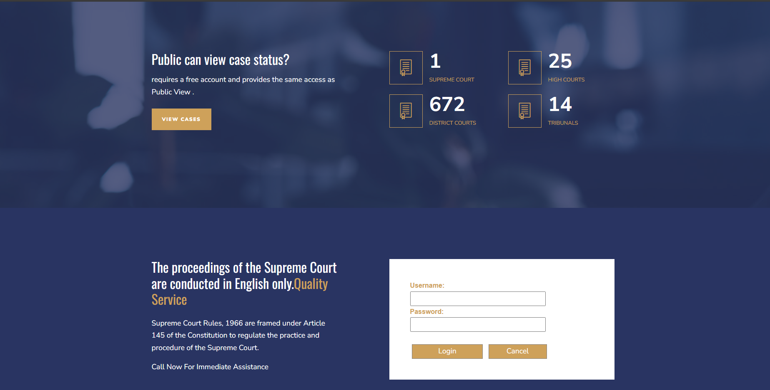

3.2.2 Output Design of User
An inevitable activity in the system design is the proper design of output in a form acceptable to the user. Outputs from the system are required primarily to communicate the result of processing to users. Outputs also provide a permanent copy of the results for later consultation. An intelligible output will improve system relationship with the user and help in the decision making process.
The approach to output design is very dependent on the type of output and nature of data. Special attention has to be made to data editing. The choice of appropriate output medium is also an important task. The selection may be affected by the following kinds of consideration:

- Response time.
- Location of users.
- Cost.
- Software/hardware.
- Suitability of the device for application concerned.
The output design must be specified and documented, data items have to be accurately defined and arranged for clarity and easy comprehension.
Court officer interface
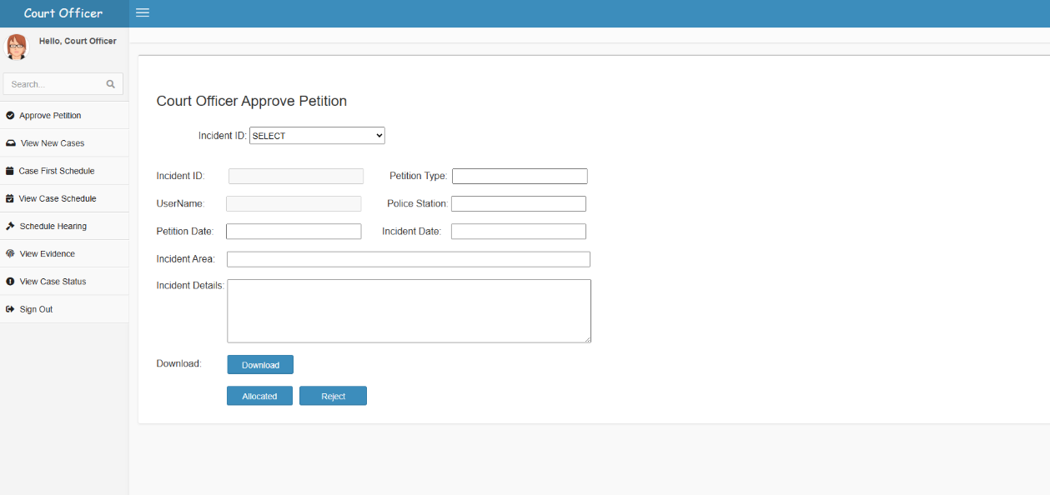

3.3 DATABASE DESIGN
The overall objective in the development of database technology has been to treat data as an organizational resource and as an integrated whole. DBMS allow data to be protected and organized separately from other resources. Database is an integrated collection of data. The most significant form of data as seen by the programmers is data as stored on the direct access storage devices. This is the difference between logical and physical data.
Database files are the key source of information into the system. It is the process of designing database files, which are the key source of information to the system. The files should be properly designed and planned for collection, accumulation, editing and retrieving the required information. The organization of data in database aims to achieve three major objectives:

- Data integration.
- Data integrity.
- Data independence.

The proposed system stores the information relevant for processing in the MongoDB database. MongoDB is an open-source NoSQL database management program. NoSQL is used as an alternative to traditional relational databases. NoSQL databases are quite useful for working with large sets of distributed data. The NoSQL DBMS uses a single master architecture for data consistency, with secondary databases that maintain copies of the primary database. Operations are automatically replicated to those secondary databases for automatic failover. MongoDB makes use of records which are made up of documents that contain a data structure composed of field and value pairs. Documents are the basic unit of data in MongoDB. The documents are similar to JavaScript Object Notation, but use a variant called Binary JSON (BSON). The benefit of using BSON is that it accommodates more data types. The fields in these documents are similar to the columns in a relational database. Values contained can be a variety of data types, including other documents, arrays and arrays of documents. Documents will also incorporate a primary key as a unique identifier. Sets of documents are called collections, which function as the equivalent of relational database tables. Collections can contain any type of data, but the restriction is the data in a collection cannot be spread across different databases.

Normalization
Normalization is a technique of separating redundant fields and braking up a large table in to a smaller one. It is also used to avoid insertion, deletion and updating anomalies. The table has been normalized up to the third normal form. It is the process of structuring a relational database in accordance with a series of so-called normal forms in order to reduce data redundancy and improve data integrity. Normalization entails organizing the columns
(attributes) and tables (relations) of a database to ensure that their dependencies are properly enforced by database integrity constraints. It is accomplished by applying some formal rules either by a process of synthesis (creating a new database design) or decomposition (improving an existing database design). In short, the rules for each of the five normal forms are as follows: -
• First normal form
A relation is said to be in 1NF if all the under lying domain of attributes contain simple individual values.
- Second normal form
The 2NF is based on the concept of full functional dependency. A relation said to be in 2NF if and only if it is in 1NF and every non-key attribute is fully functionally dependent on candidate key of the table.
- Third normal form
The 3NF is based on the concept of transitive dependency. A relation in 2NF is said to be in 3NF if every non-key attribute is non-transitively dependent on candidate key of the table. Our project is in the second normal form because every non key attribute is fully functionally dependent on primary key. A relation is in third normal form, if there is no transitive dependency for non-prime attributes as well as it is in second normal form.
- Boyce Codd normal form (BCNF)
BCNF is the advance version of 3NF. It is stricter than 3NF. A table is in BCNF if every functional dependency X → Y, X is the super key of the table. For BCNF, the table should be in 3NF, and for every FD, LHS is super key.
- Fourth normal form (4NF)
A relation will be in 4NF if it is in Boyce Codd normal form and has no multi-valued dependency. For a dependency A → B, if for a single value of A, multiple values of B exist, then the relation will be a multi-valued dependency.
• Fifth normal form (5NF)
A relation is in 5NF if it is in 4NF and not contains any join dependency and joining should be lossless. 5NF is satisfied when all the tables are broken into as many tables as possible in order to avoid redundancy. 5NF is also known as Project-join normal form (PJ/NF).
Our database us in 2NF.

3.3.1 Table Design
Advocate
Field Name | Datatype | Constraint
adid | int | PRIMARY KEY
adcode | Varchar(50) | NOT NULL
name | Varchar(50) | NOT NULL
adtype | Varchar(50) | NOT NULL
dob | Varchar(50) | NOT NULL
address | Varchar(MAX) | NOT NULL
Phone | Varchar(50) | NOT NULL
email | Varchar(50) | NOT NULL
gender | Varchar(50) | NOT NULL
username | Varchar(50) | NOT NULL
pwd | Varchar(50) | NOT NULL
certificate | Varchar(MAX) | NOT NULL
status | int | NOT NULL
aphoto | Varchar(MAX) | NOT NULL

Case details
Field Name | Datatype | Constraint
caseid | int | PRIMARY KEY
casetype | Varchar(50) | NOT NULL
ipcsection | Varchar(50) | NOT NULL
firno | Varchar(50) | NOT NULL
casedate | Varchar(50) | NOT NULL
firdate | Varchar(50) | NOT NULL
Fir | Varchar(MAX) | NOT NULL
incidate | Varchar(50) | NOT NULL
inilocation | Varchar(50) | NOT NULL
puname | Varchar(50) | NOT NULL
petuname | Varchar(50) | NOT NULL
respuname | Varchar(50) | NOT NULL
petadvuname | Varchar(50) | NOT NULL
resadvuname | Varchar(50) | NOT NULL
uploaddetails | Varchar(50) | NOT NULL
status | int | NOT NULL
petid | int | NOT NULL

Evidence
Field Name | Datatype | Constraint
evid | int | PRIMARY KEY
caseid | int | NOT NULL
firno | Varchar(50) | NOT NULL
petuname | Varchar(50) | NOT NULL
petadvuname | Varchar(50) | NOT NULL
evtype | Varchar(50) | NOT NULL
evdetails | Varchar(MAX) | NOT NULL
evupload | Varchar(MAX) | NOT NULL
evdate | Varchar(50) | NOT NULL
status | int | NOT NULL

Hearing
Field Name | Datatype | Constraint
Hid | int | PRIMARY KEY
firno | int | NOT NULL
petuname | Varchar(50) | NOT NULL
petadvuname | Varchar(50) | NOT NULL
respuname | Varchar(50) | NOT NULL
respadvuname | Varchar(50) | NOT NULL
heardate | Varchar(MAX) | NOT NULL
heartype | Varchar(MAX) | NOT NULL
details | Varchar(50) | NOT NULL
status | int | NOT NULL
cstatus | Varchar(50) | NOT NULL

Judge
Field Name | Datatype | Constraint
jd | int | PRIMARY KEY
jcode | Varchar(50) | NOT NULL
name | Varchar(50) | NOT NULL
ctype | Varchar(50) | NOT NULL
dob | Varchar(50) | NOT NULL
address | Varchar(MAX) | NOT NULL
phone | Varchar(50) | NOT NULL
email | Varchar(50) | NOT NULL
gender | Varchar(50) | NOT NULL
username | Varchar(50) | NOT NULL
pwd | Varchar(50) | NOT NULL
location | Varchar(50) | NOT NULL
status | int | NOT NULL

Login
Field Name | Datatype | Constraint
lid | int | PRIMARY KEY
username | Varchar(50) | NOT NULL
pwd | Varchar(50) | NOT NULL
status | int | NOT NULL

Maildetails
Field Name | Datatype | Constraint
Mid | int | PRIMARY KEY
mdate | Varchar(50) | NOT NULL
mform | Varchar(50) | NOT NULL
mto | Varchar(50) | NOT NULL
subject | Varchar(50) | NOT NULL
attachment | Varchar(MAX) | NOT NULL
message | Varchar(MAX) | NOT NULL
status | int | NOT NULL

Petition
Field Name | Datatype | Constraint
petitionid | int | PRIMARY KEY
puname | Varchar(50) | NOT NULL
pdate | Varchar(50) | NOT NULL
ptype | Varchar(50) | NOT NULL
pdetails | Varchar(MAX) | NOT NULL
indate | Varchar(50) | NOT NULL
inlocation | Varchar(50) | NOT NULL
pstation | Varchar(50) | NOT NULL
documents | Varchar(MAX) | NOT NULL
status | int | NOT NULL
aduname | Varchar(50) | NOT NULL

Petitioner
Field Name | Datatype | Constraint
petitionid | int | PRIMARY KEY
puname | Varchar(50) | NOT NULL
pdate | Varchar(50) | NOT NULL
pdetails | Varchar(50) | NOT NULL
indate | Varchar(50) | NOT NULL
inlocation | Varchar(50) | NOT NULL
pstation | Varchar(50) | NOT NULL
documents | Varchar(MAX) | NOT NULL
status | int | NOT NULL
aduname | Varchar(50) | NOT NULL

Police
Field Name | Datatype | Constraint
pid | int | PRIMARY KEY
pcode | Varchar(50) | NOT NULL
name | Varchar(50) | NOT NULL
dob | Varchar(50) | NOT NULL
address | Varchar(50) | NOT NULL
phone | Varchar(50) | NOT NULL
email | Varchar(50) | NOT NULL
gender | Varchar(50) | NOT NULL
username | Varchar(50) | NOT NULL
pwd | Varchar(50) | NOT NULL
certificate | Varchar(MAX) | NOT NULL
status | int | NOT NULL

3.3.2 Data Dictionary
Data Dictionary is the major component in the structured analysis model of the system. It lists all the data items appearing in DFD. A data dictionary is a file or a set of files that includes a database’s metadata (hold records about other objects in the database), like data ownership, relationships of the data to another object, and some other data.

Sl No | Field Name | Description | Data Type | Constraints
1 | adid | Id of advocate | int | Primary Key
2 | adcode | Advocate code | Varchar(50) | Not Null
3 | name | Name of the advocate | Varchar(50) | Not Null
4 | adtype | Case type of advocate | Varchar(50) | Not Null
5 | dob | Date of birth of advocate | Varchar(50) | Not Null
6 | address | Address of advocate | Varchar(50) | Not Null
7 | phone | Phone number of advocate | Varchar(50) | Not Null
8 | email | Email of advocate | Varchar(50) | Not Null
9 | gender | Gender of advocate | Varchar(50) | Not Null
10 | username | Username of advocate | Varchar(50) | Not Null
11 | pwd | Password of advocate | Varchar(50) | Not Null
12 | certificate | License certificate | Varchar(50) | Not Null
13 | status | Status of advocate approval | Varchar(50) | Not Null
14 | aphoto | Photo of advocate | Varchar(50) | Not Null
15 | caseid | ID of case | int | Primary Key
16 | casetype | Type of case | Varchar(50) | Not Null
17 | ipcsection | IPC section assigned | Varchar(MAX) | Not Null
18 | firno | FIR number | Varchar(50) | Not Null
19 | casedate | Date of case | Varchar(50) | Not Null
20 | firdate | Date of FIR | Varchar(50) | Not Null
21 | fir | FIR details | Varchar(50) | Not Null
22 | incidate | Date of incidence | Varchar(50) | Not Null
23 | inilocation | Location of incidence | Varchar(50) | Not Null
24 | puname | Username of police username | Varchar(50) | Not Null
25 | petuname | Username of petitioner | Varchar(50) | Not Null
26 | respuname | Respondent username | int | Not Null
27 | petadvuname | Name of petitioner’s advocate | int | Not Null
28 | resadvuname | Name of respondent’s advocate | Varchar(50) | Not Null
29 | uploaddetails | Details of upload | Varchar(50) | Not Null
30 | status | Status of case | Varchar(MAX) | Not Null
31 | petid | Id of petitioner | Varchar(50) | Not Null
32 | evid | ID of evidence | int | Primary Key
33 | evtype | Type of evidence | Varchar(50) | Not Null
34 | evdetails | Details of evidence | Varchar(Max) | Not Null
35 | evupload | Uploaded evidence | Varchar(Max) | Not Null
34 | evdate | Date of evidence | Varchar(50) | Not Null
35 | Status | Status of evidence | int | Not Null
36 | hid | ID of hearing | int | Primary Key
37 | heardate | Date of hearing | Varchar(Max) | Not Null
38 | heartype | Type of hearing | Varchar(Max) | Not Null
39 | details | Details of hearing | Varchar(50) | Not Null
40 | status | Status of hearing | int | Not Null
41 | cstatus | Whether case is active/closed | Varchar(50) | Not Null
42 | jid | ID of court officcer | int | Primary Key
43 | jcode | Court officer code | Varchar(50) | Not Null
44 | name | Name of court officer | Varchar(50) | Not Null
45 | ctype | Court type | Varchar(50) | Not Null
46 | dob | Date of birth of court officer | Varchar(50) | Not Null
47 | address | Address of court officer | Varchar(50) | Not Null
48 | phone | Phone number of court officer | Varchar(50) | Not Null
49 | lid | Login ID | int | Primary Key
50 | username | Username of various users | Varchar(50) | Not Null
51 | pwd | Password of various users | Varchar(50) | Not Null
52 | status | Status of login | int | Not Null
53 | mid | Mail ID | int | Primary Key
54 | madate | Date of mail | Varchar(50) | Not Null
55 | mfrom | From address of mail | Varchar(50) | Not Null
56 | mto | To address of mail | Varchar(50) | Not Null
57 | subject | Subject of mail | Varchar(50) | Not Null
58 | attachment | File attachments in mail | Varchar(Max) | Not Null
59 | message | Message in mail | Varchar(Max) | Not Null
59 | status | Status of mail | int | Not Null
60 | petitionid | ID of petition | int | Primary Key
61 | pdate | Date of petition | Varchar(50) | Not Null
62 | ptype | Type of petition | Varchar(50) | Not Null
63 | pdetails | Details of pettion | Varchar(50) | Not Null
64 | indate | Date of incident | Varchar(50) | Not Null
65 | inlocation | Location of incident | Varchar(50) | Not Null
66 | pstation | Police station | Varchar(50) | Not Null
67 | documents | Documents of petition | Varchar(50) | Not Null
68 | status | Status of petition | int | Not Null
69 | aduname | Username of advocate | Varchar(50) | Not Null
70 | pid | ID if police | int | Primary Key
71 | pcode | Police code | Varchar(50) | Not Null
72 | name | Name | Varchar(50) | Not Null
73 | dob | Date of birth of police officer | Varchar(50) | Not Null
74 | address | Address of police offficer | Varchar(50) | Not Null
75 | phone | Phone number of police station | Varchar(50) | Not Null
76 | email | Email of Police officer | Varchar(50) | Not Null
77 | gender | Gender of Police officer | Varchar(50) | Not Null
78 | username | Username of police officer | Varchar(50) | Not Null
79 | pwd | Password of login | Varchar(50) | Not Null
80 | certificate | License certificate | Varchar(Max) | Not Null

3.4 MODELLING
3.4.1 Data flow diagram (DFD)
A data flow diagram (DFD) is a graphical representation of the "flow" of data through an information system, modeling its process aspects. A DFD is often used as a preliminary step to create an overview of the system, which can later be elaborated. DFDs can also be used for the visualization of data processing (structured design). A DFD shows what kind of information will be input to and output from the system, where the data will come from and go to, and where the data will be stored. It does not show information about the timing of process or information about whether processes will operate in sequence or in parallel.

Data Flow Diagram Notations
Function:


File/Database:
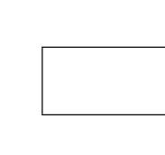
Input/output

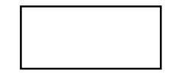
Flow of direction

DATA FLOW DIAGRAM

LEVEL-0/CONTEXT LEVEL

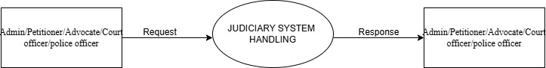

LEVEL-1

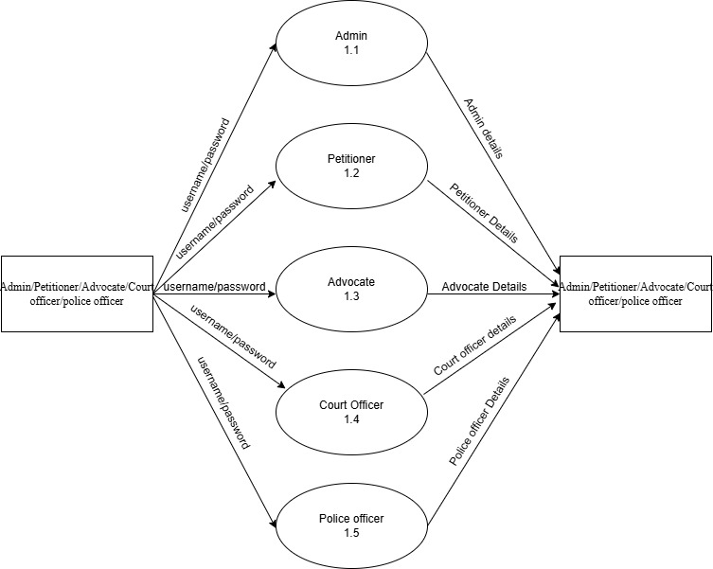

LEVEL -1.1 OF ADMIN

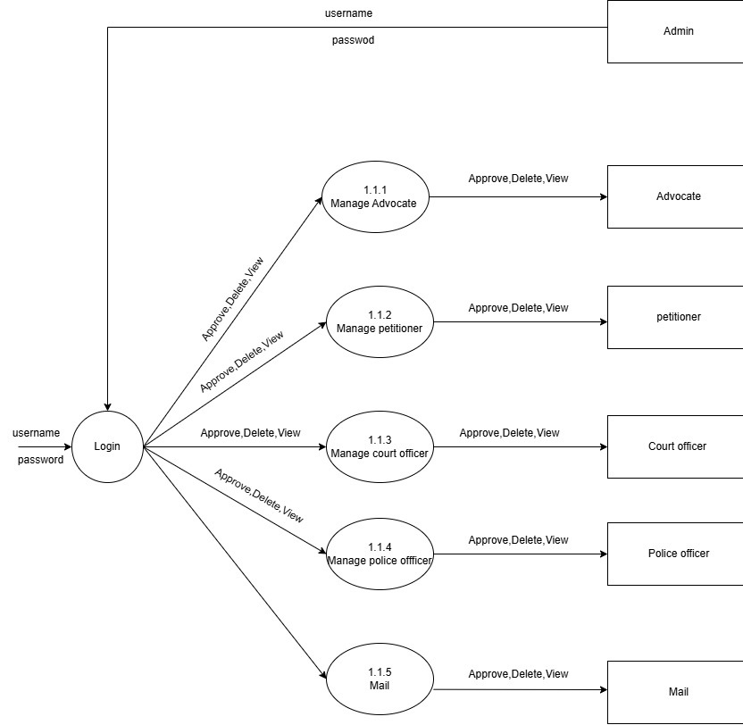

LEVEL -1.2 OF PETITIONER
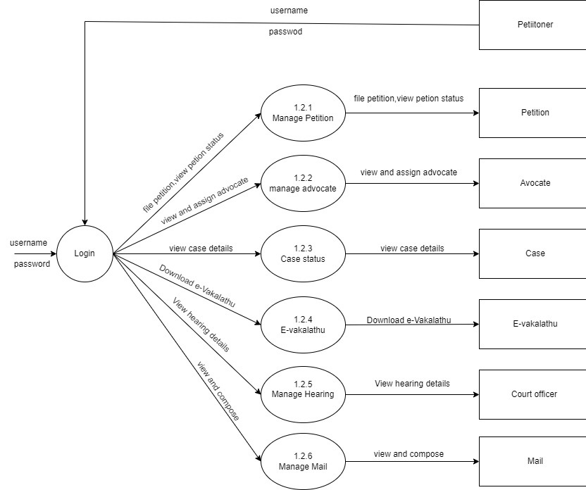

LEVEL-1.3 OF ADVOCATE

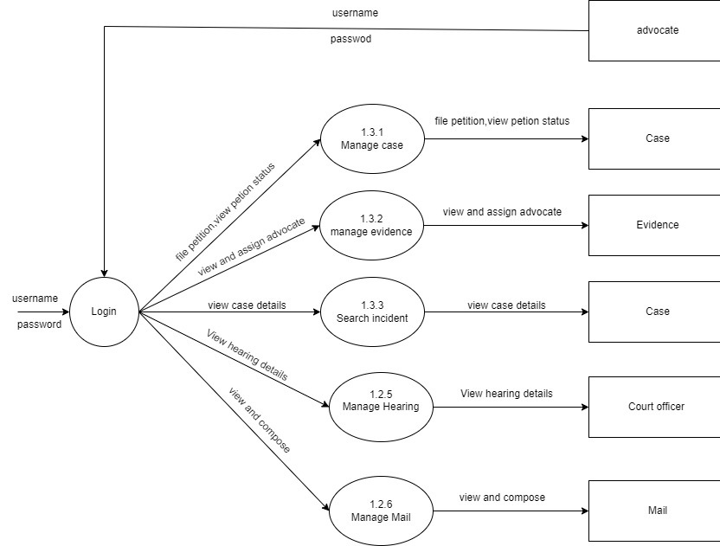

LEVEL -1.4 OF COURT OFFICER

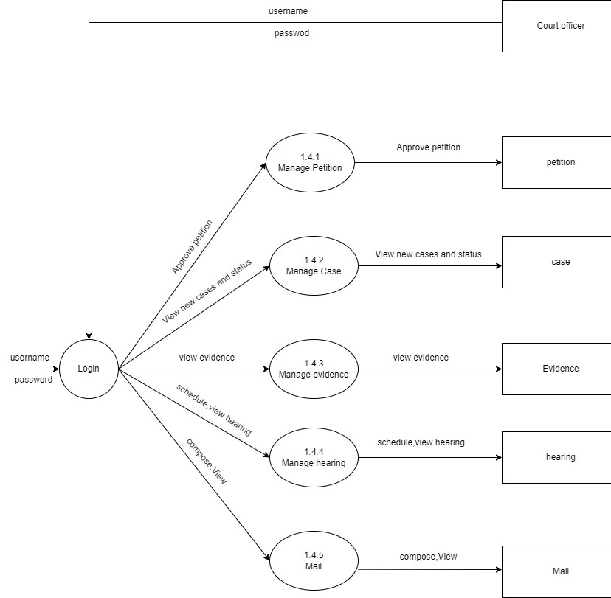

LEVEL 1.5 OF POLICE OFFICER

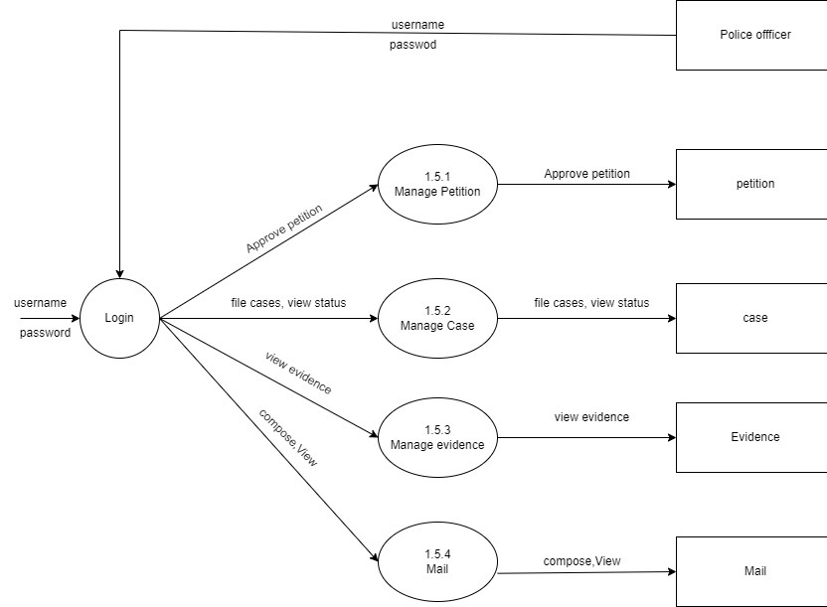

3.4.2 Entity relationship model
An entity relationship diagram is a specialized graphic that illustrates the inter-relationship between entities in a database. ER diagrams often use symbols to represent three different types of information. Boxes are commonly used to represent entities. Diamonds are normally used to represent relationships and ovals are used to represent attributes. An entity– relationship model is the result of using a systematic process to describe and define a subject area of business data. It does not define business process; only visualize business data. The data is represented as components (entities) that are linked with each other by relationships that express the dependencies and requirements between them, such as: one building may be divided into zero or more apartments, but one apartment can only be located in one building. Entities may have various properties (attributes) that characterize them. Diagrams created to represent these entities, attributes, and relationships graphically are called entity–relationship diagrams.
Symbols used in ER diagram: -

Entity:

Attributes:
Relationship:
Lines:

PROCESSING ENVIRONMENT

4.1 HARDWARE SPECIFICATIONS

Intel core i5 Processor
An Intel Core i5 is a powerful processor for consumer-end computers and devices. It offers excellent performance and is equipped with Intel Turbo Boost Technology, similar to the Core i7. The Core i5 is available in various versions, ranging from dual-core to hexa-core, allowing for efficient multitasking. It can handle up to 6 threads simultaneously. The processor clock speed of the Core i5 ranges from 1.60 GHz to 4.90 GHz, with cache memory varying from 4 to 12 MB. The thermal design power (TDP) of the Core i5 can range from 15 watts to 125 watts. The Core i5 is well-suited for multitasking, moderate media editing, gaming, and other demanding tasks. It provides a balance between performance and affordability for users.

Processor speed
With technology advancements, increasing productivity goals, faster internet speeds, and the proliferation of devices, the need for speed has become a crucial aspect of our daily lives. We have become accustomed to instant results and expect our devices to keep up with our multitasking demands. When it comes to high-performance technology, computer processors and their clock speed are key factors we consider. The speed of a computer processor, also known as CPU speed, plays a vital role in determining the performance of a computer. The CPU is often referred to as the "brain" of the computer, and its proper functioning is essential for the longevity and functionality of the system. To understand what constitutes a good processor speed, it is important to grasp the role of the processor and how its components enhance the overall functionality of the computer.

RAM
RAM (Random Access Memory) is the hardware in a computing device where the operating system (OS), application programs and data in current use are kept so they can be quickly reached by the device's processor. RAM is the main memory in a computer. This memory stores a temporary data. Temporary data means as long as your computer system is running, your data is stored in RAM and as soon as your computer is shut down, the data stored in RAM gets deleted. RAM is volatile in nature, which means, the data is lost when the device is switched off. RAM is known as the Primary memory of the computer. RAM is known to be expensive since the memory can be accessed directly. RAM is the fastest memory; therefore, it is an internal memory for the computer.

Hard Disk Capacity
A computer hard disk drive (HDD) is a non-volatile data storage device. Non-volatile refers to storage devices that maintain stored data when turned off. All computers need a storage device, and Hard Disk Drive are just one example of a type of storage device. HDD are usually installed inside desktop computers, mobile devices, consumer electronics and enterprise storage arrays in data centres. They can store operating systems, software programs and other files using magnetic disks.

Keyboard
A multimedia keyboard is one with media keys — additional buttons, typically along the top, for controlling audio playback, for starting common applications (e.g., e-mail client and Web browser) and other auxiliary functionality. Many such keyboards also contain a volume knob, implemented as a rotary encoder so as to be able to provide relative volume changes regardless of the volume level set by the user in the operating system and application software.

Mouse
A mouse is a small device that a computer user pushes across a desk surface in order to point to a place on a display screen and to select one or more actions to take from that position. The mouse first became a widely-used computer tool when Apple Computer made it a standard part of the Apple Macintosh.

USB
USB 2.0, also known as hi-speed USB was introduced in 2000. It is an updated version of USB 1.1, which provides improved functionalities and better speed. It is capable to deliver the maximum transfer speed of 480 Megabits per second. However, practically it is approximately 280 Mbps. USB 3.0, also known as SuperSpeed USB was first made available in November 2009. It is a much-improved version of USB 2.0. It supports the data transfer rate of 5 Gigabits per second, which is much faster than the speed provided by USB 2.0.

4.2 SOFTWARE SPECIFICATIONS

Windows 11
Windows 11 is the latest major release of Microsoft’s Windows NT operating system, released in October 2021. It is a free upgrade to its predecessor, Windows 10 (2015), available for any Windows 10 devices that meet the new Windows 11 system requirements. Windows 11. A version of the Windows NT operating system.
The Microsoft .NET Framework 4.0
The Microsoft .NET Framework 4.0, released in April 2010, marked a significant advancement in the evolution of Microsoft's development platform. This iteration introduced numerous enhancements and features aimed at improving developer productivity, application performance, and security. One of the key highlights of the .NET Framework 4.0 was the introduction of the Task Parallel Library (TPL) and Parallel LINQ (PLINQ), which revolutionized parallel programming by simplifying the process of writing multithreaded and parallelizable code. This allowed developers to leverage the power of modern multicore processors more effectively, resulting in faster and more scalable applications. Additionally, .NET Framework 4.0 introduced improvements to the Common Language Runtime (CLR), including background garbage collection, which helped optimize memory management and enhance application responsiveness. Other notable features included enhancements to Windows Communication Foundation (WCF), Windows Presentation Foundation (WPF), and ASP.NET, providing developers with more robust tools and frameworks for building modern and feature-rich applications across a variety of platforms and devices. With its comprehensive set of features and improvements, the Microsoft .NET Framework 4.0 continued to solidify its position as a leading development platform for building secure, reliable, and high-performance software solutions

ASP.NET
ASP.NET, developed by Microsoft, is a versatile and powerful framework for building dynamic and scalable web applications and services. Introduced in the early 2000s, ASP.NET has evolved into a comprehensive platform that empowers developers to create robust web solutions using C#, VB.NET, or any other .NET-supported language. With its Model-ViewController (MVC) architecture and Web Forms model, ASP.NET offers flexibility in application development, catering to various project requirements and developer preferences. Its rich set of built-in features, such as authentication and authorization, session management, and caching, streamline development workflows and enhance application security and performance. Moreover, ASP.NET integrates seamlessly with other Microsoft technologies, including Azure for cloud hosting and SQL Server for database management, providing a cohesive ecosystem for end-to-end application development and deployment. With its extensive documentation, vibrant community, and continuous updates, ASP.NET remains a preferred choice for developers seeking to build scalable, enterprise-grade web applications.
C#.NET
C# .NET is a versatile and powerful programming framework developed by Microsoft. Launched in the early 2000s, it combines the robustness of the C# language with the extensive libraries and tools of the .NET platform. C# .NET is used for developing a wide range of applications, from web and desktop applications to mobile and cloud-based solutions. Known for its object-oriented approach, strong type safety, and seamless integration with the Microsoft ecosystem, C# .NET offers developers a productive environment for creating high-performance applications. With features such as garbage collection, just-in-time compilation, and built-in security, C# .NET helps developers build scalable and secure applications. The framework is supported by a comprehensive set of libraries and tools, including Visual Studio, making it an ideal choice for building enterprise-grade solutions and cross-platform applications, especially when integrated with Azure cloud services and other Microsoft technologies.

MSSQL
Microsoft SQL Server (MSSQL) is a powerful relational database management system developed by Microsoft. Launched in the 1980s, MSSQL has evolved into a robust platform that supports various data management tasks, from storing and retrieving data to performing complex analytics and reporting. Known for its scalability, reliability, and performance, MSSQL caters to a wide range of applications, from small businesses to large enterprises. With features such as transaction management, advanced security mechanisms, and built-in business intelligence tools, MSSQL offers developers and database administrators a comprehensive solution for managing and optimizing data. Furthermore, MSSQL seamlessly integrates with other Microsoft products and technologies, including .NET Framework, Visual Studio, and Azure cloud services, providing a unified ecosystem for developing, deploying, and managing database-driven applications.

VISUAL STUDIO 2022
Visual Studio 2022 is an integrated development environment (IDE) developed by Microsoft for creating a wide range of applications. Released as the latest version in the Visual Studio series, it provides developers with a rich set of tools and features for building, testing, and deploying applications across multiple platforms, including Windows, web, mobile, and cloud. Known for its intuitive user interface, robust debugging capabilities, and powerful code editing tools, Visual Studio 2022 enhances developer productivity. It includes advanced features such as IntelliCode, live share collaboration, Git integration, and support for .NET, C++, Python, and other programming languages. Visual Studio 2022 is designed for performance and scalability, enabling developers to work efficiently on both small projects and large, complex enterprise applications. With its seamless integration with Microsoft Azure and other cloud services, Visual Studio 2022 offers a comprehensive, modern development environment for building, testing, and managing applications throughout their lifecycle.

CODING AND IMPLEMENTATION

Admin Homepage(AdminHome1)

<%@ Page Title="" Language="C#" MasterPageFile="~/AdminMasterPage.master" AutoEventWireup="true" CodeFile="AdminHome1.aspx.cs" Inherits="AdminHome1" %>

<asp:Content ID="Content1" ContentPlaceHolderID="head" Runat="Server">
<link href="https://cdnjs.cloudflare.com/ajax/libs/font-awesome/6.0.0-beta3/css/all.min.css" rel="stylesheet">

</asp:Content>
<asp:Content ID="Content2" ContentPlaceHolderID="ContentPlaceHolder1" Runat="Server">
<section class="content">

<!-- Small boxes (Stat box) -->
<div class="row">
<div class="col-lg-3 col-xs-6">
<!-- small box -->
<div class="small-box bg-aqua">
<div class="inner">
<h3>
<asp:Label ID="Label1" runat="server" Text="Label"></asp:Label>
</h3>
<p>
Total Cases
</p>
</div>
<div class="icon">
<img src="img/113.png" width="78" height="83" style="margin-top:10px ; margin-right:18px">
<%-- <i class="ion ion-bag"></i>--%>
</div>
<%--<a href="#" class="small-box-footer">
More info <i class="fa fa-arrow-circle-right"></i>
</a>--%>
</div>
</div><!-- ./col -->
<div class="col-lg-3 col-xs-6">
<!-- small box -->
<div class="small-box bg-green">
<div class="inner">
<h3>
<asp:Label ID="Label4" runat="server" Text="Label"></asp:Label> <sup style="font-size: 20px"></sup>
</h3>
<p>
Total Advocates
</p>
</div
<div class="icon">
<img src="img/222.png" width="105" height="105" style="margin-top:10px">
<%-- <i class="fas fa-camera fa-xs"></i>--%>
</div>
<%--<a href="#" class="small-box-footer">
More info <i class="fa fa-arrow-circle-right"></i>
</a>--%>
</div>
</div><!-- ./col -->
<div class="col-lg-3 col-xs-6">
<!-- small box -->
<div class="small-box bg-yellow">
<div class="inner">
<h3>
<asp:Label ID="Label2" runat="server" Text="Label"></asp:Label>
</h3>
<p>
User Petition
</p>
</div>
<div class="icon">
<img src="img/456.png" width="105" height="110">
<%--<i class="ion ion-person-add"></i>--%>
</div>
<%-- <a href="#" class="small-box-footer">
More info <i class="fa fa-arrow-circle-right"></i>
</a>--%>
</div>
</div>
<!-- ./col -->
<div class="col-lg-3 col-xs-6">
<!-- small box -->
<div class="small-box bg-red">
<div class="inner">
<h3>
<asp:Label ID="Label3" runat="server" Text="Label"></asp:Label>
</h3>
<p>
Total Hearings
</p>
</div>
<div class="icon">
<img src="img/123.png" width="85" height="90" style="margin-top:10px ; margin-right:5px" >
<%--<i class="fas fa-envelope fa-sm"></i>--%>
</div>
<%-- <a href="#" class="small-box-footer">
More info <i class="fa fa-arrow-circle-right"></i>
</a>--%>
</div>
</div><!-- ./col -->
</div><!-- /.row -->
</section><!-- /.content -->
</asp:Content>

Advocate Homepage(AdvocateHome1.aspx)

<%@ Page Title="Page Title" Language="C#" MasterPageFile="~/AdvocateMasterPage.master" AutoEventWireup="true" CodeFile="AdvocateHomepage1.aspx.cs" Inherits="AdvocateHomepage1" %>

<asp:Content ID="Content1" ContentPlaceHolderID="head" Runat="Server">
<link href="https://cdnjs.cloudflare.com/ajax/libs/font-awesome/6.0.0-beta3/css/all.min.css" rel="stylesheet">
</asp:Content>
<asp:Content ID="Content2" ContentPlaceHolderID="ContentPlaceHolder1" Runat="Server">
<section class="content">
<div class="row">
<div class="col-xs-12">
<div class="box">
<div class="box-header">
<h3 class="box-title">Advocate Details</h3>
</div><!-- /.box-header -->

<div class="box-body table-responsive">
<div>

<asp:DataList ID="DataList1" runat="server" Font-Names="Verdana" Font-Size="Small" GridLines="Both" Width="600px">

<%-- <FooterStyle BackColor="#F7DFB5" ForeColor="#8C4510" />--%>

<%--<HeaderStyle BackColor="#333333" Font-Bold="True" Font-Size="Large" ForeColor="White" HorizontalAlign="Center" VerticalAlign="Middle" />--%>

<%-- <HeaderTemplate>

Hospital Details</HeaderTemplate>
--%>
<ItemStyle BackColor="White" ForeColor="Black" Font-Names="Verdana" Font-Size="Small" />

<ItemTemplate>

<%-- <asp:Image ID="imgEmp" runat="server" Width="200px" Height="200px" ImageUrl='<%# Bind("uphoto") %>' style="padding-left:40px"/><br />
<br />
<br />--%>
<div style="margin-left: 10px; margin-top: 10px">
<b>Advocate ID:</b>

<asp:Label ID="Label5" runat="server" Text='<%# Bind("adid") %>' ></asp:Label>

</div>
<br />

<div style="margin-left: 10px;">
<b>Advocate Code:</b>

<asp:Label ID="Label11" runat="server" Text='<%# Bind("adcode") %>' ></asp:Label>

</div>
<br />

<div style="margin-left: 10px;">
<b>Advocate Name:</b>

<asp:Label ID="lblCName" runat="server" Text='<%# Bind("name") %>' ></asp:Label>
</div>
<br />
<div style="margin-left: 10px;">
<b>Specialization:</b>

<asp:Label ID="Label3" runat="server" Text='<%# Bind("adtype") %>' ></asp:Label>
</div>
<br />
<div style="margin-left: 10px;">
<b>Gender:</b>
<asp:Label ID="lblName" runat="server" Text='<%# Bind("gender") %>'></asp:Label>
</div>
<br />
<div style="margin-left: 10px;">
<b> Date of Birth:</b>
<asp:Label ID="lblCity" runat="server" Text=' <%# Bind("dob") %>'></asp:Label>
</div>
<br />
<div style="margin-left: 10px;">
<b>Address:</b>
<asp:Label ID="Label4" runat="server" Text='<%# Bind("address") %>'></asp:Label>
</div>
<br />
<div style="margin-left: 10px;">
<b>Mobile No:</b>
<asp:Label ID="lblCountry" runat="server" Text='<%# Bind("phone") %>'></asp:Label>
</div>
<br />
<div style="margin-left: 10px;">
<b>Email:</b>
<asp:Label ID="Label2" runat="server" Text='<%# Bind("email") %>'></asp:Label>
</div>
<br />
<div style="margin-left: 10px;">
<b>UserName</b>
<asp:Label ID="Label8" runat="server" Text='<%# Bind("username") %>'></asp:Label>
</div>
<br />
</ItemTemplate>
</asp:DataList>
</div>
</div><!-- /.box-body -->
</div><!-- /.box -->
</div>
</div>
</section><!-- /.content -->
</asp:Content>

Home page (Homepage1)

<%@ Page Language="C#" AutoEventWireup="true" CodeFile="HomePage.aspx.cs" Inherits="HomePage" %>

<!DOCTYPE html PUBLIC "-//W3C//DTD XHTML 1.0 Transitional//EN" "http://www.w3.org/TR/xhtml1/DTD/xhtml1-transitional.dtd">

<html xmlns="http://www.w3.org/1999/xhtml">
<head runat="server">
<title>Judicial &mdash; Colorlib Website Template</title>
<meta charset="utf-8">
<meta name="viewport" content="width=device-width, initial-scale=1, shrink-to-fit=no">

<link rel="stylesheet" href="https://fonts.googleapis.com/css?family=Nunito+Sans:200,300,400,700,900|Oswald:400,700">
<link rel="stylesheet" href="fonts/icomoon/style.css">
<link rel="stylesheet" href="css/bootstrap.min.css">
<link rel="stylesheet" href="css/magnific-popup.css">
<link rel="stylesheet" href="css/jquery-ui.css">
<link rel="stylesheet" href="css/owl.carousel.min.css">
<link rel="stylesheet" href="css/owl.theme.default.min.css">
<link rel="stylesheet" href="css/bootstrap-datepicker.css">
<link rel="stylesheet" href="css/mediaelementplayer.css">
<link rel="stylesheet" href="css/animate.css">
<link rel="stylesheet" href="fonts/flaticon/font/flaticon.css">
<link rel="stylesheet" href="css/fl-bigmug-line.css">
<link rel="stylesheet" href="css/aos.css">
<link rel="stylesheet" href="css/style.css">
</head>
<body>
<div class="site-wrap">
<div class="site-navbar mt-4">
<div class="container py-1">
<div class="row align-items-center">
<div class="col-8 col-md-8 col-lg-4">
<h1 class="mb-0"><a href="index.html" class="text-white h2 mb-0"><strong class="text-uppercase">Judicial<span class="text-primary">.</span></strong></a></h1>
</div>
<div class="col-4 col-md-4 col-lg-8">
<nav class="site-navigation text-right text-md-right" role="navigation">
<div class="d-inline-block d-lg-none ml-md-0 mr-auto py-3"><a href="#" class="site-menu-toggle js-menu-toggle text-white"><span class="icon-menu h3"></span></a></div>
<ul class="site-menu js-clone-nav d-none d-lg-block">
<li class="active">
<a href="HomePage.aspx">Home</a>
</li>
<li><a href="AboutUs.aspx">About Us</a></li>
<%--<li><a href="practice.html">Services</a></li>--%>
<%-- <li><a href="case-studies.html">Case Studies</a></li>--%>
<li><a href="ContactUs.aspx">Contact</a></li>
</ul>
</nav>
</div>
</div>
</div>
</div>
</div>
<div class="site-mobile-menu">
<div class="site-mobile-menu-header">
<div class="site-mobile-menu-close mt-3">
<span class="icon-close2 js-menu-toggle"></span>
</div>
</div>
<div class="site-mobile-menu-body"></div>
</div> <!-- .site-mobile-menu -->
<div class="site-blocks-cover overlay" style="background-image: url('images/hero_1.jpg');" data-aos="fade" data-stellar-background-ratio="0.5" data-aos="fade">
<div class="container">
<div class="row align-items-center justify-content-center">
<div class="col-md-8 text-center" data-aos="fade-up" data-aos-delay="400">
<h1 class="mb-4">Fighting For Justice</h1>
<%-- <p class="mb-5">Lorem ipsum dolor sit amet, consectetur adipisicing elit. Praesentium facere officiis in quo, corporis quasi.</p>
<p><a href="#" class="btn btn-primary px-4 py-3">Get Started</a></p>--%>
</div>
</div>
</div>
</div>
<div class="site-section section-1">
<div class="container">
<div class="row">
<div class="col-lg-4 mb-md-4">
<img src="images/img_sq.jpg" alt="Image" class="img-fluid">
</div>
<div class="col-lg-4">
<div class="px-lg-3">
<p class="dropcap">The Indian judicial system follows the common law system based on recorded judicial precedents as inherited from the British colonial legacy. The court system of India comprises the Supreme Court of India, the High Courts and subordinate courts at district, municipal and village levels.</p>
<%-- <p>Lorem ipsum dolor sit amet, consectetur adipisicing elit. Autem a possimus quae quis nam ducimus saepe. Facere est maiores unde magnam, incidunt saepe repellendus. Officia natus possimus inventore eius soluta!</p>--%>
</div>
</div>
<div class="col-lg-4">0
<p>The Indian Judicial system is managed and administrated by officers of judicial service, those intended to fill the post of district judge and other civil judicial posts inferior to district judge. Judges of Subordinate Judiciary are appointed by the governor on recommendation by the High Court!</p>
<%-- <p>Facere est maiores unde magnam, incidunt saepe repellendus. Officia natus possimus inventore eius soluta</p>--%>
<!-- <blockquote class="blockquote">
<p>We're committed to success &amp; genuine provider of all types of legal services</p>
</blockquote> -->
</div>
</div>
</div>
</div>
<div class="section-2">
<div class="container">
<div class="row no-gutters align-items-stretch align-items-center">
<div class="col-lg-3 section-title">
<div class="service-1-title h-100">
<h2 class="text-white">User Registration</h2>
<%-- <p>Lorem ipsum dolor sit consectetur adipisicing elit. Voluptatum dignissimos mollitia vitae accusamus eius doloribus.</p>--%>
<p><a href="#" class="more">View All</a></p>
</div>
</div>
<div class="col-lg-3">
<div class="service-1 first h-100" style="background-image: url('images/img_1.jpg')">
<div class="service-1-contents">
<span class="wrap-icon">
<span class="flaticon-balance"></span>
</span>
<h2>Advocate</h2>
<a href="AdvocateRegistration.aspx">Register Here</a>
<p>An Advocate is a person authorized to appear in a litigation on behalf of a party and who possess a law degree, enrolled with the Bar Council.</p>
</div>
</div>
</div>
<div class="col-lg-3">
<div class="service-1 h-100" style="background-image: url('images/img_2.jpg')">
<div class="service-1-contents">
<span class="wrap-icon">
<span class="flaticon-law"></span>
</span>
<h2>Petitioner</h2>
<a href="PetitionerRegistration.aspx">Register Here</a>
<p>A petitioner is a person who pleads with governmental institution for a legal remedy or a redress of grievances, through use of a petition.</p>
</div>
</div>
</div>
<div class="col-lg-3">
<div class="service-1 h-100" style="background-image: url('images/img_3.jpg')">
<div class="service-1-contents">
<span class="wrap-icon">
<span class="flaticon-courthouse"></span>
</span>
<h2>Police</h2>
<a href="PoliceRegistration.aspx">Register Here</a>
<p>The police are a constituted body of persons empowered by a state, with the aim to enforce the law and to prevent crime and civil disorder.</p>
</div>
</div>
</div>
</div>
</div>
</div>
<div class="site-section section-3">
<div class="container">
<div class="row justify-content-center mb-5">
<div class="col-lg-6 section-title text-center">
<h2>Areas of Expertise</h2>
</div>
</div>
<div class="row">
<div class="col-lg-4 col-md-6 mb-4">
<div class="service-2 d-flex">
<div class="service-2-icon mr-3"><span class="flaticon-law"></span></div>
<div class="service-2-contents">
<h3>Criminal Cases</h3>
<p>Criminal cases involve enforcing public codes of behavior, which are codified in the laws of the state.</p>
</div>
</div>
</div>
<div class="col-lg-4 col-md-6 mb-4">
<div class="service-2 d-flex">
<div class="service-2-icon mr-3"><span class="flaticon-balance"></span></div>
<div class="service-2-contents">
<h3>Guardianship</h3>
<p> who will be responsible for the medical, personal, and financial decisions over an adult who cannot care for themself.</p>
</div>
</div>
</div>
<div class="col-lg-4 col-md-6 mb-4">
<div class="service-2 d-flex">
<div class="service-2-icon mr-3"><span class="flaticon-auction"></span></div>
<div class="service-2-contents">
<h3>Domestic Violence</h3>
<p>ictims of domestic violence can ask the family court to issue protection orders to keep their abuser away.</p>
</div>
</div>
<div class="col-lg-4 col-md-6 mb-4">
<div class="service-2 d-flex">
<div class="service-2-icon mr-3"><span class="flaticon-auction"></span></div>
<div class="service-2-contents">
<h3>Juvenile Matters</h3>
<p>all matters where there are allegations of child abuse or where minors are accused of participating in illegal behavior.</p>
</div>
</div>
</div>
<div class="col-lg-4 col-md-6 mb-4">
<div class="service-2 d-flex">
<div class="service-2-icon mr-3"><span class="flaticon-courthouse"></span></div>
<div class="service-2-contents">
<h3>Rights and Adoptions</h3>
<p>Why a parent should no longer have a parental relationship with a child, the family court may terminate that parent’s rights.</p>
</div>
</div>
</div>
<div class="col-lg-4 col-md-6 mb-4">
<div class="service-2 d-flex">
<div class="service-2-icon mr-3"><span class="flaticon-law"></span></div>
<div class="service-2-contents">
<h3>Underage Marriages</h3>
<p>Those under the age of 18 who wish to marry or want to be “emancipated” can petition the family court for approval.</p>
</div>
</div>
</div>
</div>
</div>
</div>
<div class="site-section section-4" style="background-image: url('images/hero_2.jpg')">
<div class="container">
<div class="row">
<div class="col-lg-5 mr-auto mb-5">
<h2 class="mb-3">Public can view case status?</h2>
<p class="mb-4 d-block">requires a free account and provides the same access as Public View .</p>
<p><a href="#" class="btn btn-primary py-3 px-4">View Cases</a></p>
</div>
<div class="col-lg-6">
<div class="row">
<div class="col-md-6 mb-4">
<div class="feature-1 d-flex">
<span class="feature-1-icon mr-3">
<span class="flaticon-law"></span>
</span>
<div class="feature-1-contents">
<strong class="number">1</strong>
<span class="caption">Supreme court</span>
</div>
</div>
</div>
<div class="col-md-6 mb-4">
<div class="feature-1 d-flex">
<span class="feature-1-icon mr-3">
<span class="flaticon-law"></span>
</span>
<div class="feature-1-contents">
<strong class="number">25</strong>
<span class="caption">High courts</span>
</div>
</div>
</div>

<div class="col-md-6 mb-4">
<div class="feature-1 d-flex">
<span class="feature-1-icon mr-3">
<span class="flaticon-law"></span>
</span>
<div class="feature-1-contents">
<strong class="number">672</strong>
<span class="caption">District courts</span>
</div>
</div>
</div>
<div class="col-md-6 mb-4">
<div class="feature-1 d-flex">
<span class="feature-1-icon mr-3">
<span class="flaticon-law"></span>
</span>
<div class="feature-1-contents">
<strong class="number">14</strong>
<span class="caption">Tribunals</span>
</div>
</div>
</div>
</div>
</div>
</div>
</div>
</div>
<div class="site-section section-5">
<div class="container">
<div class="row">
<div class="col-lg-5 mr-auto">
<h2 class="mb-4">The proceedings of the Supreme Court are conducted in English only.<span class="text-primary">Quality Service</span></h2>
<p> Supreme Court Rules, 1966 are framed under Article 145 of the Constitution to regulate the practice and procedure of the Supreme Court.</p>
<!-- <p>Lorem ipsum dolor sit amet, consectetur adipisicing elit. Aliquid modi porro impedit ea saepe nihil distinctio labore expedita, debitis numquam!</p> -->
<div class="call-now">
<span>Call Now For Immediate Assistance</span>
</div>
</div>
<div class="col-lg-6">
<div class="form-request"
<form id="form2" runat="server">
<asp:Label ID="Label1" runat="server" Text="Username:" Font-Bold="True"
Font-Names="Arial" Font-Size="Medium" ForeColor="#cea15a"></asp:Label><br />
<asp:TextBox ID="TextBox1" runat="server" Height="35px" Width="325px" ></asp:TextBox><br />
<asp:Label ID="Label2" runat="server" Text="Password:" Font-Bold="True"
Font-Names="Arial" Font-Size="Medium" ForeColor="#cea15a"></asp:Label><br />
<asp:TextBox ID="TextBox2" runat="server" Width="325px" Height="35px"
TextMode="Password" ></asp:TextBox>
<br />
<br />
&nbsp;<asp:Button
ID="Button1" runat="server" Height="35px" Text="Login"
style="background-color:#cea15a;border:1px Solid gray;color:white;" onclick="Button1_Click"
Width="170px"/> &nbsp;&nbsp;<asp:Button ID="Button2"
runat="server" Height="35px" Text="Cancel" style="background-color:#cea15a;border:1px Solid gray;color:white;"
Width="140px" onclick="Button2_Click"/>
<br />
<asp:Label ID="Label4" runat="server" Text=""></asp:Label>
</form>
</div>
</div>
</div>
</div>
</div>
<div class="bg-primary" data-aos="fade">
<div class="container">
<div class="row">
<a href="#" class="col-2 text-center py-4 social-icon d-block"><span class="icon-facebook text-white"></span></a>
<a href="#" class="col-2 text-center py-4 social-icon d-block"><span class="icon-twitter text-white"></span></a>
<a href="#" class="col-2 text-center py-4 social-icon d-block"><span class="icon-instagram text-white"></span></a>
<a href="#" class="col-2 text-center py-4 social-icon d-block"><span class="icon-linkedin text-white"></span></a>
<a href="#" class="col-2 text-center py-4 social-icon d-block"><span class="icon-pinterest text-white"></span></a>
<a href="#" class="col-2 text-center py-4 social-icon d-block"><span class="icon-youtube text-white"></span></a>
</div>
</div>
</div>
<div class="row pt-5 mt-5 text-center">
<div class="col-md-12">
<p>
Copyright &copy;<script> document.write(new Date().getFullYear());</script> All rights reserved | This template is made with <i class="icon-heart text-danger" aria-hidden="true"></i>
<!-- Link back to Colorlib can't be removed. Template is licensed under CC BY 3.0. -->
</p>
</div>
</div>
<%-- <footer class="site-footer">
<div class="container">
<div class="row pt-5 mt-5 text-center">
<div class="col-md-12">
<p>
Copyright &copy;<script> document.write(new Date().getFullYear());</script> All rights reserved | This template is made with <i class="icon-heart text-danger" aria-hidden="true"></i> by
<!-- Link back to Colorlib can't be removed. Template is licensed under CC BY 3.0. -->
</p>
</div>
</div>
</div>
</footer>--%>

</div>

<script src="js/jquery-3.3.1.min.js"></script>
<script src="js/jquery-migrate-3.0.1.min.js"></script>
<script src="js/jquery-ui.js"></script>
<script src="js/popper.min.js"></script>
<script src="js/bootstrap.min.js"></script>
<script src="js/owl.carousel.min.js"></script>
<script src="js/mediaelement-and-player.min.js"></script>
<script src="js/jquery.stellar.min.js"></script>
<script src="js/jquery.countdown.min.js"></script>
<script src="js/jquery.magnific-popup.min.js"></script>
<script src="js/bootstrap-datepicker.min.js"></script>
<script src="js/aos.js"></script>
<!-- <script src="js/circleaudioplayer.js"></script> -->
<script src="js/main.js"></script>
<%--<form id="form1" runat="server">
</form>--%>
</body>
</html>

5.2. TESTING
Testing is the process of detecting errors. Testing performs a very critical role for quality assurance and for ensuring the reliability of software. The results of testing are used later on during maintenance also. The aim of testing is often to demonstrate that a program works by showing that it has no errors. The basic purpose of testing phase is to detect the errors that may be present in the program. Hence one should not start testing with the intent of showing that a program works, but the intent should be to show that a program doesn’t work. Testing is the process of executing a program with the intent of finding errors.
5.2.1 Unit Testing
Unit testing plays a critical role in our judicial case handling project, focusing on verifying the functionality of individual components or modules within the platform. Each module within judicial case handling, such as the Admin, petitioner, advocate, court officer, and police officer can be considered as a separate unit for testing. During the development phase, rigorous unit testing is performed to ensure that each module operates correctly and without errors. Inputs received from users, including registration data, product listings, and communication messages, undergo thorough validation to ensure accuracy and compliance with system requirements. By conducting unit testing on individual modules, developers can detect and address errors before they propagate to other parts of the platform. This approach allows for the identification and resolution of any issues arising from interactions between different modules, ensuring smooth and error-free functionality throughout judicial case handling
Black Box Testing: In the black box testing, test cases are designed from the examination of the input/output values only and no knowledge of design or code is required. The main approaches are:
- Equivalent class partitioning
- Boundary value analysis
White Box Testing: White box testing is an important type of unit testing. A large number of white box testing strategies exist. White box testing strategies are:
- Fault based testing
- Coverage Based testing
5.2.2 Integration Testing
Integration testing is a type of software testing in which the different units, modules or components of a software application are tested as a combined entity. However, these modules may be coded by different programmers. The aim of integration testing is to test the interfaces between the modules and expose any defects that may arise when these components are integrated and need to interact with each other.
Types of test cases
Integration test case: Here we execute test cases which just tell about the connectivity from one module to other module and integrating one application to other application and how the application moves from parent node to child no demand vice versa.
Functional Test case: Here we execute test cases which tell about the functionality of the application and talks about the desired output to be seen. Internally we have different type of test cases when we write here like range, output values, BVA, ECP and so on. We give input and expect some output according to the SRS. Here we check individual module completely by checking each and every tab, text box, and buttons and so on.
Non-Functional Test case: Test cases related to user friendliness like font, image, color, how easy to navigate etc., performance related, security related comes under here.
User Acceptance test case: These test cases are crucial and very important to client-side people, because these test case talks about these business and approach of the application to complete a particular client task, which is also called as End to End Business scenario test case.
Here we won’t be doing testing related to UI, Functional or Non-Functional, we talk about business and scenario for which the application is made for.
5.2.3 System Testing
Here the entire software system is tested. The reference document for this process is the requirements document, and the goal is to see if software meets its requirements. The entire software has been tested against requirements of project and it is checked whether all requirements of project have been satisfied or not.
Alpha Test: The first test of newly developed, when the first round of bugs has been fixed, the product goes with actual users for testing. For custom software the customer may be invited into the vendor's facilities for an alpha test to ensure the client's vision has been interpreted properly by the developer.
Beta Test: A test of new or revised software application that is performed by users at their facilities under normal operating conditions. Beta testing follows alpha testing. Vendors of packaged software often offer their customers the opportunity of beta testing new releases or versions and the beta testing of elaborate products such as operating systems can take months.
Acceptance testing: Testing is performed by the Client of the application to determine whether the application is developed as per the requirements specified by him/her. It is performed within the development of the organization or at the client site.
In our project the developer uses unit testing to ensure the overall working of the system.

