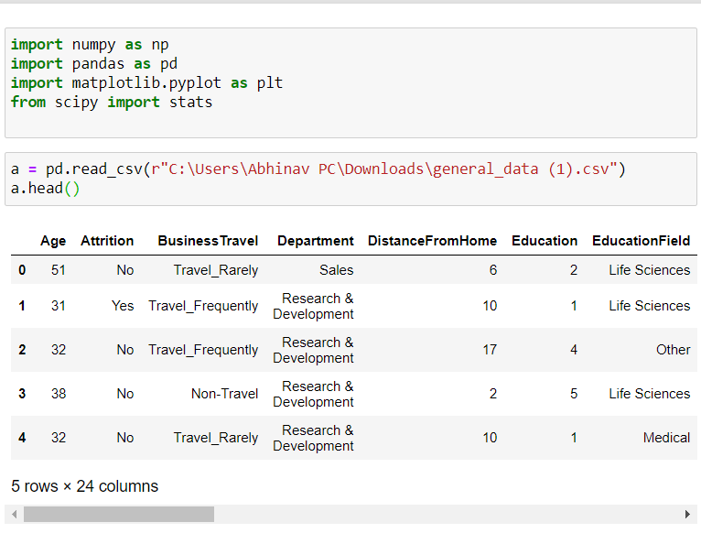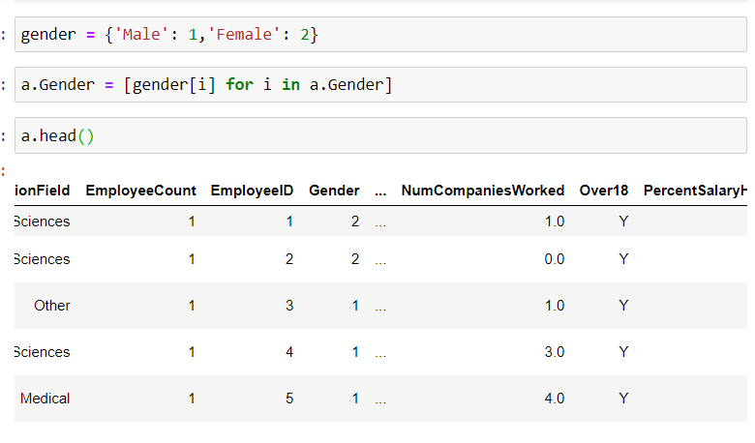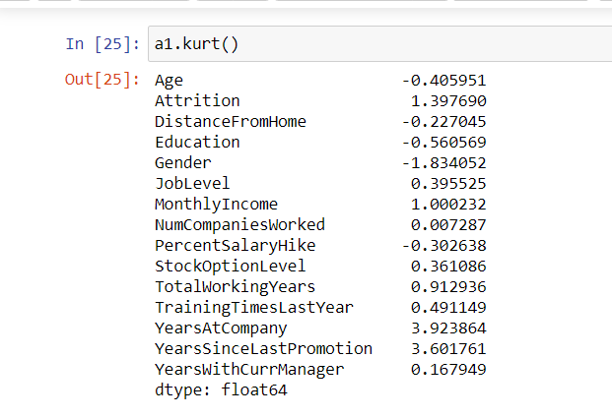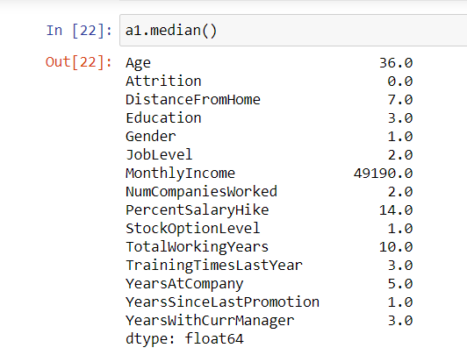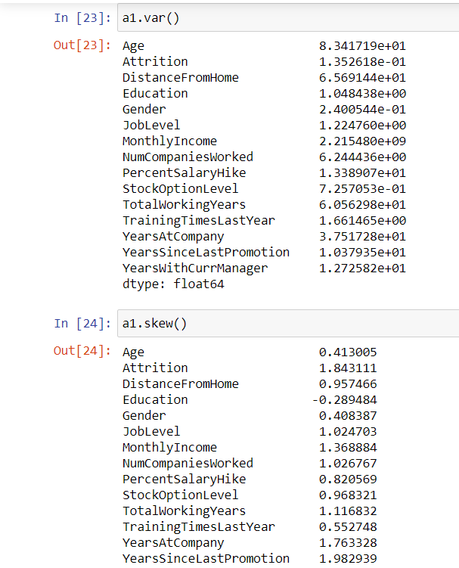

* all the above variables are positive skewness whileage DistanceFromHome ,Education ,gender,PercentSalaryHike are platykurtic

OUTLAYERS

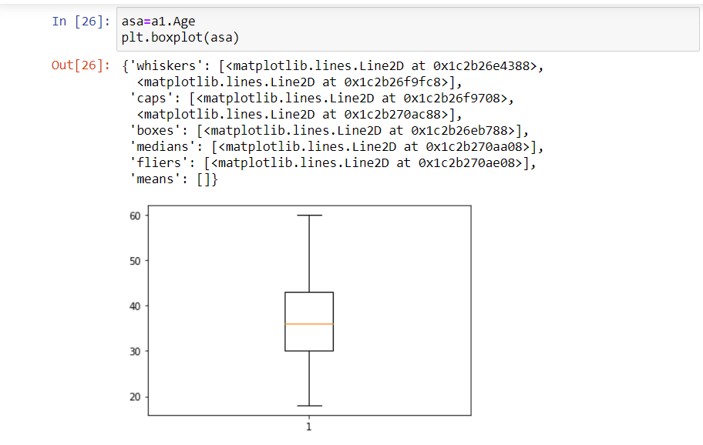

* Age is normaly distributed without outlayer

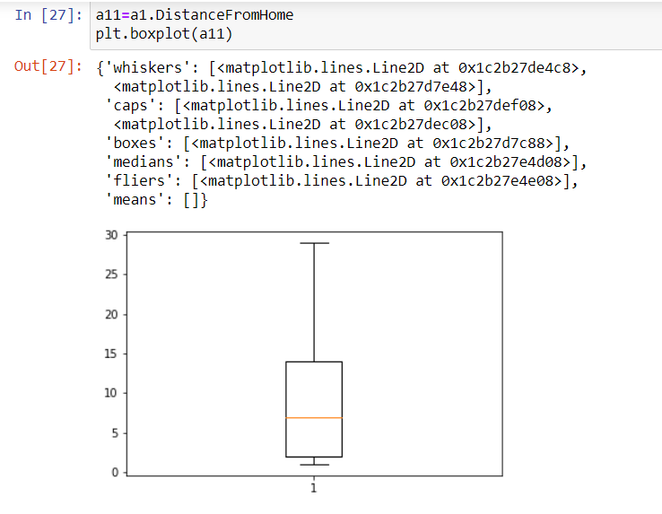

* Didtancefromehome is not normaly distributed without outlayer

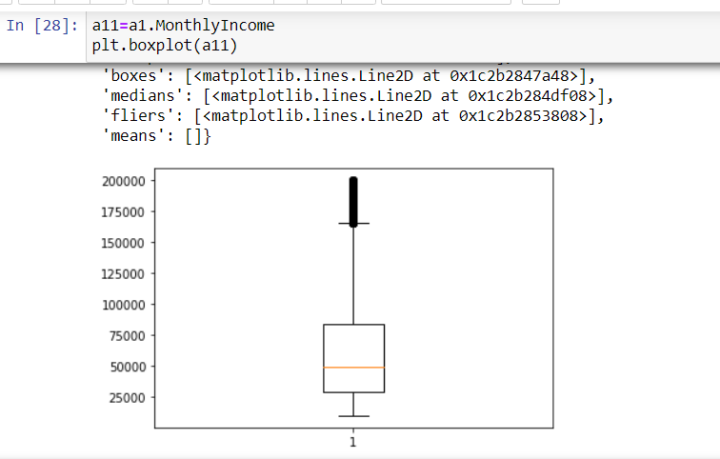

* montly income has some outlayers

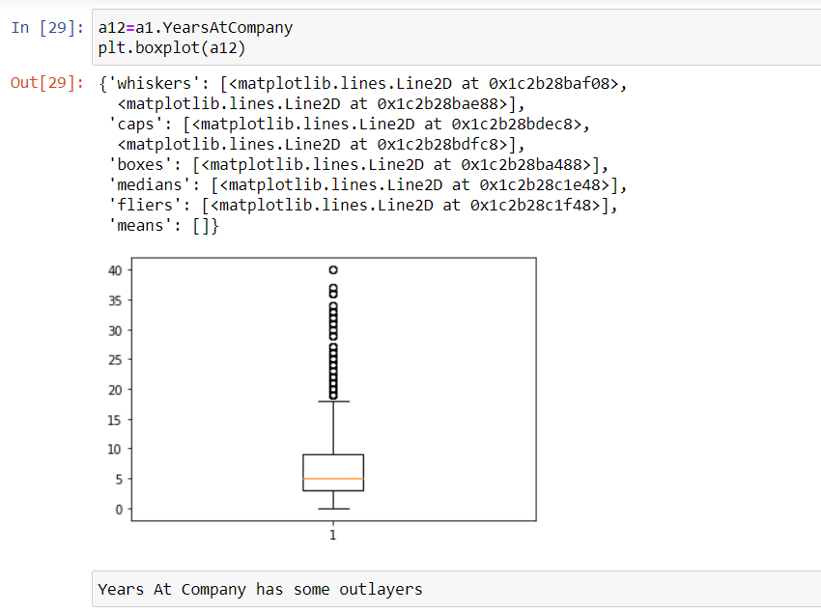

* Years At Company has some outlayers

correlation (partial correlation)

Attrition vs YearWithcurrentManager

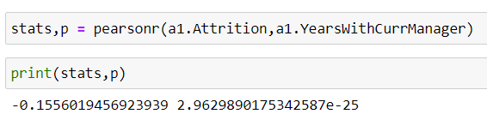

* here r=-0.15 so the correlation between attrition and YearsWithCurrManager is negative
* p < 0.05 so Ha is accepted and the significant correlation between attrition and YearsWithCurrManager

Attrition vs Totalworkingyears

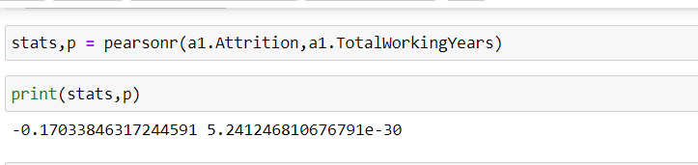

here r=-0.17 so the correlation between attrition and total working years

is negative

p < 0.05 so Ha is accepted and the significant correlation between

attrition and total working years

Attrition vs yearswithcurrentmanager

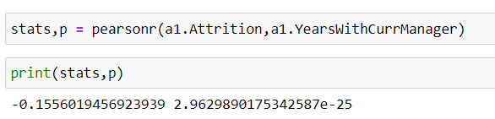

* here r=-0.15 so the correlation between attrition and YearsWithCurrManager is negative
* p < 0.05 so Ha is accepted and the significant correlation between attrition and YearsWithCurrManager

Attrition vs monthly income

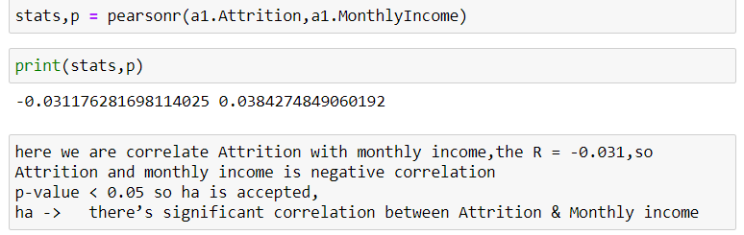

* here we are correlate Attrition with monthly income,the R = -0.031,so
* Attrition and monthly income is negative correlation
* p-value < 0.05 so ha is accepted,
* ha -> there’s significant correlation between Attrition & Monthly income