**Simple realtime react reddit recreataion.**

This project is a simple realtime reddit site using react.js and express.js.

**Installation**

Open a new terminal to the reddit-recreate directory and type following command.

**To run server:**

cd reddit-recreate to move project(server.js path)

npm install

npm start

**To run client:**

cd reddit-recreate/client to move client path

npm install

npm start

then, you see app running at localhost:3000.

If you want the test, might type as following.

cd reddit-recreate/client to move client path

yarn(or npm) test

**Brief explanation of Program function**

- a subreddit viewer that displays a list of posts in any subreddit, 25 at a time

- Each news post include the news title, a link to the news, a thumbnail if it exists(almost none), the author who posted news, time submitted, and a link to the comments on reddit.

- The viewer automatically refresh the data every minute without losing

position of the page.

In other words, Though you don't refresh, you can see refreshed news at realtime.

There are 3 important components.

- App - api part to process and response the user's request.

- NewsList - display news list.

- NewsCard - a news post.

**How a reactive approach might work?**

1. What events should exist?

* Define scroll handler in App
* Fetch(fetchNews function) the next 25 news datas from reddit in the scroll handler

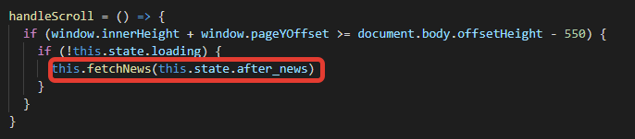

* Store index of the last news data into state value – after_news .

(This state value is base for next data fetch)

* Store the current total news count into state value – news_count.

(This state value is base for data fetch after periodic fetch)

* Pass the fetched datas into Props newsList of NewsList component via state value - newsList.

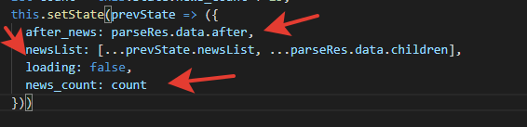

* In NewsList component, pass each new of the Props newsList into the Props news of the NewsCard component.

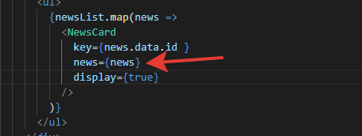

* Define timer handler(fetchPeriod function) for auto periodic fetch every minute.(The periodic fetching use the state value news_count for the current news count)

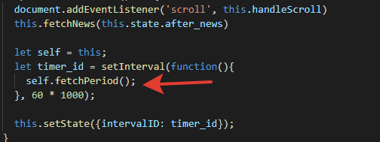

* Pass the result of fetchPeriod into Props newsList of NewsList component via state value – newList.

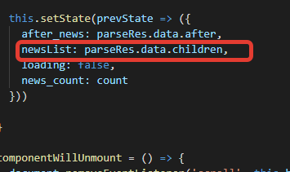

1. How should application views be rendered?

The App component fetch news datas from reddit for user request using reddit api, and transmit the news list to NewsList component.

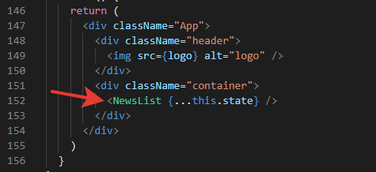

The NewsList component create and display the list of NewsCard according to given news list.

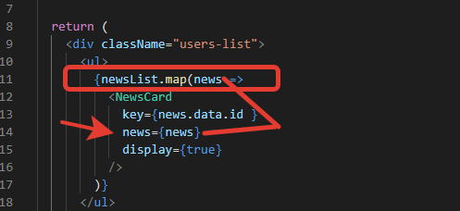

Finally. The App component render NewsCard(news) list created by NewsList.

1. What would the applications state look like and how would state changes be handled?

Each component has state and props needed for transmit and render the news data.

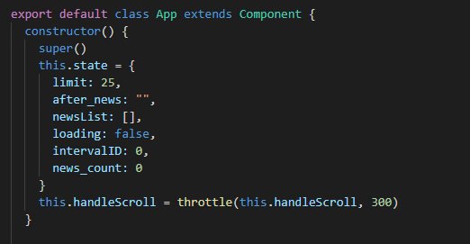

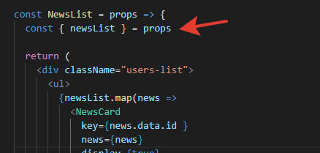

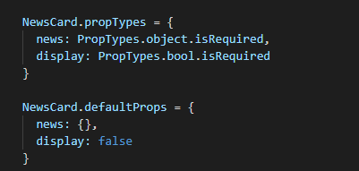

The change of state be handled by setState() funciton.

The change of state in the component itself:

The App component fetch news datas equal to current news's count (news_count) from reddit every minutes.

These is saved to state value(newsList) for news list.

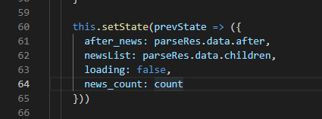

The changes of state by transmition of data between components each other:

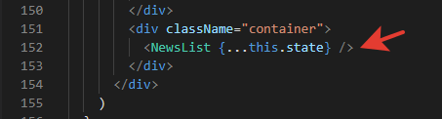

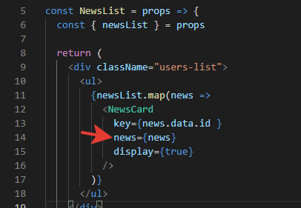

While the React components observate the state values, if the state is changed, automatically refresh the screen by it's reactive function.

1. What reactive-friendly patterns might help manage asynchronous logic?

React.js support asynchronous funciton and this help to fetch data from server asynchronously.

This example use async function (fetchNews, fetchPeriod) and provide the response for asynchronous request.

Since the these functions has the code responsible for making the asynchronous API request we need to put the **async** keyword in front of it.

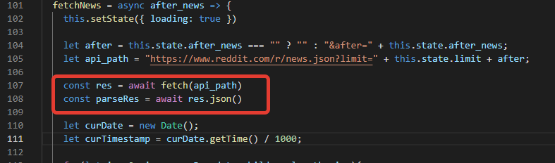

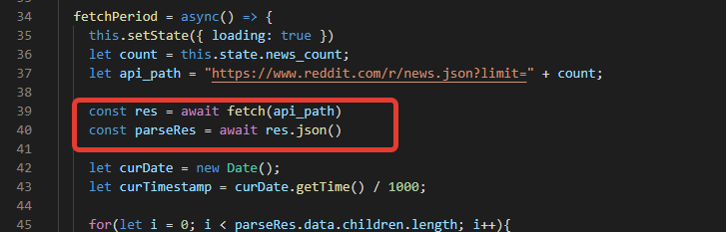

So,

const res = await fetch(api_path)

const parseRes = await res.json()

means we are waiting for the promise to resolve then placing it into the variable, res and parseRes.

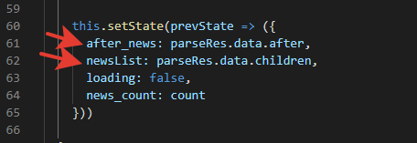

Lastly we update our state by changing our loading to false and adding the news from reddit to the after_news, newsList in the state of our application. Notice that we pass the newsList, after_news down as state to the App component in our fetchNews, fetchPeriod function.