Name: Abhinav Singh
Branch: CSIT-A
Roll No.-07
Website Link: http://127.0.0.1:5500/Clock.html

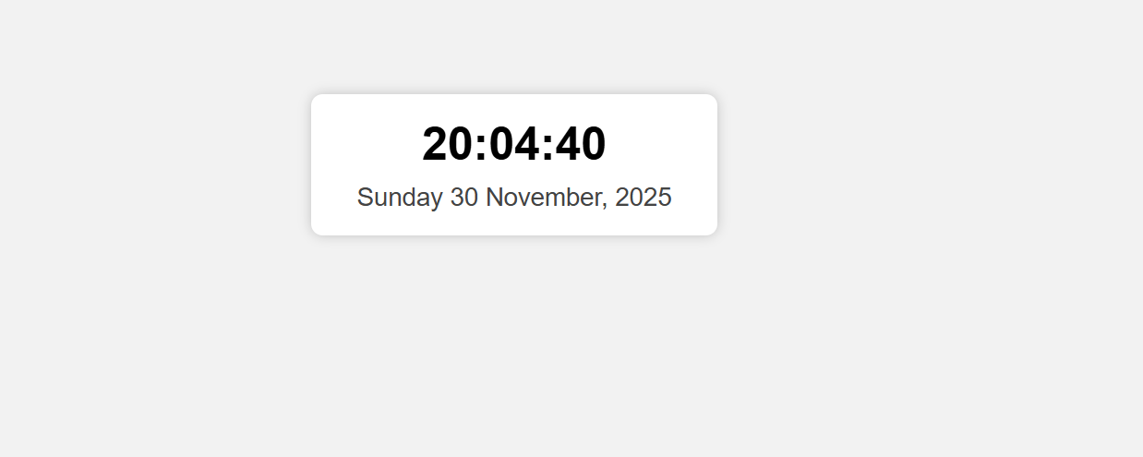
!DOCTYPE html>
<html>
<head>
<title>Clock and Date</title>
<style>
body {
font-family: Arial, sans-serif;
background: #f2f2f2;
text-align: center;
padding-top: 100px;
}
.box {
background: white;
display: inline-block;
padding: 20px 40px;
border-radius: 10px;
box-shadow: 0 0 10px rgba(0,0,0,0.2);
}
#clock {
font-size: 40px;
font-weight: bold;
margin-bottom: 10px;
}
#date {
font-size: 22px;
color: #444;
}
</style>
</head>
<body>

<div class="box">
<div id="clock"></div>
<div id="date"></div>
</div>

<script>
function updateClock() {
let now = new Date();

// Time
let hours = now.getHours().toString().padStart(2, '0');
let minutes = now.getMinutes().toString().padStart(2, '0');
let seconds = now.getSeconds().toString().padStart(2, '0');

document.getElementById("clock").innerHTML = hours + ":" + minutes + ":" + seconds;

// Date
let options = { weekday: 'long', year: 'numeric', month: 'long', day: 'numeric' };
document.getElementById("date").innerHTML = now.toLocaleDateString('en-IN', options);
}

setInterval(updateClock, 1000);
updateClock(); // Run immediately
</script>

</body>
</html>

