Name: Abhinav Singh
Branch: CSIT-A
Roll no.: 07

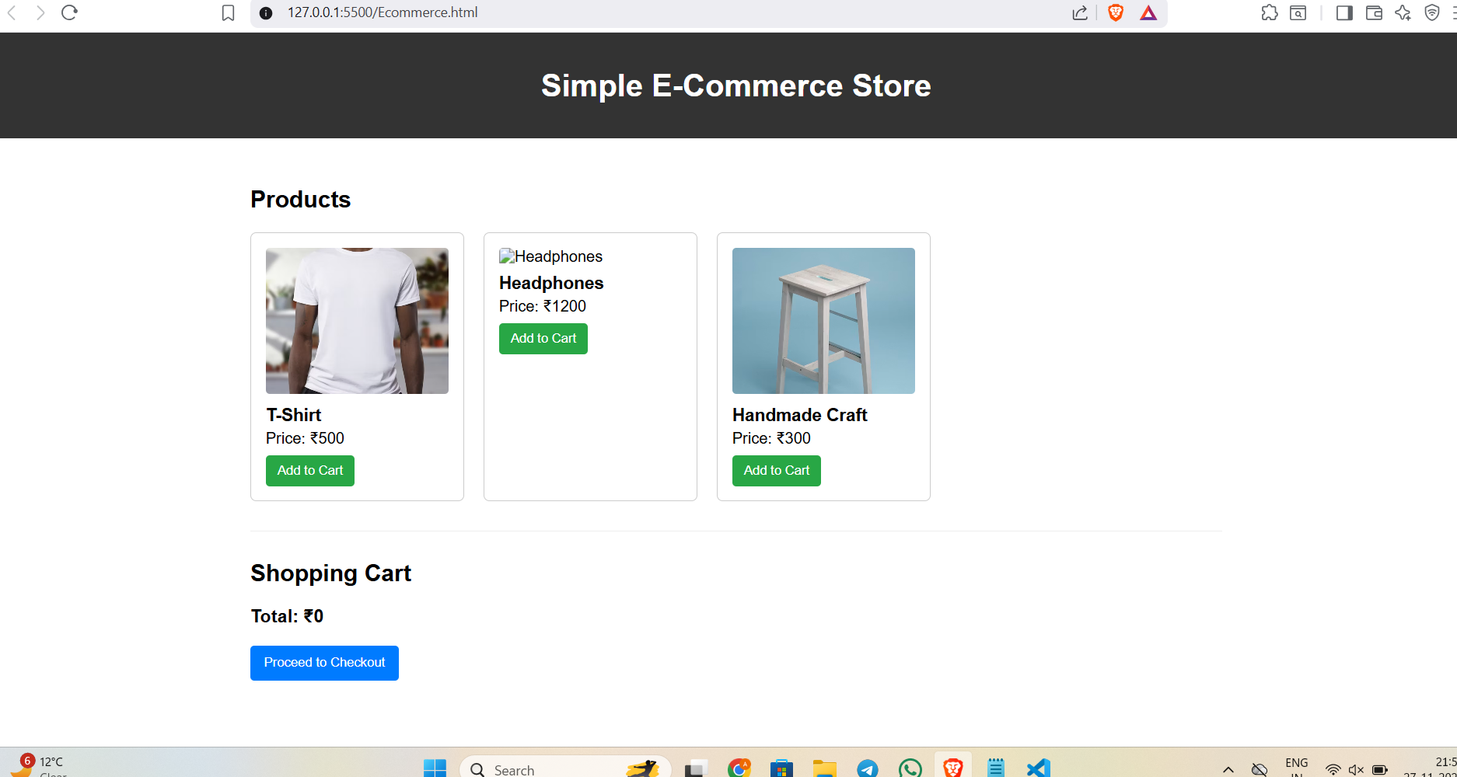
Website link: http://127.0.0.1:5500/Ecommerce.html

<!DOCTYPE html>
<html lang="en">
<head>
<meta charset="utf-8" />
<meta name="viewport" content="width=device-width, initial-scale=1" />
<title>Simple E-Commerce Store</title>
<style>
body { font-family: Arial, sans-serif; margin: 0; padding: 0; }
header { background: #333; color: white; padding: 15px; text-align: center; }
.container { width: 90%; max-width: 1000px; margin: 20px auto; padding: 10px; }
.products { display: flex; gap: 20px; flex-wrap: wrap; justify-content: flex-start; }
.product { border: 1px solid #ccc; padding: 15px; width: 220px; border-radius: 6px; box-sizing: border-box; }
.product img { width: 100%; height: 150px; object-fit: cover; border-radius: 4px; }
.product h3 { margin: 8px 0 4px; font-size: 18px; }
.product p { margin: 0 0 8px; }
.product button { background: #28a745; color: white; border: none; padding: 8px 12px; cursor: pointer; border-radius: 4px; }
.product button:hover { background: #218838; }
#cart { margin-top: 30px; padding-top: 10px; border-top: 1px solid #eee; }
#cart-items div { padding: 8px 0; border-bottom: 1px solid #ddd; display:flex; align-items:center; justify-content:space-between; gap:10px; }
#checkout { background: #007bff; color: white; border: none; padding: 10px 14px; cursor: pointer; border-radius:4px; }
#checkout:hover { background: #0069d9; }
.remove-btn { background: #dc3545; color: white; border: none; padding: 6px 8px; cursor: pointer; border-radius:4px; }
.remove-btn:hover { opacity: 0.9; }
</style>
</head>
<body>
<header>
<h1>Simple E-Commerce Store</h1>
</header>

<div class="container">
<h2>Products</h2>
<div class="products" id="products-list">
<!-- Products are rendered here by HTML so teacher can read easily -->
<div class="product">
<img src="https://images.unsplash.com/photo-1521572163474-6864f9cf17ab?auto=format&fit=crop&w=600&q=60" alt="T-Shirt">
<h3>T-Shirt</h3>
<p>Price: ₹500</p>
<button onclick="addToCart('T-Shirt', 500)">Add to Cart</button>
</div>

<div class="product">
<img src="https://images.unsplash.com/photo-1518444021321-4cd7f0e1dfc0?auto=format&fit=crop&w=600&q=60" alt="Headphones">
<h3>Headphones</h3>
<p>Price: ₹1200</p>
<button onclick="addToCart('Headphones', 1200)">Add to Cart</button>
</div>

<div class="product">
<img src="https://images.unsplash.com/photo-1503602642458-232111445657?auto=format&fit=crop&w=600&q=60" alt="Handmade Craft">
<h3>Handmade Craft</h3>
<p>Price: ₹300</p>
<button onclick="addToCart('Handmade Craft', 300)">Add to Cart</button>
</div>
</div>

<div id="cart">
<h2>Shopping Cart</h2>
<div id="cart-items" aria-live="polite"></div>
<h3 id="total">Total: ₹0</h3>
<button id="checkout" onclick="checkout()">Proceed to Checkout</button>
</div>
</div>

<script>
// safe, simple shopping cart logic
(function () {
// keep cart in-memory (array of {name, price})
window.cart = [];

window.addToCart = function (name, price) {
// simple validation
if (!name || typeof price !== 'number') {
console.error('Invalid product data', name, price);
return;
}
window.cart.push({ name: String(name), price: Number(price) });
displayCart();
};

function formatRupee(n) {
// simple formatting (no dependency)
return '₹' + n;
}

window.displayCart = function () {
const cartItemsDiv = document.getElementById('cart-items');
cartItemsDiv.innerHTML = ''; // clear previous

let total = 0;

// create elements instead of using innerHTML template literals
window.cart.forEach((item, index) => {
const row = document.createElement('div');

const left = document.createElement('div');
left.textContent = `${item.name} - ${formatRupee(item.price)}`;

const right = document.createElement('div');
const removeBtn = document.createElement('button');
removeBtn.className = 'remove-btn';
removeBtn.textContent = 'Remove';
removeBtn.onclick = function () {
// remove item at this index and re-render
window.cart.splice(index, 1);
displayCart();
};

right.appendChild(removeBtn);
row.appendChild(left);
row.appendChild(right);

cartItemsDiv.appendChild(row);

total += item.price;
});

document.getElementById('total').innerText = `Total: ${formatRupee(total)}`;
};

window.checkout = function () {
if (!Array.isArray(window.cart) || window.cart.length === 0) {
alert('Your cart is empty!');
return;
}
const total = window.cart.reduce((s, it) => s + it.price, 0);
alert(`Checkout successful! Total: ₹${total}`);
window.cart = [];
displayCart();
};

// initial render
displayCart();
})();
</script>
</body>
</html>

