Name: Abhinav Singh
Branch: CSIT-A
Roll No.- 07

Website Link: http://127.0.0.1:5500/EducationalBlog.html
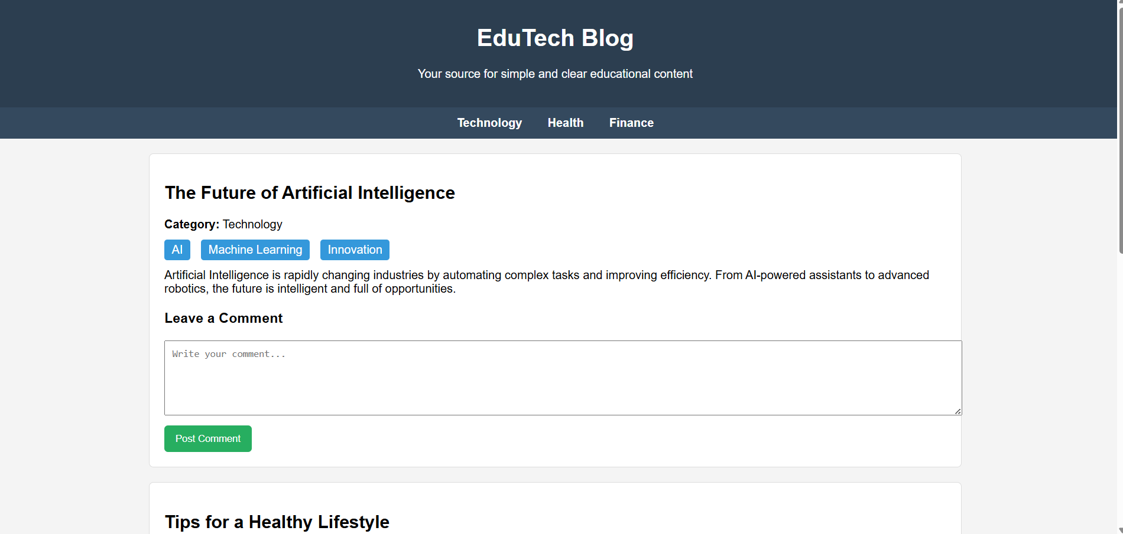
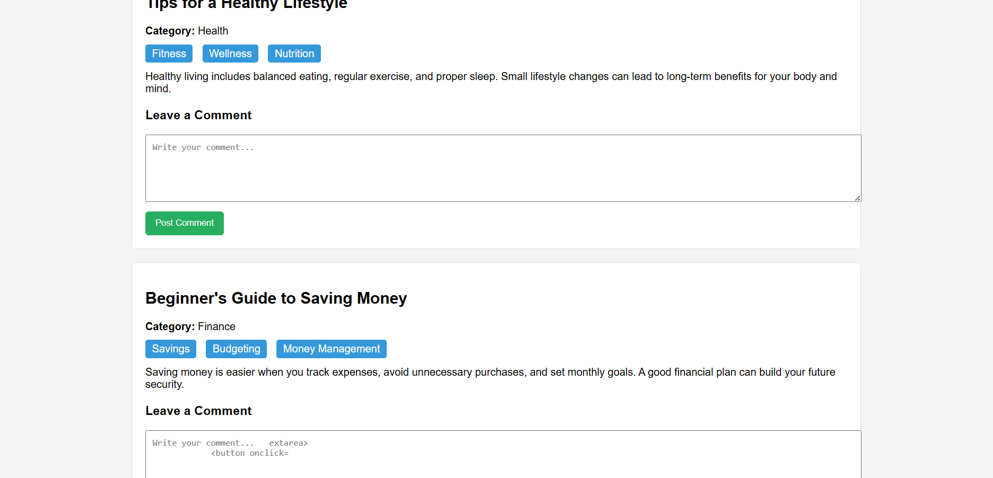

<!DOCTYPE html>
<html lang="en">
<head>
<meta charset="UTF-8">
<meta name="viewport" content="width=device-width, initial-scale=1.0">
<title>Educational Blog</title>
<style>
body {
font-family: Arial, sans-serif;
margin: 0;
padding: 0;
background: #f4f4f4;
}
header {
background: #2c3e50;
color: white;
padding: 20px;
text-align: center;
}
nav {
background: #34495e;
padding: 10px;
text-align: center;
}
nav a {
color: white;
margin: 0 15px;
text-decoration: none;
font-weight: bold;
}
.container {
width: 90%;
margin: 20px auto;
}
.post {
background: white;
padding: 20px;
margin-bottom: 20px;
border-radius: 6px;
box-shadow: 0 0 5px rgba(0,0,0,0.2);
}
.post h2 {
margin-top: 0;
}
.tags span {
background: #3498db;
color: white;
padding: 5px 10px;
margin-right: 5px;
border-radius: 4px;
font-size: 12px;
}
.comment-box {
margin-top: 20px;
}
textarea {
width: 100%;
height: 80px;
padding: 10px;
}
button {
background: #2ecc71;
padding: 10px 20px;
border: none;
color: white;
cursor: pointer;
margin-top: 10px;
}
.comment-section {
margin-top: 15px;
background: #ecf0f1;
padding: 10px;
border-radius: 6px;
}
</style>
</head>
<body>

<header>
<h1>Tech Knowledge Blog</h1>
<p>Learn Technology in Simple Language</p>
</header>

<nav>
<a href="#">Home</a>
<a href="#">Technology</a>
<a href="#">AI</a>
<a href="#">Cybersecurity</a>
<a href="#">Programming</a>
</nav>

<div class="container">

<div class="post">
<h2>What is Artificial Intelligence?</h2>
<p>Artificial Intelligence (AI) is the ability of machines to perform tasks that normally require human intelligence. It includes learning, problem-solving, speech recognition, and more.</p>
<div class="tags">
<span>AI</span>
<span>Technology</span>
</div>

<div class="comment-box">
<h3>Leave a Comment</h3>
<textarea id="comment1" placeholder="Write your comment..."></textarea>
<button onclick="postComment('comment1','comments1')">Post Comment</button>
<div id="comments1" class="comment-section"></div>
</div>
</div>

<div class="post">
<h2>The Future of Cybersecurity</h2>
<p>Cybersecurity is becoming more important as cyber threats increase. Future systems will depend heavily on AI monitoring and automated protection systems.</p>
<div class="tags">
<span>Cybersecurity</span>
<span>Future Tech</span>
</div>

<div class="comment-box">
<h3>Leave a Comment</h3>
<textarea id="comment2" placeholder="Write your comment..."></textarea>
<button onclick="postComment('comment2','comments2')">Post Comment</button>
<div id="comments2" class="comment-section"></div>
</div>
</div>

</div>

<script>
function postComment(inputId, sectionId) {
let text = document.getElementById(inputId).value;
if (text.trim() === "") return;

let commentBox = document.getElementById(sectionId);
let newComment = document.createElement("p");
newComment.textContent = text;
commentBox.appendChild(newComment);

document.getElementById(inputId).value = "";
}
</script>

</body>
</html>

