Name: Abhinav Singh
Branch: CSIT-A
Roll No.- 07
Website Link: http://127.0.0.1:5500/EventManagement.html
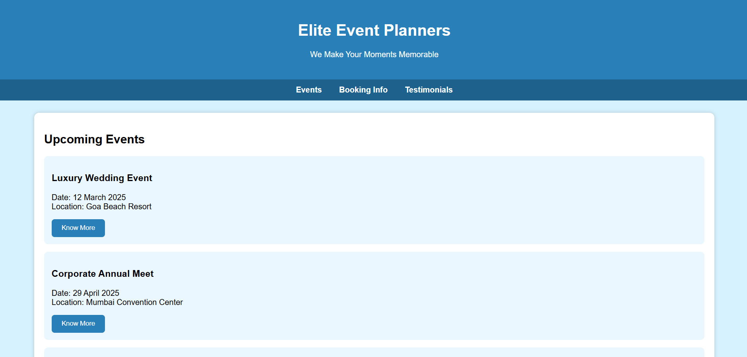
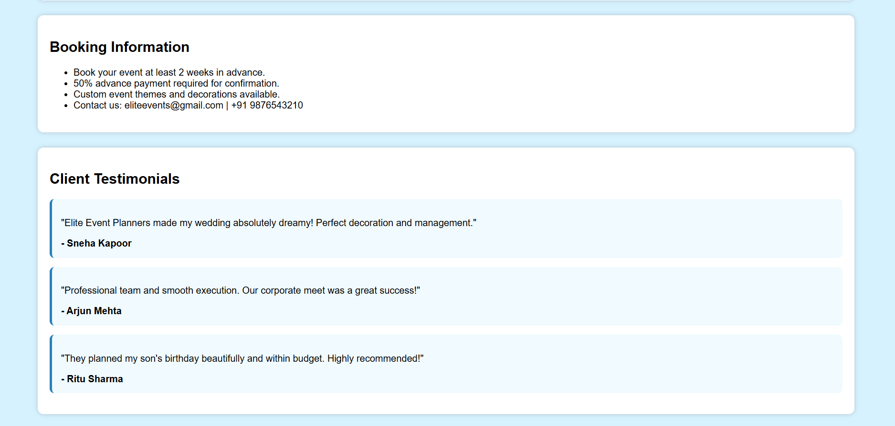

<!DOCTYPE html>
<html lang="en">
<head>
<meta charset="UTF-8">
<meta name="viewport" content="width=device-width, initial-scale=1.0">
<title>Event Management Company</title>

<style>
body {
margin: 0;
padding: 0;
font-family: Arial, sans-serif;
background: #d7f2ff; /* NEW DIFFERENT BACKGROUND COLOR */
}
header {
background: #2980b9;
color: white;
padding: 25px;
text-align: center;
}
nav {
background: #1f618d;
padding: 12px;
text-align: center;
}
nav a {
color: white;
text-decoration: none;
margin: 0 15px;
font-weight: bold;
}
.container {
width: 90%;
margin: 25px auto;
}
.section {
background: white;
padding: 20px;
border-radius: 10px;
margin-bottom: 25px;
box-shadow: 0 0 8px rgba(0,0,0,0.2);
}
.event {
background: #ebf7ff;
padding: 15px;
border-radius: 8px;
margin-bottom: 15px;
}
button {
background: #2980b9;
color: white;
border: none;
padding: 10px 20px;
cursor: pointer;
border-radius: 6px;
}
.testimonial {
background: #f0faff;
padding: 15px;
border-radius: 8px;
margin-bottom: 15px;
border-left: 4px solid #2980b9;
}
</style>
</head>
<body>

<header>
<h1>Elite Event Planners</h1>
<p>We Make Your Moments Memorable</p>
</header>

<nav>
<a href="#events">Events</a>
<a href="#booking">Booking Info</a>
<a href="#testimonials">Testimonials</a>
</nav>

<div class="container">

<!-- Event Listings -->
<div id="events" class="section">
<h2>Upcoming Events</h2>

<div class="event">
<h3>Luxury Wedding Event</h3>
<p>Date: 12 March 2025<br>Location: Goa Beach Resort</p>
<button>Know More</button>
</div>

<div class="event">
<h3>Corporate Annual Meet</h3>
<p>Date: 29 April 2025<br>Location: Mumbai Convention Center</p>
<button>Know More</button>
</div>

<div class="event">
<h3>Birthday Party Planning</h3>
<p>Available All Year<br>Location: Any Custom Venue</p>
<button>Know More</button>
</div>
</div>

<!-- Booking Info -->
<div id="booking" class="section">
<h2>Booking Information</h2>
<ul>
<li>Book your event at least 2 weeks in advance.</li>
<li>50% advance payment required for confirmation.</li>
<li>Custom event themes and decorations available.</li>
<li>Contact us: eliteevents@gmail.com | +91 9876543210</li>
</ul>
</div>

<!-- Testimonials -->
<div id="testimonials" class="section">
<h2>Client Testimonials</h2>

<div class="testimonial">
<p>"Elite Event Planners made my wedding absolutely dreamy! Perfect decoration and management."</p>
<strong>- Sneha Kapoor</strong>
</div>

<div class="testimonial">
<p>"Professional team and smooth execution. Our corporate meet was a great success!"</p>
<strong>- Arjun Mehta</strong>
</div>

<div class="testimonial">
<p>"They planned my son's birthday beautifully and within budget. Highly recommended!"</p>
<strong>- Ritu Sharma</strong>
</div>
</div>

</div>

</body>
</html>

