Name: Abhinav Singh
Branch: CSIT-A
Roll No.:07

Website Link: http://127.0.0.1:5500/E'CommerceStore.html
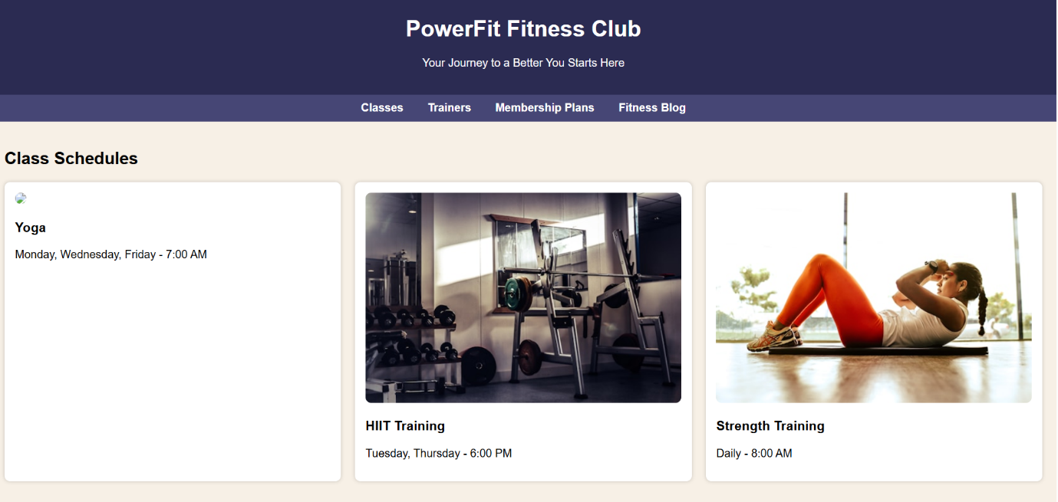
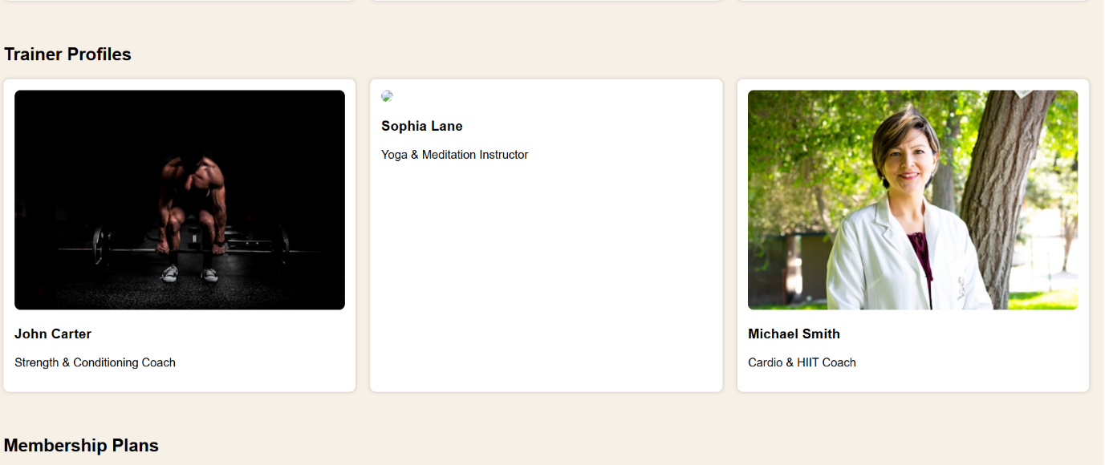
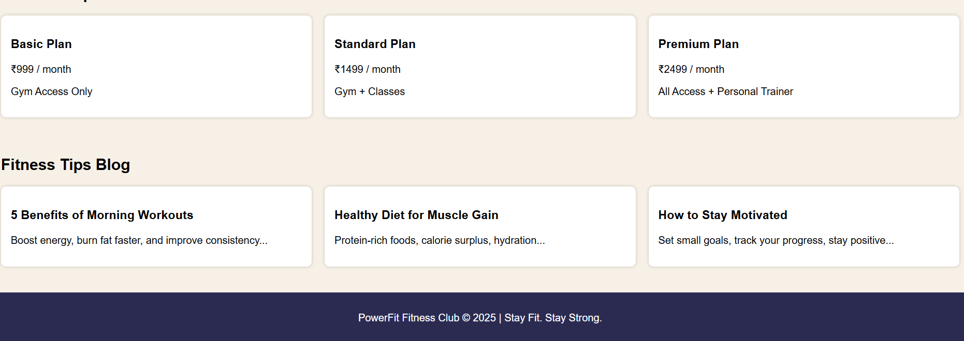

<!DOCTYPE html>
<html lang="en">
<head>
<meta charset="UTF-8" />
<meta name="viewport" content="width=device-width, initial-scale=1.0" />
<title>Fitness Club</title>
<style>
body {
margin: 0;
font-family: Arial, sans-serif;
background: #f7f0e6; /* New unique background */
}
header {
background: #2b2b52;
color: white;
padding: 20px;
text-align: center;
}
nav {
background: #464675;
padding: 10px;
text-align: center;
}
nav a {
color: white;
margin: 0 15px;
text-decoration: none;
font-weight: bold;
}
section {
padding: 20px;
}
.container {
display: grid;
grid-template-columns: repeat(auto-fit, minmax(250px, 1fr));
gap: 20px;
}
.card {
background: white;
padding: 15px;
border-radius: 8px;
box-shadow: 0 0 5px rgba(0,0,0,0.2);
}
.card img {
width: 100%;
border-radius: 8px;
}
footer {
background: #2b2b52;
color: white;
padding: 15px;
text-align: center;
margin-top: 20px;
}
</style>
</head>
<body>
<header>
<h1>PowerFit Fitness Club</h1>
<p>Your Journey to a Better You Starts Here</p>
</header>

<nav>
<a href="#classes">Classes</a>
<a href="#trainers">Trainers</a>
<a href="#plans">Membership Plans</a>
<a href="#blog">Fitness Blog</a>
</nav>

<section id="classes">
<h2>Class Schedules</h2>
<div class="container">
<div class="card">
<img src="https://images.unsplash.com/photo-1554284126-aa88f22d8b72?w=500" />
<h3>Yoga</h3>
<p>Monday, Wednesday, Friday - 7:00 AM</p>
</div>
<div class="card">
<img src="https://images.unsplash.com/photo-1558611848-73f7eb4001a1?w=500" />
<h3>HIIT Training</h3>
<p>Tuesday, Thursday - 6:00 PM</p>
</div>
<div class="card">
<img src="https://images.unsplash.com/photo-1571019613454-1cb2f99b2d8b?w=500" />
<h3>Strength Training</h3>
<p>Daily - 8:00 AM</p>
</div>
</div>
</section>

<section id="trainers">
<h2>Trainer Profiles</h2>
<div class="container">
<div class="card">
<img src="https://images.unsplash.com/photo-1605296867304-46d5465a13f1?w=500" />
<h3>John Carter</h3>
<p>Strength & Conditioning Coach</p>
</div>
<div class="card">
<img src="https://images.unsplash.com/photo-1599058918144-8f58fccfa69f?w=500" />
<h3>Sophia Lane</h3>
<p>Yoga & Meditation Instructor</p>
</div>
<div class="card">
<img src="https://images.unsplash.com/photo-1559839734-2b71ea197ec2?w=500" />
<h3>Michael Smith</h3>
<p>Cardio & HIIT Coach</p>
</div>
</div>
</section>

<section id="plans">
<h2>Membership Plans</h2>
<div class="container">
<div class="card">
<h3>Basic Plan</h3>
<p>₹999 / month</p>
<p>Gym Access Only</p>
</div>
<div class="card">
<h3>Standard Plan</h3>
<p>₹1499 / month</p>
<p>Gym + Classes</p>
</div>
<div class="card">
<h3>Premium Plan</h3>
<p>₹2499 / month</p>
<p>All Access + Personal Trainer</p>
</div>
</div>
</section>

<section id="blog">
<h2>Fitness Tips Blog</h2>
<div class="container">
<div class="card">
<h3>5 Benefits of Morning Workouts</h3>
<p>Boost energy, burn fat faster, and improve consistency...</p>
</div>
<div class="card">
<h3>Healthy Diet for Muscle Gain</h3>
<p>Protein-rich foods, calorie surplus, hydration...</p>
</div>
<div class="card">
<h3>How to Stay Motivated</h3>
<p>Set small goals, track your progress, stay positive...</p>
</div>
</div>
</section>

<footer>
<p>PowerFit Fitness Club © 2025 | Stay Fit. Stay Strong.</p>
</footer>
</body>
</html>

