Name: Abhinav Singh
Branch: CSIT-A
Roll No.: 07
Website link: http://127.0.0.1:5500/NonProfitOrganization.html
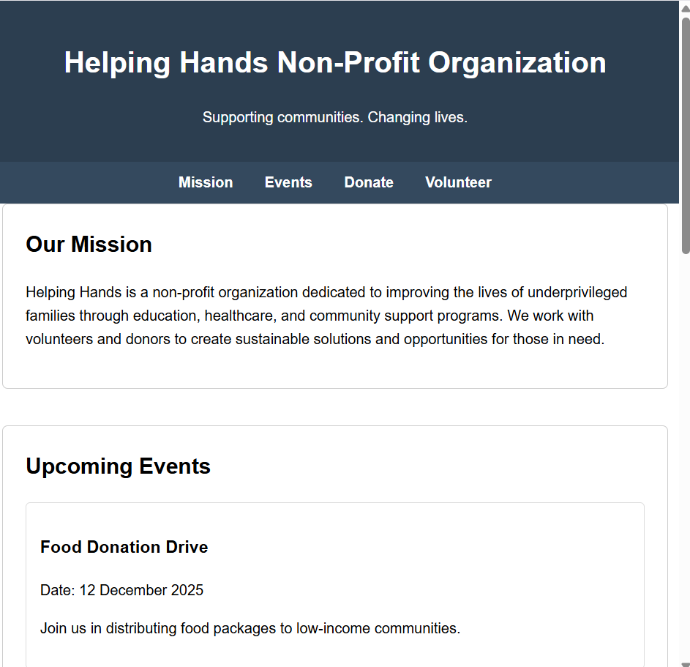

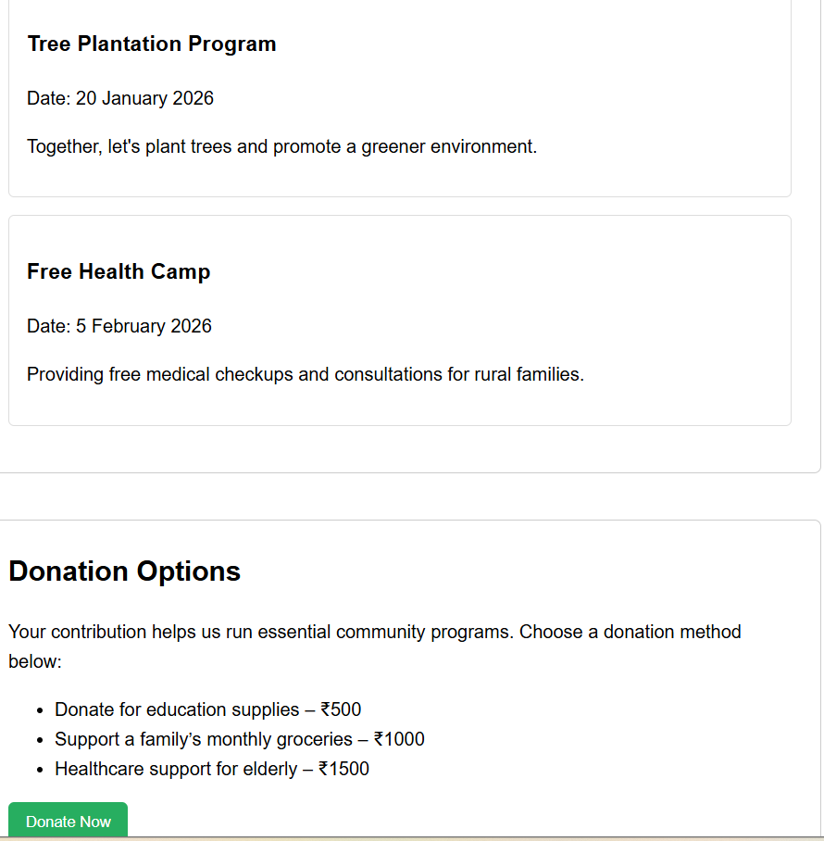

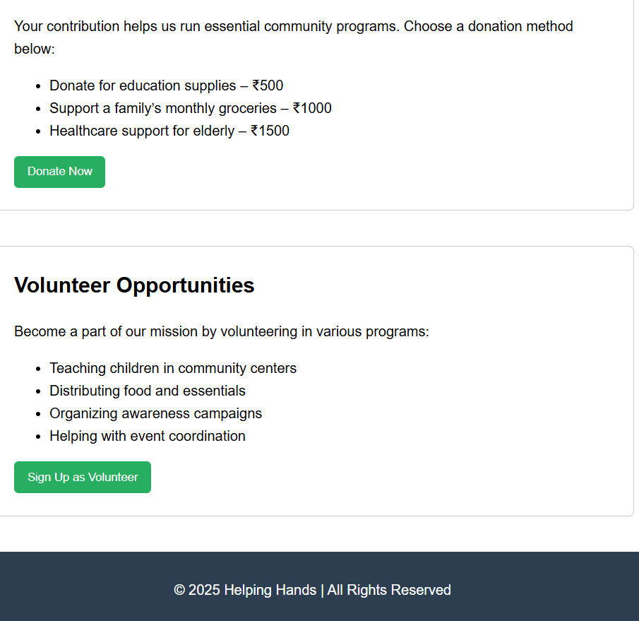

<!DOCTYPE html>
<html lang="en">
<head>
<meta charset="UTF-8">
<meta name="viewport" content="width=device-width, initial-scale=1.0">
<title>Helping Hands - Non-Profit Organization</title>
<style>
body { font-family: Arial, sans-serif; margin: 0; padding: 0; line-height: 1.6; }
header { background: #2c3e50; color: white; padding: 20px; text-align: center; }
nav { background: #34495e; padding: 10px; text-align: center; }
nav a { color: white; margin: 0 15px; text-decoration: none; font-weight: bold; }
.section { padding: 40px; width: 90%; margin: auto; }
.mission, .events, .donate, .volunteer { margin-bottom: 40px; padding: 25px; border: 1px solid #ccc; border-radius: 6px; }
h2 { margin-top: 0; }
.event-card { border: 1px solid #ddd; padding: 15px; margin-bottom: 15px; border-radius: 5px; }
button { background: #27ae60; color: white; padding: 10px 15px; border: none; cursor: pointer; border-radius: 5px; }
button:hover { background: #1e8449; }
footer { background: #2c3e50; color: white; text-align: center; padding: 15px; margin-top: 40px; }
</style>
</head>
<body>

<header>
<h1>Helping Hands Non-Profit Organization</h1>
<p>Supporting communities. Changing lives.</p>
</header>

<nav>
<a href="#mission">Mission</a>
<a href="#events">Events</a>
<a href="#donate">Donate</a>
<a href="#volunteer">Volunteer</a>
</nav>

<div class="section mission" id="mission">
<h2>Our Mission</h2>
<p>Helping Hands is a non-profit organization dedicated to improving the lives of underprivileged families through education, healthcare, and community support programs. We work with volunteers and donors to create sustainable solutions and opportunities for those in need.</p>
</div>

<div class="section events" id="events">
<h2>Upcoming Events</h2>

<div class="event-card">
<h3>Food Donation Drive</h3>
<p>Date: 12 December 2025</p>
<p>Join us in distributing food packages to low-income communities.</p>
</div>

<div class="event-card">
<h3>Tree Plantation Program</h3>
<p>Date: 20 January 2026</p>
<p>Together, let's plant trees and promote a greener environment.</p>
</div>

<div class="event-card">
<h3>Free Health Camp</h3>
<p>Date: 5 February 2026</p>
<p>Providing free medical checkups and consultations for rural families.</p>
</div>
</div>

<div class="section donate" id="donate">
<h2>Donation Options</h2>
<p>Your contribution helps us run essential community programs. Choose a donation method below:</p>

<ul>
<li>Donate for education supplies – ₹500</li>
<li>Support a family’s monthly groceries – ₹1000</li>
<li>Healthcare support for elderly – ₹1500</li>
</ul>

<button onclick="alert('Thank you for your donation!')">Donate Now</button>
</div>

<div class="section volunteer" id="volunteer">
<h2>Volunteer Opportunities</h2>
<p>Become a part of our mission by volunteering in various programs:</p>

<ul>
<li>Teaching children in community centers</li>
<li>Distributing food and essentials</li>
<li>Organizing awareness campaigns</li>
<li>Helping with event coordination</li>
</ul>

<button onclick="alert('Thank you for signing up to volunteer! We will contact you soon.')">Sign Up as Volunteer</button>
</div>

<footer>
<p>&copy; 2025 Helping Hands | All Rights Reserved</p>
</footer>

</body>
</html>

