Name: Abhinav Singh
Branch: CSIT-A
Roll No.: 07
Website link: http://127.0.0.1:5500/OnlineMagazine.html

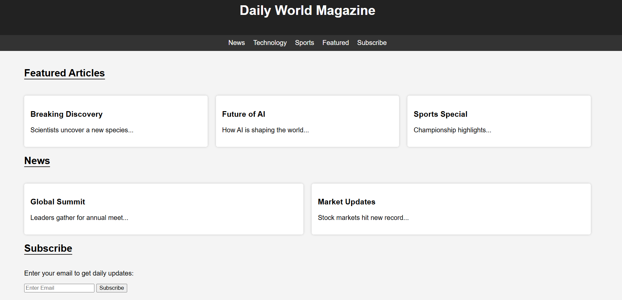
<!DOCTYPE html>
<html lang="en">
<head>
<meta charset="UTF-8" />
<meta name="viewport" content="width=device-width, initial-scale=1.0" />
<title>Online Magazine</title>
<style>
body {
font-family: Arial, sans-serif;
margin: 0;
padding: 0;
background: #f4f4f4;
}
header {
background: #222;
color: #fff;
padding: 20px;
text-align: center;
}
nav {
background: #333;
padding: 10px;
display: flex;
justify-content: center;
gap: 20px;
}
nav a {
color: white;
text-decoration: none;
}
.container {
width: 90%;
margin: auto;
padding: 20px;
}
.section-title {
font-size: 24px;
margin-top: 20px;
border-bottom: 2px solid #222;
display: inline-block;
}
.articles {
display: grid;
grid-template-columns: repeat(auto-fit, minmax(250px, 1fr));
gap: 20px;
margin-top: 20px;
}
.card {
background: white;
padding: 15px;
border-radius: 5px;
box-shadow: 0 0 5px rgba(0,0,0,0.2);
}
footer {
background: #222;
color: white;
text-align: center;
padding: 15px;
margin-top: 30px;
}
</style>
</head>
<body>
<header>
<h1>Daily World Magazine</h1>
</header>

<nav>
<a href="#news">News</a>
<a href="#tech">Technology</a>
<a href="#sports">Sports</a>
<a href="#featured">Featured</a>
<a href="#subscribe">Subscribe</a>
</nav>

<div class="container">
<h2 id="featured" class="section-title">Featured Articles</h2>
<div class="articles">
<div class="card"><h3>Breaking Discovery</h3><p>Scientists uncover a new species...</p></div>
<div class="card"><h3>Future of AI</h3><p>How AI is shaping the world...</p></div>
<div class="card"><h3>Sports Special</h3><p>Championship highlights...</p></div>
</div>

<h2 id="news" class="section-title">News</h2>
<div class="articles">
<div class="card"><h3>Global Summit</h3><p>Leaders gather for annual meet...</p></div>
<div class="card"><h3>Market Updates</h3><p>Stock markets hit new record...</p></div>
</div>

<h2 id="subscribe" class="section-title">Subscribe</h2>
<p>Enter your email to get daily updates:</p>
<input id="email" type="email" placeholder="Enter Email" />
<button onclick="subscribe()">Subscribe</button>
<p id="msg"></p>
</div>

<footer>
<p>© 2025 Daily World Magazine</p>
</footer>

<script>
function subscribe() {
const email = document.getElementById("email").value;
const msg = document.getElementById("msg");
if (email === "") {
msg.textContent = "Please enter a valid email.";
msg.style.color = "red";
} else {
msg.textContent = "Subscription successful!";
msg.style.color = "green";
}
}
</script>
</body>
</html>

