Name: Abhinav Singh
Branch: CSIT-A
Roll No.- 07
Website link: http://127.0.0.1:5500/PhotographyPortofolio.html

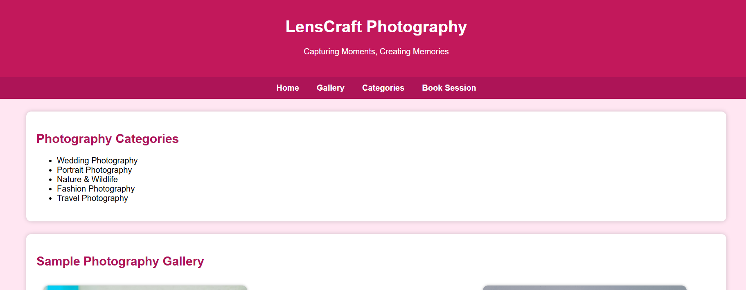
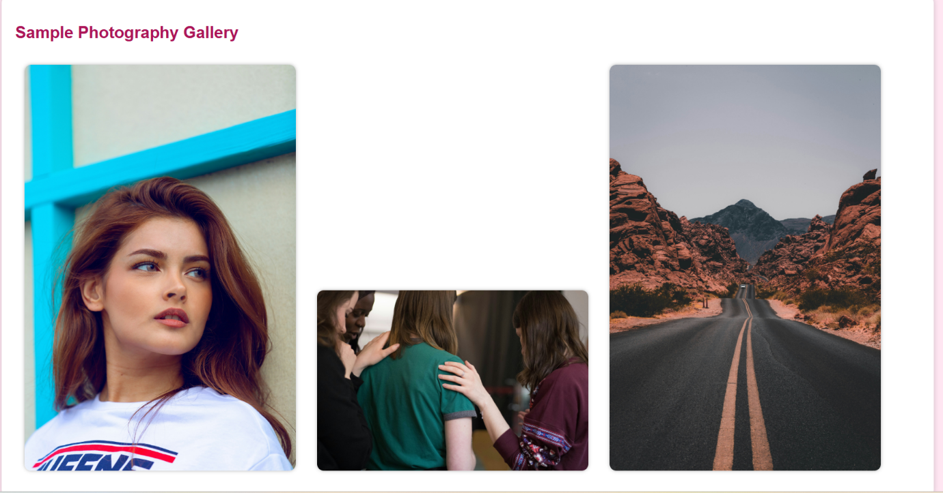
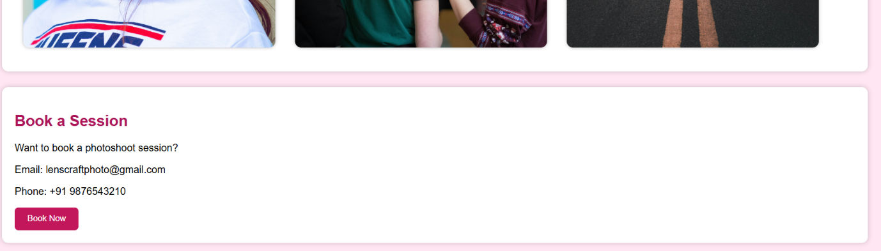
<!DOCTYPE html>
<html lang="en">
<head>
<meta charset="UTF-8">
<meta name="viewport" content="width=device-width, initial-scale=1.0">
<title>Photography Portfolio</title>

<style>
body {
margin: 0;
padding: 0;
font-family: Arial, sans-serif;
background: #ffe6f2; /* NEW DIFFERENT BACKGROUND COLOUR */
}
header {
background: #c2185b;
color: white;
padding: 25px;
text-align: center;
}
nav {
background: #ad1457;
padding: 12px;
text-align: center;
}
nav a {
color: white;
text-decoration: none;
margin: 0 15px;
font-weight: bold;
}
.container {
width: 90%;
margin: 25px auto;
}
.section {
background: white;
padding: 20px;
border-radius: 10px;
margin-bottom: 25px;
box-shadow: 0 0 8px rgba(0,0,0,0.2);
}
.gallery img {
width: 30%;
margin: 1%;
border-radius: 10px;
box-shadow: 0 0 5px rgba(0,0,0,0.3);
}
button {
background: #c2185b;
color: white;
border: none;
padding: 10px 20px;
cursor: pointer;
border-radius: 6px;
}
h2 {
color: #ad1457;
}
</style>
</head>
<body>

<header>
<h1>LensCraft Photography</h1>
<p>Capturing Moments, Creating Memories</p>
</header>

<nav>
<a href="#">Home</a>
<a href="#gallery">Gallery</a>
<a href="#categories">Categories</a>
<a href="#booking">Book Session</a>
</nav>

<div class="container">

<!-- Photography Categories -->
<div id="categories" class="section">
<h2>Photography Categories</h2>
<ul>
<li>Wedding Photography</li>
<li>Portrait Photography</li>
<li>Nature & Wildlife</li>
<li>Fashion Photography</li>
<li>Travel Photography</li>
</ul>
</div>

<!-- Gallery -->
<div id="gallery" class="section">
<h2>Sample Photography Gallery</h2>
<div class="gallery">
<img src="https://images.unsplash.com/photo-1529626455594-4ff0802cfb7e" alt="Portrait">
<img src="https://images.unsplash.com/photo-1520857014576-2c4f4c972b57" alt="Wedding">
<img src="https://images.unsplash.com/photo-1500530855697-b586d89ba3ee" alt="Nature">
</div>
</div>

<!-- Booking Section -->
<div id="booking" class="section">
<h2>Book a Session</h2>
<p>Want to book a photoshoot session?</p>
<p>Email: lenscraftphoto@gmail.com</p>
<p>Phone: +91 9876543210</p>
<button>Book Now</button>
</div>

</div>

</body>
</html>

