Name: Abhinav Singh
Branch: CSIT-A
Roll No.: 07
Website link: http://127.0.0.1:5500/Realestate.html
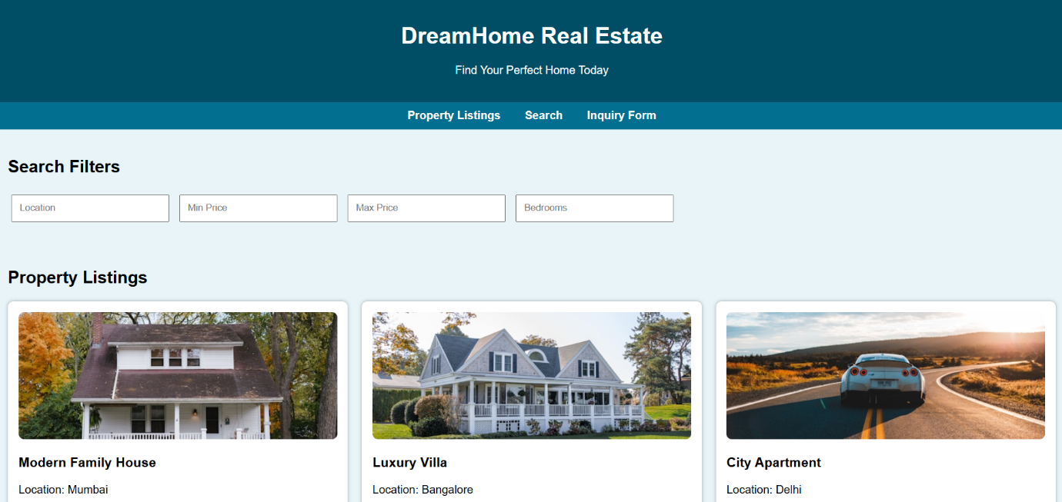
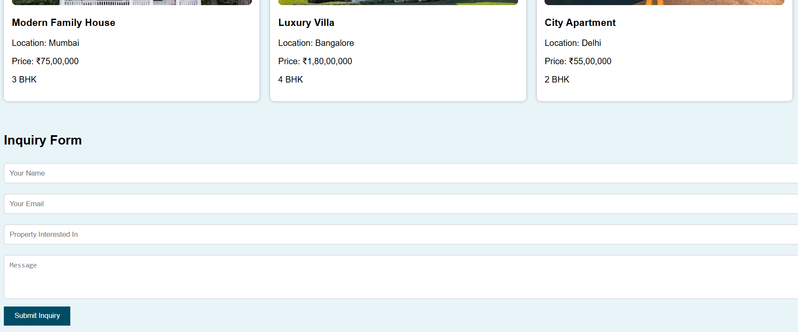

<!DOCTYPE html>
<html lang="en">
<head>
<meta charset="UTF-8" />
<meta name="viewport" content="width=device-width, initial-scale=1.0" />
<title>Real Estate Listings</title>
<style>
body {
font-family: Arial, sans-serif;
margin: 0;
background: #e8f4f8; /* Unique background color */
}
header {
background: #004d66;
color: white;
padding: 20px;
text-align: center;
}
nav {
background: #026f91;
padding: 10px;
text-align: center;
}
nav a {
color: white;
margin: 0 15px;
text-decoration: none;
font-weight: bold;
}
section { padding:20px; }

.filters input {
padding: 10px;
margin: 5px;
width: 200px;
}
.container {
display: grid;
grid-template-columns: repeat(auto-fit, minmax(260px, 1fr));
gap: 20px;
margin-top: 20px;
}
.card {
background: white;
padding: 15px;
border-radius: 8px;
box-shadow: 0 0 5px rgba(0,0,0,0.3);
}
.card img {
width: 100%;
height: 180px;
object-fit: cover;
border-radius: 8px;
}
form input, form textarea {
width: 100%;
padding: 10px;
margin: 10px 0;
border: 1px solid #ccc;
border-radius: 5px;
}
form button {
padding: 10px 20px;
background: #004d66;
color: white;
border: none;
cursor: pointer;
}
</style>
</head>
<body>
<header>
<h1>DreamHome Real Estate</h1>
<p>Find Your Perfect Home Today</p>
</header>

<nav>
<a href="#listings">Property Listings</a>
<a href="#search">Search</a>
<a href="#contact">Inquiry Form</a>
</nav>

<section id="search">
<h2>Search Filters</h2>
<div class="filters">
<input type="text" placeholder="Location" />
<input type="number" placeholder="Min Price" />
<input type="number" placeholder="Max Price" />
<input type="number" placeholder="Bedrooms" />
</div>
</section>

<section id="listings">
<h2>Property Listings</h2>
<div class="container">
<div class="card">
<img src="https://images.unsplash.com/photo-1572120360610-d971b9d7767c?w=500" />
<h3>Modern Family House</h3>
<p>Location: Mumbai</p>
<p>Price: ₹75,00,000</p>
<p>3 BHK</p>
</div>
<div class="card">
<img src="https://images.unsplash.com/photo-1570129477492-45c003edd2be?w=500" />
<h3>Luxury Villa</h3>
<p>Location: Bangalore</p>
<p>Price: ₹1,80,00,000</p>
<p>4 BHK</p>
</div>
<div class="card">
<img src="https://images.unsplash.com/photo-1568605117036-5fe5e7bab0b7?w=500" />
<h3>City Apartment</h3>
<p>Location: Delhi</p>
<p>Price: ₹55,00,000</p>
<p>2 BHK</p>
</div>
</div>
</section>

<section id="contact">
<h2>Inquiry Form</h2>
<form>
<input type="text" placeholder="Your Name" required />
<input type="email" placeholder="Your Email" required />
<input type="text" placeholder="Property Interested In" />
<textarea placeholder="Message" rows="4"></textarea>
<button type="submit">Submit Inquiry</button>
</form>
</section>

</body>
</html>

