Name: Abhinav Singh
Branch: CSIT-A
Roll No.-07

Website link: http://127.0.0.1:5500/StudentRegistrationForm.html

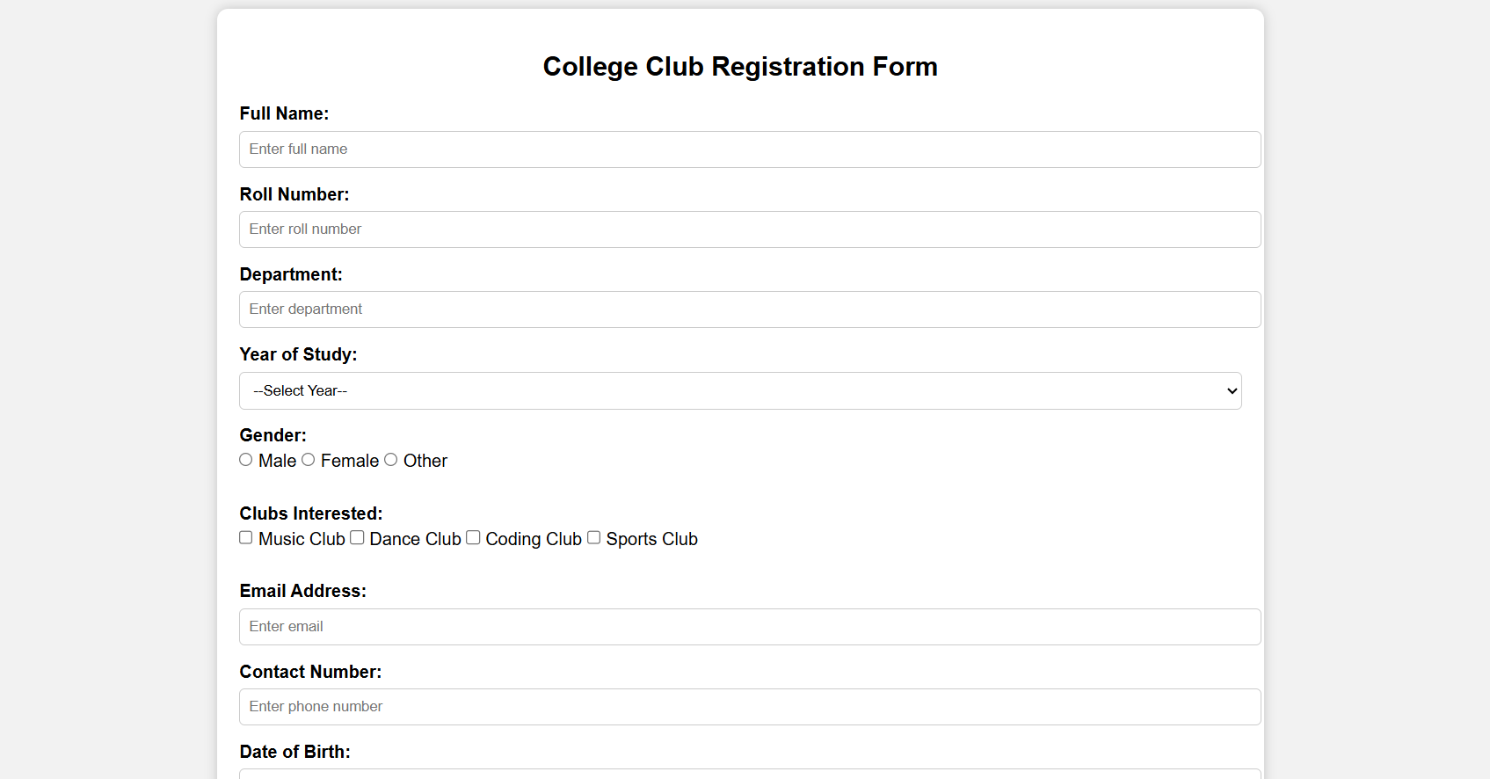
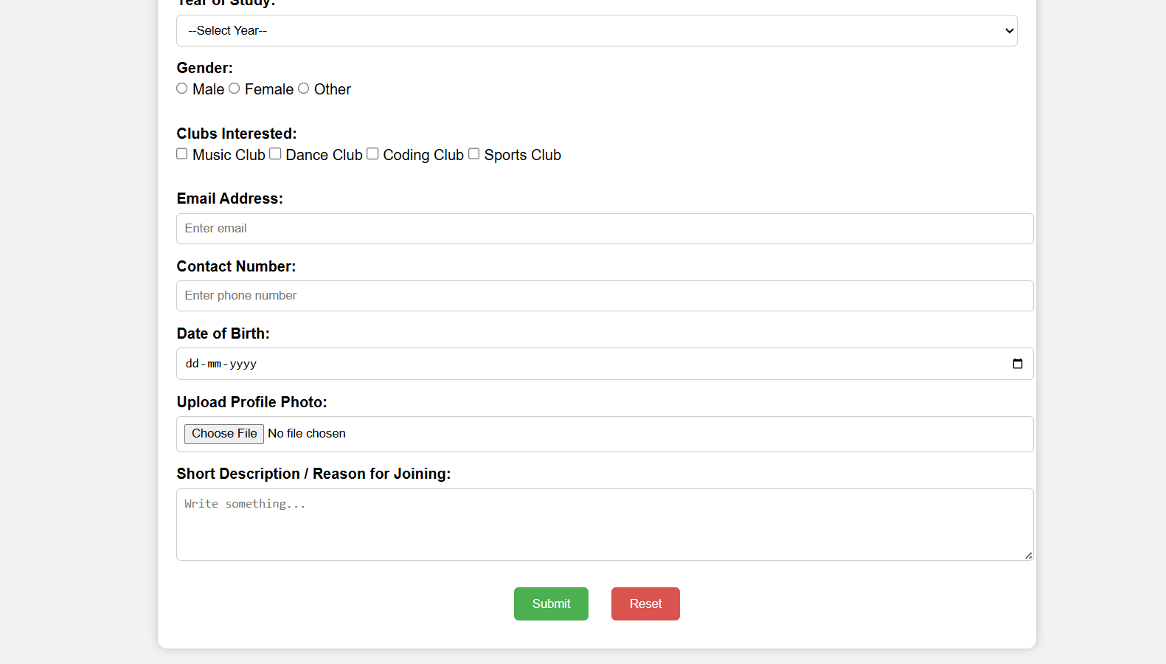
<!DOCTYPE html>
<html lang="en">
<head>
<meta charset="UTF-8">
<meta name="viewport" content="width=device-width, initial-scale=1.0">
<title>College Club Registration Form</title>
<style>
body {
font-family: Arial, sans-serif;
background-color: #f2f2f2;
margin: 0;
padding: 0;
}
.container {
width: 60%;
margin: 30px auto;
background: white;
padding: 20px;
border-radius: 10px;
box-shadow: 0 0 10px rgba(0,0,0,0.2);
}
h2 {
text-align: center;
}
label {
font-weight: bold;
}
input, select, textarea {
width: 100%;
padding: 8px;
margin: 6px 0 15px 0;
border: 1px solid #ccc;
border-radius: 5px;
}
.inline {
width: auto;
}
.btn-group {
text-align: center;
}
button {
padding: 10px 20px;
border-radius: 5px;
border: none;
margin: 10px;
cursor: pointer;
}
.submit-btn {
background-color: #4CAF50;
color: white;
}
.reset-btn {
background-color: #d9534f;
color: white;
}
</style>
</head>
<body>

<div class="container">
<h2>College Club Registration Form</h2>
<form id="regForm">

<label>Full Name:</label>
<input type="text" placeholder="Enter full name" required>

<label>Roll Number:</label>
<input type="text" placeholder="Enter roll number" required>

<label>Department:</label>
<input type="text" placeholder="Enter department" required>

<label>Year of Study:</label>
<select required>
<option value="">--Select Year--</option>
<option>1st Year</option>
<option>2nd Year</option>
<option>3rd Year</option>
<option>4th Year</option>
</select>

<label>Gender:</label><br>
<input type="radio" name="gender" class="inline" required> Male
<input type="radio" name="gender" class="inline"> Female
<input type="radio" name="gender" class="inline"> Other
<br><br>

<label>Clubs Interested:</label><br>
<input type="checkbox" class="inline"> Music Club
<input type="checkbox" class="inline"> Dance Club
<input type="checkbox" class="inline"> Coding Club
<input type="checkbox" class="inline"> Sports Club
<br><br>

<label>Email Address:</label>
<input type="email" placeholder="Enter email" required>

<label>Contact Number:</label>
<input type="tel" placeholder="Enter phone number" required>

<label>Date of Birth:</label>
<input type="date" required>

<label>Upload Profile Photo:</label>
<input type="file" required>

<label>Short Description / Reason for Joining:</label>
<textarea rows="4" placeholder="Write something..." required></textarea>

<div class="btn-group">
<button type="submit" class="submit-btn">Submit</button>
<button type="reset" class="reset-btn">Reset</button>
</div>

</form>
</div>

<script>
document.getElementById("regForm").addEventListener("submit", function(event){
alert("Your form has been submitted successfully!");
event.preventDefault();
});
</script>

</body>
</html>

