Name: Abhinav Singh
Brach: CSIT-A
Roll No.: 07
Website link: http://127.0.0.1:5500/TravelAgency.html

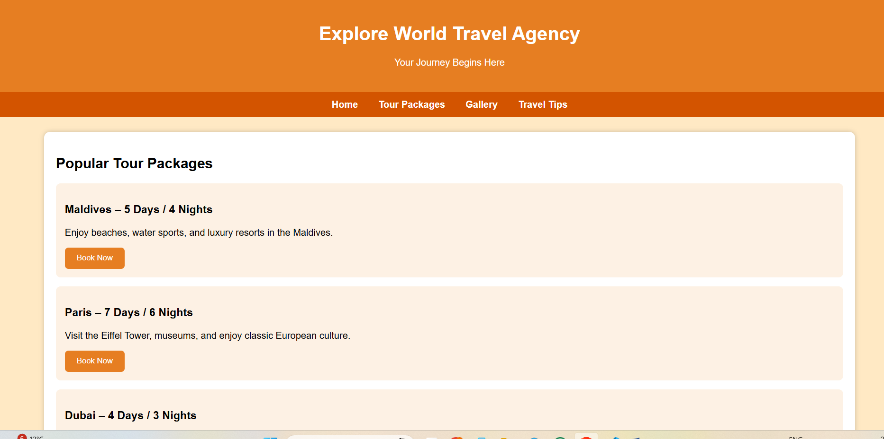
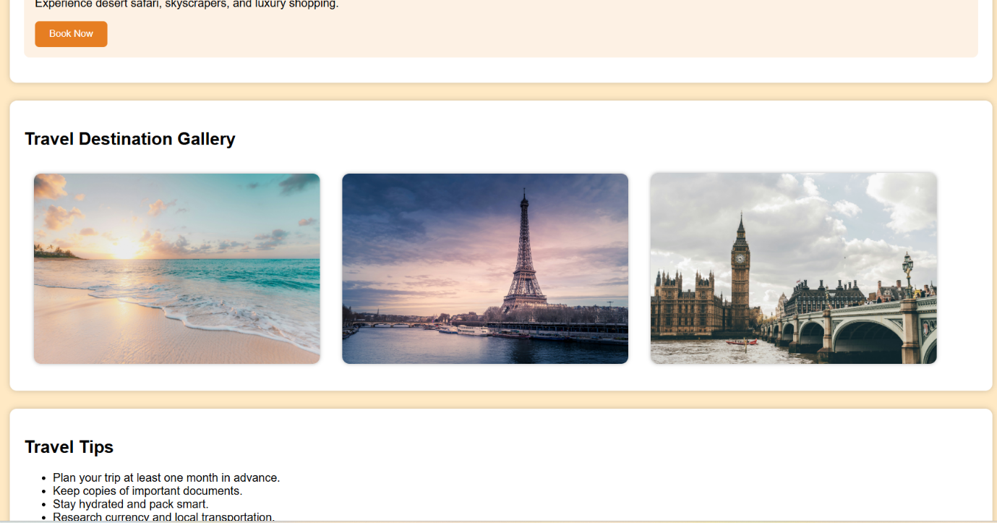
<!DOCTYPE html>
<html lang="en">
<head>
<meta charset="UTF-8">
<meta name="viewport" content="width=device-width, initial-scale=1.0">
<title>Travel Agency Website</title>

<style>
body {
margin: 0;
padding: 0;
font-family: Arial, sans-serif;
background: #ffe9c4; /* DIFFERENT BACKGROUND COLOUR */
}
header {
background: #e67e22;
color: white;
padding: 25px;
text-align: center;
}
nav {
background: #d35400;
padding: 12px;
text-align: center;
}
nav a {
color: white;
text-decoration: none;
margin: 0 15px;
font-weight: bold;
}
.container {
width: 90%;
margin: 25px auto;
}
.section {
background: white;
padding: 20px;
border-radius: 10px;
margin-bottom: 25px;
box-shadow: 0 0 8px rgba(0,0,0,0.2);
}
.gallery img {
width: 30%;
margin: 1%;
border-radius: 10px;
box-shadow: 0 0 5px rgba(0,0,0,0.3);
}
.package {
background: #fdf1e4;
padding: 15px;
border-radius: 8px;
margin-bottom: 15px;
}
button {
background: #e67e22;
color: white;
border: none;
padding: 10px 20px;
cursor: pointer;
border-radius: 6px;
}
</style>
</head>
<body>

<header>
<h1>Explore World Travel Agency</h1>
<p>Your Journey Begins Here</p>
</header>

<nav>
<a href="#">Home</a>
<a href="#packages">Tour Packages</a>
<a href="#gallery">Gallery</a>
<a href="#tips">Travel Tips</a>
</nav>

<div class="container">

<!-- Tour Packages -->
<div id="packages" class="section">
<h2>Popular Tour Packages</h2>

<div class="package">
<h3>Maldives – 5 Days / 4 Nights</h3>
<p>Enjoy beaches, water sports, and luxury resorts in the Maldives.</p>
<button>Book Now</button>
</div>

<div class="package">
<h3>Paris – 7 Days / 6 Nights</h3>
<p>Visit the Eiffel Tower, museums, and enjoy classic European culture.</p>
<button>Book Now</button>
</div>

<div class="package">
<h3>Dubai – 4 Days / 3 Nights</h3>
<p>Experience desert safari, skyscrapers, and luxury shopping.</p>
<button>Book Now</button>
</div>
</div>

<!-- Gallery -->
<div id="gallery" class="section">
<h2>Travel Destination Gallery</h2>
<div class="gallery">
<img src="https://images.unsplash.com/photo-1507525428034-b723cf961d3e" alt="Beach">
<img src="https://images.unsplash.com/photo-1502602898657-3e91760cbb34" alt="Paris">
<img src="https://images.unsplash.com/photo-1505761671935-60b3a7427bad" alt="Dubai">
</div>
</div>

<!-- Travel Tips -->
<div id="tips" class="section">
<h2>Travel Tips</h2>
<ul>
<li>Plan your trip at least one month in advance.</li>
<li>Keep copies of important documents.</li>
<li>Stay hydrated and pack smart.</li>
<li>Research currency and local transportation.</li>
</ul>
</div>

</div>

</body>
</html>

