S24CSEU0621
Abhinav Kumar
LAB_1

(1) Install Python & (2) Install Git
Note: - I had already installed both so I just checked the version
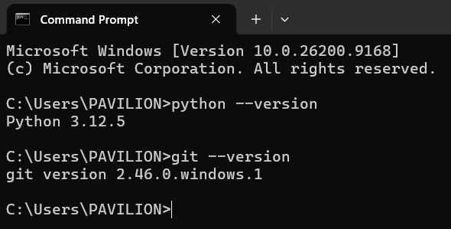
(3) Get the course Files
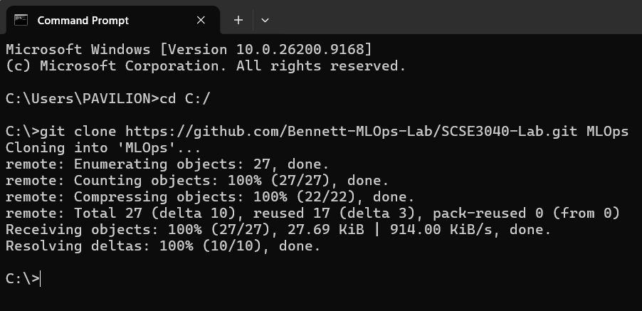

(4) Make the virtual environment
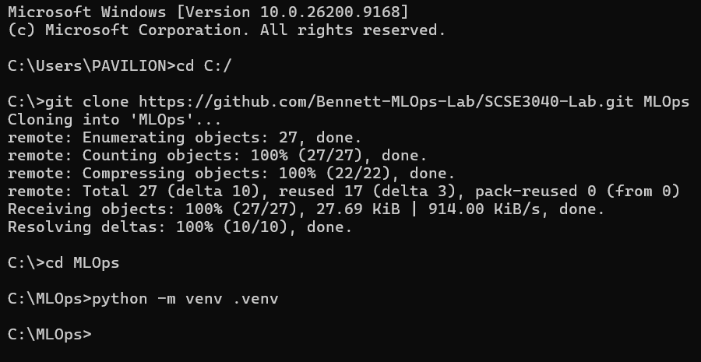
(5) Install the libraries
(i). venv\Scripts\python -m pip install --upgrade pip
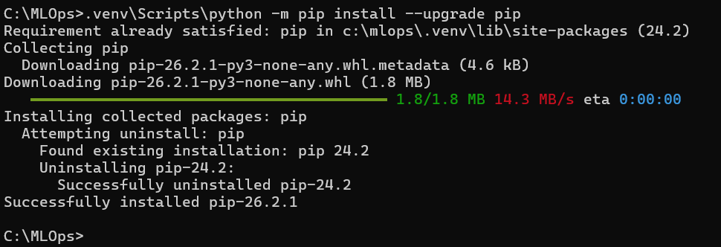
(ii) .venv\Scripts\python -m pip install -r requirements-lock.txt
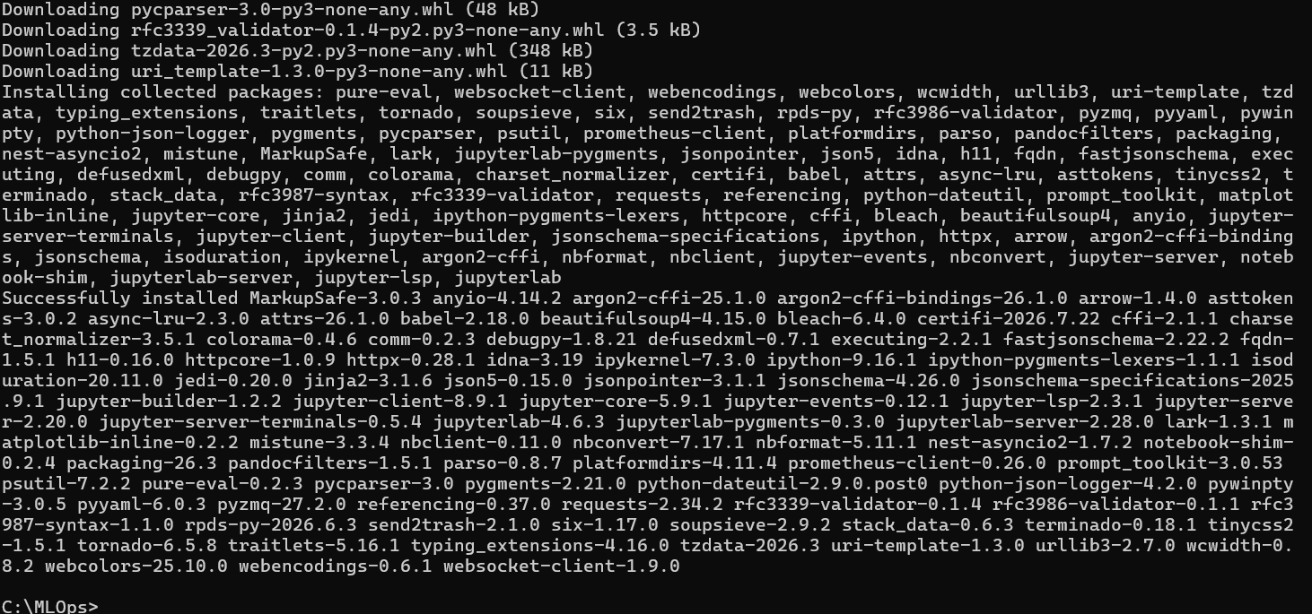
(iii). venv\Scripts\python -m pip install jupyterlab nbformat ipykernel httpx
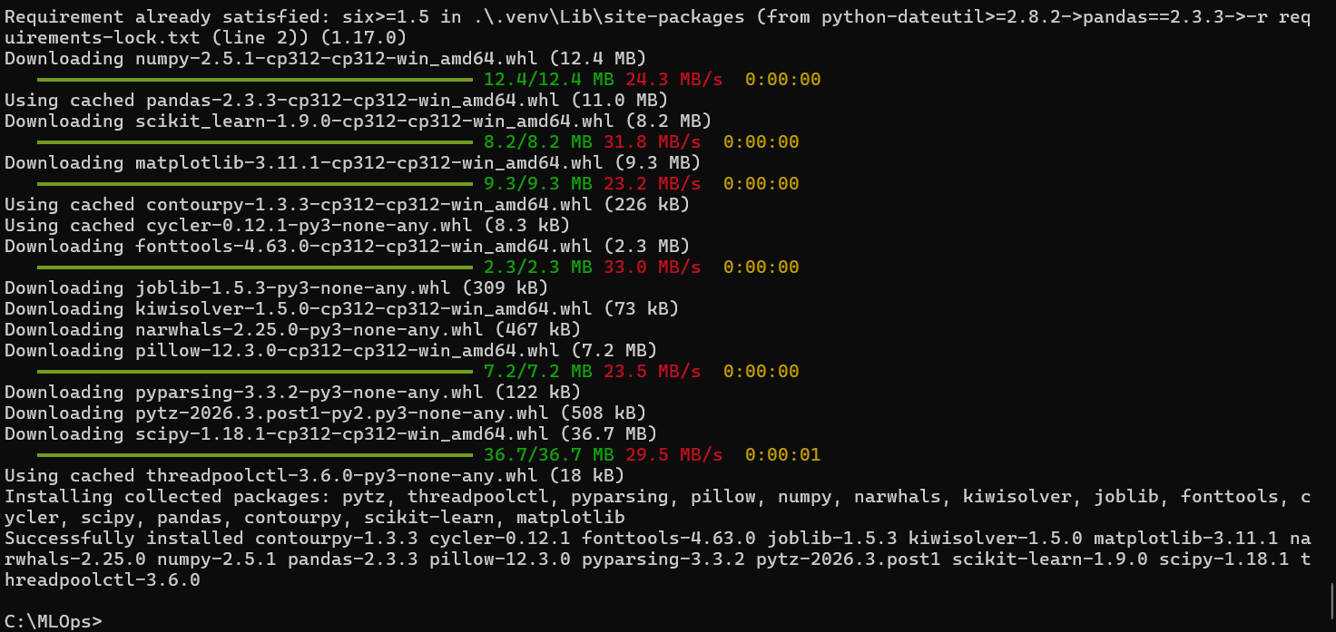
(6) Register the notebook kernel
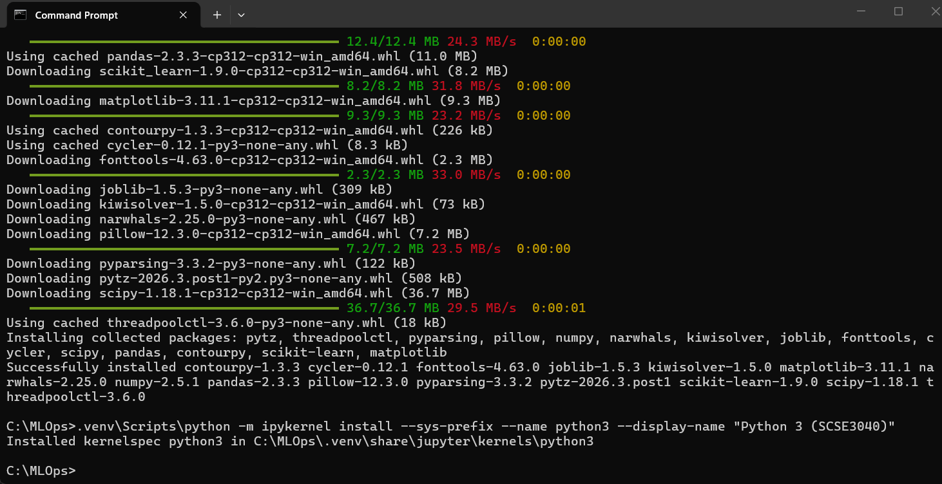
(7) Check everything

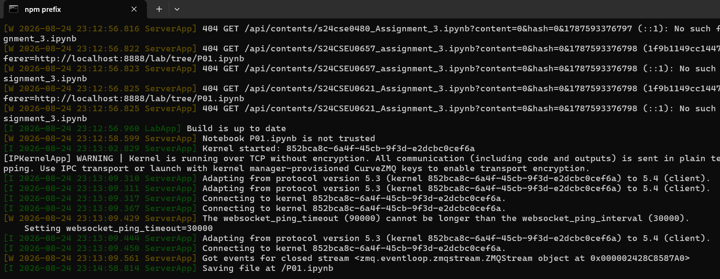
Note:- There was a problem in setting up the path for opening the default browser as chrome which was resolved.

