CSE 221 - Project Checkpoint 2 - Draft
Abhinav Mishra, Anmol Agarwal, Aaron Arpi

Memory Operations

- RAM access time

Estimation

The RAM access should happen as the array sizes are increased and the L1 through L3 caches are not able to accommodate that array size. We know that the caches are faster to access than main memory because of their smaller size and the way hardware is designed. The smallest arrays (<32kB) should access the L1 cache (onboard cache). The bigger arrays should access the L2 cache (<256kB). The even bigger arrays should access the L3 cache (<6MB). Finally the biggest arrays should access main memory (>6MB). We expect L1 cache access to be extremely fast. We expect L2 cache access to be slightly more expensive. L3 cache should a few nanoseconds slower still. Finally, main memory should be significantly slower, because it would requires leaving the CPU and making a virtual address lookup. The LmBench paper provides a graphical representation of what we should expect as well.

Implementation

To measure RAM access time, we follow the methodology used in section 6.2 of the LmBench paper. We create arrays of increasing sizes and iterate through them 1,000,000 times sequentially (wrapping around if we reached the end of the array). Each array is created at the beginning of the iteration and then freed in the end. As mentioned in the lmbench paper, we also attempt different stride sizes. We randomized the array data allocation so as to avoid cache pre-fetching effects. I suspect that we only minimized it and not avoided it completely. More comprehensive solutions need to be tried out for that. The size of the arrays we varied from 8KB to 64MB. For each array size, strides that were taken were 16,64,256 and 1024.

Results

The result of our experiment were similar to LmBench paper results and were as per our expectations. The graph below depicts our results:
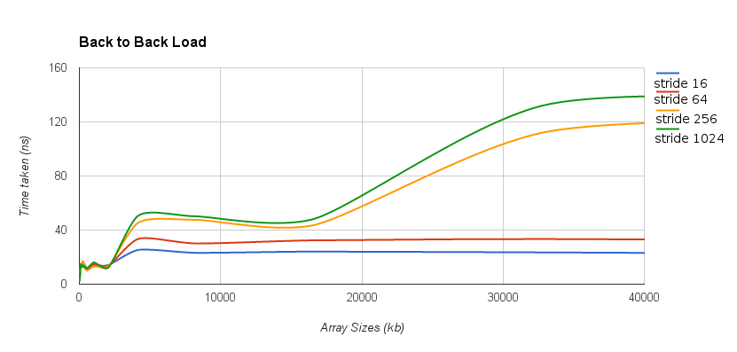

Analysis

Our system has the below cache configurations:

Cache
Level 1 (Data) | 8-way set-associative, 64 sets, 32KB size
Level 1 (Instruction) | 8-way set-associative, 64 sets, 32KB size
Level 2 (Unified) | 8-way set-associative, 512 sets, 256KB size
Level 3 (Unified) | 12-way set-associative, 8192 sets, 6144KB size

From our vendor, we known that our cache lines are 64 bytes. The transition from L1 cache to L2 cache and L3 cache to main memory are clearly visible and follow what we would expect from our knowledge of the hardware. However, the transition from L2 cache to L3 cache isn't very discrete and expected. We are unable to compare with LMBench here because the computers profiled with LmBench do not have L3 caches. One possible reasoning is that the memory latency difference between the L2 and L3 cache is small and we suffer from small software overhead from looping through the strides, which makes the transition indistinguishable. Finally, we also notice that when the stride size becomes greater than the cache line of the hardware, the main memory latency is greatly increased.

2. RAM bandwidth

Method

We tested the time required to copy slices of a large array from one location in RAM to another. In order to prevent time delays associated with memory allocation (as opposed to pure copying) from entering into the results we allocated a large array on the heap as the copy destination. We then used memcpy() to perform the copy, since this is the procedure which is fastest for array segment copying, according to the documentation for the programming language. We performed the test 1000 times for each slice size. The slice size was varied from 1MB to 49MB. Also, the array from which the slice was taken was 80MB so as to ensure it would not be stored in cache.

We had previously calculated that the overhead associated with executing a loop was approximately 32 cycles per loop iteration. We removed this overhead from the recorded copy time on each iteration.

Because memory bandwidth is reported in the form of an upper bound on performance, we stored the fastest copy time achieved over the 1000 timed copy operations performed for each slice size. We also stored the median copy time in order to check the consistency of the results and in order to ascertain whether approximately worst case performance varied in tandem with approximately best case performance as the size of the array slice was varied.

Also, before running our test, we prioritized the testing process using “friend”, and killed most of the other processes running on the machine.

Prediction

We found online sources reporting that memory bandwidth had been benchmarked through testing with memcpy(), and was shown to be approximately 15GB/sec on this machine. Thus, w expect to see memory bandwidth of approximately 15GB.

Also, because we know that the processor cache is 6MB, we expect to see that the memcpy operation takes an amount of time that is equivalent to a bandwidth of much higher than 15GB when the array slice is significantly less than 6MB. When the size of the slice is increased beyond 6MB, we expect to see that the copy operation takes significantly longer because the slice cannot be stored in cache. If we do observe this type of outcome, it will serve as verification that the cache has not been involved in the memcpy() operations involving slices greater than 6MB.

Results

We observed fairly consistent results over the entire range of array slice sizes. These results were roughly in line with the results reported online. When the copied array slice was between 7MB and 49MB, the best recorded copy times corresponded to a bandwidth of 10.1GB/sec on average. This is slower than was documented online, but not by much. The discrepancy is well within the margin of difference that could be explained by differences in testing methodology or system operating environment. The following is a table that documents these results:

Size of array slice: 1.000000 --- MB/Second coppied 874.4998168945 MB/s
Size of array slice: 2.000000 --- MB/Second coppied 19255.9511718750 MB/s
Size of array slice: 3.000000 --- MB/Second coppied 16623.2246093750 MB/s
Size of array slice: 4.000000 --- MB/Second coppied 14483.7695312500 MB/s
Size of array slice: 5.000000 --- MB/Second coppied 14164.7548828125 MB/s
Size of array slice: 6.000000 --- MB/Second coppied 13471.0859375000 MB/s
Size of array slice: 7.000000 --- MB/Second coppied 11181.6513671875 MB/s
Size of array slice: 8.000000 --- MB/Second coppied 8304.0234375000 MB/s
Size of array slice: 9.000000 --- MB/Second coppied 8533.3652343750 MB/s
Size of array slice: 10.000000 --- MB/Second coppied 11389.8798828125 MB/s
Size of array slice: 11.000000 --- MB/Second coppied 6058.4990234375 MB/s
Size of array slice: 12.000000 --- MB/Second coppied 10084.2539062500 MB/s
Size of array slice: 13.000000 --- MB/Second coppied 5462.3125000000 MB/s
Size of array slice: 14.000000 --- MB/Second coppied 9183.7558593750 MB/s
Size of array slice: 15.000001 --- MB/Second coppied 10139.9785156250 MB/s
Size of array slice: 16.000000 --- MB/Second coppied 9837.2910156250 MB/s
Size of array slice: 17.000000 --- MB/Second coppied 10076.6914062500 MB/s
Size of array slice: 18.000000 --- MB/Second coppied 9927.8535156250 MB/s
Size of array slice: 19.000000 --- MB/Second coppied 10396.2167968750 MB/s
Size of array slice: 20.000000 --- MB/Second coppied 10046.8984375000 MB/s
Size of array slice: 21.000000 --- MB/Second coppied 10262.1601562500 MB/s
Size of array slice: 22.000000 --- MB/Second coppied 10490.4375000000 MB/s
Size of array slice: 23.000000 --- MB/Second coppied 10245.6787109375 MB/s
Size of array slice: 24.000000 --- MB/Second coppied 10565.4824218750 MB/s
Size of array slice: 25.000000 --- MB/Second coppied 10340.6074218750 MB/s
Size of array slice: 26.000000 --- MB/Second coppied 10555.3447265625 MB/s
Size of array slice: 27.000002 --- MB/Second coppied 9468.3750000000 MB/s
Size of array slice: 28.000000 --- MB/Second coppied 9673.6884765625 MB/s
Size of array slice: 29.000000 --- MB/Second coppied 9432.3437500000 MB/s
Size of array slice: 30.000002 --- MB/Second coppied 8155.8862304688 MB/s
Size of array slice: 31.000000 --- MB/Second coppied 10527.5917968750 MB/s
Size of array slice: 32.000000 --- MB/Second coppied 10333.0869140625 MB/s
Size of array slice: 33.000000 --- MB/Second coppied 9736.9453125000 MB/s
Size of array slice: 34.000000 --- MB/Second coppied 9485.3076171875 MB/s
Size of array slice: 35.000000 --- MB/Second coppied 10495.6464843750 MB/s
Size of array slice: 36.000000 --- MB/Second coppied 10277.4638671875 MB/s
Size of array slice: 37.000000 --- MB/Second coppied 10466.5927734375 MB/s
Size of array slice: 38.000000 --- MB/Second coppied 10218.4160156250 MB/s
Size of array slice: 39.000000 --- MB/Second coppied 10461.4746093750 MB/s
Size of array slice: 40.000000 --- MB/Second coppied 10283.1972656250 MB/s
Size of array slice: 41.000000 --- MB/Second coppied 10182.1406250000 MB/s
Size of array slice: 42.000000 --- MB/Second coppied 10087.6435546875 MB/s
Size of array slice: 43.000000 --- MB/Second coppied 10246.2646484375 MB/s
Size of array slice: 44.000000 --- MB/Second coppied 9984.4511718750 MB/s
Size of array slice: 45.000000 --- MB/Second coppied 9469.4062500000 MB/s
Size of array slice: 46.000000 --- MB/Second coppied 10087.5605468750 MB/s
Size of array slice: 47.000000 --- MB/Second coppied 10210.1621093750 MB/s
Size of array slice: 48.000000 --- MB/Second coppied 10125.7294921875 MB/s
Size of array slice: 49.000000 --- MB/Second coppied 9901.2636718750 MB/s

Interesting Points

When the sample of best case copy times is observed for those array slices greater than 6MB, there is very little variance. This is indicative of good testing results. Also, the majority of the variance that does exist seems to come in clusters. For example, observe the dip in bandwidth measured for the 33MB slice and 34MB slice. A similar phenomenon occurred for slices of size 27MB-30MB, as well as other clusters of similarly sized slices.

Our explanation for this is not that these particular slices entailed more time to copy because of their size. Rather, the processor probably became busy during the time when the timer was running for these particular slices. That is, these particular slices may have gotten interleaved with other processes that did not affect the copying of other array slices.

3. Page Fault Service Time

Page Fault

A page fault is a type of interrupt, called trap, raised by computer hardware when a running program accesses a memory page that is mapped into the virtual address space, but not actually loaded into main memory. The hardware that detects a page fault is the processor's memory management unit (MMU), while the exception handling software that handles page faults is generally a part of the operating system kernel. When handling a page fault, the operating system generally tries to make the required page accessible at the location in physical memory, or terminates the program in case of an illegal memory access. In order for a memory load request to become a page fault, it has to first miss the TLB and then the virtual memory page table. Next, in order to succeed it will have to fetch data from disk.

Method

To get the page Fault service time we had to limit the memory usage for a process in order to calculate the time. For this we used CGROUPS which are LINUX kernel feature which helps to limit and account for resource usage. Cgroups are tags which can be specified when running process and which indicate to the operating system that only a restricted set of resources (indicated in the Cgroup description) should be allocated to the process. For example, we restrict the amount of RAM used by the process for this experiment to 75MB.

In the experiment, we proceed to allocate an array of 150 strings, each 1MB long. We filled this 150 strings with actual data of size 1 MB each.

Given the process can only use 75MB of RAM, so we expect that at least half of the pages used by the array have been flushed to disk. Given data has been allocated sequentially, we can expect, that these pages correspond to the first half of the array.

Result

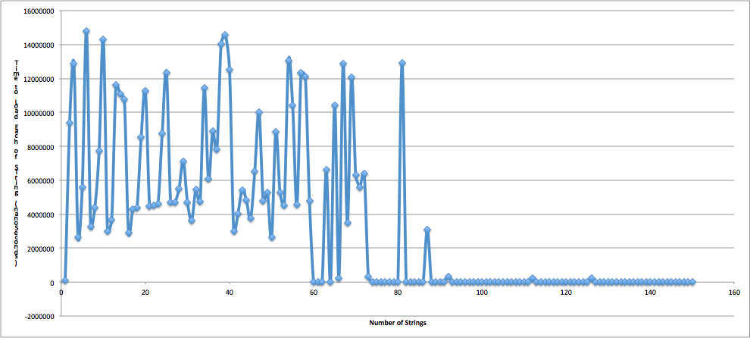

By looking at the graph we can see the time to load each of the 150 strings.

Given that the page size of our system is 4KB, 1MB corresponds to 256 pages. The meam page load time for the first 75 MB is 6503.42476/256 = 25.40 microseconds. On the other hand, the average page load time for the last 75 MB is 224.925/256 = 0.08786 microseconds.

We infer that the first 75MB of the array has been fetched from disk, as the memory was limited to 75 MB while the remaining 75MB could be fetched from main memory. In this case, the page fault service time for a single page would be 25.40 - 0.08786 = 25.312 microseconds.

