METHOD1 :

Using nnetar  
  
Data set used : Infosys

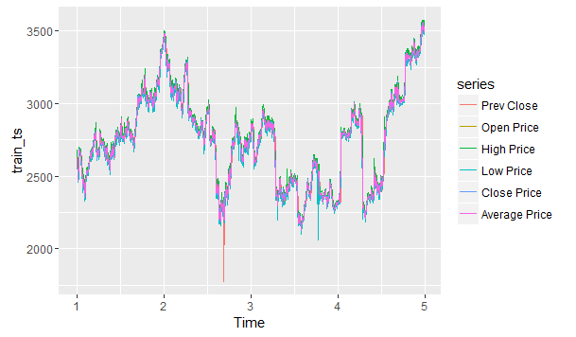  
  
All prices for 4 years  
  
  
  
Training data : only the closing price of 1005 days

1005 days spanned from 1st Jan 2010 to 31st Jan 2013

No data available for weekends

Downloaded from : <https://www.nseindia.com/index_nse.htm>

Only the closing prices over four years :  
  
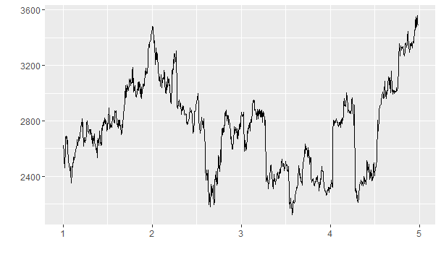

Train_ts_components : dividing time series data into 3 components,   
r : remainder, the noise

s : seasonality

t : trend

**Kindly see if we can use anymore features from train_ts_components

The predicted trend, seasonality and remainder noise are as follows :

T

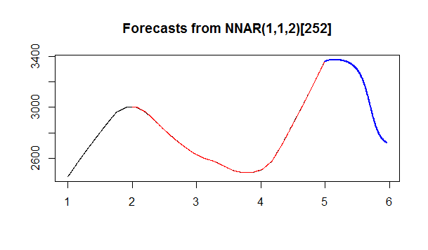

S

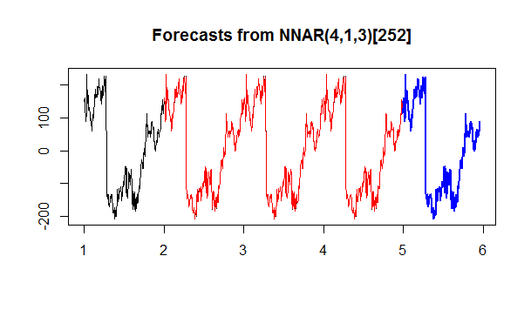

R

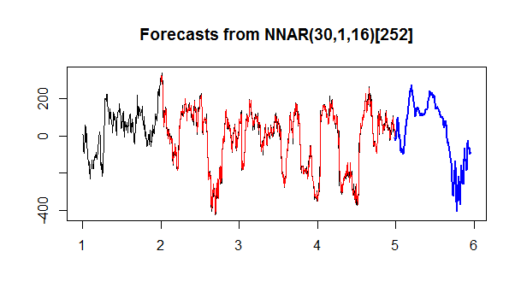

CPs of the year 2014 is as follows :

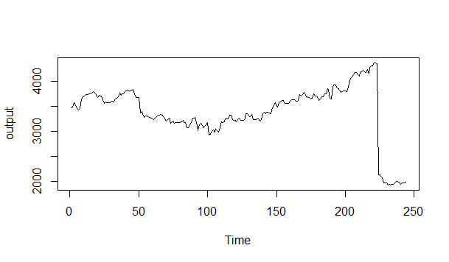

Comparision :

Values is vector containing predictions

Output is actual CP during the year 2014

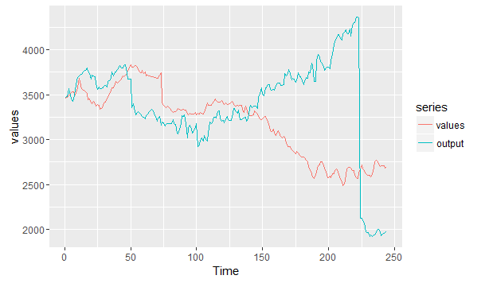

Inference :  
Good for small scale predictions..say predictions for couple of days or a month